**System Interconnections in Simulink**

**LAB # 03**



**Fall 2024**

**CSE-310L Control Systems Lab**

Submitted by: **Ali Asghar**

Registration No.: **21PWCSE2059**

Class Section: **C**

“On my honor, as student of University of Engineering and Technology, I have neither given nor received unauthorized assistance on this academic work.”

Submitted to:

**Dr. Muniba Ashfaq**

Date:

20**th October 2024**

**Department of Computer Systems Engineering**

**University of Engineering and Technology, Peshawar**

**Objectives:**

The objective of this lab is to learn about:

* Series, Parallel and feedback interconnection of systems

**Series System Interconnection:**

**Find the equivalent system of the following systems connected in series. Prove it using Simulink.**

**G1(s) = 1/(S+1)**

**G2(s) = 1/(s+4)**

**G3(s) = (s+3)/(s+5)**

**MATLAB:**

**Code:**

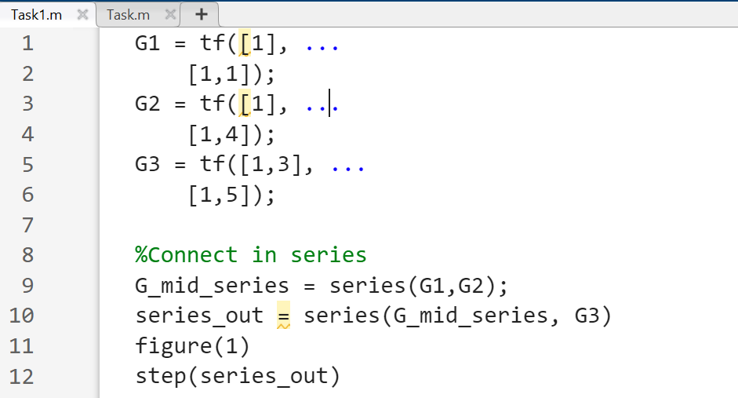

**Output:**

**Simulink:**

**Block Design:**

**Output:**

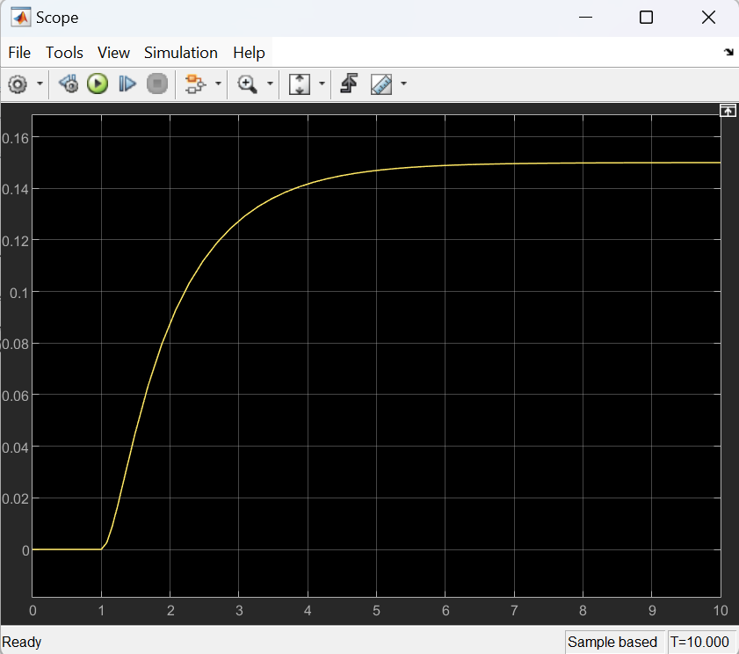

**Equivalent System:**

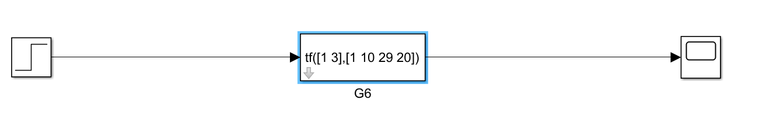

**Parallel System Interconnection:**

**Find the equivalent system of the following systems connected in parallel. Prove it using Simulink.**

**G1(s) = 1/(S+1)**

**G2(s) = 1/(s+4)**

**G3(s) = (s+3)/(s+5)**

**MATLAB:**

**Code:**

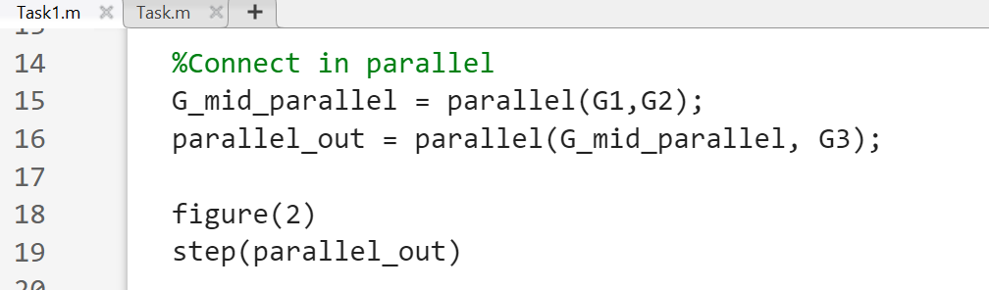

**Output:**

**Simulink:**

**Block Design:**

**Output:**

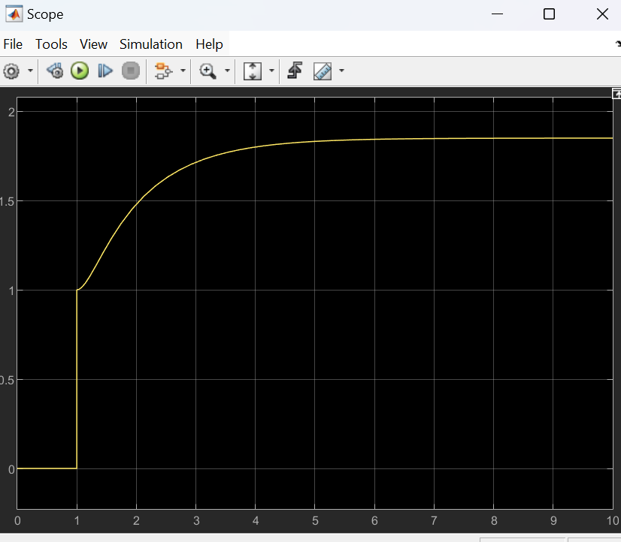

**Equivalent System:**

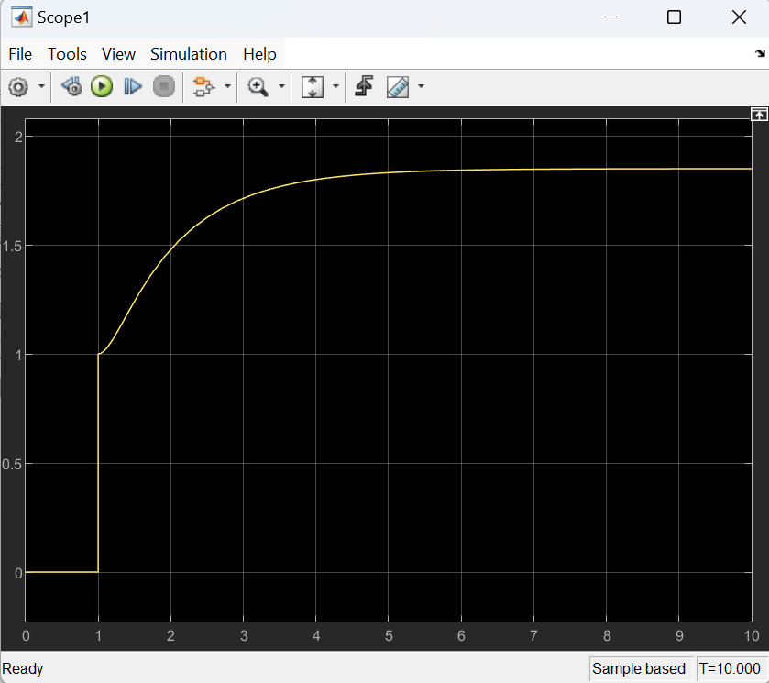

**Negative feedback system interconnection:**

**MATLAB:**

**Code:**

**Output:**

**Simulink:**

**Block Design:**

**Output:**

**Equivalent System:**

