**Simulation of Lower Order Differential Equations using MATLAB & Simulink**

**LAB # 04**



**Fall 2024**

**CSE-310L Control Systems Lab**

Submitted by: **Ali Asghar**

Registration No.: **21PWCSE2059**

Class Section: **C**

“On my honor, as student of University of Engineering and Technology, I have neither given nor received unauthorized assistance on this academic work.”

Submitted to:

**Dr. Muniba Ashfaq**

Date:

2**nd November 2024**

**Department of Computer Systems Engineering**

**University of Engineering and Technology, Peshawar**

**Objectives:**

The objective of this lab is to learn about:

* solving low order differential equation using Matlab.

**Introduction:**

This lab is about solving differential equation using Matlab. Two functions can be used for solving differential equations. One is the ODE23 and the other is ODE45. Either of the two can be used. A function is written in an M-file according to the given system. That function is called from command window using the ODE23 or ODE45 syntax.

**[T, Y] = ODE45 ('Func', TSPAN, Y0).**

The function should return a column vector which is stored in Y. “Func” is the name of the function made in Matlab M-file. TSPAN = [T0 TFINAL] integrates the system of differential equations y' = F (t, y) from time T0 to TFINAL with initial conditions Y0. Each row in solution array Y corresponds to a time returned in column vector T.

**Part(a):**

**Task 01:**

Simulate the below mentioned system which is represented by differential equations in Matlab. [Hint: ode23 or ode45]

y1(0)=0 y1’=y2y3

y2(0)=1 y2’=-y2y3

y3(0)=1 y3’=-0.51y1y3

**MATLAB:**

**Code:**

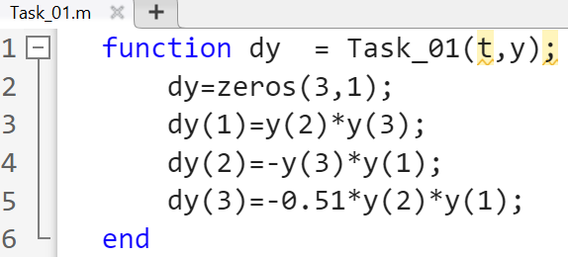

**Function Call:**

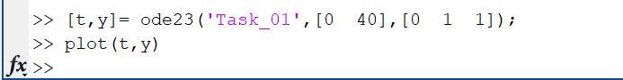

**Output:**

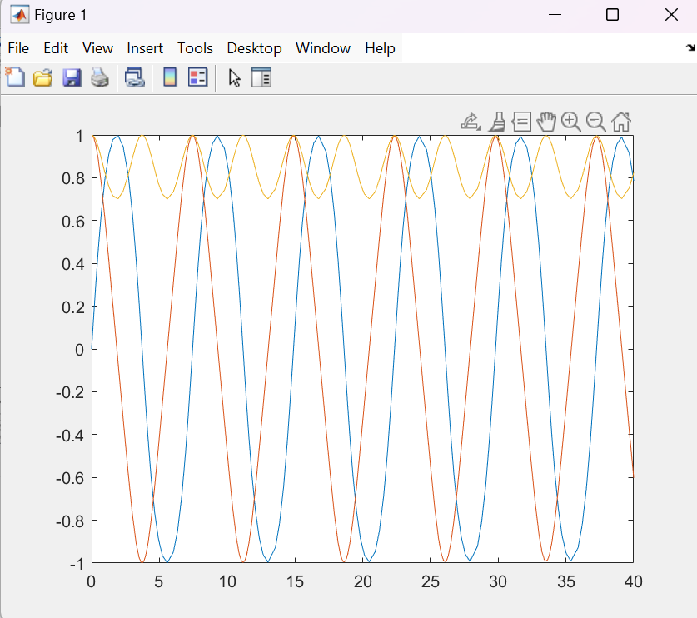

**Task 02:**

Simulate the below mentioned system which is represented by differential equations in Matlab. [Hint: ode23 or ode45] y1’’+y12y1- y1’+y1=0

**MATLAB:**

**Code:**

**Function Call:**

**Output:**

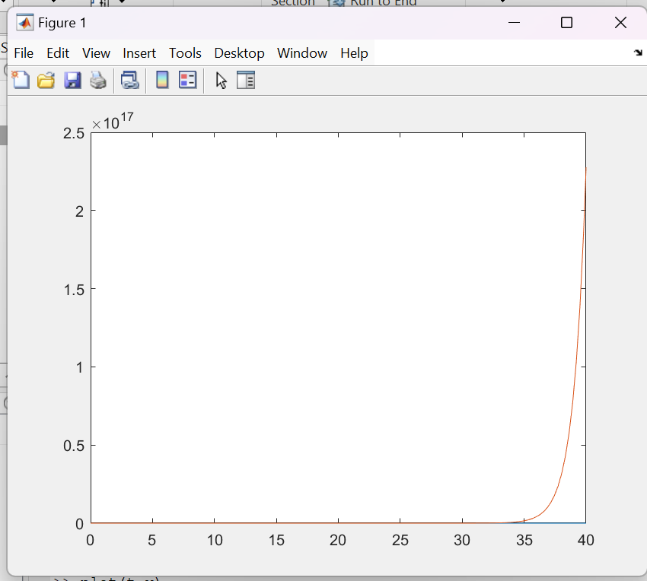

**Simulink:**

**Task 01:**

Simulate the below mentioned system which is represented by differential equations in Simulink. y1(0) = 0 y1’=y2y3

y2(0) = 1 y2’=-y2y3

y3(0) = 1 y3’=-0.51y1y3

**Block Diagram:**

**Output:**

**Task 02:**

Simulate the below mentioned system which is represented by differential equations in Matlab. [Hint: ode23 or ode45] -y1’’+y12 y2- y1’+y1=0

**Block Diagram:**

**Output:**

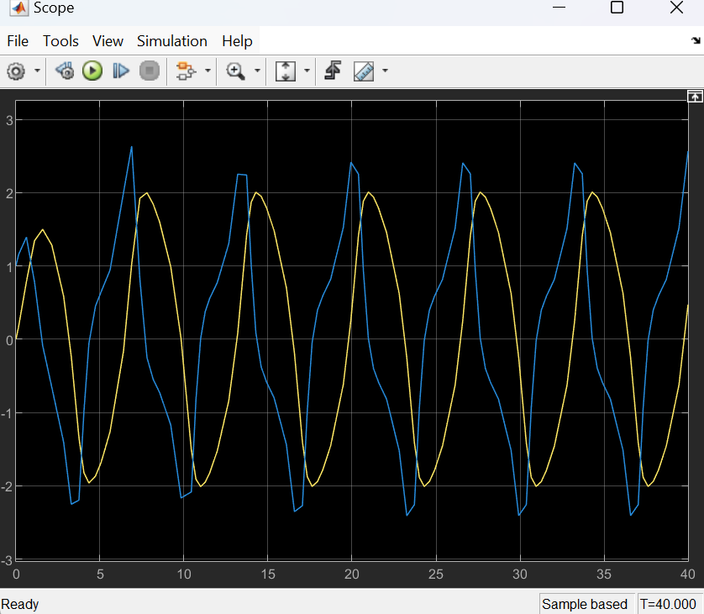

**Conclusion:**

In this lab, I learned how to implement low order differential equations in MATLAB and Simulink.