**Frequency Domain Modelling in MATLAB**

**LAB # 06**



**Fall 2024**

**CSE-310L Control Systems Lab**

Submitted by: **Ali Asghar**

Registration No.: **21PWCSE2059**

Class Section: **C**

“On my honor, as student of University of Engineering and Technology, I have neither given nor received unauthorized assistance on this academic work.”

Submitted to:

**Dr. Muniba Ashfaq**

Date:

1**st December 2024**

**Department of Computer Systems Engineering**

**University of Engineering and Technology, Peshawar**

**Objectives:**

The objective of this lab is to learn about:

* finding the Laplace and Inverse Laplace transforms using MATLAB

**5.1 Use the MATLAB and Control System Toolbox to form a linear time invariant system transfer function**

$$F\left(s\right)= \frac{2}{\left(s+1\right){(s+2)}^{2}}$$

**Code:**

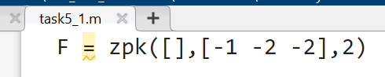

**Output:**

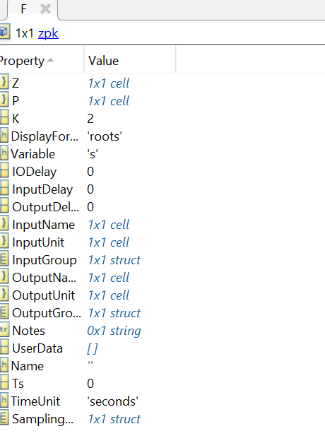

**5.2 Use the MATLAB to get the equation**

$$f\left(t\right)=2e^{-t}-2{te}^{-2t}-2e^{-2t}$$

**Task 8:**

**Code:**

**Output:**

**5.3 Use the MATLAB and Control System Toolbox to form a linear time invariant system transfer function**

$$F\left(s\right)= \frac{3}{s(s^{2}+2s+5)}$$

**Code:**

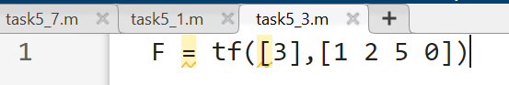

**Output:**

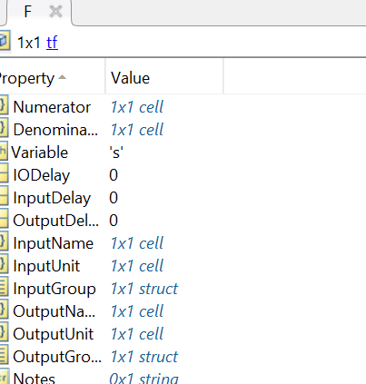

**5.4 Use the MATLAB to find the inverse laplace transform of the system transfer function**

$$F\left(s\right)= \frac{3}{s(s^{2}+2s+5)}$$

**Code:**

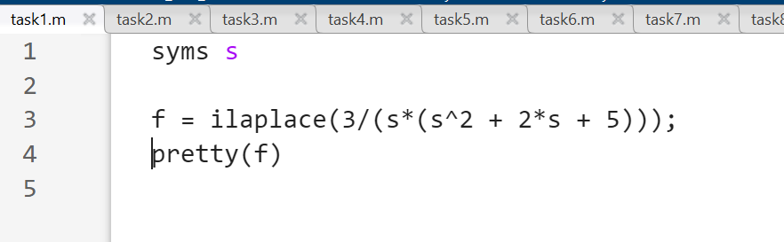

**Output:**

**5.5 Use MATLAB to get the following equation**

$$F\left(s\right)=\frac{3/5}{s}-\frac{3}{20}\left(\frac{2+j1}{s+1+j2}+\frac{2-j1}{s+1-j2}\right)$$

**Code:**

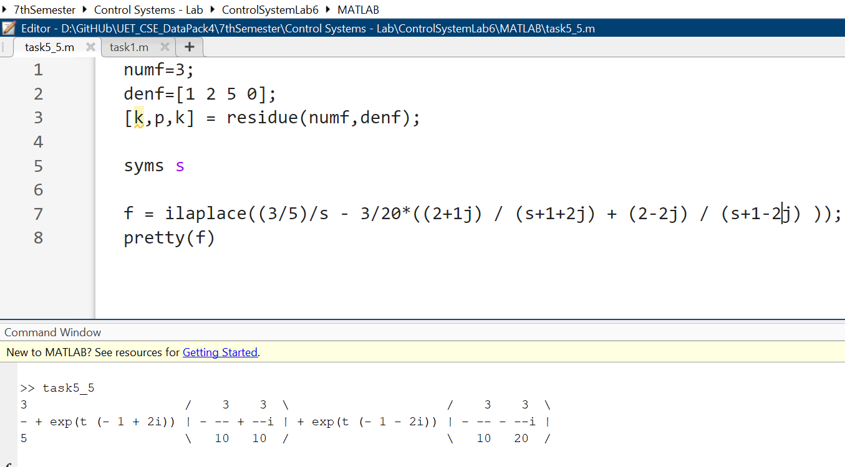

**Output:**

**5.6 Use the MATLAB to find the inverse laplace transform of the system transfer function**

**Code:**

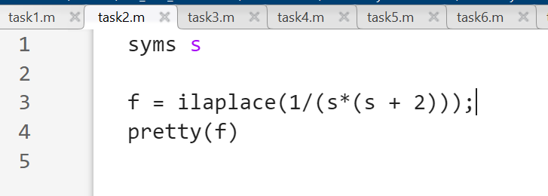

**Output:**

**5.7 Use MATLAB to plot the following function for t from 0 to 1 with the intervals of 0.01**

**Code:**

**Output:**

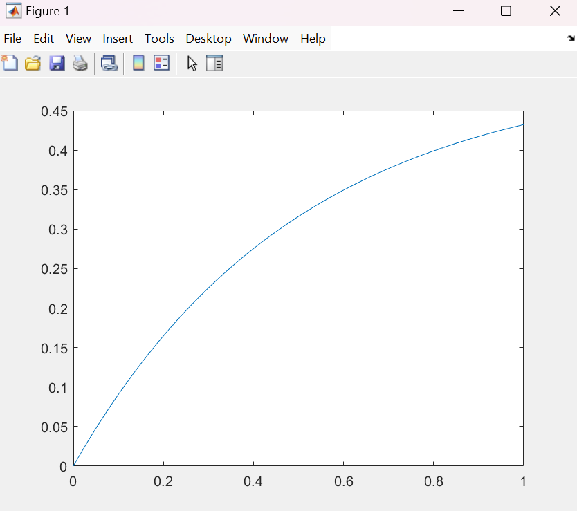

**5.8 Use MATLAB and Symbolic Math Toolbox to help you solve the following equation for currents.**

**Code:**

**Output:**

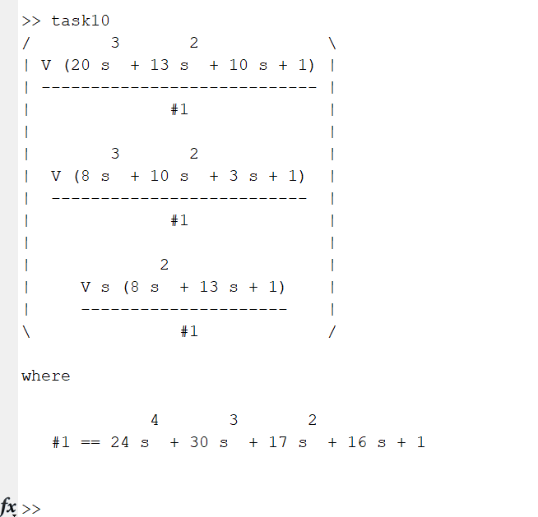

**Lab Tasks:**

**Task 1:**

**Code:**

**Output:**

**Task 2:**

**Code:**

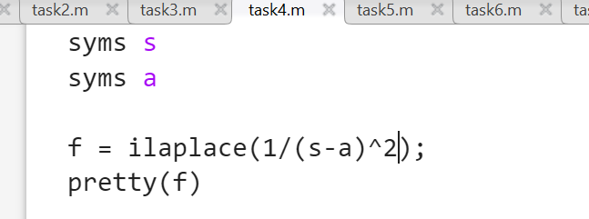

**Output:**

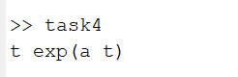

**Task 3:**

**Code:**

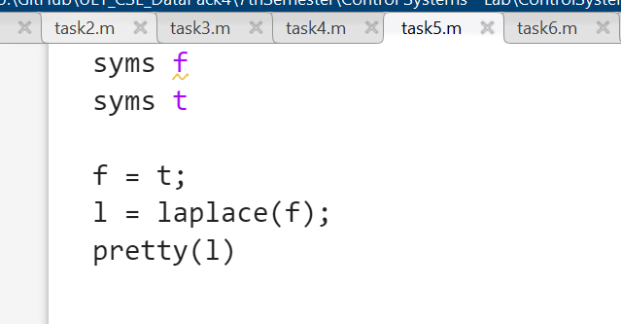

**Output:**

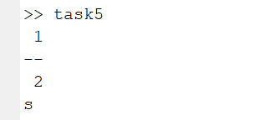

**Task 4:**

**Code:**

**Output:**

**Task 5:**

**Code:**

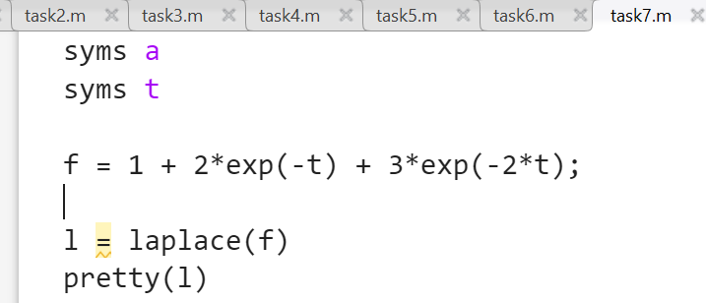

**Output:**

**Task 6:**

**Code:**

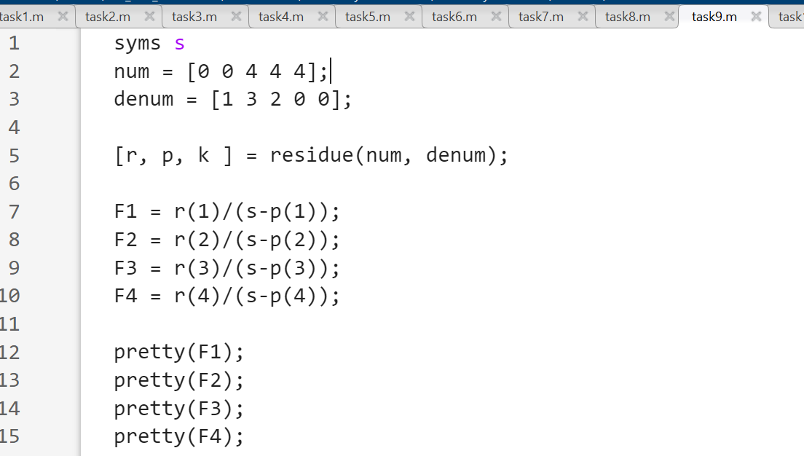

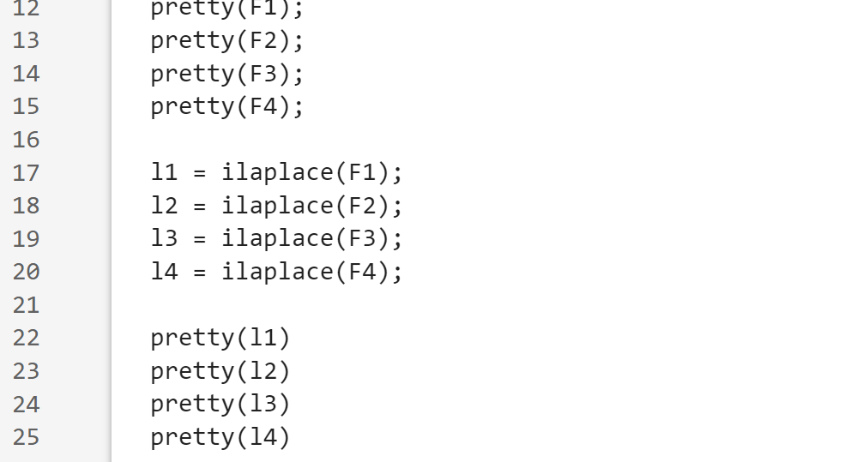

**Output:**

