**Time Domain Modelling in MATLAB**

**LAB # 07**



**Fall 2024**

**CSE-310L Control Systems Lab**

Submitted by: **Ali Asghar**

Registration No.: **21PWCSE2059**

Class Section: **C**

“On my honor, as student of University of Engineering and Technology, I have neither given nor received unauthorized assistance on this academic work.”

Submitted to:

**Dr. Muniba Ashfaq**

Date:

1**st December 2024**

**Department of Computer Systems Engineering**

**University of Engineering and Technology, Peshawar**

**Objectives:**

The objective of this lab is to:

* model the system in time domain.

**State Space Representation:**

State Space representation is one of the unified method for modeling, analyzing and designing a wide range of systems.

**6.1 Use the MATLAB code to form an LTI state space representation from the transfer function. The matrix A, B and C are shown below.**

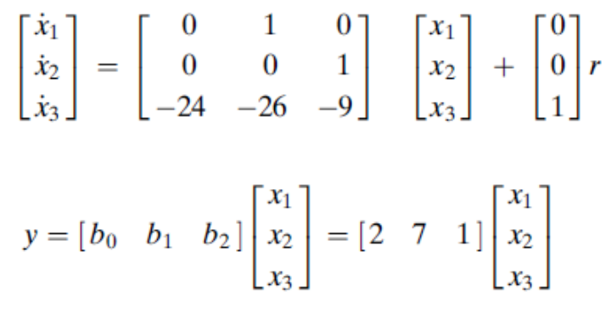

**Code:**

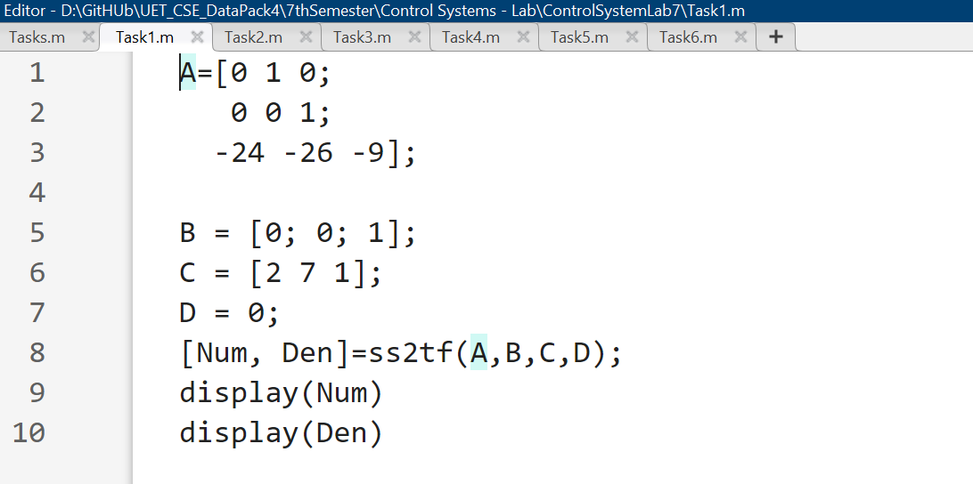

**Output:**

**6.2 Use the MATLAB to convert the state space representation to the transfer function for the following**

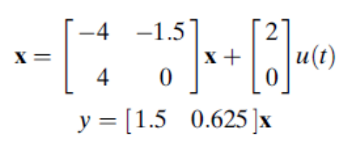

**Code:**

**Output:**

**6.3 Write the MATLAB code for the conversion of transfer function to the state space representation of the following system**

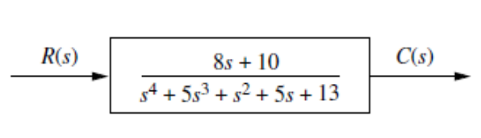

**Code:**

**Output:**

**6.4 Write the MATLAB code for the conversion of transfer function to the state space representation of the following system**

**Code:**

**Output:**

**6.5 Write the MATLAB code for the conversion of state space representation to the transfer function for the following**

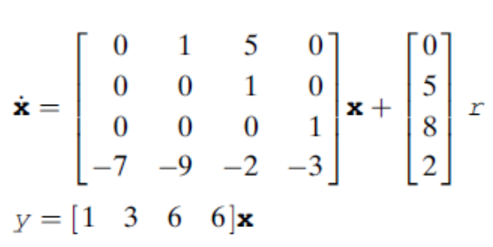

**Code:**

**Output:**

**6** **.6 Write the MATLAB code for the conversion of state space representation to the transfer function for the following**

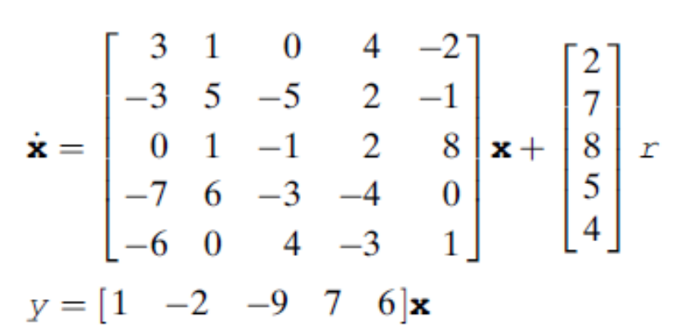

**Code:**

**Output:**

