**System Stability in Simulink**

**LAB # 08**



**Fall 2024**

**CSE-310L Control Systems Lab**

Submitted by: **Ali Asghar**

Registration No.: **21PWCSE2059**

Class Section: **C**

“On my honor, as student of University of Engineering and Technology, I have neither given nor received unauthorized assistance on this academic work.”

Submitted to:

**Dr. Muniba Ashfaq**

Date:

8**th December 2024**

**Department of Computer Systems Engineering**

**University of Engineering and Technology, Peshawar**

**Objectives:**

The objective of this lab is to:

* find systems stability using Simulink.

**Introduction:**

This practical LAB work is quite straight forward, introducing the idea of how to design a system using the complex Laplace equations, and than by studying the graphical view of the system using Simulink, one can study different aspects and behaviors of a system. Basically a system has to be examined for its stability that becomes easier using graphical methods to construct a system, and to graphically show the output of the system. The singularity of the system can also be plotted using Matlab command window.

**Design:**

The Simulink uses graphical method to deal with the complexities of a system. A simple design is to be constructed using the following Laplace equation: F(s)=100/(s2+4s+50)

In order to design such a system which is already transformed to Laplace equation, a new file should be 50 created in Simulink, the file should than be saved with any given name. Now to show the equation’s behavior graphically, the continuous option is to be selected from source library, which contains a number of tools that deals with the time dependent continuous equations. Now the transfer function block in continuous library is to be dragged to that file window. This block initially contains a transfer function which is predefined. The transfer function can be changed according to the user’s requirement, by double clicking the block. A window will appear which contain numerator part. A value of 100 needs to be inserted here as given in the equation above. In the denumerator part, a vector of three terms i.e. coefficient of square of ‘s’ which is ‘1’, coefficient of ‘s’ which is ‘4’, than the constant ‘50’ as given above. After clicking ‘ok’ required transfer function block is ready for analysis.

After the design of transfer function, an input should be given to this system which is suppose a unit step signal whose simulation duration should be kept to 8 seconds. Unit step block can be found in the sink library by just clicking the sink and then by dragging the ‘step’ block to the Simulink file. The simulation duration can be change within the Simulink file.

Now that the system is designed using transfer function and unit step input is applied to the system, it is now necessary to examine the system using the scope block, which can found in the ‘source’ library. By connecting the scope block to the system and running the simulation by clicking ‘start’ in the simulation menu, a graph appears shows the system response to the unit step input.

**Task 1:**

Design a System in Simulink whose transfer function is as given below

$$G\left(s\right)=\frac{100}{s^{2}+4s+50}$$

The input to the System is Unit Step for 8 seconds and output should be shown graphically.

**Simulink:**

**Output:**

**Task 2:**

Design 3 Systems with Complex poles such that first is stable, second is unstable and third is marginally stable. Show the result graphically.

**Code:**

**MATLAB Output:**

**Step Response and Pole-Zero Map of Stable System:**

**Step Response and Pole-Zero Map of Marginally Stable System:**

**Step Response and Pole-Zero Map of Unstable System:**

**Simulink:**

**Output:**

**Step Response of Stable System:**

**Step Response of Marginally Stable System:**

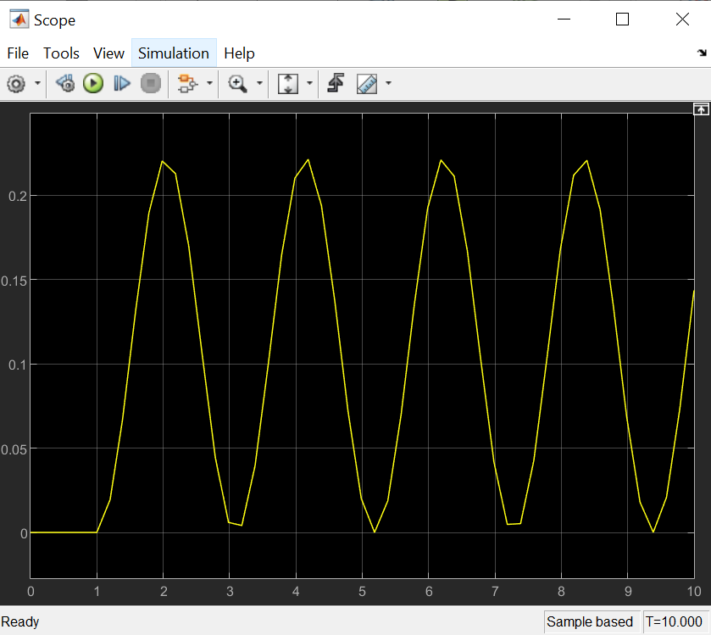

**Step Response of Unstable System:**

