**Steady State Error Analysis using Simulink**

**LAB # 09**



**Fall 2024**

**CSE-310L Control Systems Lab**

Submitted by: **SHAHZAD BANGASH**

Registration No.: **21PWCSE1980**

Class Section**: C**

“On my honor, as student of University of Engineering and Technology, I have neither given nor received unauthorized assistance on this academic work.”

Submitted to:

**Dr. Muniba Ashfaq**

Date:

**1st December 2024**

**Department of Computer Systems Engineering**

**University of Engineering and Technology, Peshawar**

**Steady State Error Analysis using Simulink**

**Objectives:**

To analyze the steady state error analysis for different test signals in Simulink

**Steady state error:**

Steady state error is the difference between the input and the output for the prescribed test input as t (time) approaches to infinity. The objective of this lab to analyze the steady state error analysis for different test signals in Simulink.

Following are the test signals that will be used for analysis of steady state error.

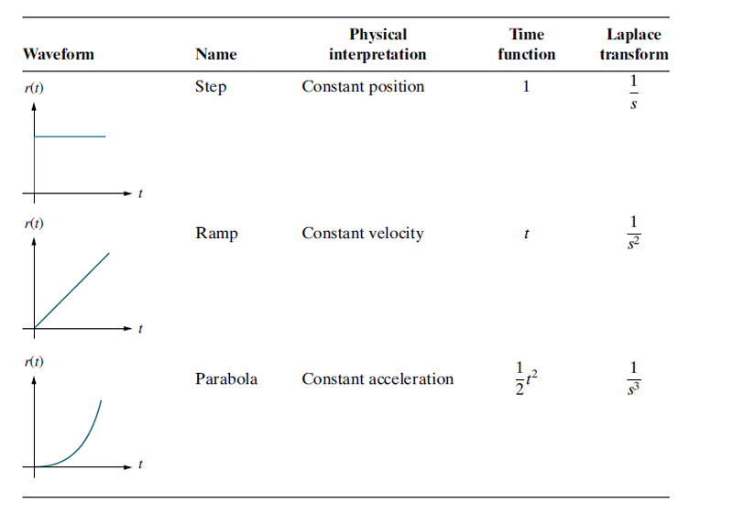

**Lab Manual Tasks:**

**Task 1:**

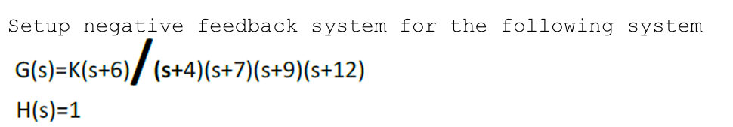

Plot on graph the error signal for the input of **5u(t)** with different values of **k=50,500,1000,5000.**

**Code/model:**



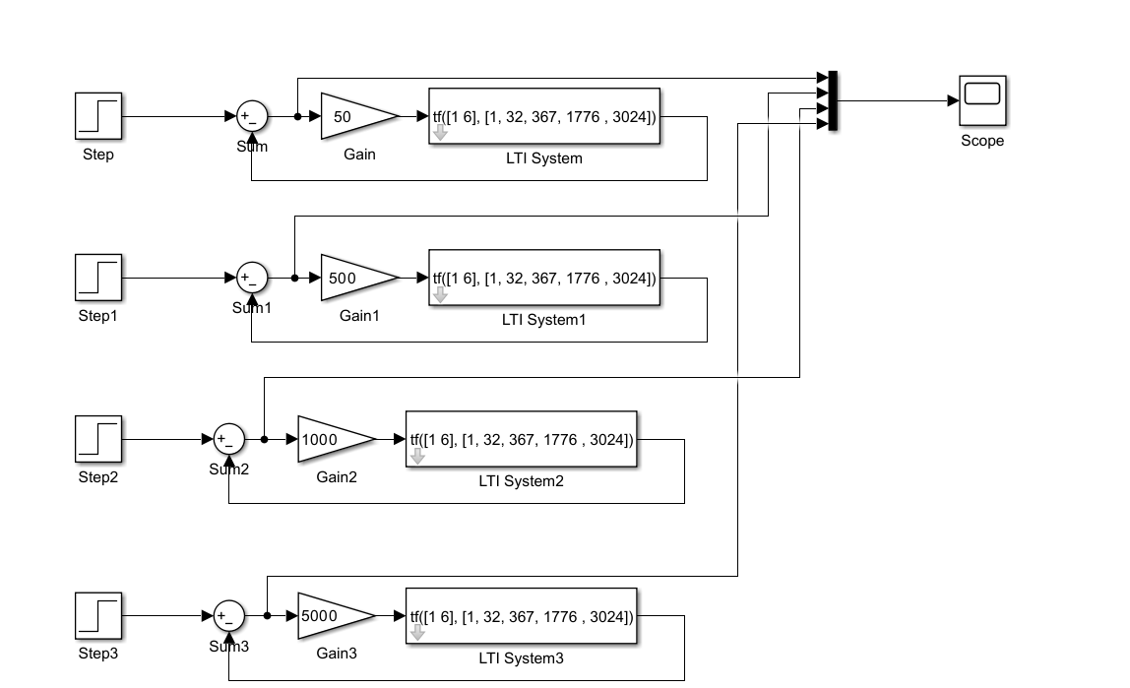

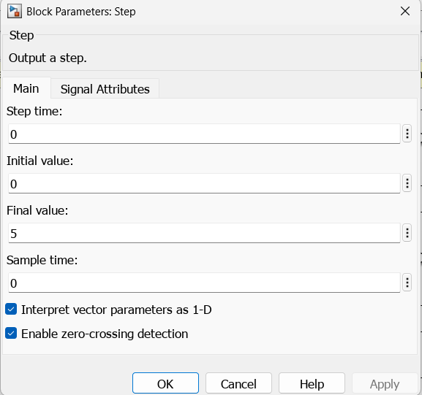

**Output:**

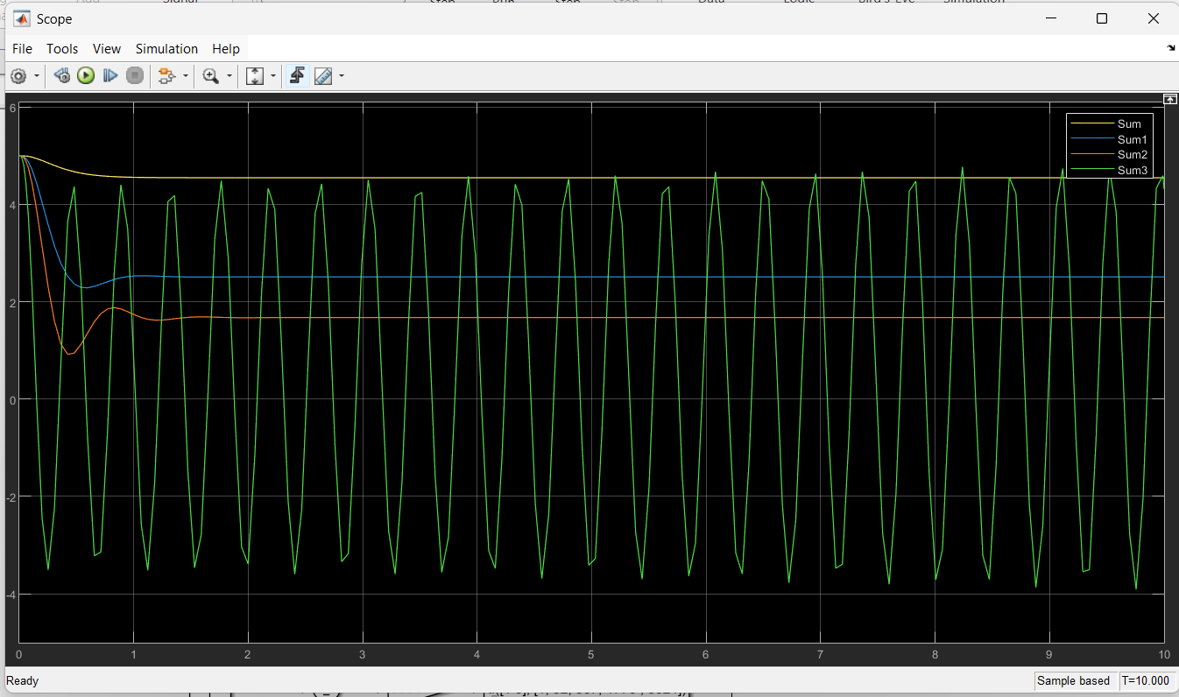

**Conclusion:**

We can see that for **k=1000,** i.e sum3 wave has the least value indicating least error for the model.

**Task 2:**

Plot on one graph Plot on graph the error signal for the input of **5tu(t)** with different values of **k=50,500,1000,5000.**

**Code/Model:**

**Output:**

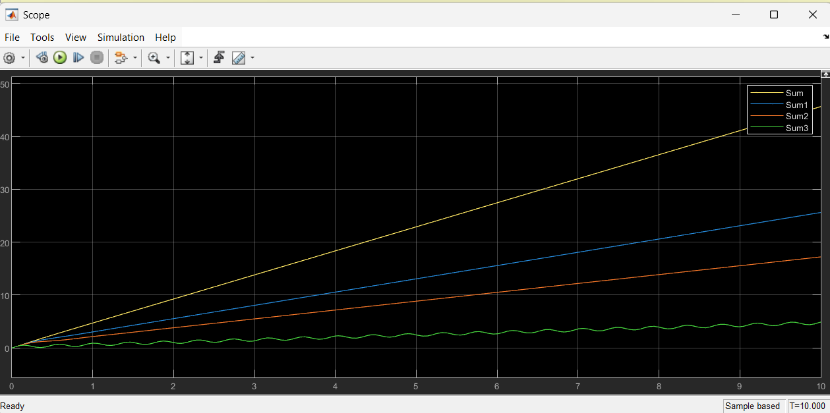

**Conclusion:**

We can see from the waves that the minium value is of the sum3 value which is for k = 5000, so for this k, the system shows steady state error.

**Task 3:**

**Plot on one graph Plot on graph the error signal for the input of 5t2u(t) with different values of k=50,500,1000,5000.**

**Code/Model:**

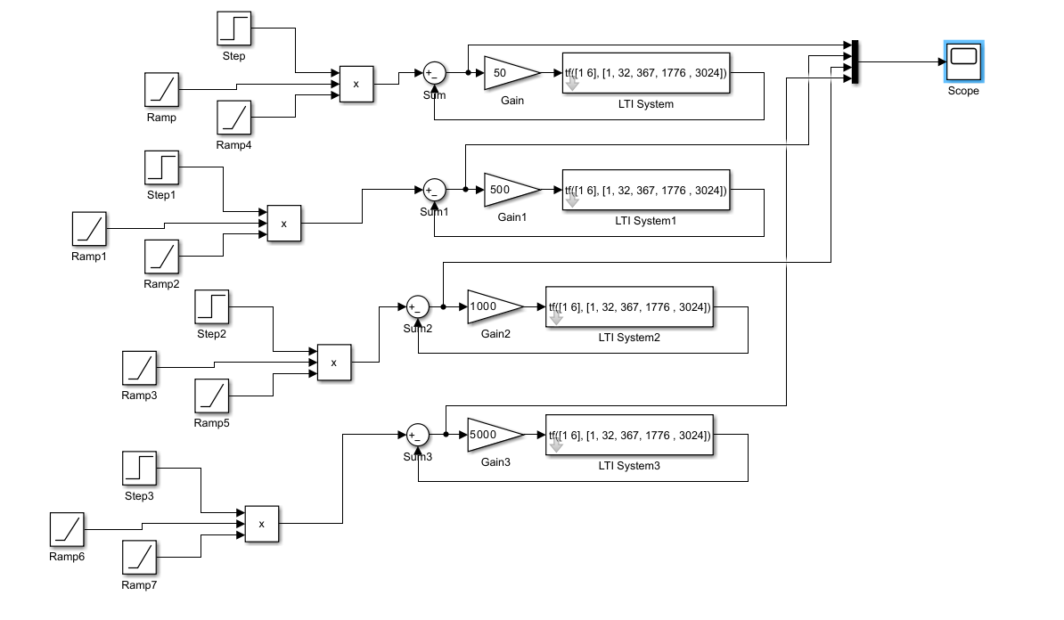

**Output:**

**Conclusion:**

We can see from the waves that the minium value is of the sum3 value which is for k = 5000, so for this k, the system shows steady state error.