**Chapter 3**

# Some Important Code Screenshots

## 3.1 TowerLibrary.cs

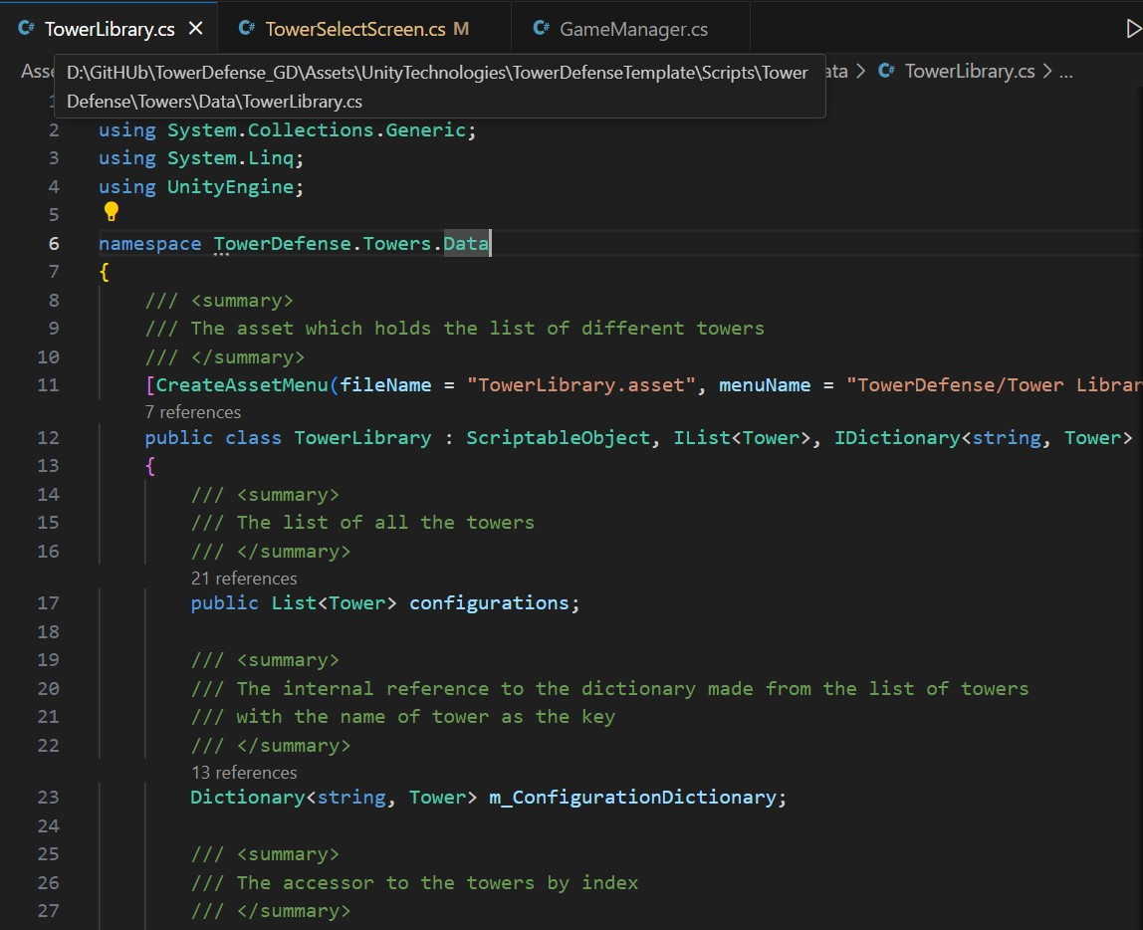

Figure 3.1: TowerLibrary Script

The Script in Figure 3.1 is a ScriptableObject that manages a collection of Tower objects, providing both list-based and dictionary-based access. It implements IList and IDictionary to enable retrieval by index and by tower name.

## 3.2 TowerLevelData.cs

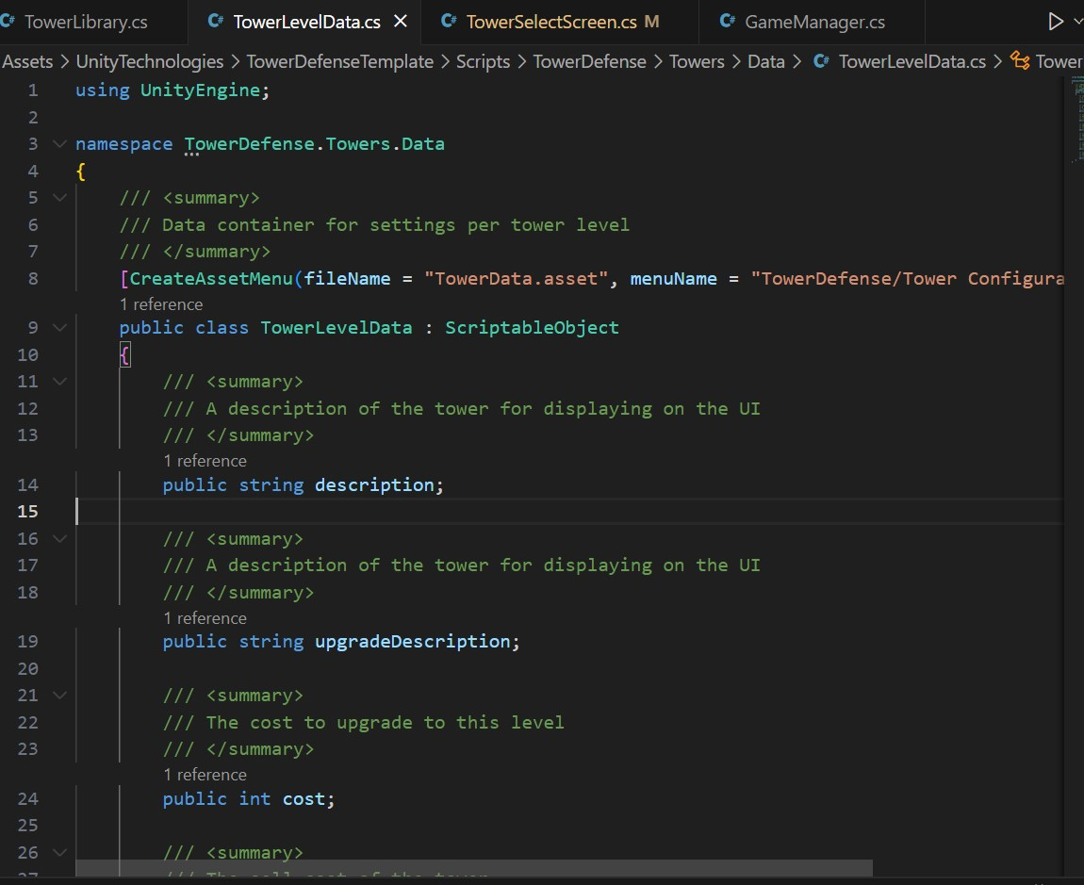

Figure 3.2: TowerLevelData Script Part 1

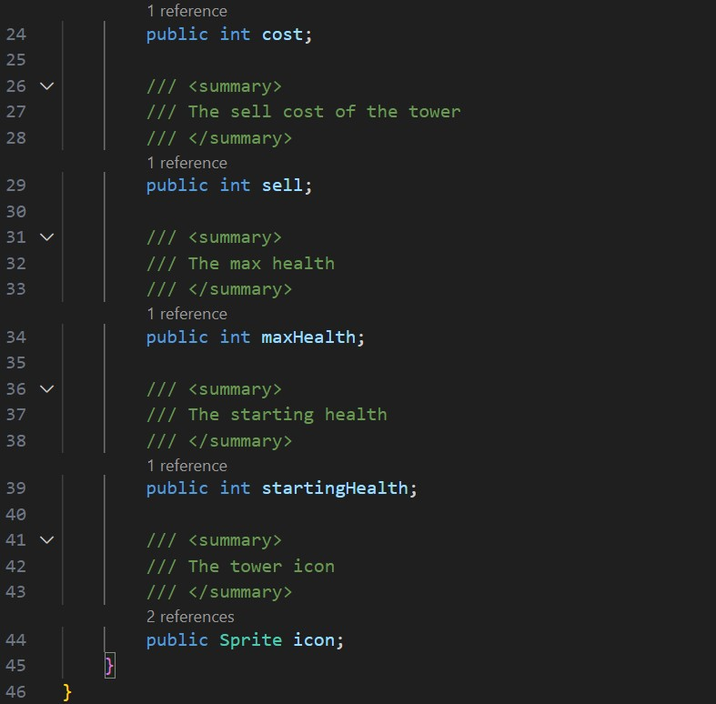

Figure 3.3: TowerLevelData Script Part 2

The script in figure [3.2,3.3] is a ‘ScriptableObject‘ that stores settings for each tower level, including descriptions, cost, health, and an icon for UI display. It helps manage tower upgrades and attributes in a Tower Defense game.

## 3.3 GameManager.cs

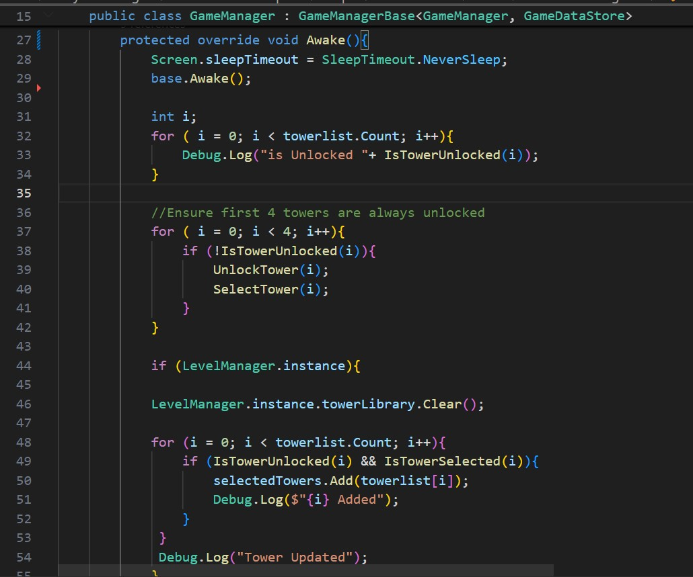

Figure 3.4: GameManager Script Part 1

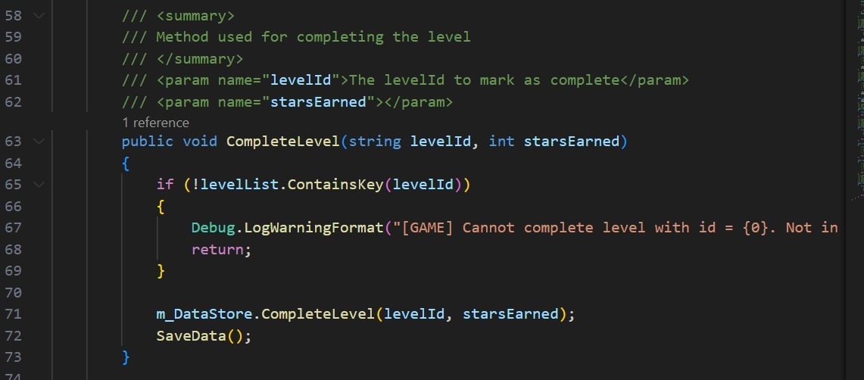

Figure 3.5: GameManager Script Part 2

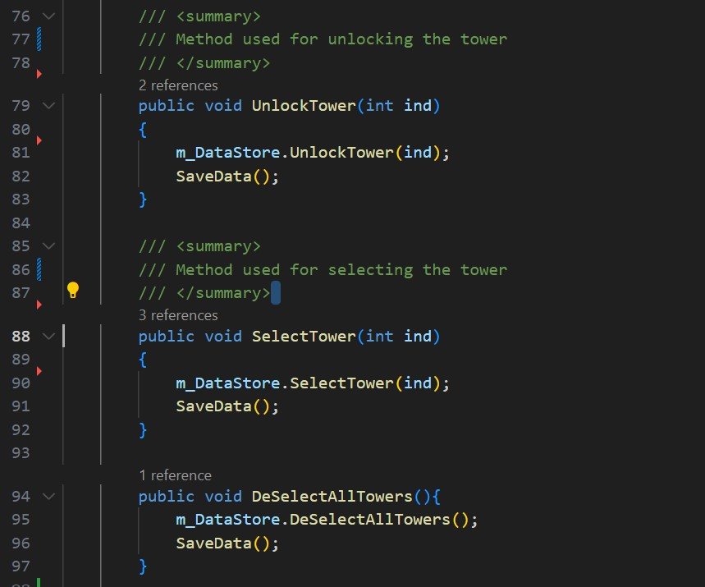

Figure 3.6: GameManager Script Part 3

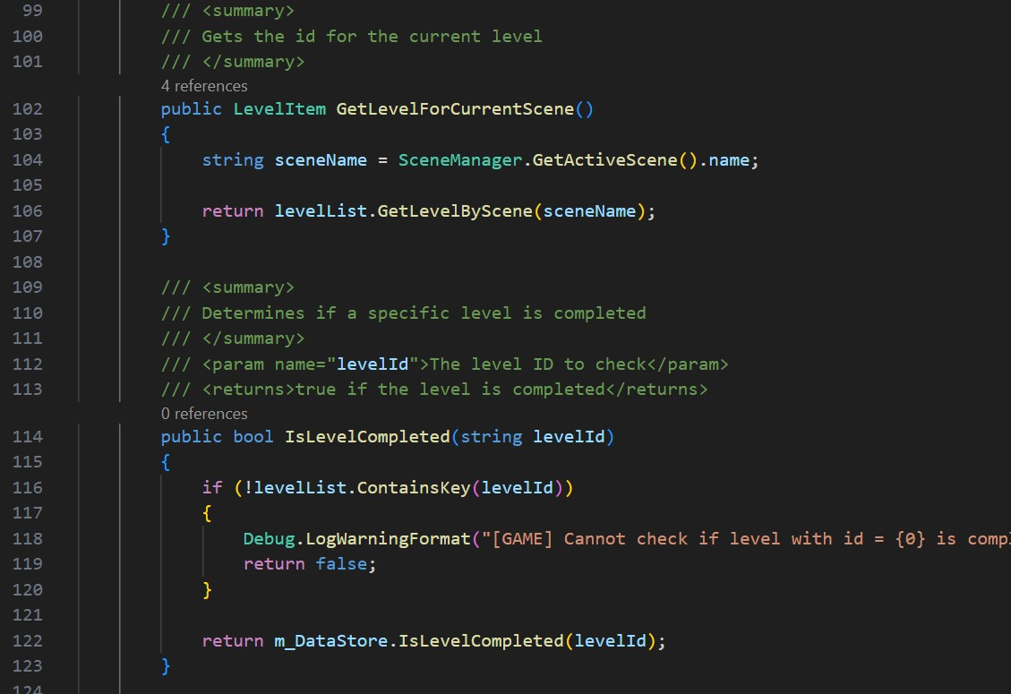

Figure 3.7: GameManager Script Part 4

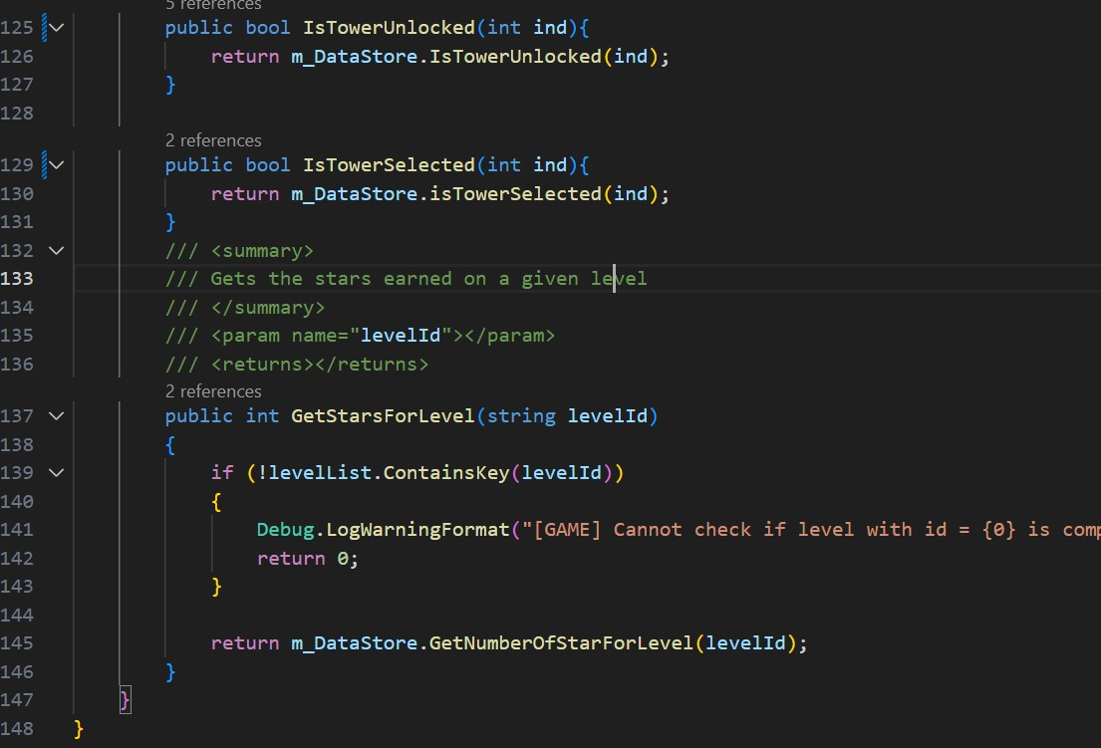

Figure 3.8: GameManager Script Part 5

The script in figure [3.4,3.8] implements the GameManager for whole game and every level. This class contain code wrappers for implementing the core methods for towers and levels unlocking and selecting logic.

## 3.4 GameDataStore.cs

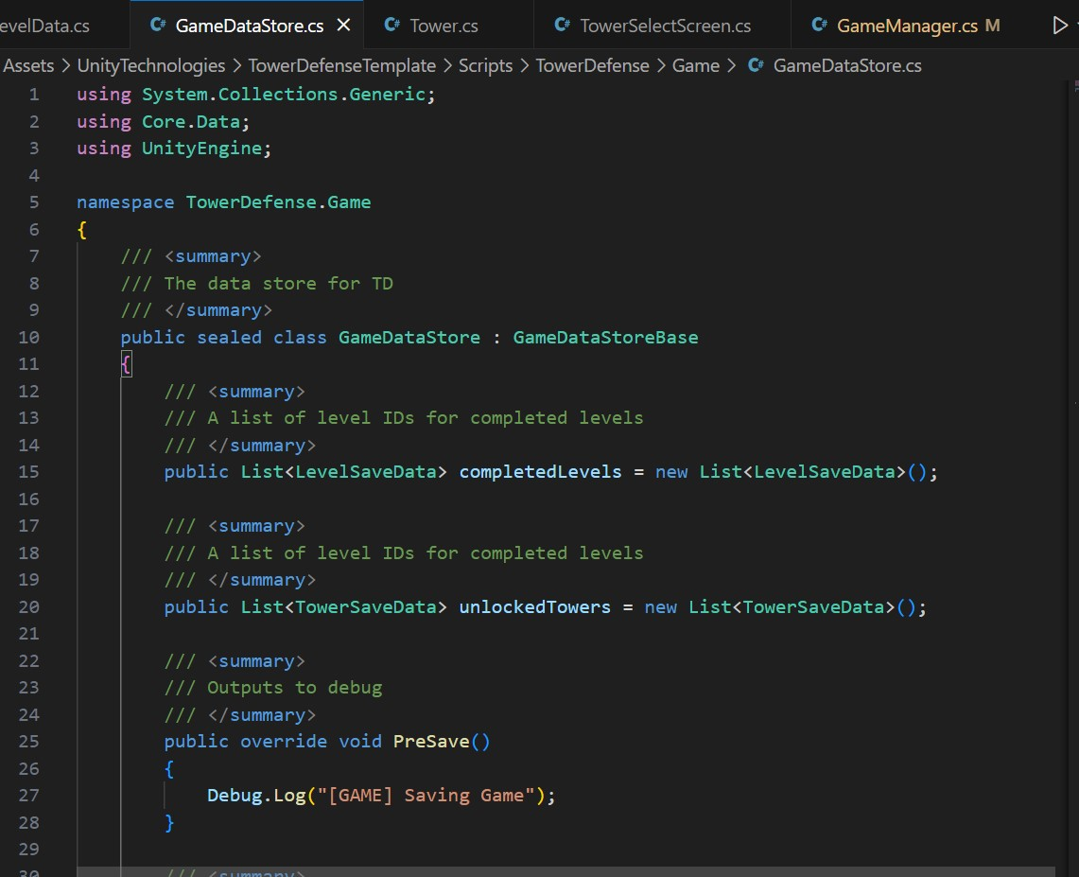

Figure 3.9: GameDataStore Script Part 1

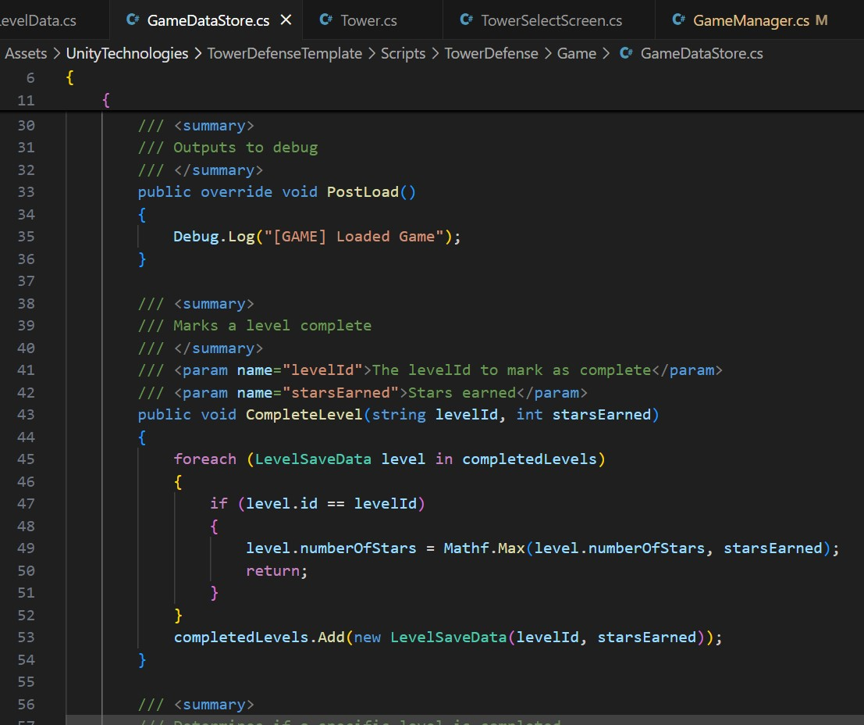

Figure 3.10: GameDataStore Script Part 2

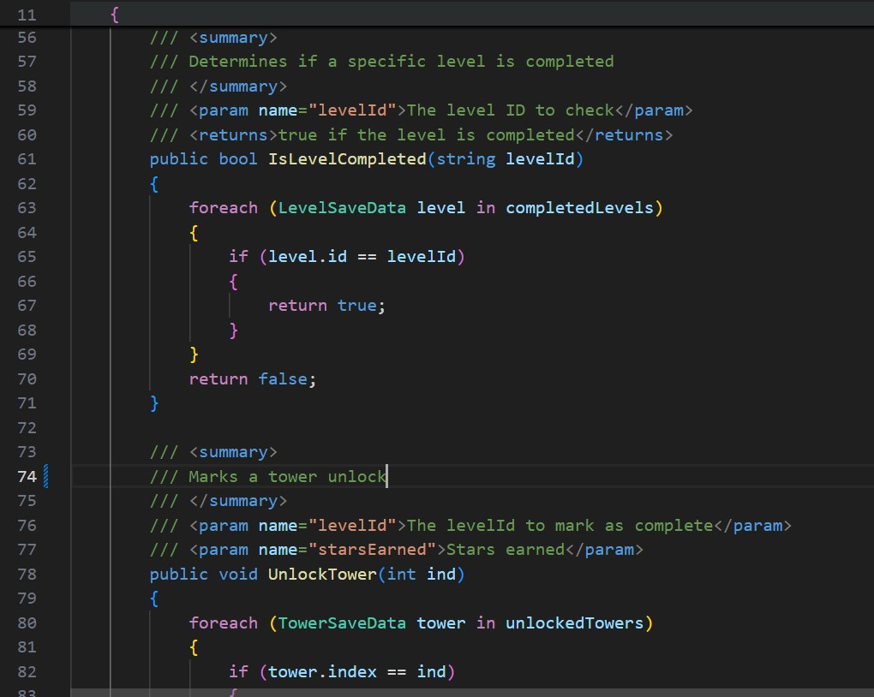

Figure 3.11: GameDataStore Script Part 3

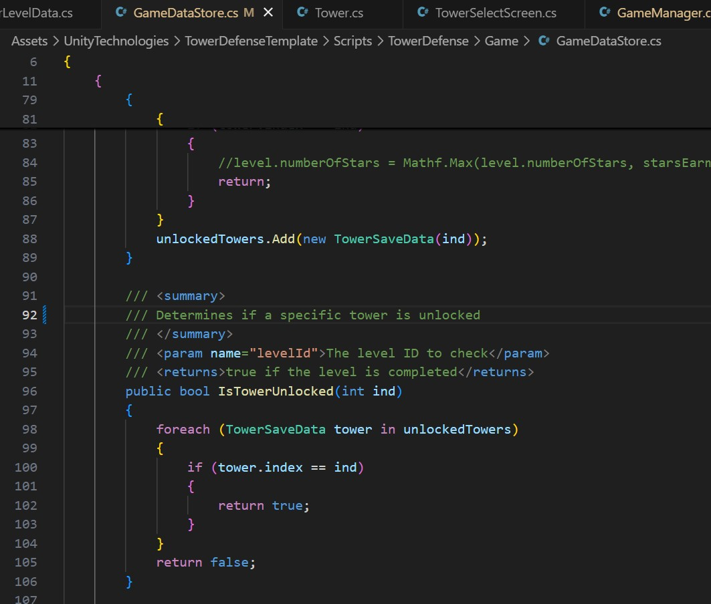

Figure 3.12: GameDataStore Script Part 4

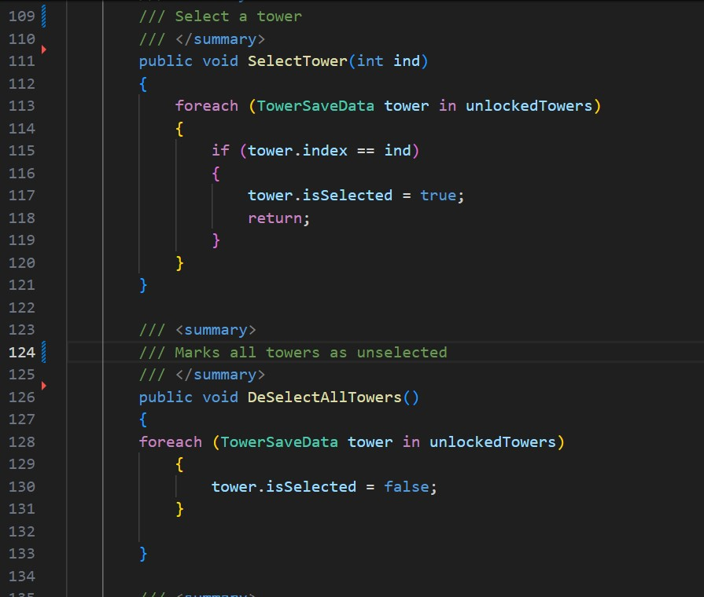

Figure 3.13: GameDataStore Script Part 5

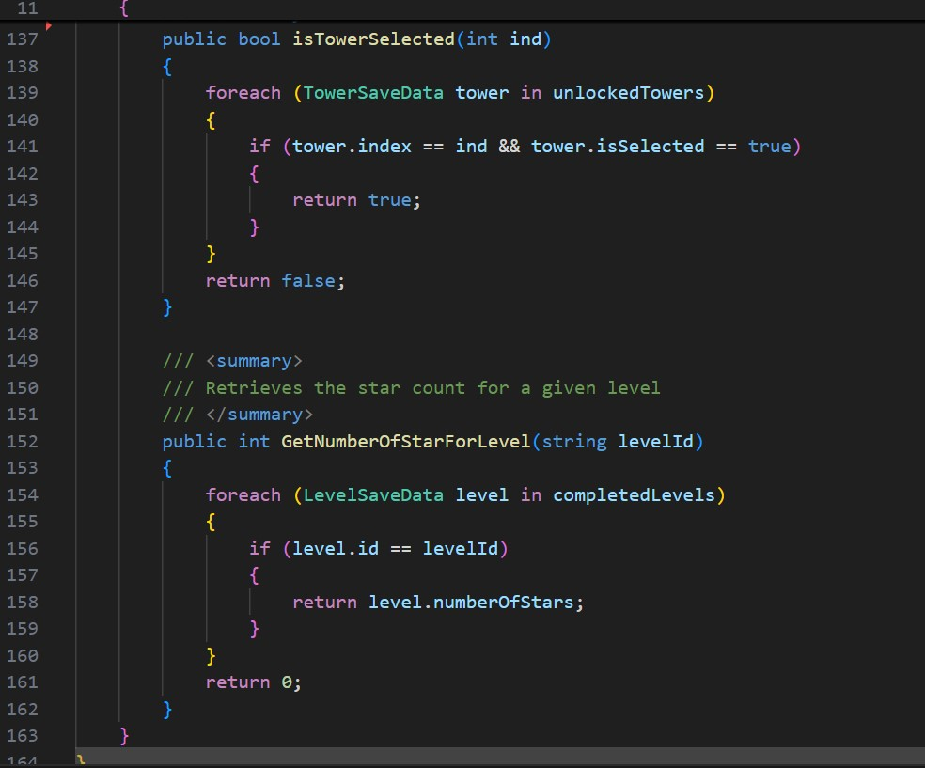

Figure 3.14: GameDataStore Script Part 6

The script in figure [3.9 - 3.14] is a Data Storage Container and contains the implementation of the levels and towers unlocking and selecting. The data is saved in a file in persistent path of the device.

## 3.5 LevelSaveData.cs

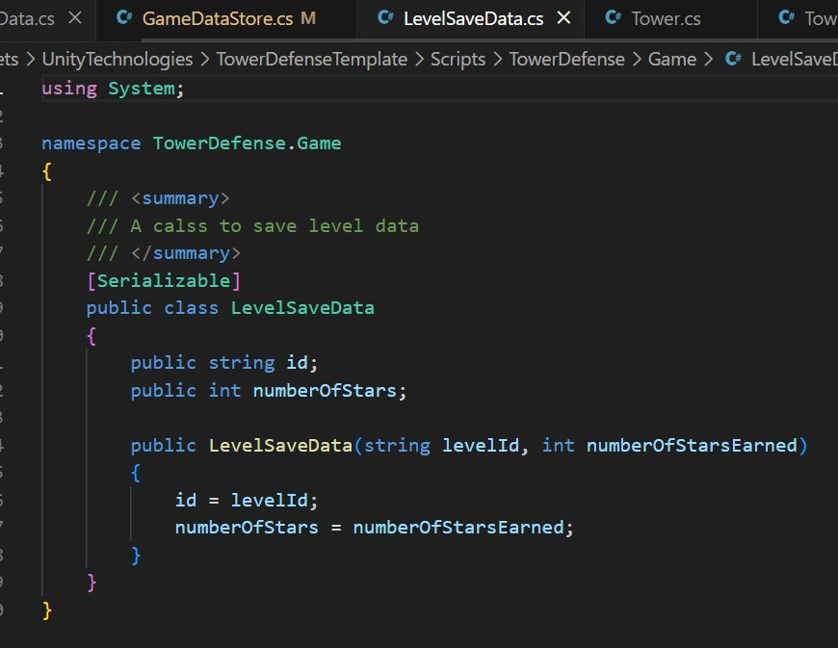

Figure 3.15: LevelSaveData Script

The script in figure [3.15] is a serialized class for saving level data.

## 3.6 TowerSaveData.cs

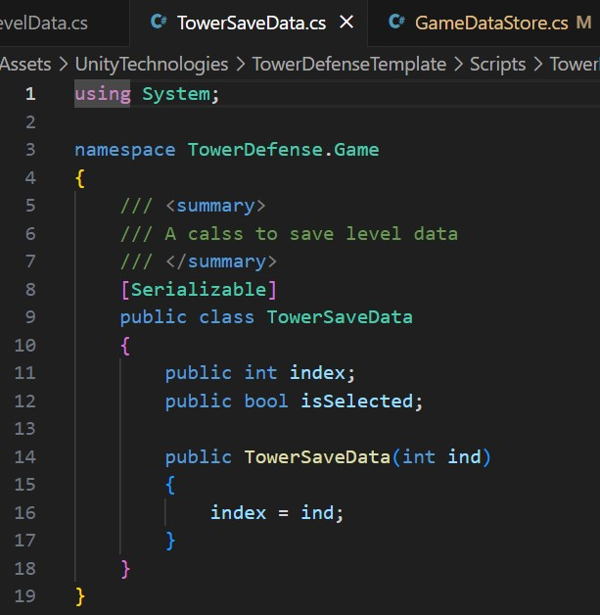

Figure 3.16: TowerSaveData Script

The script in figure [3.16] is a serialized class for saving tower data.

## 3.7 CardDragHandler.cs

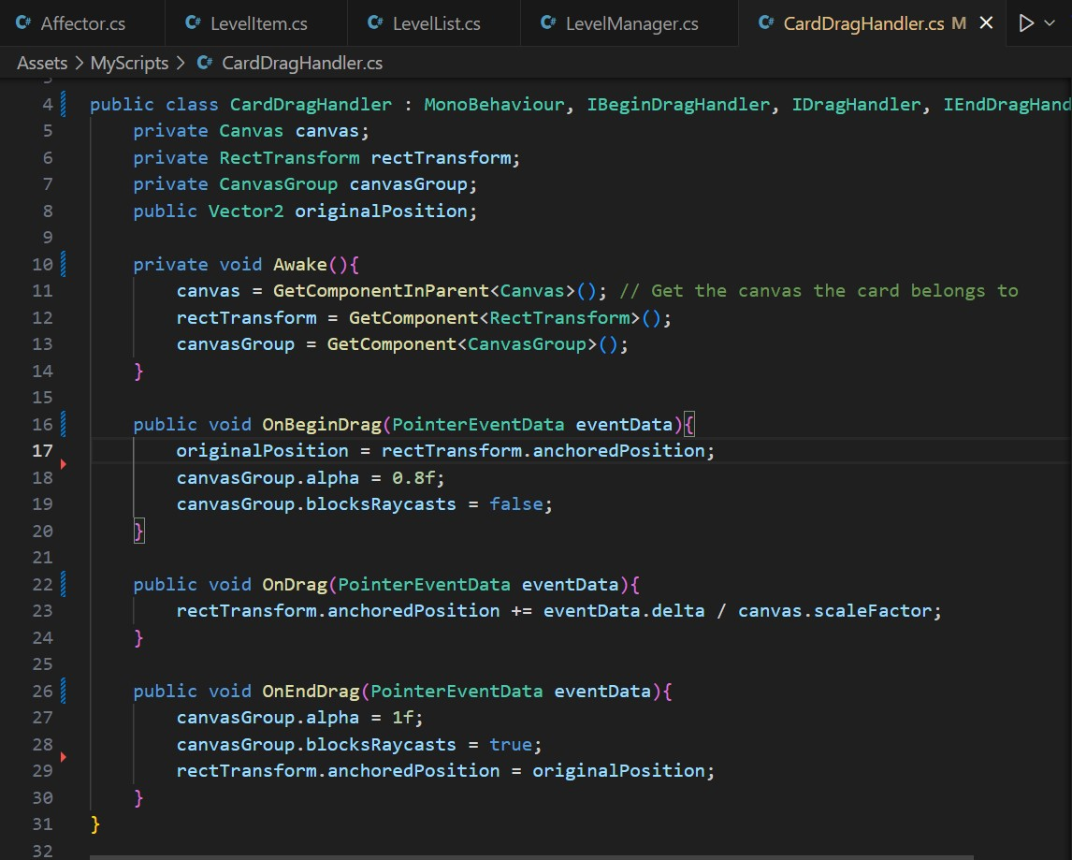

Figure 3.18: CardDragHandler Script

The script in figure [3.18] contains the implementation of unity built-in methods for drag and drop.

## 3.8 DropZone.cs

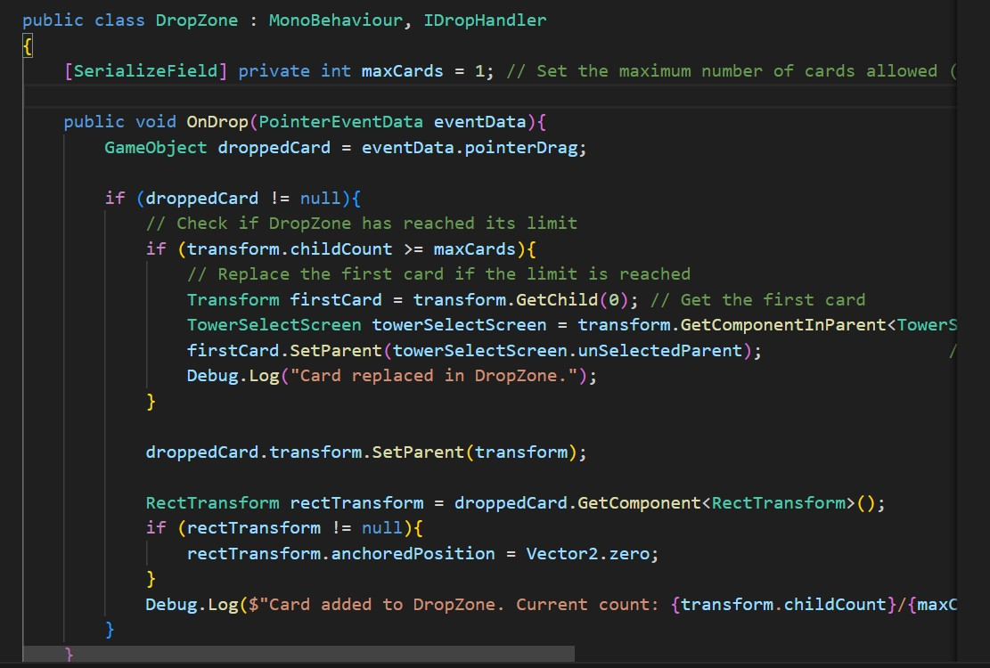

Figure 3.19: DropZone Script

The script in figure [3.19] creates a drop zone for the draggable object.

## 3.9 TowerSelector.cs

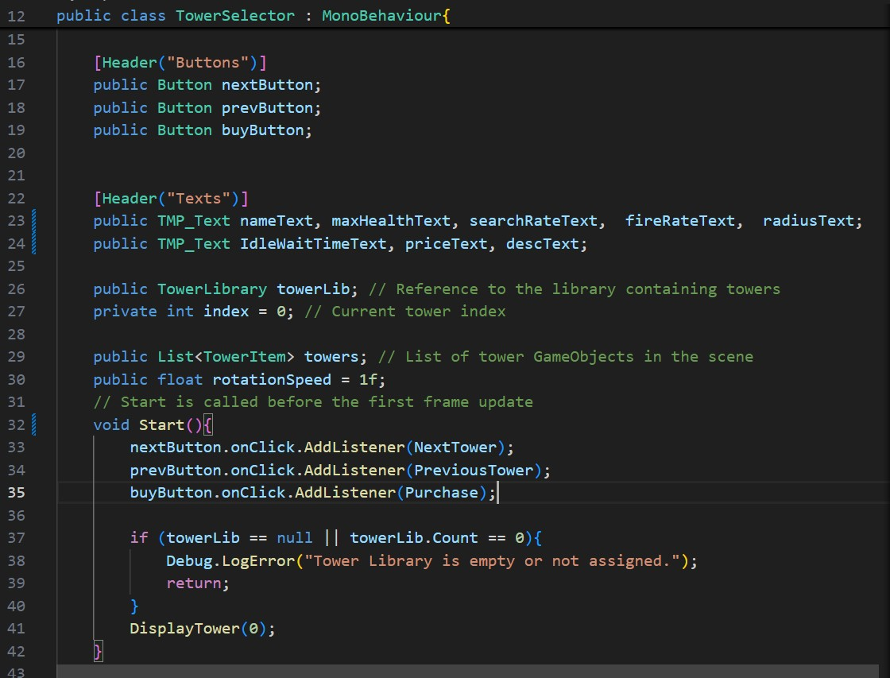

Figure 3.20: TowerSelector Script Part 1

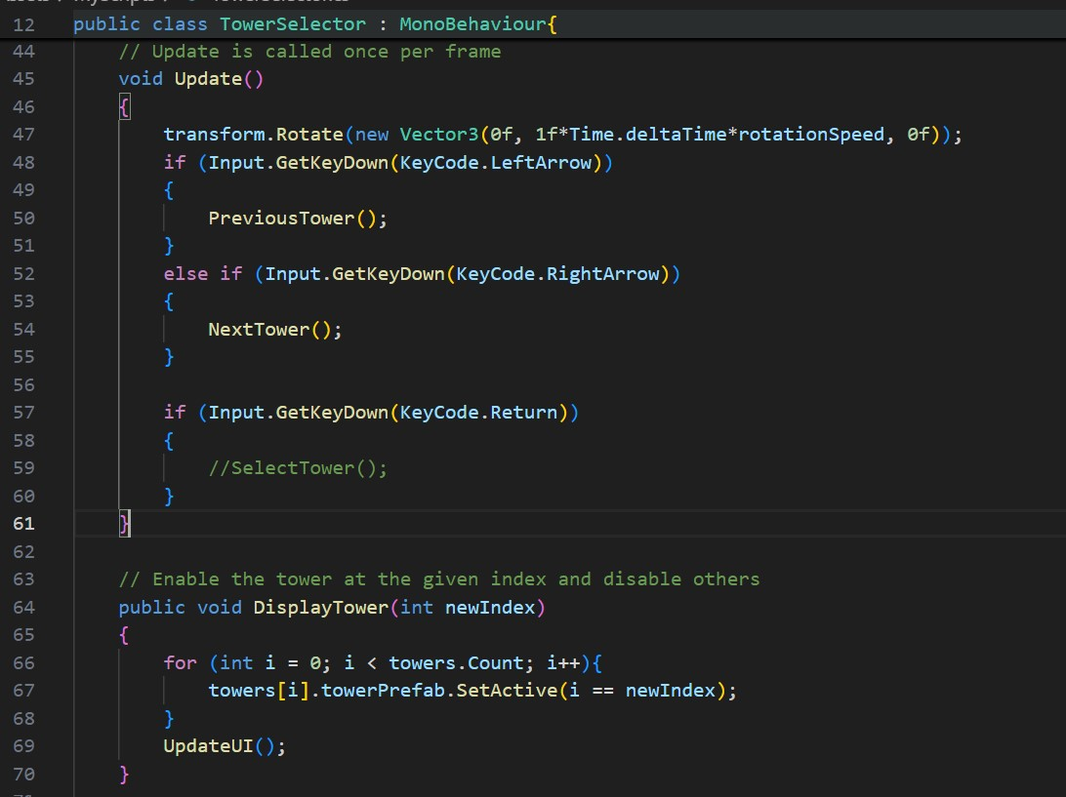

Figure 3.21: TowerSelector Script Part 2

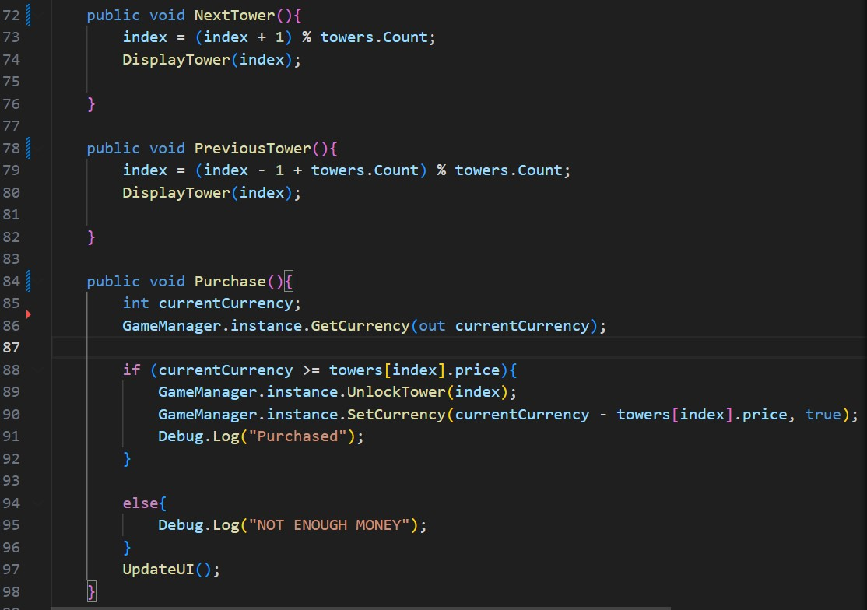

Figure 3.22: TowerSelector Script Part 3

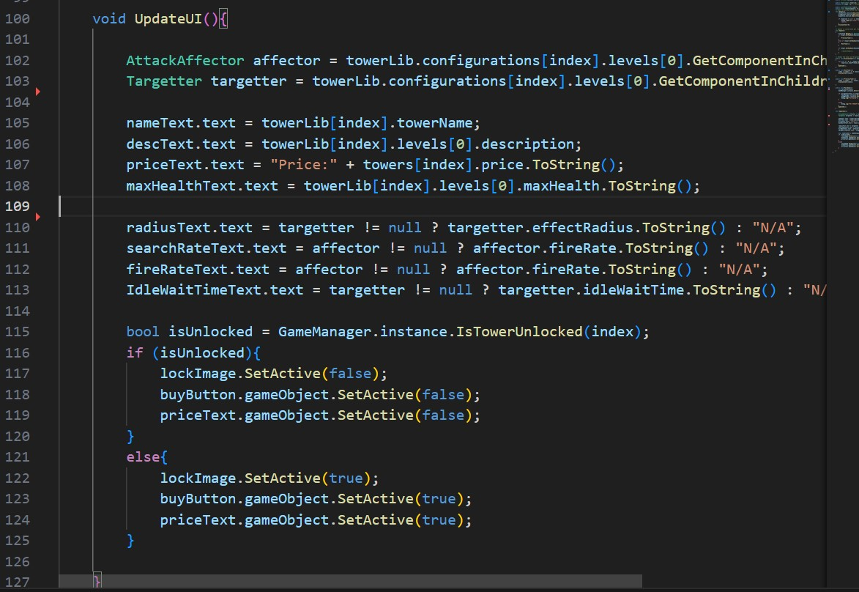

Figure 3.23: TowerSelector Script Part 4

The script in figure [3.20 – 3.23] implements the tower shop. It contain methods for selecting and buying different towers.