AI-Assignment-2

Spring 2020

M. Hassan Ahmed – K173654 – Section: D

# Q1 – Genetic Algorithm Report:

Genetic Aalgorithm is similar to the process of natural selection where the fittest individuals are selected for reproduction in order to produce offspring of the next generation.

The 4 lines in each graph represent each iteration of Genetic Algorithm for statistical Significance.

Part 2: population size vs number of generations:

Range of Population size: 4 – 12

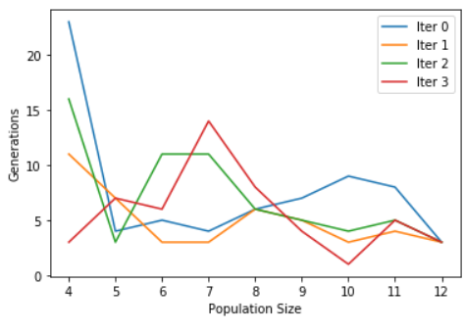

Chromosome Length: 8

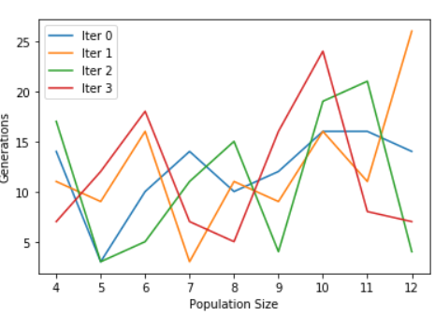

Chromosome Length: 12

Chromosome Length: 16

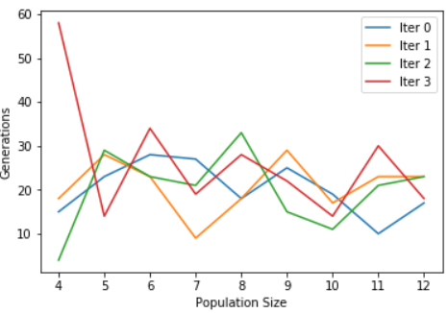

Inference:

Number of Generations to solution Decreases slightly as Population Sizes increase.

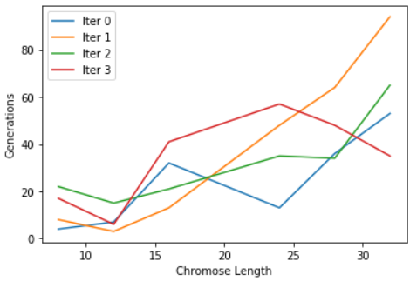Part 3: Chromosome Length vs number of generations:

Population size: 4

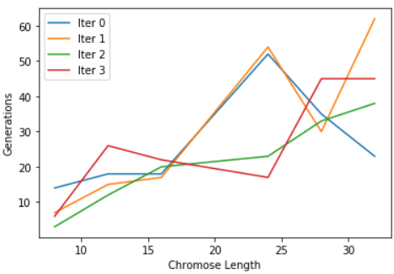

Population size: 6

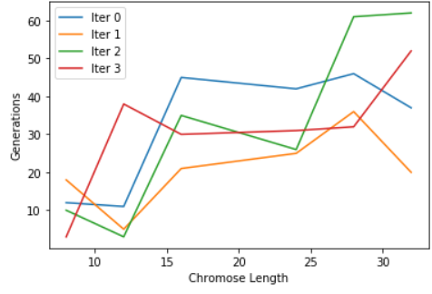Population size: 8

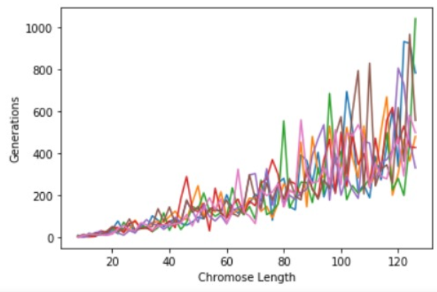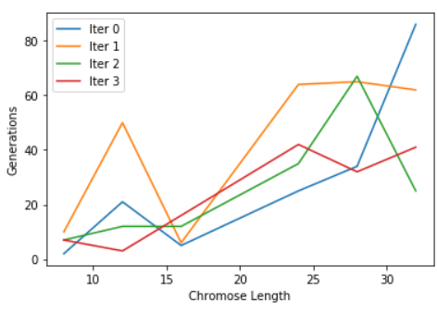

Population size: 10

All lines are different values of Population sizes Ranging from 4 – 100.

Inference: Number of Generations to solution increase as Chromosome Length increase.