AI-Assignment# 3 - CS-401 – Spring 2020

Name: M. Hassan Ahmed Roll No: K17-3654 Section: D

# Q1. Gaussian Naïve Bayes Classifier:

Attached Files:

Submission/Q1:

K173654-A3-Q1.ipynb parktesting.xlsx parktraining.xlsx

# Q2. Naïve Bayes Classifier using RapidMiner:

Attached Files:

/Submission/Q2:

'Q2)wine-NB-Kernel.properties' 'Q2)wine-NB-simple.properties'

'Q2)wine-NB-Kernel.rmp' 'Q2)wine-NB-simple.rmp'

## Screenshots:

Q2. Naïve Bayes Simple

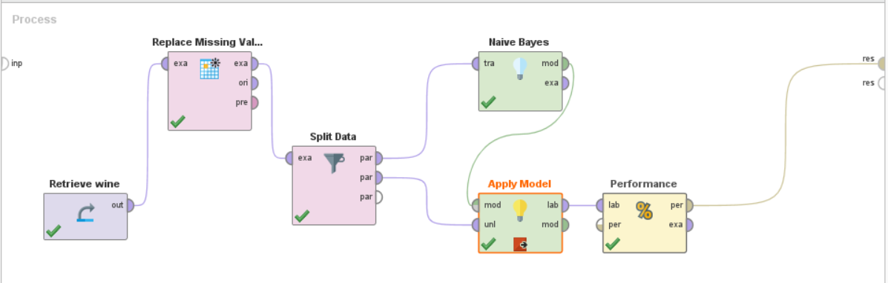

Q2. Naïve Bayes Simple Accuracy

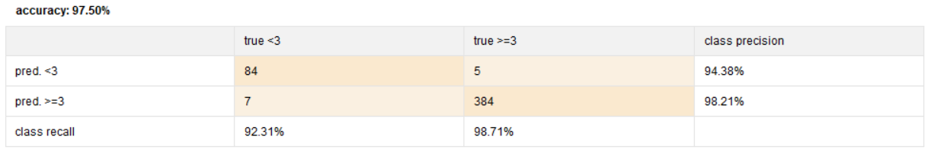

Q2. Naïve Bayes Simple Precision

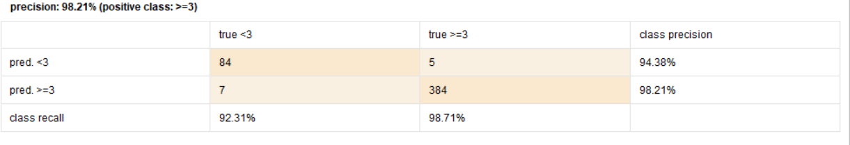

Q2. Naïve Bayes Simple Recall

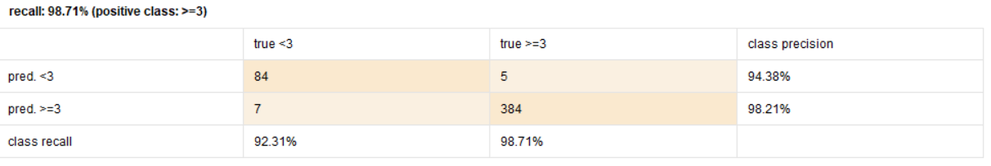

Q2. Naïve Bayes Kernel

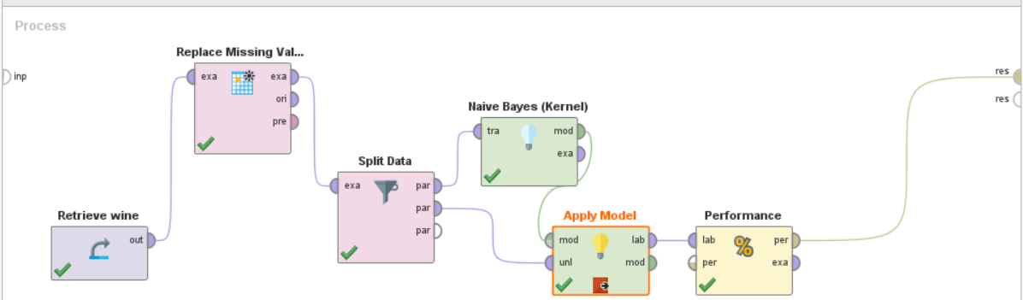

Q2. Naïve Bayes Kernel Accuracy

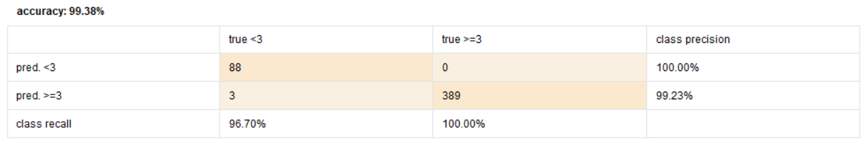

Q2. Naïve Bayes Kernel Precision

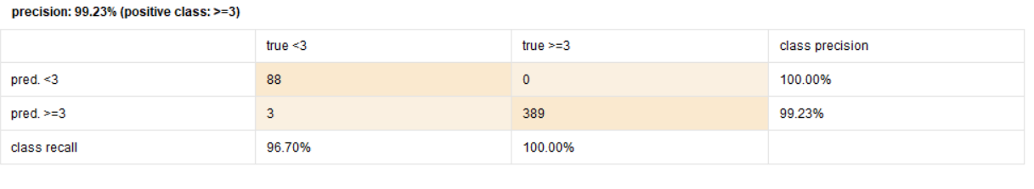

Q2. Naïve Bayes Kernel Recall

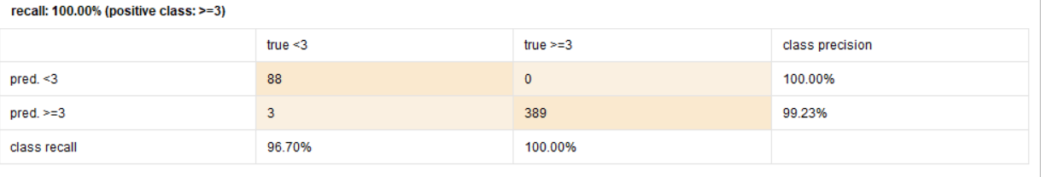

Accuracy Difference: 99.38 – 97.50 = 1.88%

# Q3. Naïve Bayes Classifier using RapidMiner:

Attached Files:

Submission/Q3:

'Q3)PD-NB-Kernel.properties' 'Q3)PD-NB-Simple.properties'

'Q3)PD-NB-Kernel.rmp' 'Q3)PD-NB-Simple.rmp'

## Screenshots:

Q3. Naïve Bayes Simple

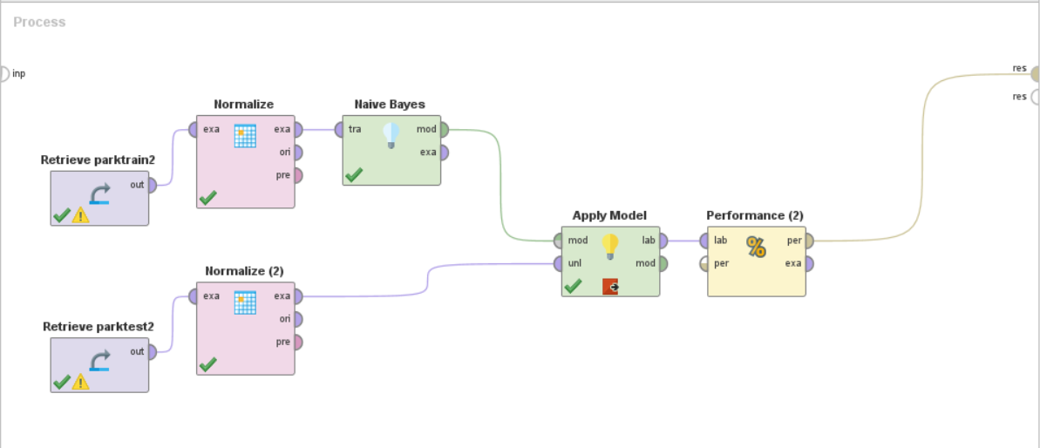

Q3. Naïve Bayes Simple Accuracy

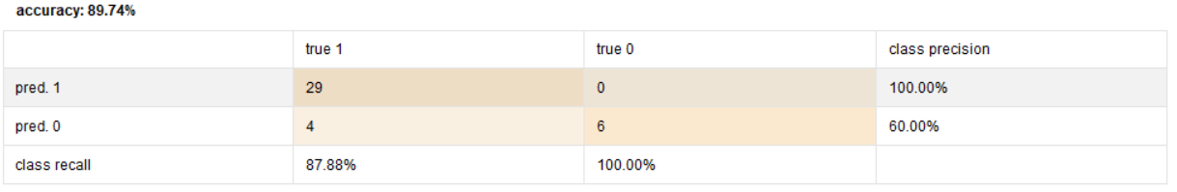

Q3. Naïve Bayes Simple Precision

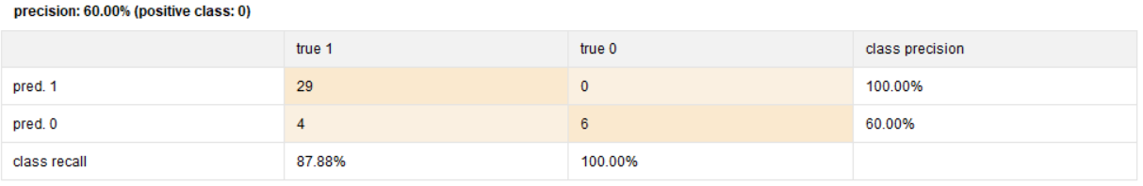

Q3. Naïve Bayes Simple Recall

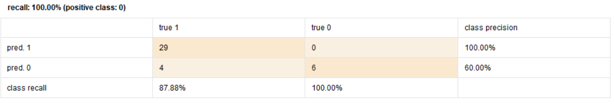

Q3. Naïve Bayes Kernel

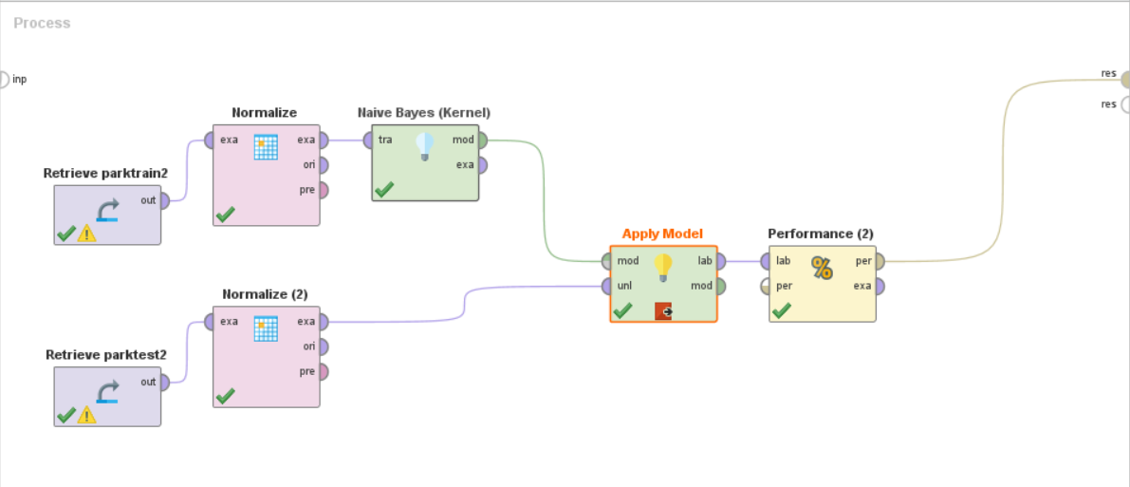

Q3. NB Kernel Accuracy

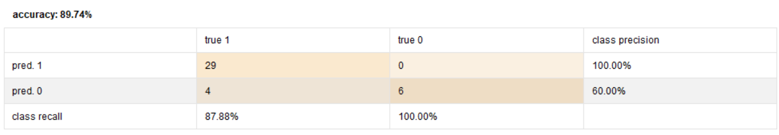

Q3. NB Kernel Precision

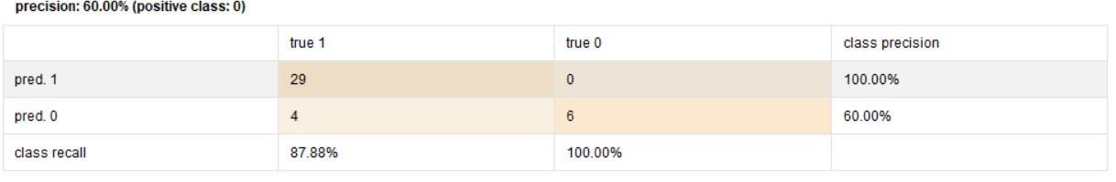

Q3. NB Kernel Recall

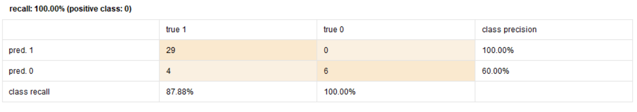

Accuracy Difference: 89.74 – 89.74 = 0%

# Q4. K- MEANS CLUSTERING using RapidMiner:

Attached Files:

Submission/Q4:

'Q4)wine-KMeans-new.properties' 'Q4)wine-KMeans-new.rmp'

## Screenshots:

Q4. K-Means Accuracy

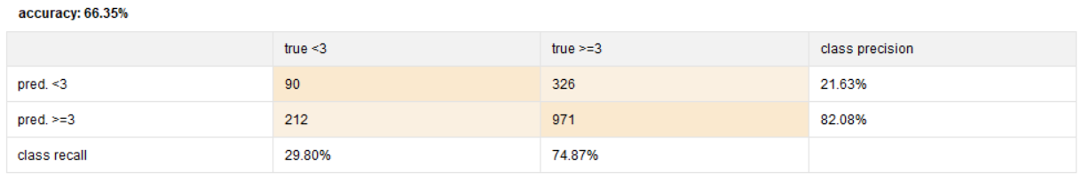

Q4. K-Means Precision

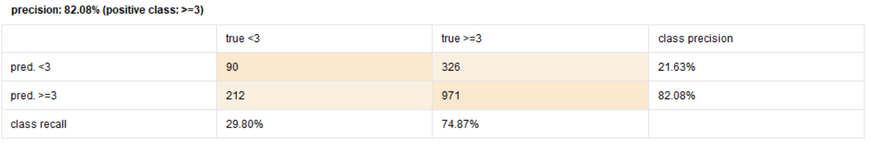

Q4. K-Means Recall

