1. Introduction and Architecture

This report will document the design and the decisions made in Assignment 1 for Sfwr Eng 2AA4/Comp Sci 2ME3. The report will begin with an overview of the architecture and modules used in the application. Then the decomposition hierarchy will be examined in order to highlight its dependencies and to prepare a premise for a discussion on anticipated changes and other traditional software engineering practices. This report will end with a test plan, which will show that the application does fulfil the requirements up to the level specified in the document.  
  
The architecture chosen for this application is the Model-Controller-View (MCV) architecture. The MCV architecture was chosen because it accentuates the principle of separation of concerns. The MCV architecture consists of three main components: the model, the controller, and the view. With the MCV architecture, the model represents data related to the logic the user works with, the view represents the user interface, and the controller facilitates the interaction between the model and the view. We believe that by using this architecture, different aspects of the program could be separated in order to facilitate testing and implementing future changes.

1. Modular Decomposition and Hierarchy

The application was designed using a top down approach. The top down approach was used in order to facilitate modular design and to accentuate separations of concerns. By using top down design, the application can be decomposed into modules, which are responsible for a single work assignment. Knowing the individual modules will allow programmers to program using the bottom-up approach, which would allow for early testing, and quick implementation of the application.

The figure below shows the modular decomposition hierarchy for the application. Arrows point towards increasing modularity (from less modular to more modular):

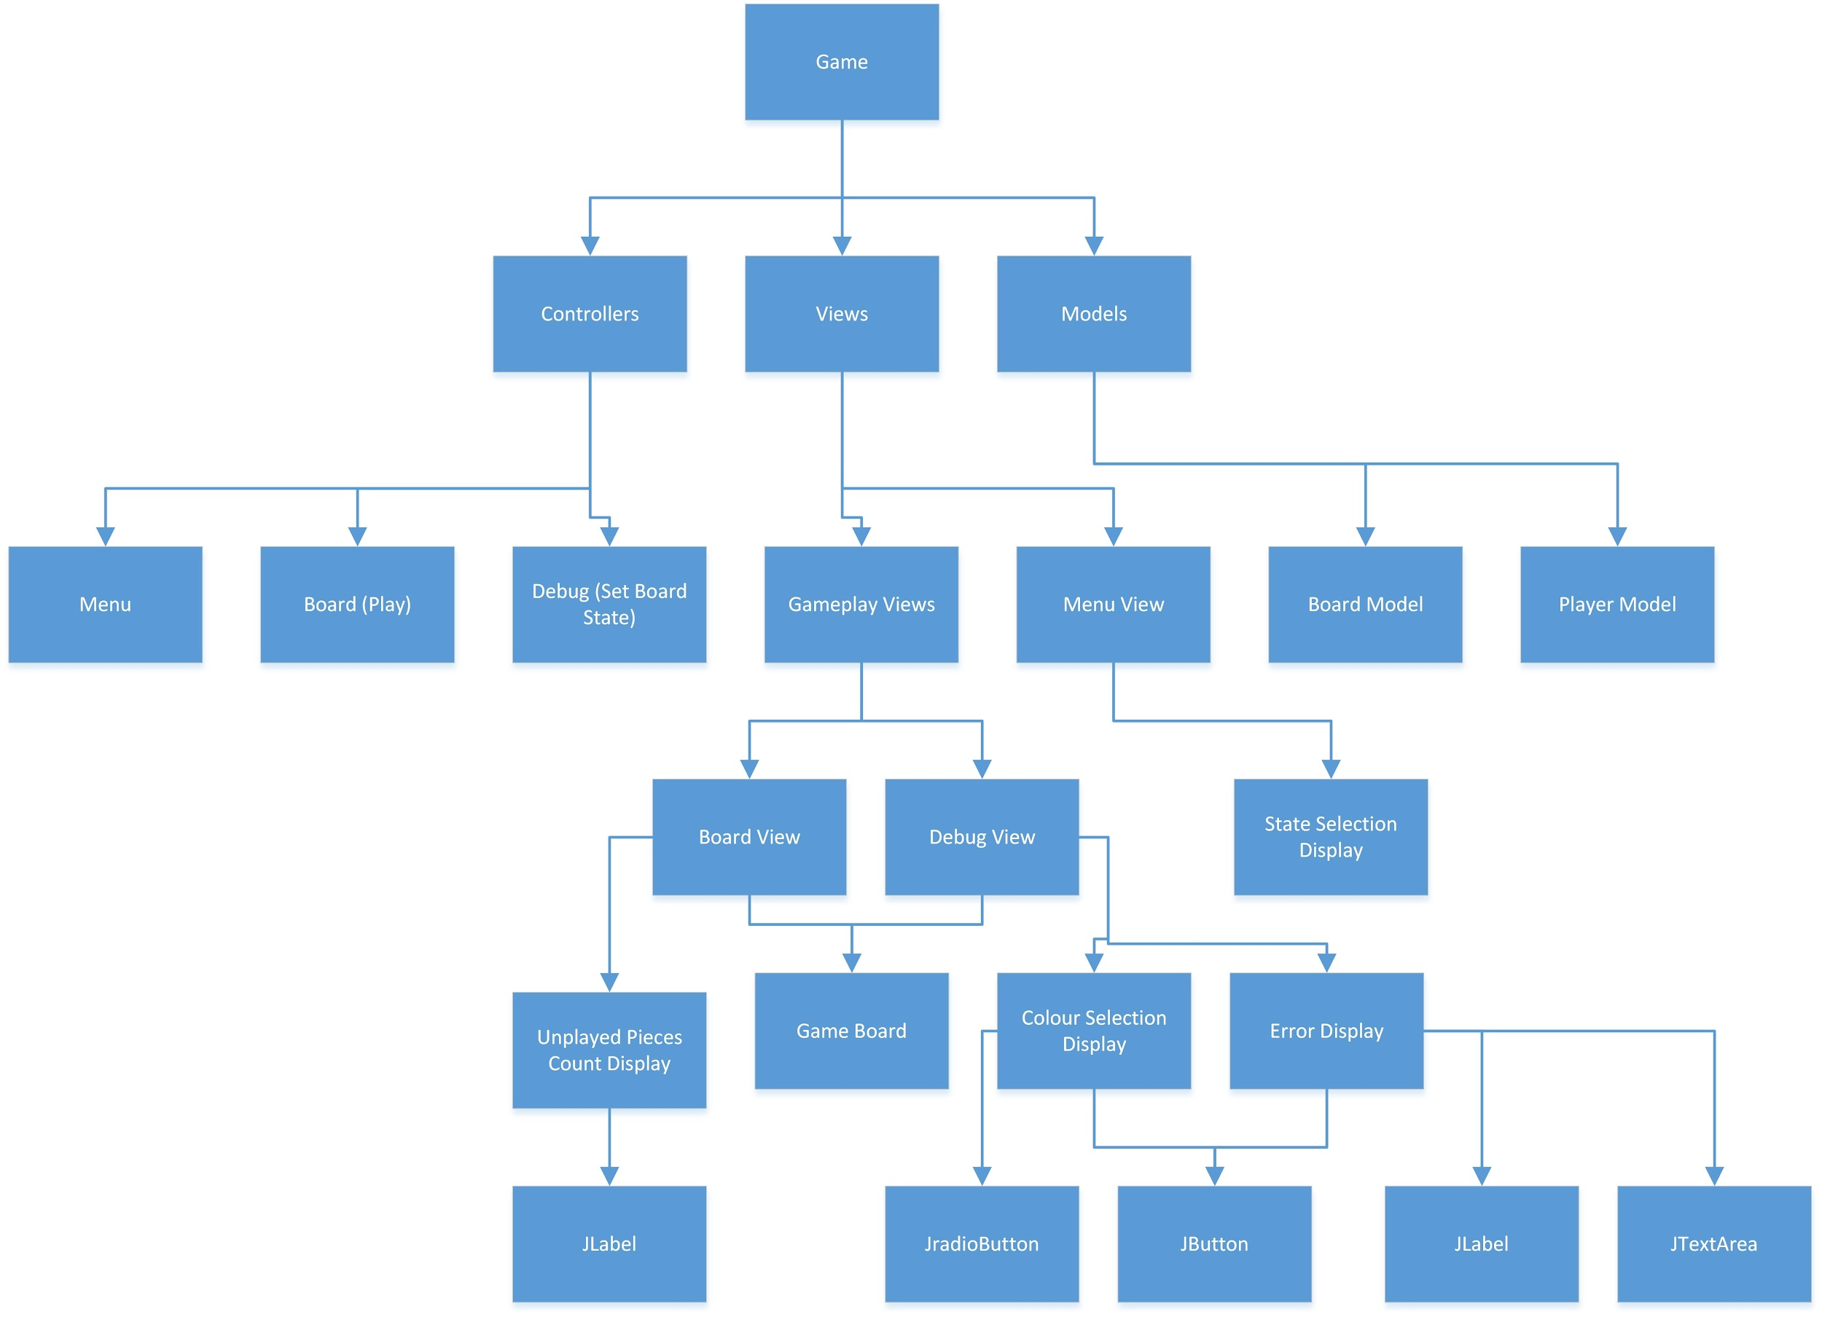

From the diagram, we can see that the Game decomposes into Controllers, Views, and Models. The Controller further decomposes into different states of the game, the Menu, the Board, and the Debug state. The children of Controllers are responsible for facilitating the interaction between the model and the views in their states.

The Views decompose to GamePlay Views and Menu Views. The GamePlay Views are responsible for drawing the screen during game play and debugging. They are composed of the game board, and other built in Swing and AWT components that allow the user to configure settings. The game board is further decomposed into rectangles and circles, which are decomposed into points. The menu view is decomposed into the State Selection display.

The models decompose into Board and Player. The Board is a representation of the game board. It contains the board’s states and methods that the controller and view can use to interact with the board. The Player represents the player. It contains information about the player’s colour and number of unplayed pieces.

1. Module Guide (MIS and MID)

See below.

1. Trace to Requirements

The table below lists the assignment's requirements, and the modules that fulfil those requirements.

|  |  |
| --- | --- |
| **Requirements** | **Modules** |
| Enable the user to set up a board to play the game. | Board  BoardController  BoardView |
| The board includes two types of discs. | BoardController  BoardView |
| The discs are placed on either side of the board. | BoardController |
| There are no discs at the start of the game. | BoardController  Board  BoardView |
| The order of play is determined randomly. | BoardController |
| The user should be able to start a new game, or enter discs to represent the current state of a game. | MenuController  MenuView |
| The user should be able to enter discs to represent the current state of a game by selecting a colour and clicking on the position of the disc. | DebugController  Board  BoardView |
| When all the discs the user wants to play have been played, the system should analyze whether the current state is possible. | DebugController |
| Errors should be displayed to the user. | ErrorDialog |

1. Uses Relationship

The figure below shows the dependencies between the different modules. Arrows point from the user to the dependency.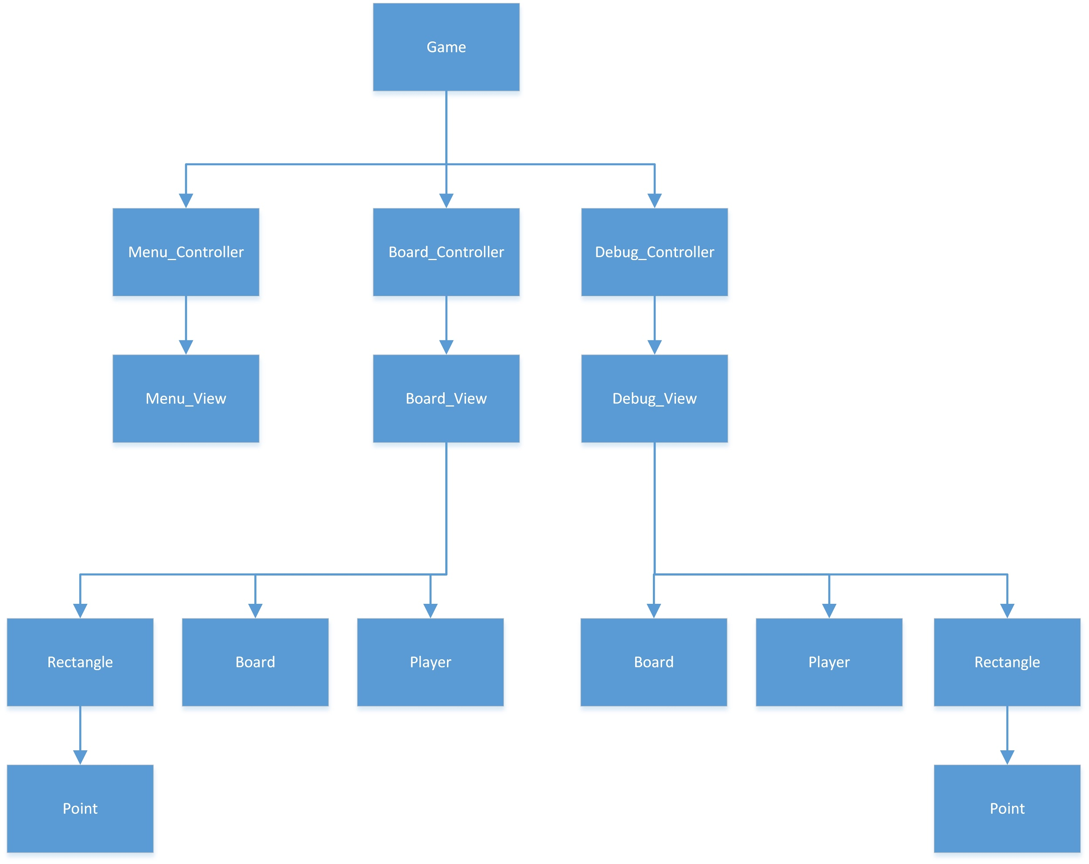

1. Anticipated Changes and Discussion

In the design of Assignment 1, we anticipated the following changes:  
\begin{itemize}  
 \item The Board\_Controller can move between different states (i.e. setup, play, results)  
 \item The player can play against the computer  
 \item There can be more than 2 players  
 \item There game can be expanded to N Men's Morris, where N is greater than 6  
 \item Additional components can be added onto the Board\_View and the Debug\_View  
 \item Players can make an infinite number of moves  
 \item The platform which to run the game will change over time  
 \item The resolution of computer screens will change over time  
\end{itemize}

**The Board_Controller can move between different states (i.e. setup, play, results)**

The MenuController class allows for additional classes to be added to the application. It serves as a link to other states, so that an unforeseen state, such as the option to play another game besides N-Men’s Morris can be implemented as another module within the same application.

**The game can be expanded to N Men’s Morris, where N is greater than 6.**

The modules are implemented such that the number of layers (of rectangles) the board contains, and the number of pieces each player has is contained in variables such as N and NUMBER_OF_PIECES. This makes modification of such parameters simple, as the rest of the code will remain constant.

**Additional components can be added onto the Board_View and the Debug_View.**

Different components of the screen are encapsulated into JPanels which are then assembled in the controller. This allows for new components to be created as JPanels which can then replace existing components in the screen.

**Players can make an infinite number of moves**

The turn based system is implemented such that one player increments the turn counter while the other player decrements the turn counter. This makes the turn counter switch between 0 and 1. This allows for an infinite number of moves to be played while using as little space as possible. That is, the program will not crash if 2 computers decided to play against each other, and they use more than 232 moves.

**The platform which to run the game will change over time.**

Java was the language of choice because it allowed for cross-platform integration of the application. Additionally, only the standard Java libraries were used in order to allow users to run the application with the minimal number of additional installations. This saves usage space, and it further prevents compatibility and licensing issues. The user of standard Java library is also, in our opinion, the best guarantee that the libraries used will be supported, as long as Java is supported.

**The resolution of computer screens will change over time**

The program has been designed to fit screens of all shapes and sizes. The size of the components on the screen is based on the the screen’s width and height, and the user can resize the screen so that it fits comfortable on their monitor. The screen is rendered at a resolution of 500 x 500, which is small for 2016 standards, so that it can accommodate platforms with smaller screens, but it can be scaled indefinitely large for larger screens.

1. Test Plan/Design

Requirement 1: Enable the user to set up a board to play the game.

|  |  |
| --- | --- |
| **Input** | **Result** |
| Run MenuController and choose Start game. | Window with a board with 2 rectangles, one within the other, with circles on the corners and at the midpoint of the lines. Lines connecting the middle circles of the big rectangle to the middle circles of the middle rectangle. |

Conclusion: This is the proper setup for 9 Men’s Morris.

Requirement 2: The board includes two types of discs.

|  |  |
| --- | --- |
| **Input** | **Result** |
| Run MenuController, choose start game, place discs on black circles. | Discs placed alternate between red and blue, the first colour determined randomly. |

Conclusion: There are blue and red discs.

Requirement 3: The discs are placed on either side of the board.

|  |  |
| --- | --- |
| **Input** | **Result** |
| Run MenuController, choose start game, place discs on black circles. | On the left there is the amount of Blue discs remaining, on the right the amount of Red (beginning with 6 discs each). When a disc is place the number decreases depending on the colour of the disc placed. |

Conclusion: The amount of discs for each player is placed on the sides of the board. The amount of discs decreases as they are placed.

Requirement 4: There are no discs at the start of the game.

|  |  |
| --- | --- |
| **Input** | **Result** |
| Run MenuController, choose start game. | All the circles on the board are black, not red or blue. |

Conclusion: Black circles mean there are no discs placed on them.

Requirement 5: Order of Play determined randomly

|  |  |
| --- | --- |
| **Input** | **Result** |
| Run MenuController, choose Start Game and place a piece anywhere. | Blue piece placed |
| Run MenuController, choose Start Game and place a piece anywhere. | Red piece placed |
| Run MenuController, choose Start Game and place a piece anywhere. | Blue piece placed |
| Run MenuController, choose Start Game and place a piece anywhere. | Blue piece placed |

Conclusion: It is not consistent blue, red, blue, red or just one colour starting everytime, therefore it is randomly decided which player starts.

Requirement 6: The user should be able to start a new game, or enter discs to represent the current state of a game.

|  |  |
| --- | --- |
| **Input** | **Result** |
| Run MenuController, click Start Game. | Menu with option of Start game or Debug. When Start game button clicked goes to game mode. |
| Run MenuController, click Debug. | Menu with option of Start game or Debug. When Debug chosen it gives the user the option of what colour to place and user is able to place pieces. |

Conclusion: Menu directs the user to either game mode or to place pieces and then start the game.

Requirement 7:The user should be able to enter discs to represent the current state of a game by selecting a colour and clicking on the position of the disc.

|  |  |
| --- | --- |
| **Input** | **Result** |
| Run MenuController and choose Debug, choose colours and click circles. | Circles clicked change to the colour of the colour chosen from the menu on the left. |

Conclusion: The circles clicked change to the colour chosen and the user is able to enter the discs to represent a state of the game.

Requirement 8: When all the discs the user wants to play have been played, the system should analyze whether the current state is possible.

|  |  |
| --- | --- |
| **Input** | **Result** |
| Run MenuController, choose Debug, place 4 blue pieces and 4 red pieces. Play game. | Game mode begins. |
| Run MenuController, choose Debug, place 10 blue pieces and 6 red pieces. Play game | Error Message. |

Conclusion: When a legal amount of discs are placed the player is able to play the game, when an illegal amount is placed they receive and error message.

Requirement 9: Errors should be displayed to the user.

|  |  |
| --- | --- |
| **Input** | **Result** |
| Run MenuController, choose Debug, place 10 blue pieces and 6 red pieces. Play game | Error window appears, there are too many pieces. |
| Press ok on error message, replace all pieces with black. Play game | Error window appears, both players have fewer than 3 pieces. |

Conclusion: When a user tries to make an impossible state the application tells them that it is illegal and why. The user is able to go back and change the discs to create a legal state.

MIS

CLASS: CIRCLE

Defines a mathematical representation of a circle using its center point and radius. Contains access programs to field variables, and to detect user input.

INTERFACE

USES

Point

TYPE

None

ACCESS PROGRAMS

Circle(Point center, double radius)

Constructor method required to create object of type Circle with a radius and center

point.

getIntDiameter(): int

Returns the diameter *d* of the circle as an integer, $d = 2r$

getIntPointX(): int

Returns the x-coordinate of the center point as an integer.

getIntPointY(): int

Returns the y-coordinate of the center point as an integer.

getIntRadius(): int

Returns the radius of the circle as an integer.

isMouseOver(Point mouse): boolean

Returns TRUE if mouse is pointing over the circle, otherwise returns FALSE

CLASS: CONTROLLER

The Controller receives information from the model and accesses the View.

INTERFACE

USES

View

TYPE

none

ACCESS PROGRAMS

Controller(int N)

The controller can access the view and receive information from the model.

main(String[] args)

The Main method that creates an object of type controller and sets the window to be

visible. Essentially runs the entire program.

CLASS: DEBUGCONTROLLER

Creates the window and all labels or buttons needed to access and update the view which in turn will change values in the model.

INTERFACE

USES

BoardView

DebugController

TYPE

none

ACCESS PROGRAMS

DebugController(int N)

Construct the state based on the number of layers.

CLASS: ERRORDIALOG

Defines a dialog box to display error messages to the user. Contains an access program to respond to the user’s input.

INTERFACE

USES

JDialog, ActionListener

TYPE

None

ACCESS PROGRAMS

ErrorDialog(JFrame parent, String title, String message)

Initializes a dialog to display any errors found during the execution of the application

actionPerformed(ActionEvent e)

Responds to the user’s input

CLASS: MENUCONTROLLER

Defines a controller to mediate the views and models used in the menu.

INTERFACE

USES

MenuView, JFrame

TYPE

None

ACCESS PROGRAMS

MenuController()

Instantiates the view and any field variables used in the module.

run(): void

Runs any operations associated with the controller.

getJFrame(): JFrame

Returns the JFrame.

main(String[] args): void

The main method. This runs the application.

CLASS: MENUVIEW

Defines a view for the menu screen.

INTERFACE

USES

Screen

TYPE

None

ACCESS PROGRAMS

MenuView(int N)

Instantiates the objects on the screen and any field variables used in the module.

getState():int

Returns the state of the application.

updateScreen(): void

Updates the screen.

paintComponent(Graphics g): void

Draws the required components onto the screen.

CLASS: PLAYER

Each player is determined by two integers. An integer that represents their color , and the number of pieces they have left to place.

INTERFACE

USES

None

TYPE

None

Player(int color, int numberOfUnplayedPieces)

Initializes field variables

getColor():int

Returns the color of the player.

getNumberOfUnplayedPieces():int

Returns the number of pieces the player has yet to place.

placePiece(): void

Models the action of the user playing a piece on the board.

CLASS: POINT

Defines a mathematical representation of a circle using its x-coordinate and its y-coordinate.

INTERFACE

USES

None

TYPE

None

ACCESS PROGRAMS

Point(double x, double y)

Initializes the field variables

getX(): double

Returns the x-coordinate.

getY(): double

Returns the y-coordinate.

getIntX(): int

Returns the x-coordinate as an integer.

getIntY(): int

Returns the y-coordinate as an integer.

getDistance(Point that): double

Return the distance between two point objects, $d = \sqrt{{{\left(x_{2}-x_{1}\right)}^{2}+{\left(y_{2}-y_{1}\right)}^{2}}^{}}$

CLASS: RECTANGLE

Defines a mathematical representation of a rectangle defined by the top left, top right, and bottom left corners.

INTERFACE

USES

Point

TYPE

None

ACCESS PROGRAMS

Rectangle(Point topLeft, Point topRight, Point bottomRight)

Initializes the field variables

getTopLeft(): Point

Returns the top left point of the rectangle.

getTopRight(): Point

Returns the top right point of the rectangle.

getBottomRight(): Point

Returns the bottom right point of the rectangle.

getIntWidth(): int

Returns the width of the rectangle, $w=\left|x_{top left} -x_{top right} \right|$.

getIntHeight():int

Return the height of the rectangle, $h = \left|y_{top right} - y_{bottom right}\right|$

getTopLeftIntX(): int

Return the x-coordinate of the top left corner as an integer.

getTopLeftIntY(): int

Return the y-coordinate of the top left corner as an integer.

getBottomLeft(): Point

Return the bottom left point, defined by $\left(x_{top left}, y_{bottom right}\right)$

CLASS: SCREEN

Declares a function that will be used in classes that extend from it. In this assignment, that would be the classes menuView, and boardView. It is a template for the views.

INTERFACE

USES

None

VARIABLES

None

ACCESS PROGRAMS

updateScreen():void

Updates the screen

CLASS: VIEW

What the user sees...

INTERFACE

USES

Board

Circle

TYPE

None

ACCESS PROGRAMS

View(int N)

Constructor method of type View. Creates a board of the current application state.

setBoardState(int number, int state): void

Set the state of the board.

getBoardState(int number): int

Return the current state of the board from accessing getPieceState.

getCircles(): Circle[]

Return the array of all circles in the board.

setStates(int[] states): void

Set the states of the game.

CLASS: BOARD

This is an abstract representation of the game board. It keeps the state of each piece in a 1 dimensional array in order to reduce run time and space.

INTERFACE

USES

None

TYPE

None

ACCESS PROGRAMS

Board(int N)

Constructs an array representation of the board.

Board(int N, int[] pieces)

Constructs an array representation of the board given a preset state.

setPieces(int[] pieces): void

Initializes the pieces array.

getN(): int

Returns the number of squares on the board.

setPieceState(int number, int state): void

Set the state of a piece on the board

getBoardState: int[]

Return the current state of the board

getPieceState(int number): int

Return the current state of the piece (black, red or blue)

CLASS: BOARDCONTROLLER

This is a controller for the board class. It acts as an intermediary between the Board model (Board.java), and the Board view (BoardView.java).

INTERFACE

USES

BoardView

Player

TYPE

none

ACCESS PROGRAMS

BoardController(int N)

Construct the board.

BoardController(int N, int[] boardState)

Construct or update the board based on the correct state

CLASS: BoardView

INTERFACE

USES

Screen

Board

Circle[]

TYPE:

none

ACCESS PROGRAMS

BoardView(int N)

Constructs the screen needed to play the game, and adds all EventListeners needed to obtain input from the user.

BoardView(int N, int[] boardState)

Construct the screen needed to play the game given a certain state, and adds all EventListers needed to obtain input from the user.

pieceNotTaken(int number): boolean

Return a boolean value that determines if a piece is already placed in a certain

location.

getBoardStates(): int[]

Return the state of the board (player Red or player Blue).

setBoardState(int number, int state): void

Set the state of the board.

getBoardState(int number): int

Return the state of the board.

getCircles(): Circle[]

Return the array of all circles in the board

setState(int[] states): void

Set the states of the game.

updateScreen(): void

Updates the screen.

paintComponent(Graphics g): void

Draw board.

Class: Game

Interface

Uses

Type

Access Programs

main(String[] args)

The Main method that creates an object of type controller and sets the window to be

visible. Essentially runs the entire program.

MID

CLASS: CIRCLE

Defines a mathematical representation of a circle using its center point and radius. Contains access programs to field variables, and to detect user input.

IMPLEMENTATION

USES

Point

VARIABLES

center: Point

The center point of the circle

radius: double

The radius of the circle.

ACCESS PROGRAMS

Circle(Point center, double radius)

Constructor method required to create object of type Circle with a radius and center

point.

getIntDiameter(): int

Returns the diameter *d* of the circle as an integer, $d = 2r$

getIntPointX(): int

Return the X - coordinate of the center point

getIntPointY(): int

Return the Y - coordinate of the center point

getIntRadius(): int

Return the radius of the circle as an integer.

isMouseOver(Point mouse): boolean

Returns TRUE if mouse is pointing over the circle, otherwise returns FALSE

return x > center.getIntX() - radius && x < center.getIntX() + radius && y > center.getIntY() - radius && y < center.getIntY() + radius;

CLASS: DEBUGCONTROLLER

Creates the window and all labels or buttons needed to access and update the view which in turn will change values in the model.

IMPLEMENTATION

USES

JFrame

BoardView

JRadioButton

ButtonGroup

JButton

DebugController

VARIABLES

jFrame: JFrame

boardView: BoardView

NUMBER_OF_PIECES = 6: int

Instantiate number of pieces per player, if this was 9 men's morris, it would change to 9 etc.

BLUE_STATE = 1: int

Blue state is index 1

RED_STATE = 2: int

Red state is index 2

FONT_SIZE = 25: int

Set default font size

DEFAULT_SCREEN_WIDTH = 500: int

Set default screen width

DEFAULT_SCREEN_HEIGHT = 500: int

Set default screen height

blue, red, black: JRadioButton

Series of JRadio buttons

buttonGroup: ButtonGroup

Put buttons in a group so only one can be pressed at a time

playGame: JButton

Will change the application state to regular gameplay

N: int

Number of layers/ rectangles

ACCESS PROGRAMS

DebugController(int N)

Construct the state based on the number of layers.

Instantiate debugging window

Font size scalable to window, frame width * FONT_SIZE/DEFAULT_SCREEN_WIDTH

3 JRadio buttons

playGameMouseClicked(MouseEvent e): void

This method performs when the play game button is clicked.

if boardIsLegal is true

Set up boardController

boardIsLegal(): boolean

Return a boolean value that determines if the board is of legal creation by the user.

if error

new error dialog

return false

checkNumbers(): String

This method checks the debugging board to see how many pieces of each colour are

present, if the number is illegal, returns error message.

|  |  |
| --- | --- |
| Condition | Result |
| blueCont>NUMBER_OF_PIECES | errorMessage += "There are more than the allowed number of blue pieces.<br>"; |
| redCount>NUMBER_OF_PIECES | errorMessage += "There are more than the allowed number of red pieces.<br>"; |
| blueCount<3 | errorMessage += "Both players have fewer than 3 pieces<br>"; |
| redCount<3 | errorMessage += "Both players have fewer than 3 pieces<br>"; |

resizeText(): void

Adjusts the font for all text involved, making it able to be resized based on the window

size. Sets the font of blue, red, black and playGame.

Equation for font

updateView(): void

Updates the view if and where it is needed by using invalidate and repaint.

MouseClickEventHandler implements MouseListener

mouseClicked(MouseEvent e): void

Called if the mouse is clicked on a board node, and one of the JRadio buttons  
 (red, blue or black) is selected.

Instantiate points

for i in range of length circles

if blue is selected

make circle at i blue

else if red is selected

make circle at i red

else if black is Selected

make circle at i black

update view

mouseEntered(MouseEvent e): void

mouseExited(MouseEvent e): void

mousePressed(MouseEvent e): void

mouseReleased(MouseEvent e): void

CLASS: ERRORDIALOG

Defines a dialog box to display error messages to the user. Contains an access program to respond to the user’s input.

IMPLEMENTATION

USES

JDialog

Action Listener

BorderLayout

VARIABLES

FONT_SIZE = 0: int

The default font size.

ACCESS PROGRAMS

ErrorDialog(JFrame parent, String title, String message)

Catches errors that may occur in the application while the user is running it.

Set the font

Button when clicked analyses board

Instantiate errorMessages

actionPerformed(ActionEvent e)

If an action can be performed, then there is no need to show the error message, so this will set the visible value to false.

CLASS: MENUCONTROLLER

Defines a controller to mediate the views and models used in the menu.

IMPLEMENTATION

USES

JFrame

MenuView

VARIABLES

jFrame: JFrame

view: MenuView

nextState: int

ACCESS PROGRAMS

MenuController()

Method to construct the output that the controller will handle everything inside of it.

Instantiate views

run(): void

Update the screen whenever the components need to be resized.

getJFrame(): JFrame

Return the window object.

getNextState(): int

Return the next state of the application.

CLASS: MENUVIEW

Defines a view for the menu screen. Instantiates what thing must be communicated to the user when called by the controller.

IMPLEMENTATION

USES

Screen

JLabel

JButton

VARIABLES

title: JLabel

The label title

playGame: JButton

User will click to go directle to play state

debug: JButton

User will click to go to debugging and then to play state

state: int

Keeps track of the state the game is in

defaultFontSize = 36: int

Sets the default font size

defaultScreenWidth = 500: int

Sets the default screen width

N: int

The number of layers.

ACCESS PROGRAMS

MenuView(int N)

Constructor method.

Instantiate play game and debug buttons

mouseClicked method

Instantiate Box

getState():int

Return the state of the application

playGameMouseClicked(MouseEvent e): void

If the mouse was clicked on the play game button

Set BoardController to visible

debugMouseClicked(MouseEvent e): void

If the mouse was clicked on the debug button

Set DebugController to visible

draw(Graphics g): void

This method formats all of the required components to the menu.

Set font

updateScreen(): void

Updates the screen

paintComponent(Graphics g): void

This method paints all of the formatted components to the menu.

CLASS: PLAYER

This class models a player. Each player is determined by two integers. An integer that represents their color , and the number of pieces they have left to place.

IMPLEMENTATION

USES

none

TYPE

COLOR: int

The value that corresponds to the colour.

numberOfUnplayedPieces: int

The number of pieces that have not been played on the board.

ACCESSOR PROGRAMS

Player(int color, int numberOfUnplayedPieces)

Constructor method that takes in two parameters, color and number of unplayed

pieces.

getColor():int

Returns the color of the player.

getNumberOfUnplayedPieces():int

Returns the number of pieces the player has yet to place.

placePiece(): void

When the player places a piece decrement numberOfUnplayedPieces by 1

CLASS: POINT

Defines a mathematical representation of a circle using its x-coordinate and its y-coordinate.

IMPLEMENTATION

USES

none

VARIABLES

x,y: double

X and Y coordinates of the point object

ACCESSOR PROGRAMS

Point(double x, double y)

Point constructor using two parameters

getX(): double

Return X coordinate.

getY(): double

Return Y coordinate.

getIntX(): int

Return integer approximation of the X coordinate.

getIntY(): int

Return integer approximation of the Y coordinate.

getDistance(Point that): double

Return the distance between two point objects, $d = \sqrt{{{\left(x_{2}-x_{1}\right)}^{2}+{\left(y_{2}-y_{1}\right)}^{2}}^{}}$

CLASS: RECTANGLE

Defines a mathematical representation of a rectangle defined by the top left, top right, and bottom left corners.

IMPLEMENTATION

USES

Point

VARIABLES

topLeft, topRight, bottomRight: Point

Three points will be used to construct each rectangle

ACCESS PROGRAMS

getTopLeft(): Point

Return the top left point of the rectangle. Used for assistance in geometric methods.

getTopRight(): Point

Return the top right point of the rectangle. Used for assistance in geometric methods.

getBottomRight(): Point

Return the bottom right point of the rectangle. Used for assistance in geometric

methods.

Rectangle(Point topLeft, Point topRight, Point bottomRight)

Constructor method with 3 parameters.

getIntWidth(): int

Returns the width of the rectangle, $w=\left|x_{top left} -x_{top right} \right|$ This will be used for

assistance in properly scaling based on window size.

getIntHeight():int

Return the height of the rectangle, $h = \left|y_{top right} - y_{bottom right}\right|$ This will be used for

assistance in properly scaling based on window size.

getTopLeftIntX(): int

Return the X coordinate of the top left corner. Parameter to draw the rectangle.

getTopLeftIntY(): int

Return the Y coordinate of the top left corner. Parameter to draw the rectangle.

getBottomLeft(): Point

Return the bottom left point, defined by $\left(x_{top left}, y_{bottom right}\right)$

CLASS: SCREEN

Declares a function that will be used in classes that extend from it. In this assignment, that would be the classes menuView, and boardView. It is a template for the views.

IMPLEMENTATION

USES

JPanel

VARIABLES

none

ACCESS PROGRAMS

updateScreen(): void

CLASS: BOARD

Creates the model used by other classes in the program to construct the board. The class is essentially used to allow access to specific properties of the Six Men’s Morris board. Properties such as state, and the number of pieces.

IMPLEMENTATION

USES

none

VARIABLES

N: int

Number of squares needed for the board.

NUM_PIECES_PER_LAYER = 8: int

Amount of pieces per layer

pieces: int[]

Amount of positions to place pieces.

ACCESS PROGRAMS

Board(int N)

Determine the number of pieces

pieces = N*NUM_PIECES_PER_LAYER

Board(int N, int[] pieces)

Construct a custom board depending on pieces

setPieces(int[] pieces): void

Allow for access to number of squares, and piece array for custom functions.

getN(): int

Return the number of squares of the board

setPieceState(int number, int state): void

Set state, not started, play mode or debug mode.

getBoardState: int[]

Return the current state of the board.

getPieceState(int number): int

Return the current state of the piece (black, red or blue).

Number is an index that will help determine the piece state.

CLASS: BoardController

This class creates a window with labels and buttons during the regular gameplay process. User interaction with those buttons will call for updates in the view, which in turn changes the representative values in the model.

IMPLEMENTATION

USES

JFrame

BoardView

Player

JLabel

VARIABLES

jFrame: JFrame

boardView: BoardView

turn: int

If turn is 0 then it’s blue’s turn, if it’s 1 then red’s turn.

blue, red: Player

state = 0: int

If it is state 0, place pieces. If it is state 1, play game

NUMBER_OF_PIECES = 6: int

Number of pieces we’re using. This can change to 9 if we are going to do 9 Men's Morris instead.

BLUE_STATE = 1: int

Blue state has a value of 1

RED_STATE = 2: int

Red state has a value of 2

FONT_SIZE = 25: int

Declaring a size for the font used in the application

DEFAULT_SCREEN_WIDTH = 500: int

The default width of screen (will scale if stretch/compress window)

DEFAULT_SCREEN_HEIGHT = 500: int

The default height of screen (will scale if stretch/compress window)

blueLabel, blueCount, redLabel, redCount, cLabel, cCount: JLabel

Some labels to properly update the view

ACCESS PROGRAMS

BoardController(int N)

Framework for the game, manipulates the model to know how to update the view.

Instantiate Random Turns

Instantiate Models

Instantiate Views

BoardController(int N, int[] boardState)

Construct or update the board based on the correct state. Add up all pieces for each player

for i in range length of boardState

if boardState[i]==blue

bluePieces increment by 1

else if baordState[i] == red

redPieces increment by 1

resizeText(): void

Resize the text based on the dimensions of the window. This allows for dynamic

change, such that the user can play with any size of window.

Set Font

updateLabels(): void

This method will update the labels of each player involved.

updateView(): void

Controller takes information from the view and calls methods from the java.awt library

on it. Repaints if it has been changed.

MouseClickEventHandler implements MouseListener

Contains all possible methods that may be used for the Six Men's Morris Game. If

suddenly we decide to use other MouseListener methods, we can slightly change the code to do so.

mouseClicked(MouseEvent e): void

This method allows for alternate colour pieces to be placed on the board after each click.

for i in range of length circles

if mouse clicks circles[i]

if state==0

switch turn%2

case 0:

if pieceNotTaken at i on boardView

if blue number of unplayed pieces >

0

set that spot at i as 2 (red)

place blue piece

increment turn

case 1:

if pieceNotTaken at i on boardView

if red number of unplayed pieces > 0

set that spot at i as 2 (blue)

place red piece

decrement turn

update labels and view

if red and blue number of unplayed pieces == 0

state =1

else if state==1

mouseEntered(MouseEvent e): void

mouseExited(MouseEvent e): void

mousePressed(MouseEvent e): void

mouseReleased(MouseEvent e): void

CLASS: BOARDVIEW

Creates the information that the controller will access in order to communicate to the user. The controller will call the view and this is what will draw the graphics to the application window.

INTERFACE

USES

Screen

Board

Circle[]

VARIABLES

board: Board

N: int

Number of squares

states: int[]

Array of integers that holds each state

COLORS = { Color.BLACK, Color.BLUE, Color.RED }: Color[]

If a third colour was introduced, add it here

RECTANGLE_WIDTH_SCALING = 0.19: double

Rectangle width scaling

RECTANGLE_HEIGHT_SCALING = 0.19: double

Rectangle height scaling

CIRCLE_SCALING = 0.07: double

Circle scaling

HORIZONTAL_LINE_SCALING = (this.CIRCLE_SCALING/this.RECTANGLE_WIDTH_SCALING)*0.9: double

Horizontal line scaling

VERTICAL_LINE_SCALING = (this.CIRCLE_SCALING/this.RECTANGLE_HEIGHT_SCALING)*0.9: double

Vertical line scaling

circles: Circle[]

Array of circles , will be used multiple times

ACCESS PROGRAMS

BoardView(int N)

Construct a board from the board model, where N is the number of pieces (squares).

BoardView(int N, int[] boardState)

Construct the board from the model using a current state.

pieceNotTaken(int number): boolean

This method will allow us to make sure the user can only place one piece per node on

the board. It will return a boolean value that determines if a piece is already places in location FALSE, a piece is already there.

getBoardStates(): int[]

Return the state of the board (player Red or player Blue).

setBoardState(int number, int state): void

Set the state of the board. Number is the specific index of the array of states. State will be the previous state of the board and will be updated

getBoardState(int number): int

Returns the current state of the board from accessing getPieceState. Number is the number used to index the array of states.

getCircles(): Circle[]

Return the array of all circles in the board

setState(int[] states): void

Set the states of the game. States is the array of states (black, red, blue).

draw(Graphics g): void

Draw the entire board.

drawRectangle(Graphics g, Rectangle rect): void

Draws a black rectangle (layer / square) that updates based on window size.

drawCircle(Graphcis g, Circle circle, int state): void

Draws a coloured circle based on current state of the board.switch states[state]

case 0:

set colour to black

case 1:

set colour to blue

case 2:

set colour to red

default:

set colour to green

drawLine(Graphics g, Point a, Point b): void

Draw a line from point a to b. This will be used to connect layers.

drawBoardCircles(Graphics g, Rectangle rect, int layer): void

Draw all circles needed for the board

Instantiate points

Draw Circles

drawMiddleLines(Graphics g, Rectangle rect): void

Connect the layers of the board together through the midpoints of inner layers. diameterWidth = rect.getIntWidth() * this.HORIZONTAL_LINE_SCALING

diameterHeight = rect.getIntHeight()* this.VERTICAL_LINE_SCALING

Instantiate points

Draw lines

drawBoard(Graphics g, int N): void

Draw the entire board based on predetermined scaling constants.

Instantiate Points

for i in range of length N

New Rectangle object

if i<(N-1)

drawMiddleLines

drawRectangle

drawBoardCircles

updateScreen(): void

Updates the screen.

paintComponent(Graphics g): void

Draw sections of the board only when they need to be.

Class: GAME

Launches the menu.

INTERFACE

TYPE

None

VARIABLES

None

ACCESS PROGRAMS

main(String[] args): void

Main method that calls the controller constructor. This makes the menu appear. Create a new menuController object and set to visible.