Requirements Document

April 5, 2013

**Client Names:** Ricky, Jonathan, T-something (not 100% sure on her name)

**Company Name:** JTR Jeux

**Logo:**

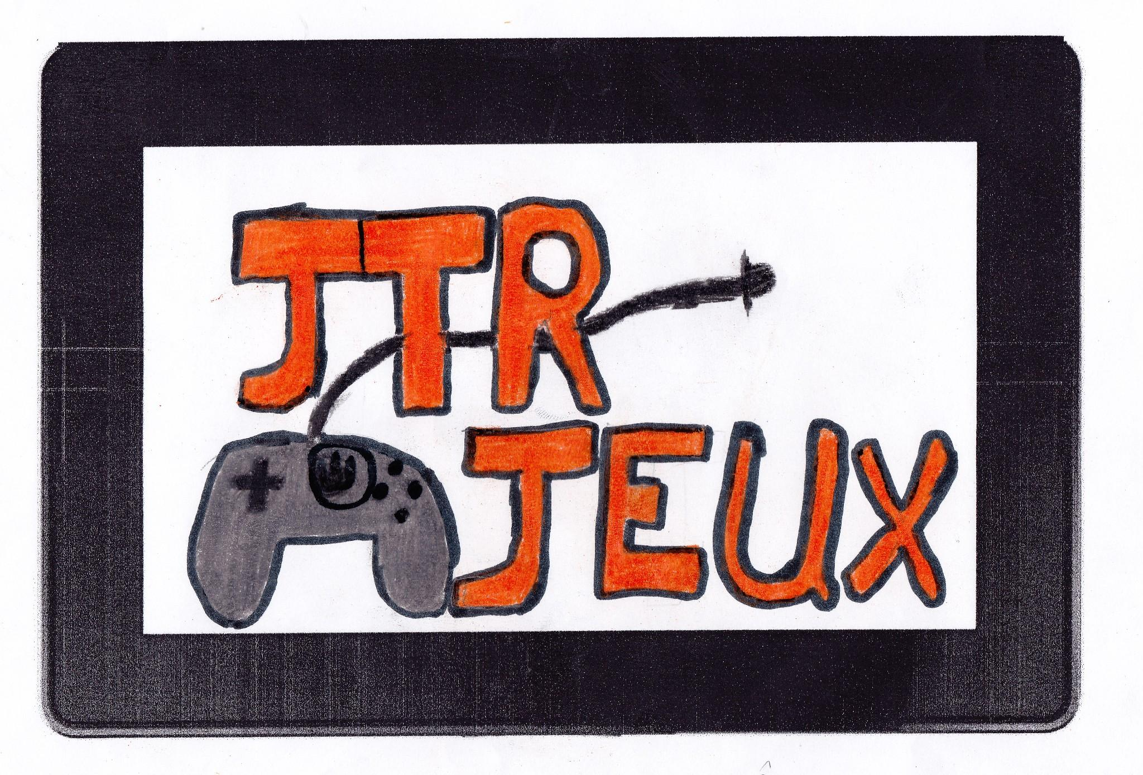

**Development Team:** Peter Kim, Alic Jiang

**Game Name:** Not yet decided

**Game Description:**

In this game, the player controls a spaceship, and has to destroy asteroids that fly towards it. In order to prevent the asteroids from hitting, the player must answer the math questions that appear on the asteroids. Answering the question on an asteroid causes it to be destroyed. If an asteroid reaches the ship, the ship loses a life. When the ship loses all lives, the game is over. The math questions will be of the grade 4 skill level, but since the answering time is short, the questions may be a bit easier, similar to the “mad minute” quizzes that are done (or were done).

**Detailed Requirements:**

* **Splash Screen**
  + This screen will briefly show on the opening of the app, displaying the company name and logo.
* **Title Screen**
  + This screen will be the main menu for the game, the player will see this after the splash screen, and it contains the links to the settings, credits, and level screens.
* **Settings Menu**
  + This menu will allow the player to change the audio and video settings.
* **Levels Menu**
  + This menu will contain all the game levels, and the player can access any level from this screen.
* **In game Screen**
  + This screen will hold the actual game.
  + The screen will contain a small menu to travel to the settings and levels menu, as well as a keypad to answer the questions.
    - The keypad will be a grid of buttons, including submit and clear buttons.
* **Players**
  + The game is single player, there will be no multiplayer capabilities.
  + However, we plan on having multiple save files, so individual players can save their progress.