**List of figures**

Figure 1. The geographic location and climate at 10 field sites. (A). The 10 sites across the latitudinal gradients from southern Texas to North Dakota. The experimental sites in this study span much of the natural range of switchgrass (the green layer with buffered points). (B). The mean temperature and annual rainfall of the 10 sites for the study year in 2016 (ordered from south to north).

Figure 2. The diagram depicting the panicle traits of switchgrass. PL is the panicle length (in mm), PBN is the primary branching number, and SBN is the secondary branching number. Photos show examples of panicles from the four grandparents WBC, AP13, VS16 and DAC.

Figure 3. The phenotypic distribution of the F2 population, and the phenotypic means of the four grandparents (lowland AP13, WBC and upland DAC and VS16) for panicle length (PL in mm), primary branching number (PBN), and secondary branching number (SBN) across the 10 field sites (ordered from south to north).

Figure 4. The summary of QTL and significant QTL-by-environment interaction (marked as * in red) identified for panicle length (PL in mm), primary branching number (PBN), and secondary branching number (SBN), along with QTL from flowering (FL50), plant height (HT) and tiller count (TC) originally identified from Lowry et al. (2019).

Figure 5. The additive effects of each QTL identified for (a) panicle length (PL in mm), (b) primary branching number (PBN), and (c) secondary branching number (SBN) across geographic regions ordered by from south to north. Genstat reports all of the means as equal when there is not a significant effect of the environment in the model.

Figure 6. The BMTME (Bayesian multi-trait and multi-environment) model performance of panicle length (PL in mm), primary branching number (PBN), and secondary branching number (SBN) for the 380 core genotypes grown at the 10 field sites, measured with R2 between genomic predictions and field observations, and cross validated with Pearson’s correlation coefficient at each site using BMORS (Bayesian multi-output regressor stacking) function in R package ‘BMTME’.

Figure 7. The genomic prediction of panicle length (PL), number of primary branches (PBN), and number of secondary branches (SBN) for the extra 370 genotypes (i.e., independent datasets) at the three sites (KBSM, CLMB, and PKLE), evaluated based on the BMTME (Bayesian multi-trait and multi-environment) model performance for the core genotypes at the 10 field sites. Statistical measures of r and %bias represent the prediction accuracy and percentage of bias between observed and predicted values.

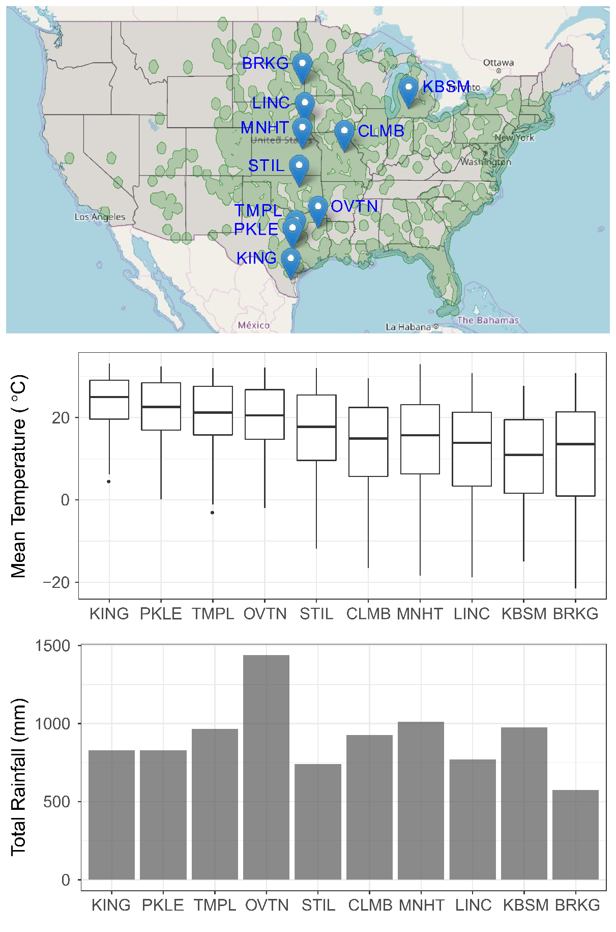

B

A

Figure 1

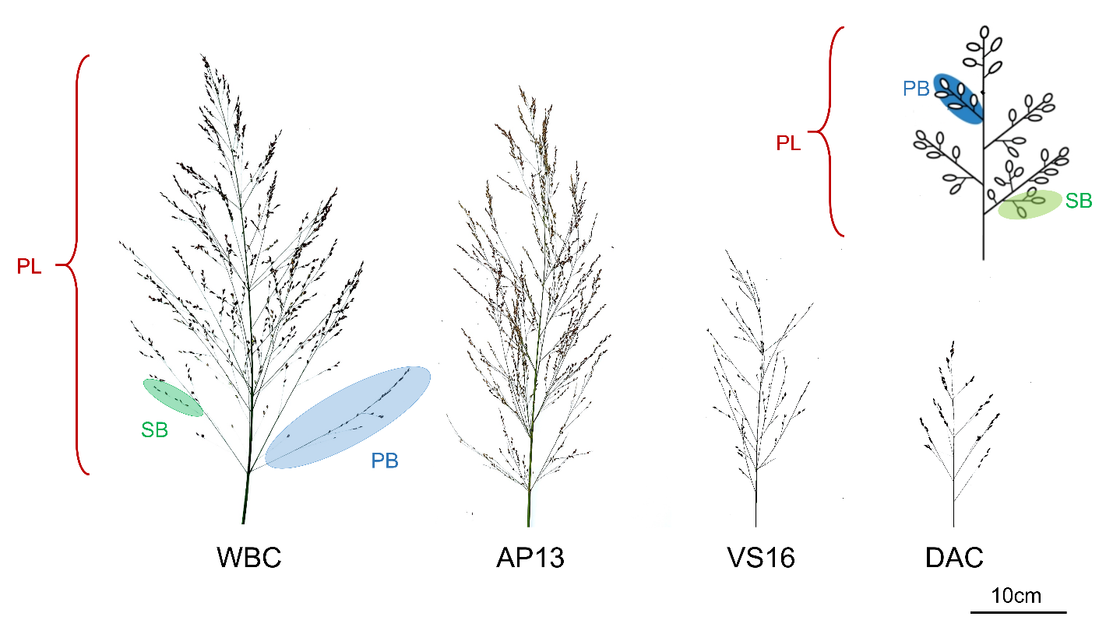

Figure 2

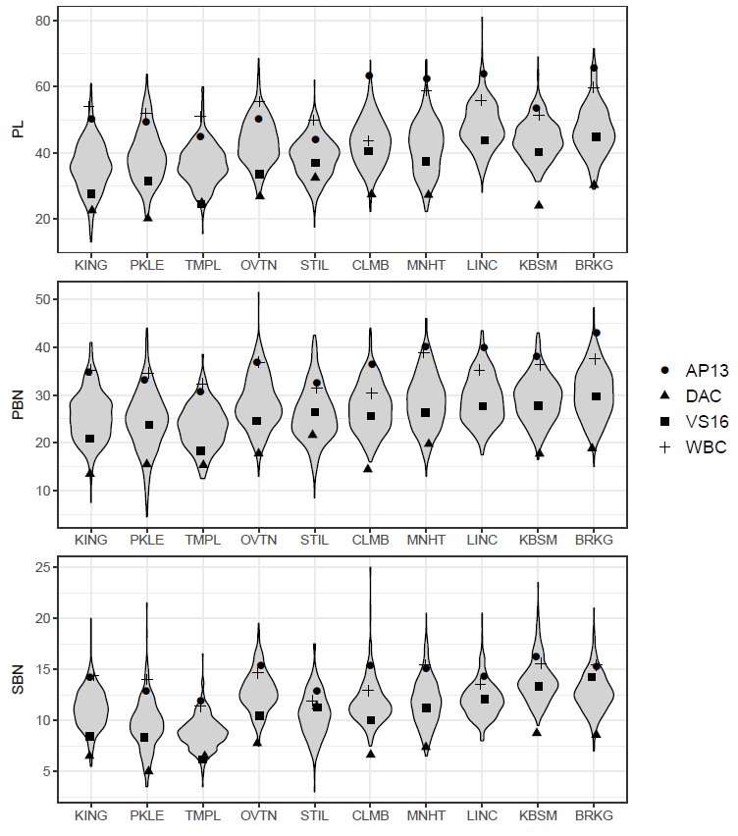

Figure 3

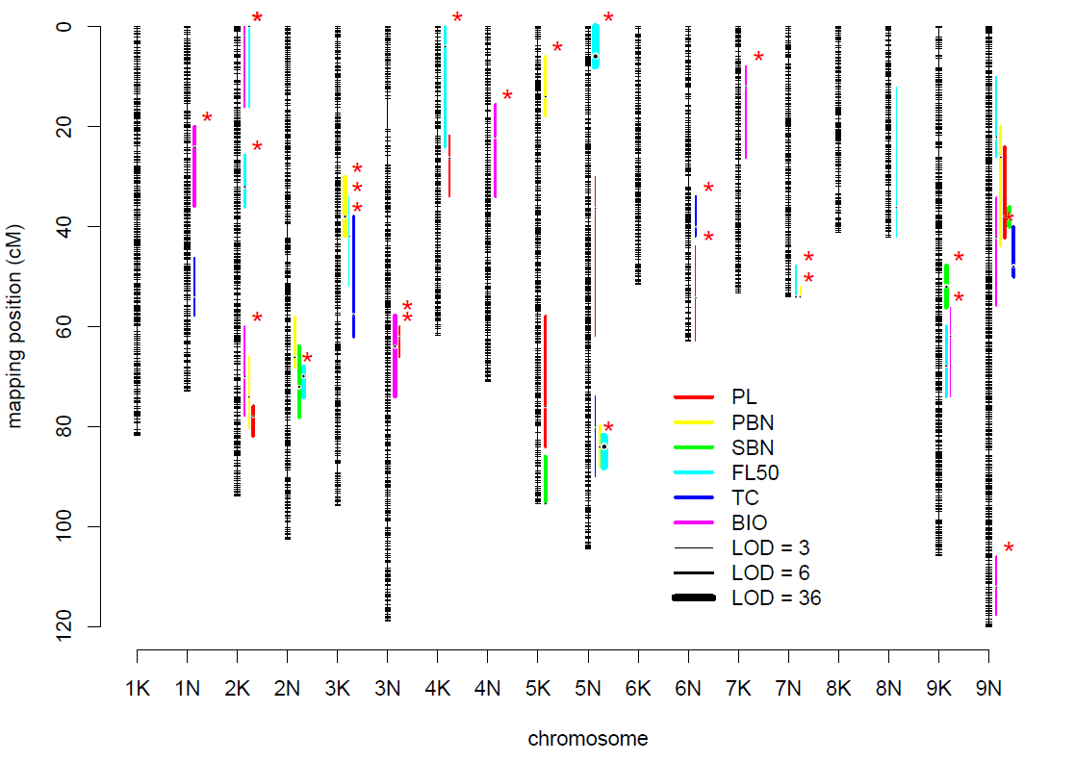

Figure 4

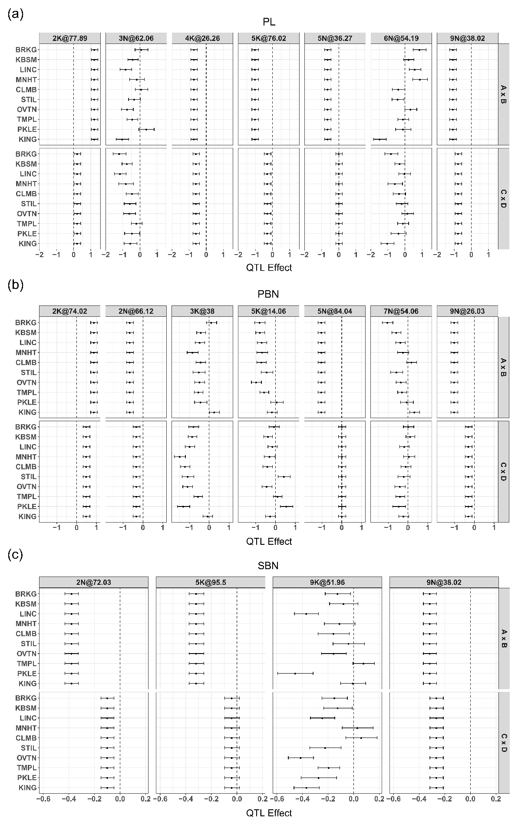

Figure 5



Figure 6



Figure 7