From local to continent-scale variation in yield and heritability in common bean (Phaseolus vulgaris)

Potential Authors

Alice H. MacQueen*, Patrick M. Ewing*, Jeffrey W. White, Phil Miklas, Phillip E. McClean, Bryan Runck, Michael Kantar, Thomas Kono, Colin K. Khoury

* Contributed equally to the manuscript

Target Audience: domestication story (long term effects of selection and domestication)
Target journal: New Phytologist, Proceedings of the Royal Society B, TAG, Evolutionary Applications, Annals of Botany, Heredity, Frontiers in Plant Science, Global Food security

Abstract

Local and broad adaptation are concepts that resonate across the fields of ecology and agriculture. Large scale (fitness landscapes) and small scale (phenotypic plasticity) genotype by environment interactions are central to food production and plant breeding. Selection has been conducted for plants for millennia, historically it has been a highly local decentralized endeavor. However the advent of large public and private sector entities dedicated specifically to the breeding of a few important crops has led to more centralized efforts. These centralized efforts have led to increases in yields, however they have tended to concentrate these increases in fewer geographies.We quantified patterns of broad and narrow adaptation in modern, commercial common bean cultivars and breeding lines planted across 2170 site-years, from 1981–2013, for the Cooperative Dry Bean Nursery (CDBN) trials. We extended previous models of home field advantage by using the kinship between lines as a covariate in the model, Accounting for the genetic relationships (SNP covariance matrix) did not improve estimates of home field advantage. Location was the largest single source of yield variation (XXX%), and yearly weather was the smallest (XXX%), which suggested a benefit for reliable performance in narrow biophysical environments. Varieties displayed a large “home field advantage” accounted for XXX% of GxE and provided a yield increase of XXXX Mg ∙ ha-1, but this was smaller than predicted by a null model and unchanged across time. This shows that the dominant paradigm has been to select for broad adaptation leaving potential yield on the table in favor of stability across geographic space.

Introduction

Genetic variation in phenotypes is the fundamental property that makes both natural and artificial selection effective. However, there is a consistent loss of genetic variation when “improved” or commercial genomes are compared to domesticated “landrace” or non-commercial genomes, and again when domesticated genomes are compared to the genomes of wild relatives (Miller and Gross 2011, Moyer et al 2018). Domestication typically involves a genetic bottleneck followed by a long period of weak or variable selection. During the process of crop improvement, intense selection over short time frames is coupled with a reduction in effective population size and limited recombination, and often followed by long-distance migration events and rapid population expansion. To date, losses of genetic diversity range from 5 to 77% between wild and improved populations (Gray et al 2009, Lin et al 2014), and the only case with a gain in genetic diversity is in the Andean domestication event in common bean (Schmutz et al 2014).
Common bean (Phaseolus vulgaris) is the most important food legume for direct human consumption. Common bean is currently grown across a large range of latitudes (from 52 N to 32 S), altitudes (50 – 3000m), growth temperatures (14-26 C), and average yearly precipitation (400-1600mm) and precipitation regimes (Singh 1989; FAOSTAT 2015), on over 35 million ha globally with production in nearly every country that keeps statistics (FAOSTAT 2015). In contrast, the habitat niche of wild common bean is extremely narrow (Gepts 2009). Common bean originated in Mesoamerica (Bitocchi et al 2012) and was dispersed to the Andes ~165,000 years ago with a strong genetic bottleneck that lasted ~76,000 years (Schmutz et al 2014). From these two wild gene pools, common bean was domesticated at least twice, once in Mesoamerica and once in the Andes (Gepts, et al. 1986; Gepts 1998; Schmutz, et al. 2014). The domestication bottleneck was stronger in the Mesoamerican than in the Andean gene pool, probably because loss of diversity occurred in the Andes before domestication (Gepts et al., 1986; Bitocchi et al., 2012; Bellucci et al., 2014a; Schmutz et al., 2014). The gain in genetic diversity during the Andean domestication event was likely a result of gene flow from the more genetically diverse Mesoamerican common bean (Schmutz et al 2014). Common bean was widely cultivated in Mexico and North America during pre-Columbian times (Kaplan 1965), and New World settlers cultivated common bean from landraces cultivated by Native Americans and from European introductions (Vandemark et al 2014). The first North American improvement efforts were initiated in the late 1800s and early 1900s by the United States state and federal governments (Vandemark et al 2014); since the 1950s, these improvements have typically taken advantage of a multi-environment trial known as the Cooperative Dry Bean Nursery (CDBN), the largest multi-environment trial of common bean in the United States and Canada (Myers 1988; Singh 2000). CDBN cooperators develop germplasm at their home locations, then test that material for broad adaptation across all CDBN field locations, typically releasing varieties that yield well across CDBN locations. This approach maximizes the expected performance of released varieties across a large geographical area, but may ignore benefits of environmental specialization. Recently, hundreds of CDBN entries that group into three major races from both independent domestication events have been genotyped at 1.2 million SNPs and used for genetic work (MacQueen et al 2020). The CDBN dataset offers an exciting opportunity to examine the genetic component of yield in two domestication clades which differ in their genetic diversity, and to examine the impact of common bean improvement in the CDBN on genetic variation in yield at local and continental scales.
CDBN entries are advanced breeding material without ‘locations of origin’ in the sense of their wild progenitors. However, progenitors of these entries were grown in North America in pre-Columbian times, and these specific entries were developed by breeders at many locations that took part in the CDBN trials; thus, local adaptation of CDBN entries to specific North American regions may have arisen from long-term selection of improved material within those regions. If present, local adaptation could also be leveraged in breeding programs which have focused on broad-scale adaptation for large yield gains (Ewing et al., 2019). At the continental scale, understanding the spatial and temporal decay of yield heritability and its interaction with yield variation attributable to local adaptation could provide fundamental insights into the adaptation and domestication process of this species, which may differ by domestication clade (Papa & Gepts 2003; Papa et al., 2007; Eckert et al 2010; Rodrigues et al 2013; Kraft et al 2014; Rodriguez et al 2015).
Here, we introduce a home field advantage (HFA) component for each CDBN entry into a traditional partitioning of yield variation and explore patterns of HFA across these races and gene pools. We expected that higher performance at an entry’s home location would explain a significant amount of yield variation in each bean race. We then examined overall variation in yield heritability across years and locations in the CDBN and across races and gene pools. We expected to observe substantial differences in heritability across space due to environmental differences (Wilson et al 2006? Finlay Wilkinson?). We also expected to observe decreases in heritability over time in the Mesoamerican domestication clade as genetic sources of yield variation were eliminated, and potential increases in heritability over time in the Andean domestication clade, given its increase in genetic diversity from wild to domesticated gene pools. We conclude by investigating the potential for local adaptation to be incorporated into breeding programs, by characterizing the relationship between yield heritability and home field advantage across CDBN locations.

Materials and Methods
Data Acquisition

Phaseolus yield data were retrieved from MacQueen et al. 2020; briefly, yield data from digitized reports from 1981 to 2015 were obtained, which included data from 71 unique locations, and 327 entries (including released cultivars and unreleased advanced breeding lines) with 11 common check entries. CDBN entries include released cultivars and unreleased breeding lines from most bean types grown in North America and represent at least thirteen diverse market classes of common bean that group into three major races from both independent domestication events (Mamidi, et al. 2011). In addition to the 13989 yield datapoints used in this analysis, each variety was genotyped using genotyping by sequencing resulting in 1,221,540 SNPs, which were used to create a kinship matrix of relationships calculated using default methods in GAPIT.
The breeding and selection strategy in the CDBN likely impacts partitioning of yield variance in this material in a number of ways. The breeding strategy in the CDBN was developed to test dry bean material for broad adaptation across CDBN locations. Within years, CDBN locations grew an identical complement of CDBN entries, with only rare entries missing yield phenotypes at single locations. The entries in the CDBN shift gradually through the years, with each entry typically present in the CDBN for three consecutive years. This shift in CDBN genotypes is a direct result of the improvement strategy employed by CDBN cooperators over the trial years. This strategy confounds partitioning of yield variation into genetic and environmental components across years, but not across locations. Specifically, comparisons of heritabilities for different locations within years are not confounded by the presence of different genotypes. Heritabilities of different years within locations reflect both environmental differences across years and a change in the complement of genotypes used to compute the heritability.

Statistical analysis
Expectation of home field advantage standardized for kinship between CDBN entries

Statistics were performed in base R ], and plots made using ggplot2. Centering and scaling refer to a group mean of zero and standard deviation of one. We estimated home field advantage following Ewing et al., 2019, briefly HFA is the additional yield benefit conferred to a CDBN entry after accounting for inherent site and genetic yield potential, with the additional step of accounting for entry genetic relationships to eliminate effects of double counting similar CDBN entries. The first step was to assign each entry a “home” site, the site where an entry performed best relative to other varieties. We calculated relative yields within each site-year by centering and scaling. The home site for each CDBN entry was the site with the maximum average relative yield across years. We then modeled observed yield as:
Yield ~ site + year + site*year + genotype + KPC1 + KPC2 + KPC3 + KPC4 + home_site + population + error

Where home_site is an indicator for whether site j is the home site for entry i; its coefficient is the home field advantage. Coefficients on entry, site, and year respectively represent the genetic potential of a CDBN entry, the site’s productive potential, and the year’s weather suitability. Finally, we investigated the proportion of variation in yield explained by each factor of the above model using a Type-II analysis of variance using the Anova function in R package ‘car’. We estimated the trajectory of home field advantage across years. Each year, we estimated a home field advantage found in that year using Eq 1, but without terms including year. The model used median quantile regression using the rq function in quantreg v5.33, which is robust to non-normal response distributions. The coefficient for the is_homeij term, the yearly home field advantage, was then regressed against year. To explore potential pitfalls we conducted a counterfactual using permutation to compare our estimates of home field advantage to what we might expect given a neutral breeding approach. Within each site-year combination, we randomly reassigned yields to different check genotypes. This approach preserves within-site-year variation, but negates genotype advantages. Based on this permuted data, we then re-assigned a home site and calculated home advantage for each year as described above, repeating this process 999 times.

Spatial variation in heritability

Narrow sense heritability was calculated on a per site on an entry mean basis,

We combined data from all breeding trials to explore gain from selection for yield. We built linear models using the R package lme4 version 1.1.15 to calculate heritability by site-year combination and the variance in heritability at each site. Five year sliding windows of heritability were used to assess heritability changes over the time series. Ordinary kriging was then used to explore the spatial variability of heritability across North America.

Results
We first assessed overall yield performance and performance gains across the study period as in previous work (Vandemark et al 2014). We assessed this for three groups of CDBN entries: entries from the Andean domestication clade, and entries from two genetically distinct races within the Mesoamerican domestication clade, the Durango and the Mesoamerican race. In agreement with previous studies (Vandemark et al 2014), each of the major dry bean races had a different expected yield by 2015 (F2,13170 = 608; p < 0.001, Figure 2a; Table S1): Andean entries were expected to yield 2370 ± 40 kg ha-1, Durango entries, 3060 ± 30 kg ha-1, and Mesoamerican entries, 2850 ± 40 kg ha-1. All races’ yields improved during the study period, albeit at different rates (F2,13170 = 4.00, p = 0.02). Andean yields grew by 16 ± 2 kg ha-1 (p < 0.001), Durango yields grew by 14 ± 1 kg ha-1 (p < 0.001). Mesoamerican yields grew the fastest, by 20 ± 2 kg ha-1 (p < 0.001).

We partitioned yield variation into genetic and environmental components within the two domestication clades and three races (Table 2). The largest source of variability in yield across all races was a location-by-year interaction (44.9-48.7%), followed by an effect of location alone (29-33.1%). In contrast, year-to-year variation and genotype variation were small (2.4-3% and 3.2-4.1%). To test for a contribution of local adaptation to these yield gains, we also assessed the variation explained by each CDBN entry’s home field advantage (HFA). In Andean entries, HFA accounted for 1.1% of yield variation, and reduced unexplained yield variation by 6.4 percentage points (Table 2). In Durango entries, HFA accounted for 1.3% of yield variation and reduced residual variation by 8.3%. Similarly, HFA accounted for 1.3% of Mesoamerican yield variation, and reduced residual variation by 7.7%. <something about testing whether genetics account for HFA, e.g.: Previous work testing for HFA found larger HFA components (Ewing et al 2019), but was unable to determine if accounting for genetic relatedness was an effective substitute for HFA.> None of the races’ home field advantages were tempered by genetic relatedness, as linear models where HFA interacted with first three principle components (PCs) of respective kinship matrices were less parsimonious (ΔAIC = -339 (Andean), -890 (Durango), and -608 (Jalisco); Table S2). These three PCs accounted for 39%, 44%, and 42% of genetic variance in the Andean, Durango, and Mesoamerican lines, respectively (Figure S2).

We next determined if race-average HFA were larger than expected under neutral breeding scenarios and whether these average HFA were agronomically significant. Andean entries had yield gains that were not significantly different from the expectation of 357 kg ha-1 based on variation in Andean yields (p = 0.21; Figure 2b). In Durango entries, HFA conferred an average yield gain of 472 kg ha-1, 109 kg ha-1 larger than expected (5%: 72 kg ha-1; 95%: 146 kg ha-1 ; p = 0.002). The Durango HFA was 15% of expected 2015 yields, equivalent to 34 years of yield gains for this race. In Mesoamerican lines, HFA conferred a yield gain of 453 kg ha-1, 89 kg ha-1 larger than expected (5%: 44 kg ha-1; 95%: 134 kg ha-1; p = 0.002). The average Mesoamerican HFA was 16% of expected 2015 yields and equivalent to 22 years of yield gains for this race. Thus for the Mesoamerican, but not the Andean domestication clade, some environmental specialization has been preserved within the dry bean race.

Though environmental specialization was present within two dry bean races, we found inconsistent evidence that dry bean breeders tried to leverage HFA, in that there were inconsistent, and only moderately significant changes HFA among races and across time (F2,94 = 4.82; p = 0.01; Table S3). HFA increased slightly across the study period in Durango entries, by 4.3 ± 2.0 kg ha-1 yr-1 (p = 0.04; Figure 2b). In Mesoamerican entries, however, HFA decreased by 8.4 ± 3.5 kg ha-1 yr-1 (p = 0.02), and was indistinguishable from the expected HFA in later trial years based on variation.

We next determined narrow-sense yield heritability for 2170 location-year combinations in the CDBN, without accounting for HFA. We expected both variation across locations and a decrease in yield heritability in later trial years. Yield heritabilities ranged from 0.7 to 0.4, and were highest in the northwestern United States and southwestern Canada and decreased along a south-eastern gradient (Figure 3). More commonly used trial locations did not have more consistent heritabilities: in fact, there was a positive relationship between the number of trial years at a location and the standard deviation in heritabilities (yield stability) for a location across trial years (p = 0.014, Figure S1A). Location-specific heritability was also unrelated to yield stability at the location (p > 0.05; Figure S1B). There was a significant positive relationship between heritability and environmental quality of each location-year, with environmental quality measured as the average yield of entries of a race in that site-year (Fig S1C, cite Finlay Wilkinson). However, this trend was confounded with trends across year which reflected the direct act of selection for improvement on CDBN entries. Specifically, there were trends in yield heritability across years which varied by bean race. As hypothesized, heritability decreased in Mesoamerican entries by 0.005 points yr-1 (p < 0.001). Both this decrease and the decrease in Mesoamerican HFA over time suggest a reduction in genetic diversity in this race during the course of improvement. In contrast, Andean and Durango entries showed an increase in yield heritability over time, with yield heritability increasing by 0.007 points yr-1 and 0.004 points yr-1, respectively (p < 0.001). Durango entries thus exhibited both a modest increase in HFA and an increase in yield heritability over time, suggesting increasing adaptation to local and continental conditions in this race. In Andean entries, however, the increase in yield heritability over time occurred without an increase in HFA.

Efficiently breeding for environmental specialization requires high yield gains from specialization, and high heritability in yields. We found no tradeoff between heritability and home field advantage within races (F2,97 = 1.27; p = 0.3; Figure 4a). In addition, environmental specialization must have a predictable genetic basis. To test this, we determined whether more closely related CDBN entries had spatially closer home sites. Entries in the Durango (Mantel’s r = 0.11; p = 0.001) and Mesoamerican (Mantel’s r = 0.068; p = 0.01) races showed this relationship, while entries in the Andean race did not (p = 0.6; Figure 4b).

Discussion

Overall, the low-yielding, low genetic diversity Andean domestication clade experienced modest improvements in yield across the study period and showed little evidence of local adaptation to specific regions within North America, though strong evidence for increasing adaptation at a continental scale, in that yield heritabilities increased in this race over the 35 year study period. The high-yielding, high genetic diversity Durango race also saw modest improvements in yield across the study period, which coincided with a modest increase in local adaptation and increases in adaptation at a continental scale over time. Finally, the moderately yielding Mesoamerican race showed the largest improvements in yield across the study period, at the expense of local adaptation and heritability of yield in more modern entries.

In Durango and Mesoamerican entries, local adaptation conferred agronomically significant yield gains that were equivalent to decades worth of background yield improvements.

For New Phyt:
We see increasingly broad adaptation, tempered by the domestication events that have experienced different selection histories. Notes: Growth habit has been selected for differently over past 30 years (Andean arrived compact; mesoamerican has been made more compact through introgression; durango has not been reshaped).

Discuss this purposeful selection in terms of genetic variation and costs of local adaptation and heritability (reduced potential to further genetic gains with decreasing H).

Briefly touch on food security.

For global food security:
Frame in food sovereignty (impacts of broad breeding for small countries productive potential).

Spatial Variation in Yield Heritability

The goal of this work is to link breeding, geography and market into a single metric to create financially stable public breeding programs that are responsive to changing markets. In order to reduce the dimensions of this problem we will combine information on agroecological ecoregion and heritability of market specific traits economic value to identify the rate of gain needed to tap into individual markets Heritability ranges from 0-1, high heritability traits tend to be <0.8 tend to have mendelian inheritance, these traits are insensitive to selection in different environments. But for traits with low heritabilities (0.2-0.4), we expect differences in heritabilities when calculated in different environments. This is because due to the genotype x environment interaction causes larger variability in the measurements of phenotypes. There was extensive spatial variation in yield heritability (Fig 4), there was a clear northwest/southeast gradient that may be associated with either a flowering time gradient or related to how long the breeding programs have been operating. There was also a clear pattern of sites that had high heritability and low standard deviations, these sites (12/70), have the highest potential for rapid response to selection. The slight positive relationship suggests breeding locally adapted varieties is valuable and tractable in high heritability regions and that breeding for broadly adapted varieties in low heritability regions. If there had been no relationship locally adapted varieties would be generally valuable everywhere. Had the relationship been negative it would have been suggested that breeding broadly adapted varieties is valuable in high heritability regions and local varieties valuable in low heritability regions but that breeding for a local effect would be difficult, it would also suggest that current practices have maximized selection for yield and that we should maintain the status quo. In all cases progress can be made in regions with higher heritability more quickly. The data show both spatial and temporal decay, there is a fairly large range over which heritability was stable (~1013 km), while the over time there was a decrease of -0.005 per year for Mesoamerican, an increase for 0.007 for Nueva Granada and and an increase of 0.004 for Durango (p<0.001; Figure 4). While the home field advantage is stable, it accounts for more of the variation that can be selected for in specific locations.

More Discussion

Historic maize improvement has been about ~6% per year over the last 30 years, for bean, it’s only ~0.5%. So the previous estimate of a 26% home site advantage for maize (Ewing at al., 2019) is actually smaller than than vs a 6.5% advantage for bean, given the rate of gain. As this implies that for maize the home field advantage is a little more than 4.5x per year while for bean it is 13x greater than the yearly gain. This implies that the home field advantage (local adaptation) is a large potential source of improvement. There were differences in the impact of heritability by bean subpopulation, with a decrease in the Mesoamerican population overtime but an increase in the Durango and Nueva Granada populations. This is likely related to the narrow genetic base of the Nueva Granada which has actually been diversified over time. We also see a difference in selfing vs outcrossing species, but the sample size of one species each makes it difficult to make inferences.

Food systems are increasingly connected throughout the global supply chains often with regional offshoots that can provide important income streams to regional communities. There is limited private sector investment in bean breeding, but there are significant resources in different geographic regions representing many different market classes. This has been fundamental to improving food security and here we show that focusing on narrower geographies could increase yields even more. Different breeding strategies have been used across the many breeding programs that make up the CDBN to reach different markets, however, there is a clear pattern of breeding for large geographical regions that leaves yield on the table, in fact a larger amount of yield has been left on the table than in hybrid crops such as maize (Ewing et al., 2019). This yield from local adaptation is considerably larger than the year on year gains made from the breeding programs. Natural systems are expected to take advantage of local adaptation, exploration of fitness sets have shown both local and broad adaptation. Local adaptation has been seen in crop landraces but a deficit of local adaptation has been found in hybrids. This is a direct result of breeding practices which have favored stability and limiting genotype x environment interaction at wide geographic scales leaving potential local adaptation and therefore leaving favorable genotype x environment interaction.
There are many different viable breeding strategies, some meet the expectations of population biology for local or broad adaptation. There has been increasing evidence that while modern breeding techniques have increased stability, the scale has changed to the point where individual programs and lines do not optimize for specific regions. There did not appear to be a difference in the way breeding impacted different domestication events. The large amount of site-specific variation across regions, where it is difficult to assure the same environmental conditions, shows how changing the scale may provide value to farmers. These results show that variety development strategies in a commodity are similar between breeding systems (self-pollinated vs hybrid) and species (monocot and dicot), but there is not an increase in home field advantage, our metric of local adaptation, this means that changing methods and scale may have great implications for food security. We also found this result was robust to familial relationships within breeding programs across sites, increasing the utility of this method. This supports the contention that breeding programs do not view local adaptation as an economically viable approach, and that narrowly adapted varieties require too many resources to develop. It is possible to overcome this by use of judicious site selection, one way of doing this is to look at variance in heritability over space and identifying the decay of selection efficiency for various traits. This may provide an opportunity to create spatially defined local regions to optimize gain, profitability and sustainability of breeding programs.
Decay in heritability over time implies that major genes were fixed a long time ago and that selection should be increasingly for local adaptation as this is likely a place where improvement can still be made. The temporal decay and spatial decay of heritability, imply that home field advantage, while stable is accounting for a larger proportion of variation over time despite staying constant over time Improvement strategies overall, signatures of historic improvement strategies (range size/environmental specialization) and then we are quantifying benefits and then we talking about the potential benefits of HFA for specialization
Conclusion

More specialized varieties have larger HFA, however, this has not been a major target of selection. As breeding technology has advanced they rely more heavily upon economies of scale. This spatial scale of breeding impacts individual farmers’ bottom lines, but it is unclear if broad or narrow adaptation will benefit them most. As home field advantage has not been the focus of breeding programs this suggests that streamlining variety release decreases local adaptation.

References

Beebe, S. (2012). Common bean breeding in the tropics. Plant breeding reviews (pp. 357–426). Hoboken, NJ, USA: John Wiley & Sons Inc.

Farid, M., Earl, H. J., Pauls, K. P., & Navabi, A. (2017). Response to selection for improved nitrogen fixation in common bean (Phaseolus vulgaris L.). Euphytica, 213(4), 99.

Fischer, R. A. (2015). Definitions and determination of crop yield, yield gaps, and of rates of change. Field Crops Research, 182, 9-18.

MacQueen, A. H., White, J. W., Lee, R., Osorno, J. M., Schmutz, J., Miklas, P. N., ... & Juenger, T. E. (2020). Genetic Associations in Four Decades of Multienvironment Trials Reveal Agronomic Trait Evolution in Common Bean. Genetics, 215(1), 267-284.

Mamidi, S., M. Rossi, D. Annam, S. Moghaddam, R. Lee et al., 2011 Investigation of the domestication of common bean (Phaseolus vulgaris) using multilocus sequence data. Funct. Plant Biol. 38: 953. https://doi.org/10.1071/FP11124

Myers, J., 1988 The Cooperative Dry Bean Nursery. Reports of the Bean Improvement Cooperative: 209–210.

Parker, T. A., Berny Mier y Teran, J. C., Palkovic, A., Jernstedt, J., & Gepts, P. (2020). Pod indehiscence is a domestication and aridity resilience trait in common bean. New Phytologist, 225(1), 558-570.

Voss-Fels, K. P., Stahl, A., Wittkop, B., Lichthardt, C., Nagler, S., Rose, T., ... & Ballvora, A. (2019). Breeding improves wheat productivity under contrasting agrochemical input levels. Nature plants, 5(7), 706-714.

Ramirez‐Villegas, J., Khoury, C. K., Achicanoy, H. A., Mendez, A. C., Diaz, M. V., Sosa, C. C., ... & Guarino, L. (2020). A gap analysis modelling framework to prioritize collecting for ex situ conservation of crop landraces. Diversity and Distributions, 26(6), 730-742.

Singh, S., Gepts, P., & Debouck, D. (1991). Races of common bean (Phaseolus vulgaris, Fabaceae). Economic Botany, 45, 379–396. https://doi.org/10.1007/BF02887079

Singh, S., 2000 50 years of the Cooperative Dry Bean Nursery. Reports of the Bean Improvement Cooperative: 110–111.

https://nph.onlinelibrary.wiley.com/doi/full/10.1111/nph.13713

Resende, R. T., Piepho, H. P., Rosa, G. J., Silva-Junior, O. B., e Silva, F. F., de Resende, M. D. V., & Grattapaglia, D. (2020). Enviromics in breeding: applications and perspectives on envirotypic-assisted selection. Theoretical and Applied Genetics, 1-18.

##########################################################################################
NOTES
##########################################################################################
Don’t have any fitness sets…

Challenges:
MAUP

So compare:
Whole continent
Within major bean-producing regions (ex PNW, ND)

Alice’s permutation/LOO idea:
- Eliminate observed home site yield for each variety
- Re-calculate home field advantage
- Is the 2nd site near the home site (geographically, or environmentally).

Understanding the economic value of HFA
- Monte carlo simulation of price over time
- Alter spatial scale
- Alter Genetic diversity
- For 1000 simulations at what time point does the breeding program fail
- Survival analysis

story is the spatial decay in heritability and temporal decay in heritability, is the homefield advantage decreasing overtime or is the homefield advantage becoming more important, the hoemfield advantage does change but the proportion does?
Spatial Efficiency in plant breeding
Kriging of Yield Heritability across the breeding sites
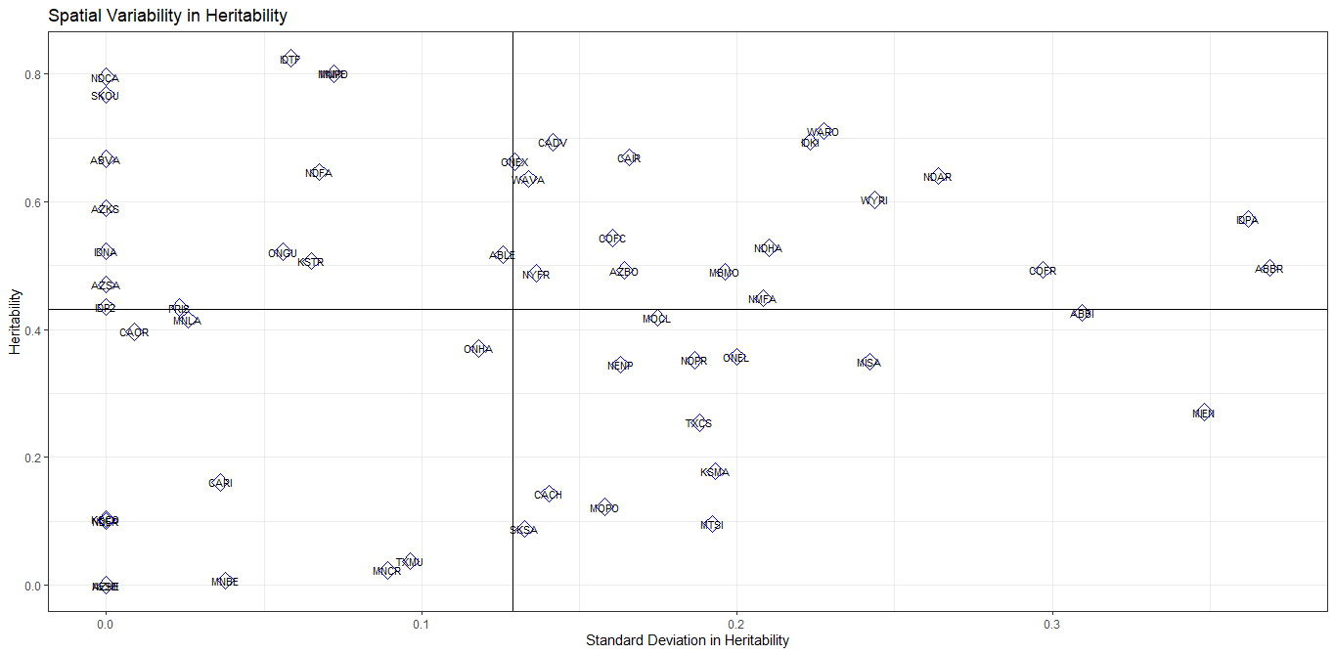

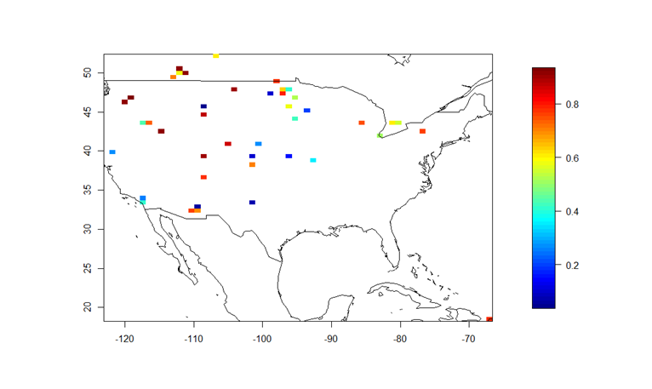
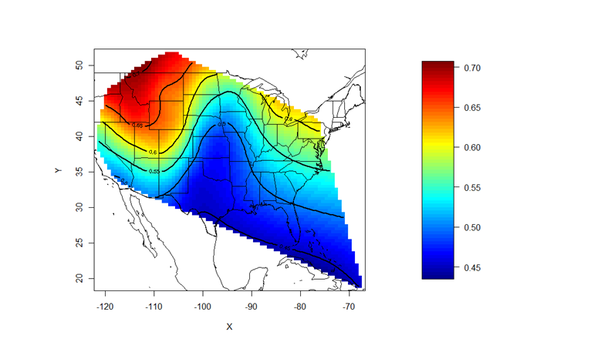
All data together
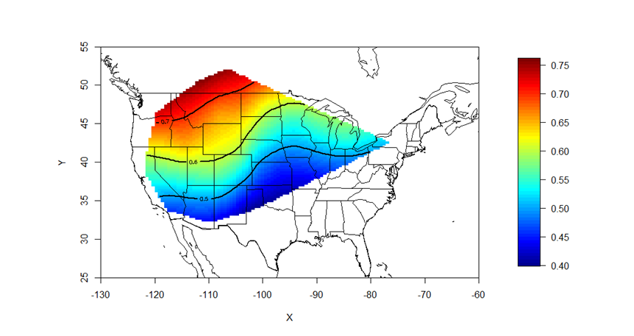
Create heritability map for single year -1981, 1985, 1990, 1995, 2000, 2005, 2010, create new map of mean over time and variance over time

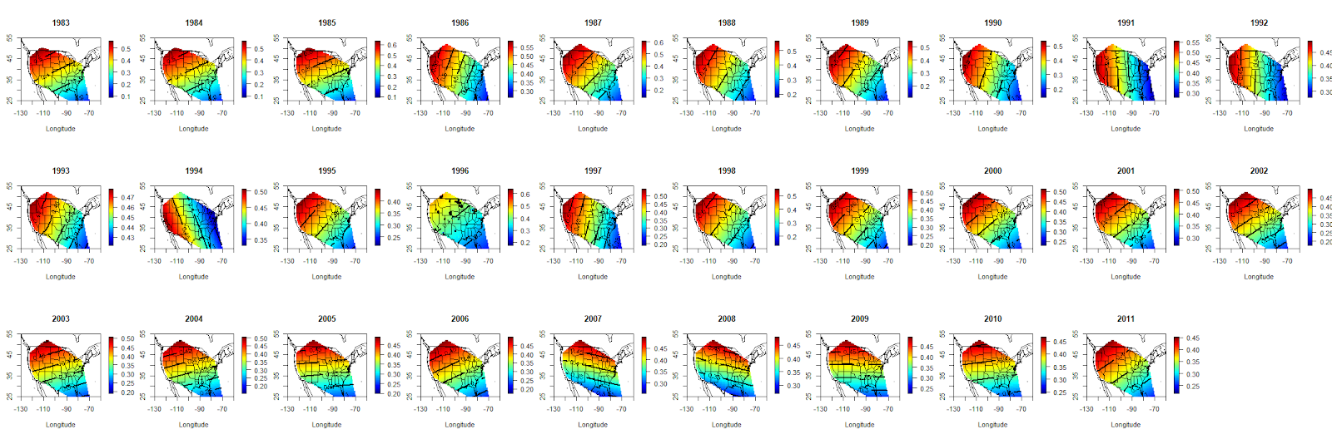
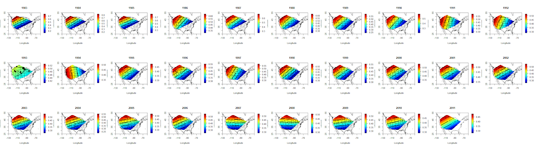
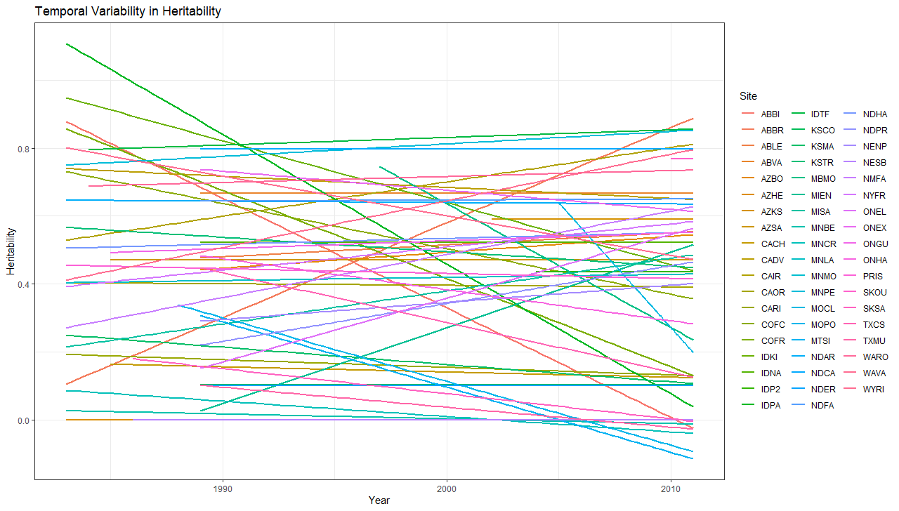
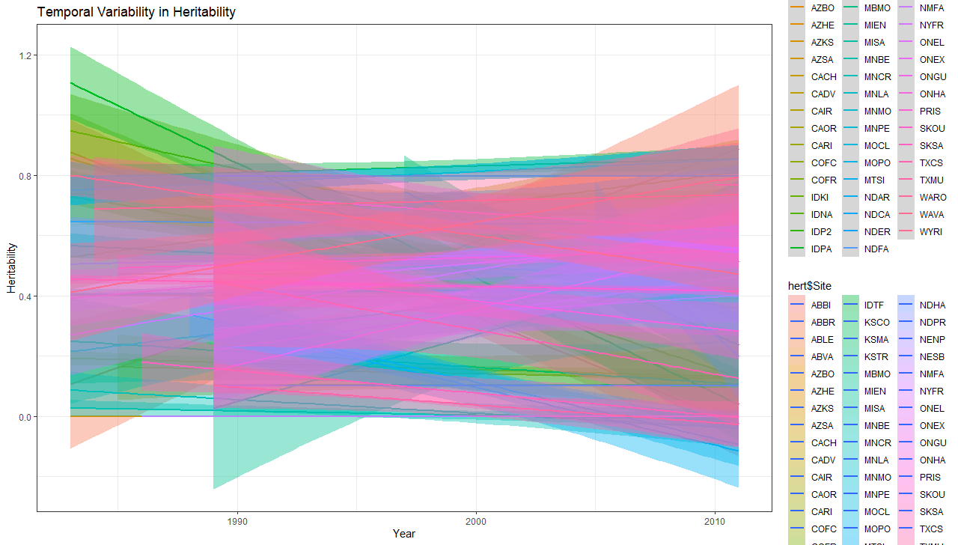
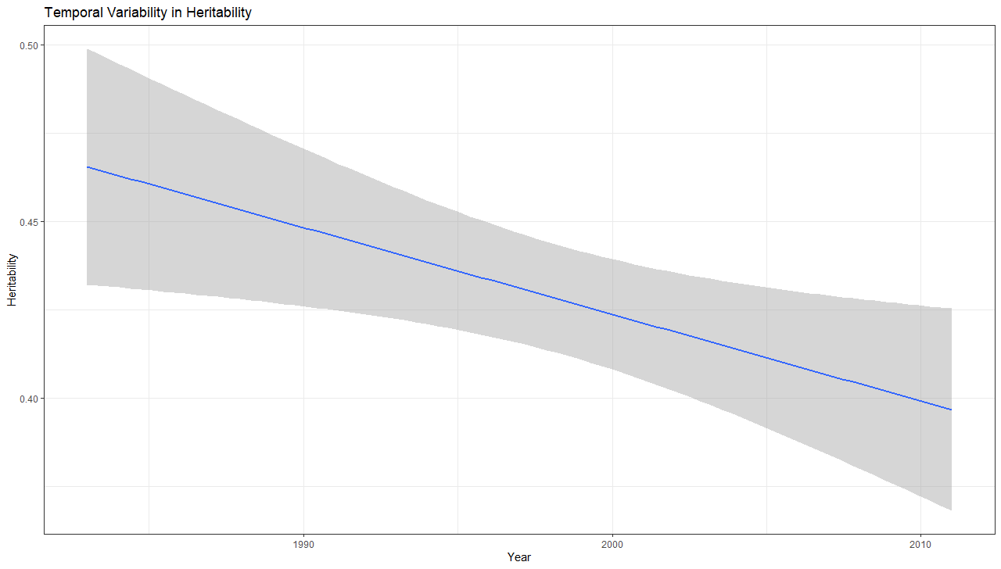
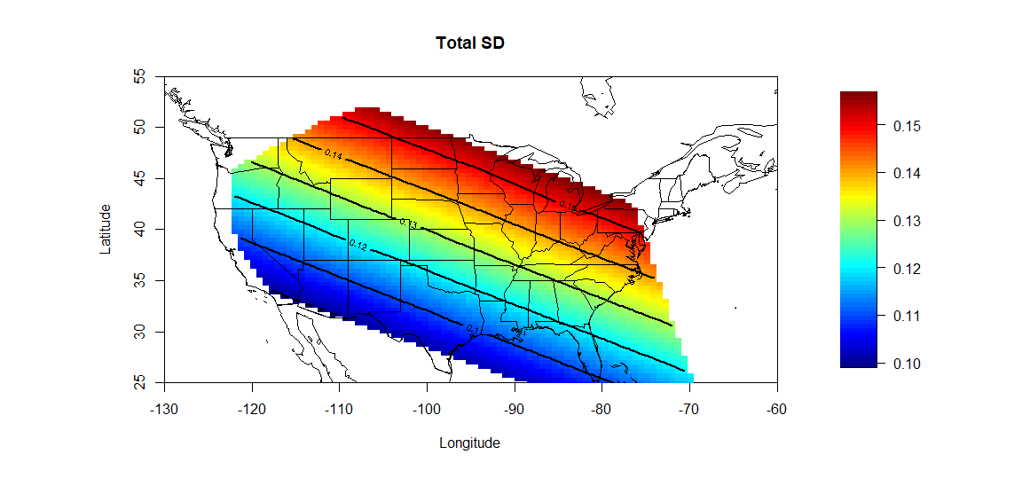
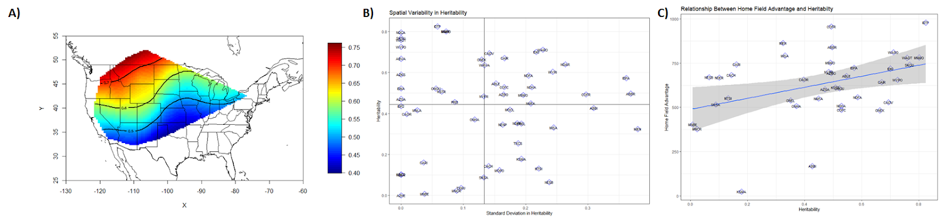

Plot heritability into climate space, project climate space into the future and see where heritability values occur. All projections are in climate space so there is no need to predict future yields.

Due to intensive breeding? Or due to weather variation increasing? Do we also see an increase in the variance of heritability across time (supporting weather)?

Is this decrease in heritability indicative of widespread adaptation?(Alice doesn’t think so.)
Old Figures

