Contents
FIGURES
- Mean yield | race at each location
- Yield and HFA
  - Yield trend by race
  - HFA trend by race, with permutation means (or medians each year?)
- Heritability
  - Heritability by locations (by race?)
  - Heritability across time by race
- HFA and Breeding
  - HFA ~ Heritability
  - Home location ~ Genetic Location.

SUPPLEMENTARY FIGURES
- Heritability ~ Variance
- PCs and scree plots

TABLES
- Interpretation of heritability combined with HFA (increases, no change, decreases across time)
- HFA variance explained

SUPPLEMENTARY TABLES
- ANOVA yields by year (year zero = present for ease of getting effects)
- SUPPL - HFA model AIC
- HFA ~ Time | Variety

Figures

Figure 1
Figure 1: Locations and mean yields at sites within the CDBN variety trials. Only sites used at least three years are shown.

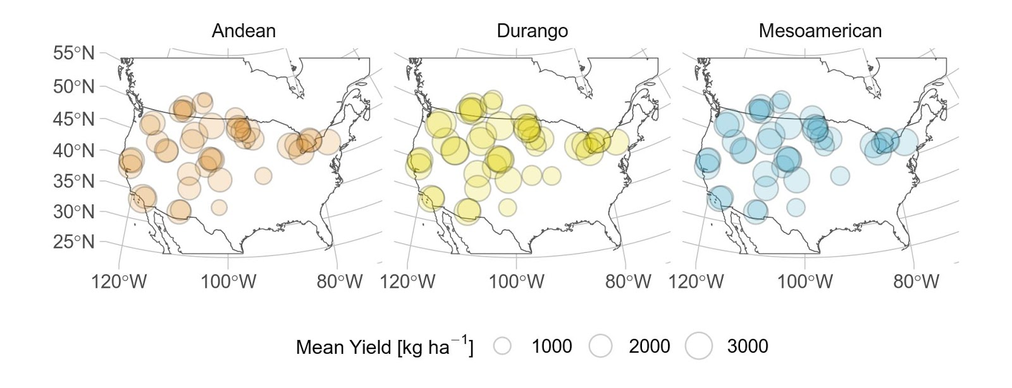

Figure 2
Figure 2: Trends in A) yield and B) home field advantage across the study period by race. In B), the gray bar indicates the 90% confidence interval of the expected home field advantage based on permutation within site-year. Error bars are standard errors. Shading around regression lines indicates 95% confidence intervals. n.s.: not significant at p < 0.05.
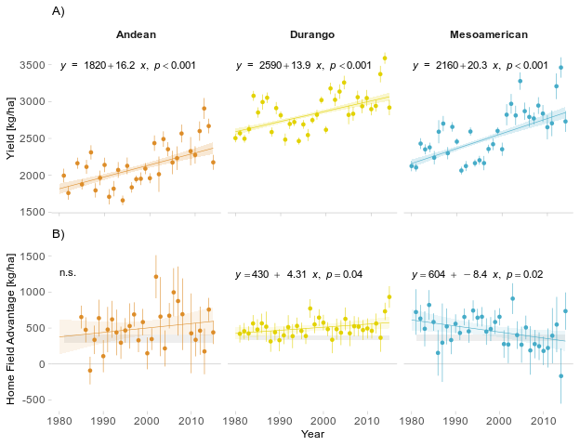

Figure 3
Figure 3: A) Ordinary kriging of yield heritability across 2170 site years. B) Mean and standard deviation of site heritability for 70 field sites, sites with a high heritability and low variance provide better opportunity for selection C) relationship between HFA and heritability.
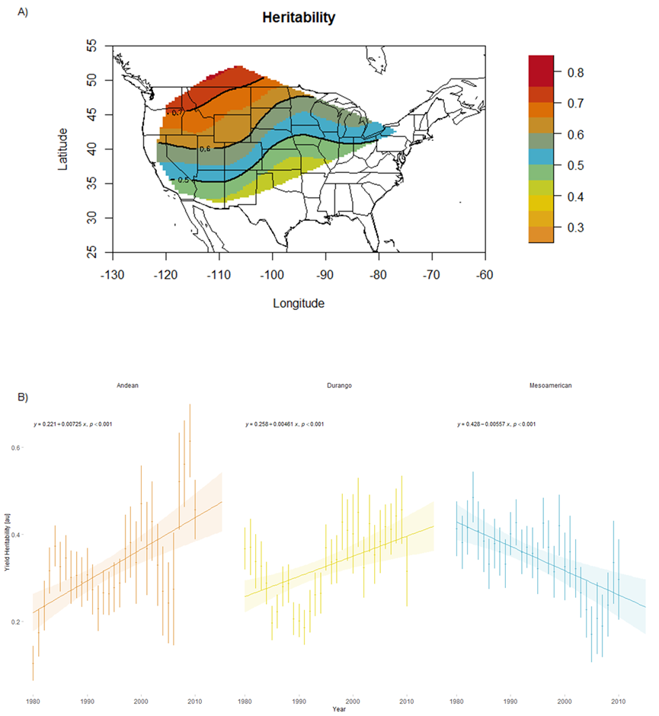
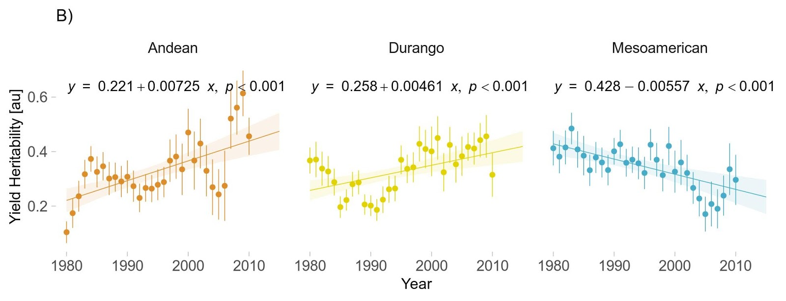

Figure 4
Figure 4: A) Correlation between yield heritability and home field advantage at each site, by race. B) Mantel’s correlation between genetic distance and the distance of home sites for lines within race. Genetic distance is based on the first three principal components of a linkage-corrected kinship matrix (Figure S2). Shading around regression lines indicates 95% confidence intervals. n.s.: not significant at p < 0.05.
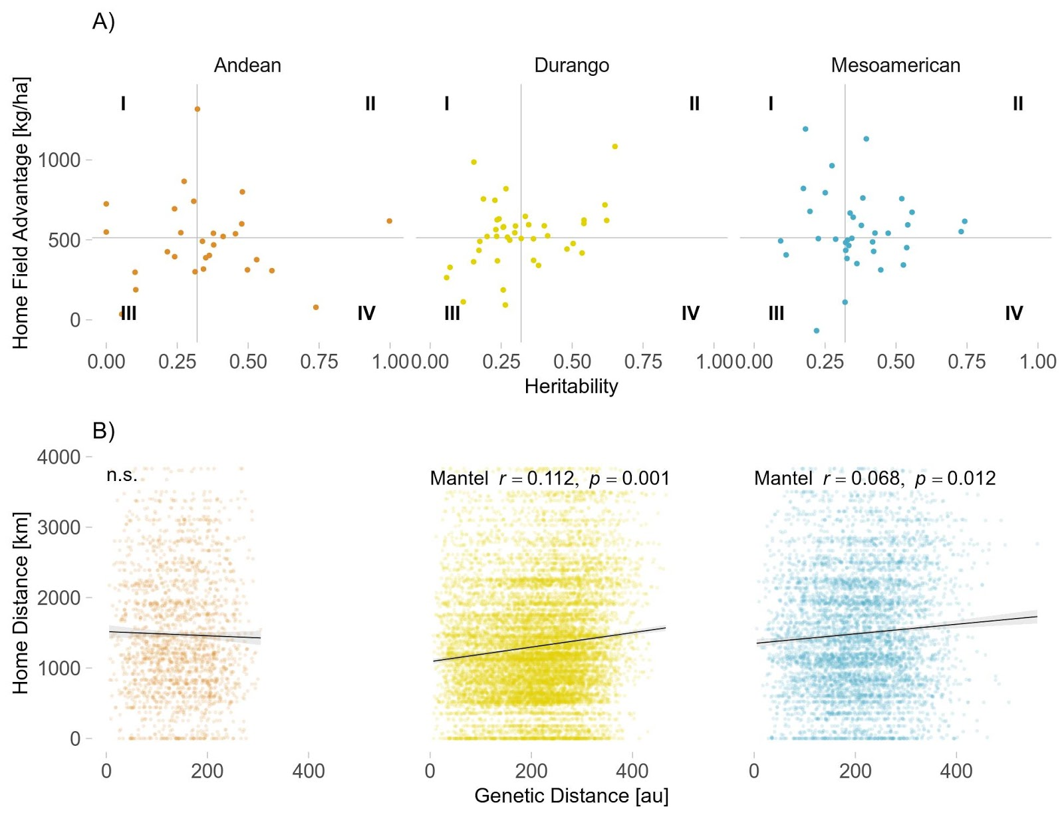

Heritability for specialists would either be lower (everywhere) or more variable (between locations)

Tables

Table 1
 |  | Home Field Advantage
 |  | high | low
Heritability | high | can improve both locally and by selecting on particular varieties | Breed broadly adapted varieties here
Heritability | low | Hard to breed, but benefits for selecting the right varieties (or parents in the breeding program) | Grow broadly adapted varieties, but don’t breed

Table 2
Table 2
Partitioning of CDBN Yield Variances
 | Race
 | Andean | Durango | Mesoamerican
Home Site | 1.1% | 1.3% | 1.3%
Residuals | 15.6% | 14.1% | 15.8%
Genotype | 3.2% | 3.3% | 4.1%
Site | 29.0% | 33.1% | 30.9%
Year | 2.5% | 2.4% | 3.0%
Site-Year | 48.7% | 45.7% | 44.9%
Residual Reduction1 | 6.3% | 8.3% | 7.7%
1 Proportion of residual variance explained by home site

Supplement

Figure S1
Figure S1: a) relationship between standard deviation in heritability at each site, and the number of trials at that site; b) relationship between mean and standard deviation in heritability at each site; c) relationship between mean yield and mean heritability at each site.

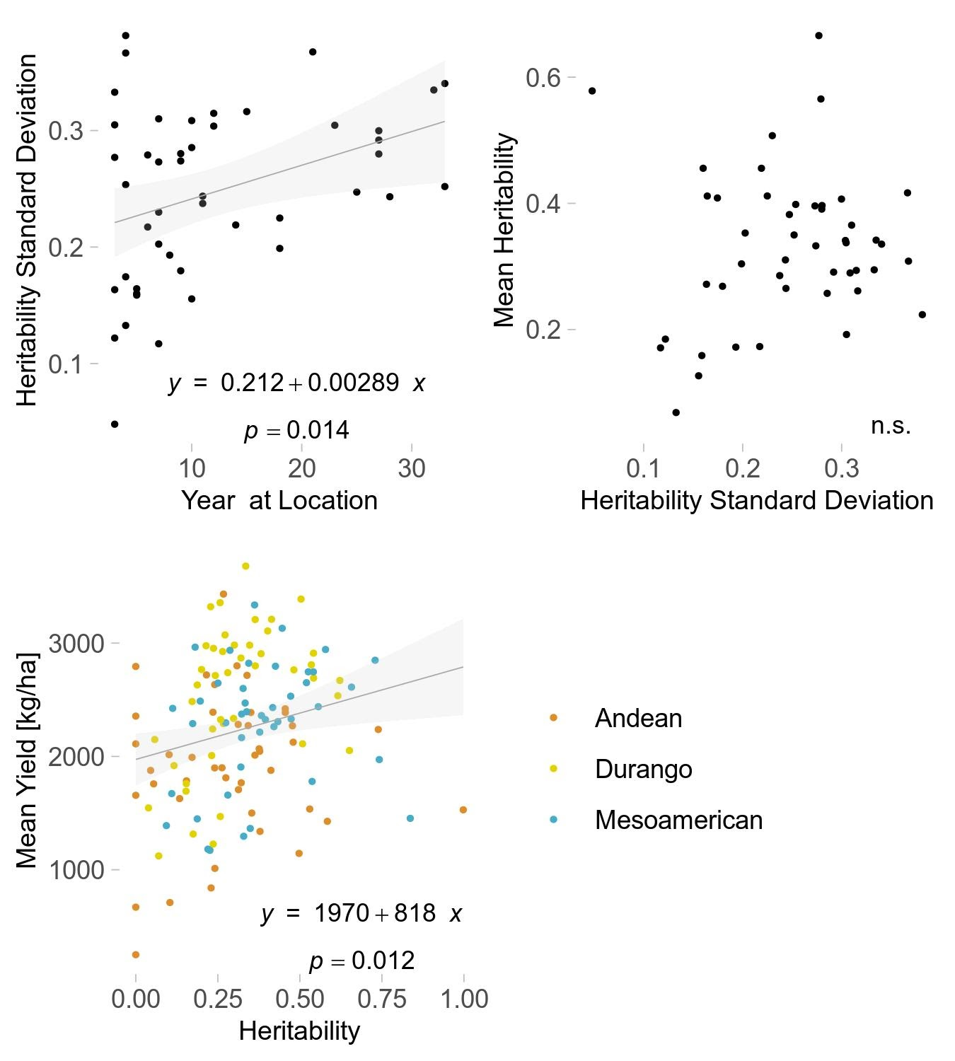

Figure S2
Figure S2: Summary of kinship among varieties within race. A) ordination of varieties along principal component axes 1 and 2. B) Scree plot of variance explained by successive principal axes.

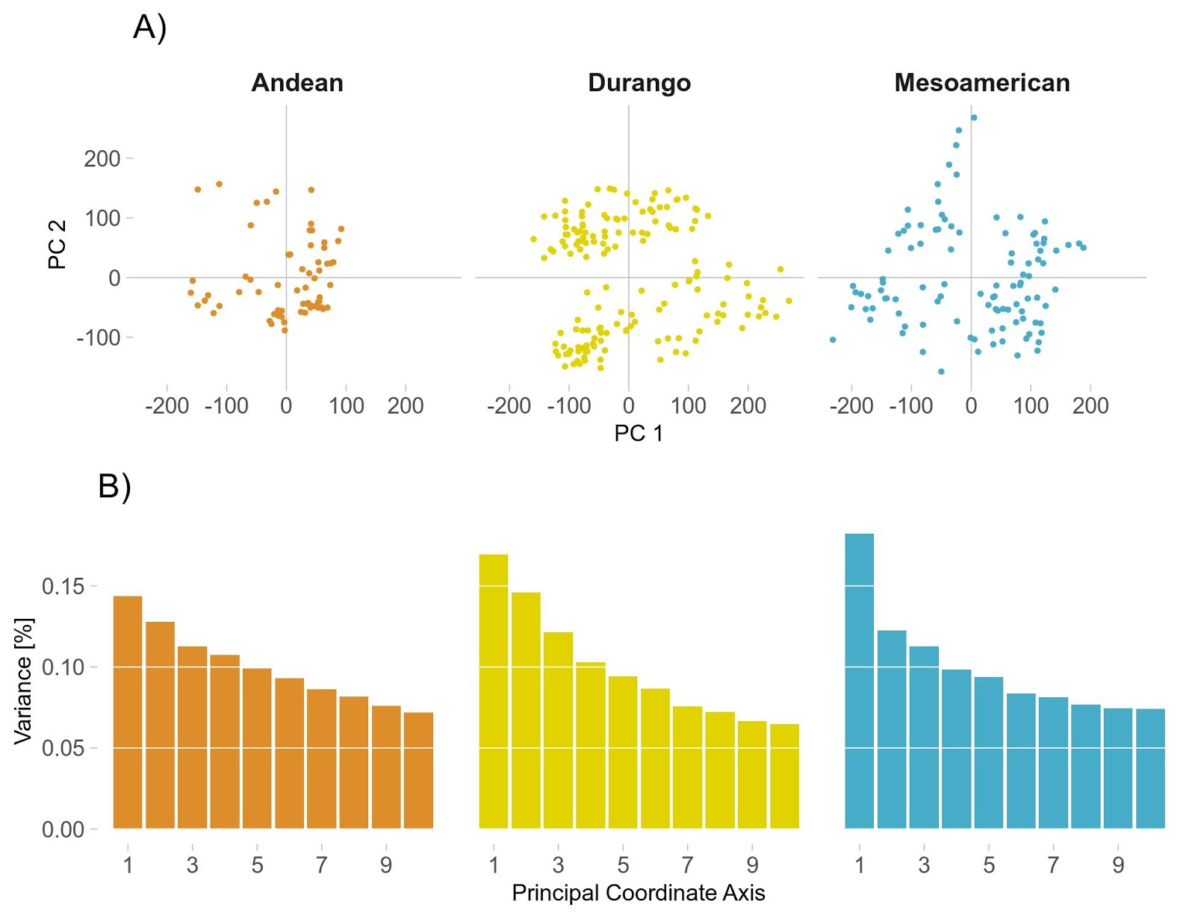

Table S1
Table S1
ANOVA of Yield Across Time
 | Sum Sq | Df | F value | Pr(>F)
Year | 252,500,000 | 1 | 292.70 | 0.000
Race | 1,050,000,000 | 2 | 608.26 | 0.000
Year*Race | 6,895,000 | 2 | 4.00 | 0.018
Residuals | 11,370,000,000 | 13174 | - | -

Table S2

Table S2
AIC1 of Competing Home Field Advantage Models
 | Andean | Durango | Mesoamerican
With Home Field | 3434 | 6772 | 5095
Variety, Site, Year | 3599 | 7323 | 5421
With Home Field, Kinship | 3773 | 7662 | 5703
With Kinship | 3926 | 8143 | 5997
1Akaike Information Criterion

Table S3

Table S3
ANOVA of Home Field Advantage Across Time
 | Sum Sq | Df | F value | Pr(>F)
Year | 4.755 | 1 | 0.00 | 0.992
Race | 36,290 | 2 | 0.43 | 0.654
Year * Race | 410,000 | 2 | 4.82 | 0.010
Residuals | 3,994,000 | 94 | - | -

