**possible title: QTL x environment interactions underlie the ionome divergence in switchgrass**

Li Zhang1*, Alice MacQueen1*, Jason Bonnette1, Felix B. Fritschi2, KBSM site co-PI? People who did the ionome assay? And who else? Thomas E. Juenger1

1 Department of Integrative Biology, University of Texas at Austin, Austin TX 78712; 2Division of Plant Sciences, University of Missouri, Columbia MO 65211;

*corresponding authors. Email: lz5943@utexas.edu or alice.macqueen@utexas.edu

Target Journal: PCE or New Phytologist

**Abstract**

*<<Should be a bullet point abstract if we’re targeting NP>>*

**Introduction**

The ionome is the mineral nutrient and trace element composition of a tissue or an organism (Lahner et al., 2003; Salt et al., 2008). The ionome includes all mineral elements, whether essential or non-essential for life, in whatever chemical form these occur, and represents the inorganic component of cellular and organismal systems. Ionomics, the study of the ionome, involves the precise and simultaneous quantification of both the elemental composition of living organisms, and the changes in this composition in response to physiological stimuli (biotic and abiotic), developmental state, and genetic modifications. Ionomics thus provides a snapshot of the functional status of a biological organism and captures information about the functional status under different conditions. Ionomics requires high throughput elemental profiling and has been used to discover the genes and gene networks controlling the ionome in plants. Numerous studies on ionome from more than 10 organisms have been performed over the last decade as reviewed in Baxter (2015) and Huang & Salt (2016).

Plants take up most elements of the ionome from the soil, which is highly heterogeneous across multiple spatial scales (cite). Studies in many plant species have examined the genetic architecture of the ionome and discovered strong genetic effects underlying divergence in elemental composition, and many quantitative trait loci (QTL) in genetic mapping experiments (Shakoor et al., 2016; Zhang et al., 2014; Lowry et al., 2012; Buescher et al., 2010). Studies in *A. thaliana*, where transgenic manipulation is possible, have identified several causal genes controlling elemental variations (Chao et al., 2014; Morrissey et al., 2009; Rus et al., 2006). Recent work in *A. thaliana* has also shown signals of local adaptation to soil salinity, which could be driven by genetic loci that affect the ionome (Busoms et al., 2015). Regardless of plant species, studying genetic variation in the ionome can provide insights into how plants adapt to the highly variable soils that comprise the natural landscape, and can lead to the discovery of genes involved in elemental accumulation (Baxter & Dilkes, 2012; Baxter et al, 2010; Baxter et al., 2008; Rus et al., 2006). However, the ionome of an individual depends not only on its genetic makeup, but also on the environment it experiences. The ionome of plants may thus reflect both environmental effects and also exhibit local adaptation to that environment (Baxter et al., 2012; Anderson & Mitchell-Olds, 2010). Genetic variation in the makeup of the ionome between environments is a type of genotype by environment interaction (GxE).

The pattern of phenotypic expression of a single genotype across a range of environments is known as a *reaction norm*. Reaction norms make two important points about GxE explicit: first, that the phenotype expressed by a given genotype depends on the environmental context, and second, that the phenotypic effect in a given environment depends on the genotype in question. The reaction norm of a particular genotype and its underlying genetic architecture are heritable properties of the genome and can evolve. Alleles of a gene that affect a reaction norm can do so, and thus exhibit GxE, in multiple ways. For continuous phenotypes like elemental abundances, which have a given mean and standard deviation in two environments for a reference allele, the alternate allele of that gene can affect the magnitude, the sign, or the standard deviation of the phenotypic effect in one environment relative to the second. *Differential sensitivity* (DS) occurs when the magnitude of the phenotypic effect of an allele depends on the environment. Conditional neutrality is the most extreme case of DS, which occurs when an allele affects the magnitude of the phenotype in one environment and not in another. *Antagonistic pleiotropy* (AP) occurs when the sign of the phenotypic effect of an allele depends on the environment. Finally, *variable expressivity* occurs when an allele yields a range of phenotypes that differ in the strength of the phenotypic effect. A large number of replicates for each genotype in each environment are necessary to detect *variable expressivity* in genetic mapping experiments. In contrast, AP and DS are less experimentally demanding to detect, and studies in their local environments found antagonistic pleiotropyde When conditionally neutral or DS alleles have been identified, transcription factors and transporters involving essential elements are often found (Mickelbart et al., 2015).

Identifying molecular mechanisms causing GxE in the plant ionome has been difficult. GxE could not be examined in the many previous studies that identified ionomic QTL in a single environment (Gu et al., 2015; Baxter et al., 2014; Zhang et al., 2014; Norton et al., 2010; Loudet et al., 2007). More recently, studies have begun to identify GxE and QTL by environment interactions for the plant ionome, and for some of the elemental components of the ionome (Asaro et al., 2019; Veley et a; 2017; Asaro et al., 2016; Xu et al., 2015). Thus far, these studies have been limited to biparental crosses or diversity panels with limited number of genotypes, particularly in the short-lived, inbred crop species maize and rice. Studies of GxE in the ionome in outbred, perennial, non-domesticated systems may reflect different patterns of GxE, as these plants must cope with heterogenous environments, including non-optimal abundances of essential and non-essential elements, over their longer lifespans.

Switchgrass (*Panicum virgatum*) is a warm-season, outbred, perennial species with wide environmental adaptation across the eastern half of North America and high biomass productivity across a large geographic range (Casler et al., 2007). Switchgrass has substantial morphological diversity over its native range, including highly divergent southern lowland and northern upland ecotypes. The southern lowland ecotype of switchgrass is typically adapted to wet and riparian areas of southern United States, tends to be more biomass-productive, nutrient-use-efficient, heat-tolerant, and pathogen-resistant than the northern upland ecotype (Lowry et al., 2014; Aspinwall et al., 2013; Uppalapati et al., 2013; Casler, 2012; Porter et al, 1996), while the northern upland ecotype is often adapted to dry areas of mid and northern latitudes, and tends to be more freezing-tolerant (Peixoto & Sage, 2016; Casler et al., 2013; Hultquist et al., 1997).

In this study, we expand the scope of GxE research in ionomics by evaluating the genetic architecture and reaction norms of 18 elements of the ionome in switchgrass. We use an outbred, F2 mapping population derived from a four-parent cross of lowland and upland ecotypes (Milano et al., 2016). We clonally propagated and planted the four parents, the two F1 genotypes, and 425 F2 individuals at ten common gardens, then quantified elemental accumulation at three of these gardens. The 18 elements included macronutrients (Mg, P, K, Ca), analogues of macronutrients (Rb, Sr), micronutrients (B, Mn, Fe, Co, Cu, Zn, Se, Mo), and elements that can be harmful to plant growth (Na, Al, As, Cd). With these data, we evaluated the reaction norms of QTL for elements in the ionome. Our results allow us to address the following questions: 1) What is the genomic basis for variation in elemental content in the switchgrass ionome? 2) What fraction of QTL for distinct elements co-localize, suggesting common genetic architectures underlying their abundances? 3) How frequently do ionomic QTL show GxE? 4) Which QTL colocalize with candidate genes, suggesting avenues for future molecular characterization of the switchgrass ionome?

**Materials and Methods**

**Experimental Design and Phenotyping**

The details of the creation of the mapping population can be found in Milano et al. (2016). In brief, the genetic mapping population was produced from two initial crosses of two pairs of highly divergent southern lowland and northern upland ecotypes: lowland AP13 (A) x upland DAC6 (B) and lowland WBC3 (C) x upland VS16 (D). The F1 hybrids (A x B, C x D) were then intercrossed reciprocally to create the outbred four-way mapping population (F2).

The details of experimental design are described in Lowry et al. (2019). Briefly, the parents, F1 hybrids, and the F2 progeny were propagated clonally in 3.8-L pots at the Brackenridge Field Laboratory, Austin, TX in 2013-2015, and then transported to and planted at each of the 10 field sites in May-July of 2015. Weed cloth was used to suppress weeds, and holes were cut in a honeycomb fashion for planting of the experimental plants. Edge effects were prevented with a row of border plants. Plants were hand-watered as needed through the summer of 2015 to facilitate establishment. Out of the 10 field sites, three (Austin, TX, Columbia, MO, and Hickory Corners, MI) representing distinct soil and climatic conditions were selected for ionomic data collection in 201X. TX site (30.384°N, -97.73°W) has clay soil, MO (38.897°N, -92.22°W) and MI (42.420°N, -85.37°W) sites have loam soil. The average temperatures in 201X for TX, MO, and MI sites were XXX, XXX, XXX, respectively. The annual precipitations in 201X for TX, MO and MI sites were XXX, XXX, XXX, respectively.

Phenotyping XXXXXXXXXXX ICP-MS?

Samples of leaves of plants were collected at each of the three sites, and XXXXXXXXXXX. XXXXXXXXXX

Ionomic data on B, Na, Mg, Al, P, K, Ca, Mn, Fe, Co, Cu, Zn, As, Se, Rb, Sr, Mo, Cd were collected. Outliers and negative values yielded due to machine error were excluded from analysis.

**Genotyping and Map Construction**

Details on the genetic map construction can be accessed on https://datadryad.org/stash/dataset/doi:10.5061/dryad.ghx3ffbjv (Lovell et al., 2020). In brief, Illumina fragment paired end libraries from each of the four grandparents were aligned to the *P.virgatum* reference genome v5 via bwa *mem* (Li & Durbin, 2009) and used for single-nucleotide polymorphism (SNP) calling. Then a kmer-based approach was used to capture multiple variant and distinguish each grandparent when genotyping the progeny. The resulting genotype matrix was polished via sliding windows across the physical V5 switchgrass genome position and markers were re-ordered within linkage groups (Lovell et al., 2020; Lowry et al., 2019).

**Heritability Estimates and Genetic Correlation**

Narrow-sense heritability (*h2*) was estimated as *Va/Vp*, where *Va* is the additive variance attributable to genetic relatedness, and *Vp* is the total phenotypic variance. *h2* was estimated for each ionomic element at each site using the additive kinship matrix, which was obtained based on marker genotypic information. The process was implemented via the Sommer package (Covarrubias-Pazaran, 2016) in R (2018). Details on the implementation of the Sommer, particularly the multivariate mixed model (i.e., mmer) can be found in Lowry et al. (2019). Briefly, in multivariate mixed models of this outbred four-way population, the kinship matrix was modeled as a random effect and used to estimate the variance attributable to that additive kinship matrix for each ionomic element. Genetic correlations between sites for each element were also estimated using the same mixed model.

**Multi-environment QTL Mapping**

Details of the mapping procedures and implementation for our four-way population are described in Malosetti et al., (2013) and Lowry et al., (2019). In brief, a multienvironment mixed model implemented in Genstat v.19 (2019) was fit for each ionomic element to identify QTL and potential QTL x E interactions:

$$trait=µ+E+ \sum{QTL}+ \sum{\left(QTL x E\right)}+e$$

where *μ* represents the population mean; *E* represents the environment effect; $\sum{QTL}=\sum{(a^{a1}+a^{a2}+a^{d})}$, represents the total effect from the additive effect from the first grandparent (i.e., the difference between *A* (AP13) and *B* (DAC) alleles, $a^{a1})$, the second grandparent (i.e., the difference between *C* (WBC) and *D* (VS16) alleles, $a^{a2})$, and the dominance effect (i.e., the intralocus interaction, $a^{d})$; $\sum{\left(QTL x E\right) }$ represents the QTL × environment interactions; and *e* represents the error term. Genome-wide QTL and QTL x E significance was assessed at *α* = 0.05 with a Bonferroni correction (Li & Ji, 2005).

**Candidate Gene Search and GO Enrichment Analyses**

We consider the genes located in the 1.5 LOD-score drop confidence intervals of the detected QTL as candidate genes. We then determined if homologs from rice (v7) and *A. thaliana* (TAIR 10) were overrepresented in our QTL regions. The annotation file for switchgrass was accessed on JGI (Joint Genome Institute) Phytozome 13 website: https://njp-spin.jgi.doe.gov/. The Gene Ontology (GO) enrichment analysis was tested using Fisher’s exact test for each GO term via R package ‘topGO’ (Alexa and Rahnenuhrer, 2019). GOs with adjusted *p* < 0.05 were considered significant.

**Results**

**Elemental content variation and correlations across the common gardens**

We phenotyped 380 plants at three common gardens (Austin, Texas, hereafter TX; Columbia, Missouri, hereafter MO; and Hickory Corners, Michigan, hereafter MI) for 18 elemental compositions. Average leaf element content varied over six orders of magnitude, with Co, Se, Mo, and Cd having the lowest accumulation (~1x10-2 µg g-1 dry weight) and K having the highest content (~1x104 µg g-1 dry weight). Five (Na, Mg, P, Ca, Sr) of 18 elemental accumulations different significantly between the four parents (AP13, DAC6, WBC, and VS16) at every site, with the largest difference between the two lowland genotypes, AP13 and WBC (Table 1). Across the F2 genotypes, the content of each element followed a continuous, unimodal, approximately normal distribution of abundance within each site (Figure 1A), and the distributions of all elements differed significantly between sites (Table 2). Within each site, the majority of the element abundances were not strongly correlated (r < 0.5). Fewer than 2% element pairs had positive correlations greater than 0.5 (Figure 1B). Among these, Ca was positively correlated with Sr at each site (0.7-0.8), and Al was positively correlated with Fe at MI (0.7) and TX (0.6).

The heritability for each element varied significantly between the three gardens (Figure 2A). The majority of the elements (Na, Mg, Al, P, K, Ca, Mn, Fe, Cu, Zn, Se, Rb, Sr, Mo, and Cd) had moderate heritabilities (0.2 or greater) for at least one site, while B, Co, and As did not. There were moderate heritabilities for 8 elements in the TX garden (none unique to TX), 12 elements at the MO garden, (Na and Al content were moderately heritable only at MO), and 15 elements at the MI garden (K, Zn, Se and Cd content were moderately heritable only at MI). The heritability of Mg, Mn, Fe, Rb and Sr content did not differ significantly between the three gardens. The low heritabilities of some elements at certain sites (B, K, Co, As, and Se) were due to both the large error variance (*Ve*) and the near zero additive genetic variance (*Va*) for these elemental contents (Supplemental Figure S1). These results indicated that the accumulation of these elements at these sites were more affected by environmental factors, most likely the soil characteristics, and not under explicit genetic control. The other elements with heritabilities greater than 0.2 had significant *Va* and *Ve*, indicating that these elements at these sites were affected likely by soil characteristics but were also under genetic control. In addition, we observed strong positive genetic correlations less than 1 for the majority of the elements among sites (Figure 2B), indicating that there was GxE and there were no trade-offs of loci controlling these elements on average. Only a negative correlation was observed for B between TX and MO (-0.46), indicating a possible trade-off of loci controlling B at these two sites. The genetic correlations for some elements (i.e., As and Se) were not converged due to close to zero of genetic variance.

**Genomic basis of variation in elemental abundances**

We detected 77 significant QTL with LOD threshold above 3.5 for 14 out of the 18 total elemental compositions (Figure 3, and Supplemental Table S1). There was no significant QTL detected for B, As, Co and Se, probably related to the low heritabilities for these four elements (Figure 1A). The significant QTL were distributed on 16 of the 18 chromosomes, and 14 chromosomes had QTL with QTL by environment interactions (QTL x E). The number of QTL was between two and 14 QTL per element. P had 14 QTL regions, while Na, Fe, Mo, and Cd had two. There were significant QTL x E effects for 38 (49%) of the QTL (Supplemental Table S1).

**Colocalization of QTL for distinct elemental abundances**

Overall, there were 21 sets of QTL that had overlapping intervals (1.5-LOD support interval around the significant QTL), and 20 QTL that did not overlap another ionomic QTL (Figure 3). P had 9 out of 14 overlapping intervals with other ionomic QTL, Mg had 3 out of 9, Sr had 7 out of 9, Rb had 5 out of 8, K had 5 out of 7, Cu had 4 out of 5, and Na had 1 out of 2. Ca (5 QTL), Mn (5 QTL), Al (4 QTL), Zn (3 QTL), Fe (2 QTL), Mo (2 QTL), and Cd (2 QTL) had all their respective QTL overlapping with other ionomic QTL. The partial co-localization of QTL between Ca and Sr, and between Al and Fe, may be responsible for the phenotypic correlation in these traits across the outbred population (Figure 1B). There were several sets of overlapping QTL forming clusters. For example, one cluster was located at 20-33cM on Chr02N with Ca, Zn and Sr QTL, and another larger cluster was located at 22-46cM on Chr07K with Al, Ca, Mn, Fe, Zn, and Sr QTL.

**Reaction norms for ionomic QTL**

The design of the crosses to generate the four-way population allowed us to quantify the differences in effects of AP13 vs. DAC (A x B) and WBC vs. VS16 (C x D) at the same time. We observed large differences in additive effects across the three field sites for the elements (Figure 4). Among these 77 total QTL, 39 had consistent effects across the three sites (i.e., no QTL x E) for both contrasts (A x B and C x D), and most of the effects (75%) had the same direction in both contrasts. For the QTL with QTL x E, 29 had conditionally neutral effects (i.e., magnitude change) across sites for at least one contrast (A x B or/and C x D). For example, the effect of QTL 5K@51.99 for Na was conditionally neutral for both contrasts, and with the same effect direction, while the effect of QTL 2N@10.06 for Mn was neutral only for A x B contrast. Thirty QTL had antagonistic pleiotropic effects or trade-offs (i.e., sign change of allelic effects across environments) between sites for at least one contrast (A x B or/and C x D), with majority of the antagonistic effects presenting in one contrast. For example, the effects of QTL 2N@72.03, and 9N@24.08 for Rb were antagonistic for A x B contrast. Further, the QTL with QTL x E per element did not have apparent patterns across environments. For example, the QTL 2N@78.05 and 3K@26.18 for P had the largest effects in TX, while the other two QTL 3N@56.03 and 4K@6.08 for P had the largest effect in MO.

**QTL and candidate gene colocalization**

We found several important candidate genes underlying the natural variation in ion accumulation in switchgrass. For example, *Pavir.9NG231800*, a homology of *MOT1*, is a potential candidate gene in Mo accumulation, which is located within the 1.5-LOD interval of the largest Mo QTL (Chr09N@43.81) on Chr09N. *MOT1*, which encodes molybdate transporter, is known to be responsible for the natural variation in Mo accumulation in Arabidopsis and rice (Baxter et al., 2008; Huang et al., 2019), and may play an important role in adaptation, in particular to acid soil (Poormohammad Kiani et al., 2012). *Pavir.7kg416470*, a homolog of *HKT1*, is another potential candidate gene found in the interval for the largest QTL cluster on Chr07K. *HKT1*, encoding Na transporter, is responsible for the variation of Na concentration in Arabidopsis (Rus et al., 2006; Baxter et al., 2010), rice (Ren et al., 2015) and wheat (Munns et al., 2012). However, interestingly, this candidate gene was found in the QTL interval for Al, Ca, Fe, Mn, Sr, and Zn, not for Na in our mapping population. It may be not that surprising though as some of these ions compete with Na. Candidate genes for heavy metal-associated ATPase, homolog of HMA in Arabidopsis and rice, were also found in Cu (Chr01K@14.42 and Chr07K@26.27), Cd (Chr02N@85.72), and Zn (Chr02N@71.96) QTL intervals. These genes are responsible for copper-transporting, Cadmium/zinc-transporting, respectively. Another potential candidate gene, *Pavir.9KG014451*, is associated with the homolog of *MYB36* gene in Arabidopsis. MYB domain transcription factor regulates the expression of the genes involved in the formation of Casparian strips, the absence of which results in the changes of concentration of Na, Mg, Zn, Ca, Mn, and Fe in leaves in Arabidopsis (Kamiya et al., 2015). We found this candidate gene on the overlapping QTL for Ca (Chr09K@20.05), Mg (Chr09K@18.15), and Mn (Chr09K@20.05). These potential candidate genes provide targets for the follow up fine-mapping and molecular studies in switchgrass.

**GO enrichment suggests molecular mechanisms for ionomic natural variation**

We identified 251 unique significant GO terms across the ionomic traits (*p* < 0.05). The majority of the terms was associated with GO ontologies of DNA-binding transcription factor activity, ADP binding, oxidoreductase activity and other functions. For example, the QTL regions of macronutrient Mg were significantly enriched for GO ontologies of carbohydrate binding, protein transport, DNA binding, ADP binding, and signal peptide processing among other 39 ontologies. Mg is known to be involved in protein synthesis (approximately 75% of leaf Mg) and be associated with chlorophyll pigments (15-20% of total Mg), mainly functioning as a cofactor of a series of enzymes involved in photosynthetic carbon fixation and metabolism (White and Broadley, 2009; Cakmak and Kirkby, 2008). K QTL regions were significantly enriched for GO ontologies of oxidoreductase activity, carbohydrate binding, and in particular, antioxidant activity. K, as a constituent of the plant structure, has a regulatory function in several biochemical processes related to protein synthesis, carbohydrate metabolism, and enzyme activation. K was found to enhance antioxidant defense in plants and therefore protects them from oxidative stress under various environmental adversities (Hasanuzzaman et al., 2018).

Among the micronutrients, Mn QTL regions were significantly enriched for GO ontologies of multicellular organism development, ubiquitin-dependent protein catabolic process, the mitochondrion, photosystem I, the photosystem I reaction center, and electron transfer activity. Mn functions as a major contributor to various biological systems including photosynthesis, respiration, and nitrogen assimilation in plants among other functions (Millaleo et al., 2010). Cu QTL regions were significantly enriched for GO ontologies of cell wall biogenesis, oxidoreductase activity, mitochondrion, ADP binding (*p* = 4.9x10-6), and DNA-binding transcription factor activity among 27 ontologies. Cu, acting as essential cofactor of numerous proteins, is an essential player in electron transport and controls chloroplastic and mitochondrial Cu transport and homeostasis. Cu is also involved in the control of cellular redox state (a major Cu-binding protein is the Cu/Zn superoxide dismutase) and the remodeling of the cell wall (Cohu and Pilon, 2010). On the other hand, among the elements that can be harmful to plant growth, Cd QTL regions were significantly enriched for GO ontologies of metal ion binding, peroxidase activity, and cell growth among others. Cd, as one of the most toxic and non-essential heavy metals for plants, can displace essential metals (such as Zn, Fe and Ca) from a wealth of metalloproteins and disturb normal physiological processes. It can also cause severe developmental aberrance such as chloroplast structure change, reactive oxygen species (ROS) production and cell death (Wan and Zhang, 2012). The GO enrichment analyses can help elucidate the underlaying cellular mechanisms associated with ion functions in switchgrass in the future studies.

**Discussion**

Table 1. Grandparental means and standard error for elemental accumulation (µg g-1) in each field site TX, MO, and MI, and comparison by Welch one-way test.

|  |  |  |  |  |  |  |
| --- | --- | --- | --- | --- | --- | --- |
| Element | Site | AP13 | DAC | VS16 | WBC | P-Value |
|  | MI | 3.417±0.247 | 4.12±1.188 | 3.294±0.431 | 0.431±3.32 | 0.9330 |
| B | MO | 3.402±0.704 | 3.196±0.673 | 3.319±2.247 | 2.247±2.476 | 0.6658 |
|  | TX | 4.925±0.421 | 7.211±0.432 | 6.852±0.537 | 0.537±4.402 | 0.0005* |
|  | MI | 50.5±3.48 | 8.67±1.64 | 12.71±4.98 | 4.98±47.89 | <0.0001* |
| Na | MO | 160.83±7.53 | 11.87±1.43 | 10.08±1.31 | 1.31±59.69 | <0.0001* |
|  | TX | 122.87±12.37 | 35.46±5.04 | 65.56±14.28 | 14.28±124.89 | <0.0001* |
|  | MI | 1367±50 | 1011±73 | 1059±50 | 50±1686 | <0.0001* |
| Mg | MO | 857±25 | 767±47 | 784±50 | 50±1497 | 0.0175* |
|  | TX | 949±55 | 1333±101 | 1154±42 | 42±1027 | 0.0182* |
|  | MI | 48.79±2.46 | 69.19±14.38 | 59.73±5.04 | 5.04±49.2 | 0.1845 |
| Al | MO | 102.17±10.24 | 95.78±30.36 | 77.56±10.51 | 10.51±84.23 | 0.5187 |
|  | TX | 68.36±5.2 | 100.48±16.74 | 77.55±7.45 | 7.45±56.92 | 0.0656 |
|  | MI | 296±10 | 391±21 | 386±18 | 18±441 | <0.0001* |
| P | MO | 615±41 | 378±43 | 346±5 | 5±851 | <0.0001* |
|  | TX | 316±12 | 758±53 | 650±41 | 41±300 | <0.0001* |
|  | MI | 72581±3741 | 46184±1711 | 31615±3024 | 3024±66643 | <0.0001* |
| K | MO | 54865±5417 | 44609±11478 | 24143±8032 | 8032±83190 | 0.0419* |
|  | TX | 54414±5221 | 59728±13856 | 39167±5242 | 5242±67527 | 0.0525 |
|  | MI | 1614±48 | 2046±102 | 1163±48 | 48±1454 | <0.0001* |
| Ca | MO | 1445±47 | 1395±80 | 1101±24 | 24±1736 | 0.0002* |
|  | TX | 2947±149 | 5293±362 | 3953±156 | 156±2168 | <0.0001* |
|  | MI | 47.3±2.14 | 52.22±3.88 | 53.39±3.76 | 3.76±33.61 | 0.0009* |
| Mn | MO | 67.04±3.74 | 70.9±7.88 | 101.45±24.06 | 24.06±76.52 | 0.5783 |
|  | TX | 25.56±1.49 | 39.85±3.61 | 38.86±3.17 | 3.17±14.21 | <0.0001* |
|  | MI | 32.33±1.21 | 41.7±3.58 | 34.27±1.84 | 1.84±30.2 | 0.0458* |
| Fe | MO | 39.64±2.4 | 83.06±52.69 | 32.4±1.78 | 1.78±45.76 | 0.1069 |
|  | TX | 51.5±2.75 | 78.42±12.89 | 50.78±7 | 7±44.09 | 0.1662 |
|  | MI | 0.029±0.002 | 0.066±0.016 | 0.046±0.007 | 0.007±0.026 | 0.0356* |
| Co | MO | 0.219±0.057 | 0.321±0.186 | 0.145±0.025 | 0.025±0.168 | 0.6059 |
|  | TX | 0.082±0.008 | 0.149±0.047 | 0.189±0.122 | 0.122±0.11 | 0.4476 |
|  | MI | 3.223±0.144 | 5.333±0.261 | 4.919±0.125 | 0.125±3.332 | <0.0001* |
| Cu | MO | 8.715±0.538 | 12.848±4.019 | 8.03±0.291 | 0.291±9.919 | 0.1985 |
|  | TX | 4.205±0.229 | 6.152±0.727 | 4.141±0.403 | 0.403±5.094 | 0.0729 |
|  | MI | 7.51±0.934 | 7.54±0.406 | 11.39±2.796 | 2.796±8.14 | 0.6080 |
| Zn | MO | 22.43±3.802 | 11.36±0.912 | 11.58±0.898 | 0.898±28.5 | 0.0754 |
|  | TX | 49.34±13.966 | 110.91±86.947 | 15.75±2.458 | 2.458±18.85 | 0.1489 |
|  | MI | 0.01±0.001 | 0.019±0.004 | 0.012±0.001 | 0.001±0.011 | 0.1384 |
| As | MO | 0.016±0.003 | 0.022±0.017 | NA | NA | 0.1384 |
|  | TX | 0.011±0.001 | 0.017±0.005 | 0.012±0.001 | 0.001±0.01 | 0.1384 |
|  | MI | 0.01±0.004 | 0.012±0.004 | 0.007±0.002 | 0.002±0.011 | 0.1384 |
| Se | MO | 0.042±0.003 | 0.05±0.017 | NA | NA | 0.1384 |
|  | TX | 0.044±0.004 | 0.048±0.01 | 0.038±0.006 | 0.006±0.043 | 0.1384 |
|  | MI | 1.509±0.084 | 0.966±0.112 | 0.728±0.07 | 0.07±3.026 | <0.0001* |
| Rb | MO | 2.923±0.162 | 1.245±0.129 | 0.94±0.036 | 0.036±3.719 | <0.0001* |
|  | TX | 1.565±0.123 | 1.5±0.305 | 1.451±0.21 | 0.21±2.079 | 0.1951 |
|  | MI | 3.831±0.14 | 5.834±0.977 | 3.258±0.201 | 0.201±3.709 | 0.0418* |
| Sr | MO | 9.093±0.575 | 8.81±0.768 | 6.27±0.221 | 0.221±9.684 | 0.0011* |
|  | TX | 6.362±0.263 | 8.866±0.287 | 9.502±0.482 | 0.482±5.601 | <0.0001* |
|  | MI | 0.046±0.002 | 0.039±0.003 | 0.051±0.003 | 0.003±0.041 | 0.0603 |
| Mo | MO | 0.087±0.004 | 0.056±0.005 | 0.053±0.015 | 0.015±0.122 | 0.0143* |
|  | TX | 0.092±0.011 | 0.044±0.005 | 0.053±0.007 | 0.007±0.117 | 0.0004* |
|  | MI | 0.016±0.001 | 0.022±0.002 | 0.012±0.001 | 0.001±0.013 | 0.0027* |
| Cd | MO | 0.03±0.011 | 0.028±0.01 | 0.015±0.006 | 0.006±0.017 | 0.6142 |
|  | TX | 0.002±0 | 0.003±0 | 0.002±0 | 0±0.002 | 0.0216* |

Table 2. The outbred mapping population (F2) means and standard error for elemental accumulation (µg g-1) in each field site TX, MO, and MI, and comparison by Welch one-way test.

|  |  |  |  |  |
| --- | --- | --- | --- | --- |
| Element | MI | MO | TX | P-Value |
| B | 3.233±0.06 | 2.645±0.046 | 5.565±0.059 | <0.0001* |
| Na | 9.72±0.17 | 25.56±0.53 | 70.46±1.47 | <0.0001* |
| Mg | 1309±11 | 1144±8 | 1530±14 | <0.0001* |
| Al | 41.06±0.5 | 76.17±0.71 | 58.96±0.73 | <0.0001* |
| P | 294±3 | 485±7 | 421±4 | <0.0001* |
| K | 55912±958 | 60032±1010 | 60162±882 | 0.0016* |
| Ca | 1408±15 | 1420±12 | 3768±35 | <0.0001* |
| Mn | 48.27±0.58 | 80.63±0.97 | 27.46±0.31 | <0.0001* |
| Fe | 27.69±0.25 | 32.88±0.41 | 43.48±0.4 | <0.0001* |
| Co | 0.028±0 | 0.14±0.004 | 0.065±0.001 | <0.0001* |
| Cu | 3.801±0.036 | 8.325±0.117 | 4.926±0.058 | <0.0001* |
| Zn | 6.509±0.096 | 10.995±0.147 | 18.819±0.349 | <0.0001* |
| As | 0.01±0 | 0.013±0 | 0.01±0 | <0.0001* |
| Se | 0.009±0.001 | 0.039±0.001 | 0.047±0.001 | <0.0001* |
| Rb | 1.087±0.019 | 2.436±0.026 | 1.788±0.027 | <0.0001* |
| Sr | 3.846±0.04 | 8.534±0.078 | 8.459±0.073 | <0.0001* |
| Mo | 0.032±0 | 0.059±0.001 | 0.053±0.001 | <0.0001* |
| Cd | 0.03±0.001 | 0.024±0.001 | 0.003±0 | <0.0001* |

List of figures

Figure 1. A) Phenotypic variations (histograms) of ionomic traits for the mapping population (F2) at the three field sites (TX, MO, and MI). B) Phenotypic correlation among ionomic traits at each site

Figure 2. A) Heritability of each ionomic trait at each of the three field sites (TX, MO, and MI). B) Genetic correlations between the three field sites for each ionomic trait.

Figure 3. QTL with 1.5-LOD supportive intervals for each ionomic trait using the multi-environment QTL model from Genstat.

Figure 4. QTL effects across the three field sites (TX, MO, and MI) for each ionomic trait. A x B represents the AP13 x DAC cross, C x D represents the WBC x VS16 cross.

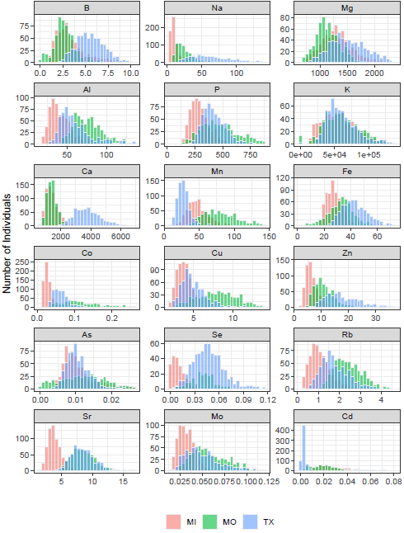

Figure 1A

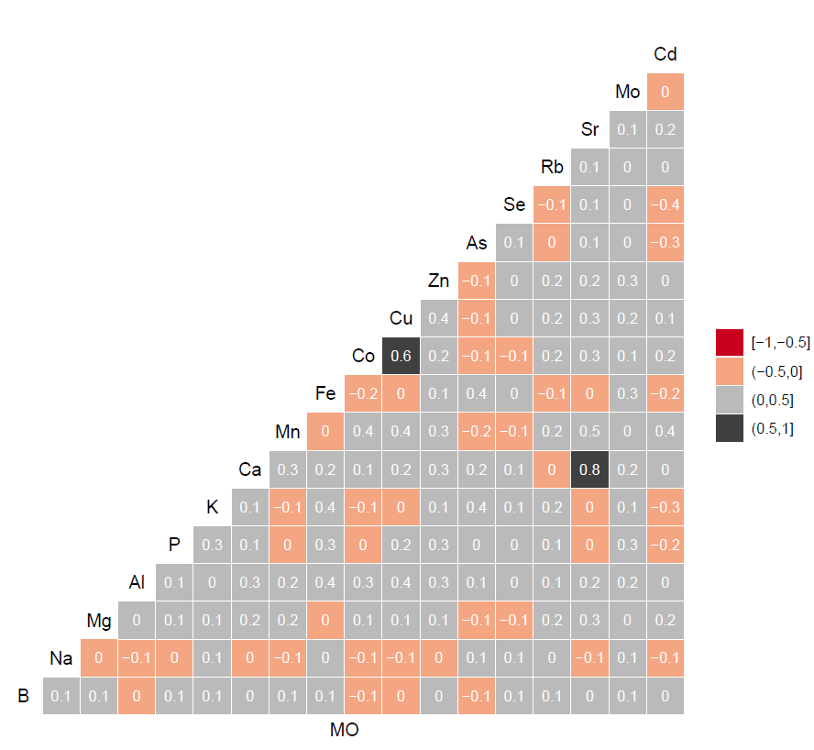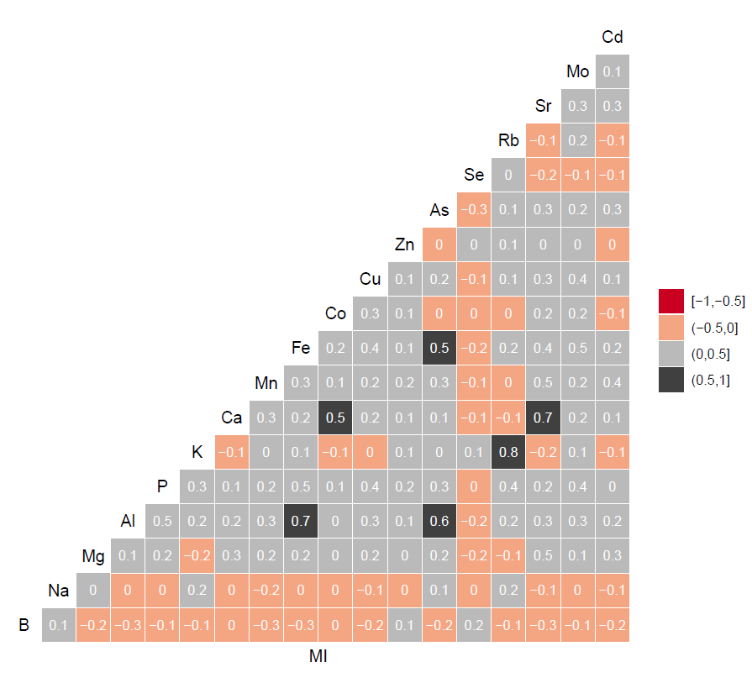

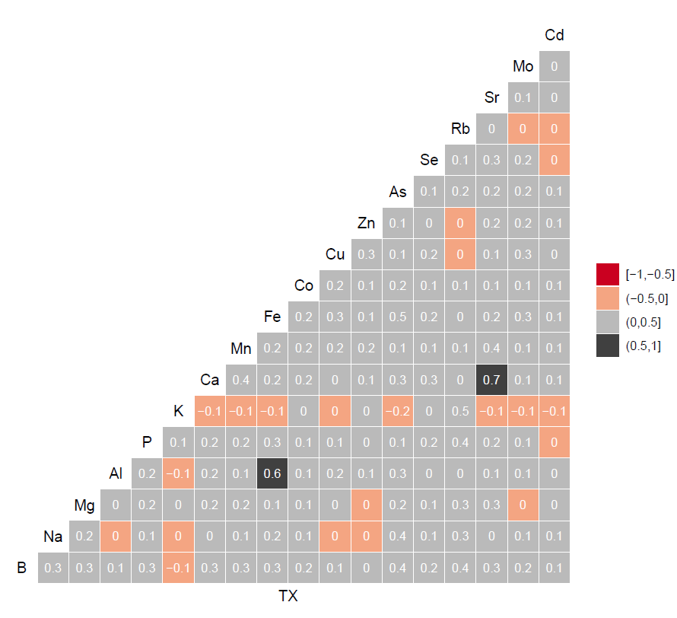

Figure 1B