**QTL x environment interactions underlie ionome divergence in switchgrass**

Li Zhang1*, Alice MacQueen1*, Jason Bonnette1, Felix B. Fritschi2, David B. Lowry3, Thomas E. Juenger1

1 Department of Integrative Biology, University of Texas at Austin, Austin TX 78712; 2Division of Plant Sciences, University of Missouri, Columbia MO 65211; 3Department of Plant Biology and DOE Great Lakes Bioenergy Research Center, Michigan State University, East Lansing, MI 48824

*corresponding authors. Email: lz5943@utexas.edu or alice.macqueen@utexas.edu

Target Journal: New Phytologist or PCE

### Suggested reviewers: Michael Udvardi (or his postdocs), Gautum Sarath, Geoff Morris, Brian Dilkes, Jian Feng Ma or Marinus Pilon as possible editors.

Total word count:

Word count for Introduction:

Word count for Materials and Methods:

Word count of Results:

Word count of Discussion:

Number of Figures: 4

Number of Tables: 2

Number of Supporting Documents: 1

**Summary**

* The ionome is the elemental composition of a tissue or an organism. Natural variation in the regulation of the ionome in plants is critical to metabolism and development across different environments. This study evaluates the genetic variation of the ionome in an outbred, perennial system and explores the importance of genotype-by-environment interactions (GxE).
* Progeny from an outbred mapping population of switchgrass derived from upland and lowland ecotypes were sampled from three field sites, and the abundance of 18 mineral elements were determined for whole tillers. Heritabilities and genetic correlations were estimated using the additive kinship matrix, and GxE were tested at the trait level. Significant quantitative trait loci (QTL) and QTL-by-environment interactions (QTLxE) were identified using multi-environment QTL approach.
* GxE was detected through low to moderate heritabilities at each site and positive genetic correlations among sites for elemental abundances. A total of 77 QTL were detected for 14 of the 18 elements, forming several clusters of overlapping QTL across the chromosomes. Half of the QTL exhibited significant QTLxE, with some QTL having conditionally neutral effects and others exhibiting antagonistic pleiotropy across environments.
* Loci with highly variable effects across environments underlie the ionomic variation in switchgrass.

Key words: GxE, QTLxE, conditional neutrality, antagonistic pleiotropy, bioenergy, reaction norm

**Introduction**

The ionome is the mineral nutrient and trace element composition of a tissue or an organism (Lahner et al., 2003; Salt et al., 2008). The ionome includes all mineral elements, whether essential or non-essential for life, in whatever chemical form these occur, and represents the inorganic component of cellular and organismal systems. Ionomics, the study of the ionome, involves the precise and simultaneous quantification of both the elemental composition of living organisms, and the changes in this composition in response to physiological stimuli (biotic and abiotic), developmental state, and genetic modifications. Ionomics thus provides a snapshot of the functional status of a biological organism and captures information about physiological status under different conditions. Ionomics requires high throughput elemental profiling and has been used to discover the genes and gene networks controlling the ionome in plants including transporters, transcription factors, and metal binding proteins. Numerous studies on ionome from more than 10 plant species have been performed over the last decade as reviewed in Baxter (2015) and Huang & Salt (2016). These studies have provided valuable knowledge in our understanding of the loci or genes that control natural ionomic variation, although it can still be a long road from gene to function.

Plants take up most the elements of the ionome from soil, which is highly heterogeneous across multiple spatial scales (Huang and Salt, 2016). Studies in many plant species have examined the genetic architecture of the ionome and discovered strong genetic effects underlying divergence in elemental composition, and many quantitative trait loci (QTL) in genetic mapping experiments (Shakoor et al., 2016; Zhang et al., 2014; Lowry et al., 2012; Buescher et al., 2010). Studies in *A. thaliana*, where transgenic manipulation is possible, have identified several causal genes controlling elemental variations (Chao et al., 2014; Morrissey et al., 2009; Rus et al., 2006). Recent work in *A. thaliana* has also shown signals of local adaptation to soil salinity, which could be driven by genetic loci that affect the ionome (Busoms et al., 2015). Regardless of plant species, studying genetic variation in the ionome can provide insights into how plants adapt to the highly variable soils that comprise the natural landscape, and can lead to the discovery of genes involved in elemental accumulation (Baxter & Dilkes, 2012; Baxter et al, 2010; Baxter et al., 2008; Rus et al., 2006). However, the ionome of an individual depends not only on its genetic makeup, but also on the environment it experiences. The ionome of plants may thus reflect both environmental effects and also exhibit local adaptation to that environment (Baxter et al., 2012; Anderson & Mitchell-Olds, 2010). Genetic variation in the makeup of the ionome between environments is a type of genotype by environment interactions (GxE).

The pattern of phenotypic expression of a single genotype across a range of environments is known as a *reaction norm*. Reaction norms make two important points about GxE explicit: first, that the phenotype expressed by a given genotype depends on the environmental context, and second, that the phenotypic effect in a given environment depends on the genotype in question (Gomulkiewicz & Kirkpatrick, 1992). The reaction norm of a particular genotype and its underlying genetic architecture are heritable properties of the genome and can evolve. Alleles of a gene that affect a reaction norm can do so, and thus exhibit GxE, in multiple ways (Des Marais et al., 2013). For continuous phenotypes like elemental abundances, which have a given mean and standard deviation in two environments for a reference allele, the alternate allele of that gene can affect the magnitude, or the sign of the phenotypic effect in one environment relative to the second. *Differential sensitivity* occurs when the magnitude of the phenotypic effect of an allele depends on the environment. Conditional neutrality is the most extreme case of differential sensitivity, which occurs when an allele affects the magnitude of the phenotype in one environment and not in another. *Antagonistic pleiotropy* occurs when the sign of the phenotypic effect of an allele depends on the environment. Studies of several biological systems in their local environments have found that local adaptation is more often caused by conditional neutrality than antagonistic pleiotropy at the level of the QTL (Wadgymar et al., 2017; des Marais et al., 2013). When conditionally neutral or differentially sensitive alleles have been identified for ionomic traits, transcription factors and transporters involving essential elements are often found (Mickelbart et al., 2015).

Identifying molecular mechanisms causing GxE in the plant ionome has been difficult. GxE could not be examined in the many previous studies that identified ionomic QTL in a single environment (Gu et al., 2015; Baxter et al., 2014; Zhang et al., 2014; Norton et al., 2010; Loudet et al., 2007). These studies have largely focused on charactering the elemental accumulation of various plant tissues or species, and have led to valuable knowledge on the genetic control of element accumulation in plants. However, they offered limited insights into how the ionome interacts with environment. More recently, studies have begun to identify GxE and QTL-by-environment interactions (QTLxE) for the plant ionome (Asaro et al., 2019; Phuke et al., 2017; Ziegler et al., 2017; Veley et a; 2017; Asaro et al., 2016; Xu et al., 2015). Thus far, these studies have been limited to biparental crosses or diversity panels with limited numbers of genotypes, particularly in the short-lived, inbred crop species such as rice and maize. Studies of GxE in the ionome in outbred, perennial systems may reflect different patterns of GxE, as these plants must cope with heterogenous environments, including non-optimal abundances of essential and non-essential elements, over their longer lifespans.

Switchgrass (*Panicum virgatum*) is a warm season, outbred, perennial species with wide environmental adaptation across the eastern half of North America and high biomass productivity across a large geographic range (Casler et al., 2007). Switchgrass was selected as a model bioenergy species by the U.S. Department of Energy (DOE) in 1991 (Wright, 2007), not only because of its high productivity across environments, but also its ecosystem services associated with carbon sequestration, soil erosion and wildlife biodiversity (McBride et al., 2011). Switchgrass has substantial morphological diversity over its native range, including highly divergent southern lowland and northern upland ecotypes. The southern lowland ecotype of switchgrass is typically adapted to wet and riparian areas of southern United States, tends to be more biomass-productive, nutrient-use-efficient, heat-tolerant, and pathogen-resistant than the northern upland ecotype (Lowry et al., 2014; Aspinwall et al., 2013; Uppalapati et al., 2013; Casler, 2012; Porter et al, 1996), while the northern upland ecotype is often adapted to dry areas of mid and northern latitudes, and tends to be more freezing-tolerant (Peixoto & Sage, 2016; Casler et al., 2013; Hultquist et al., 1997).

In this study, we expand the scope of GxE research in ionomics by evaluating the genetic architecture and reaction norms of the ionome in switchgrass. We use an outbred, F2 mapping population derived from a four-parent cross of lowland and upland ecotypes (Milano et al., 2016). We clonally propagated and planted the four parents, the two F1 genotypes, and approximately 750 F2 individuals at ten common gardens, then quantified the accumulation of 18 elements at three of these gardens. The 18 elements included macronutrients (Mg, P, K, Ca), analogues of macronutrients (Rb, Sr), micronutrients (B, Mn, Fe, Co, Cu, Zn, Se, Mo), and elements that can be harmful to plant growth (Na, Al, As, Cd). With these data, we evaluated the reaction norms of particular QTL for elements in the ionome. Our results allow us to address the following questions: 1) What is the genomic basis for variation in elemental abundances in the switchgrass ionome? 2) What fraction of QTL for distinct elements co-localize, suggesting common genetic architectures underlying their abundances? 3) How frequently do ionomic QTL show GxE? 4) Which QTL colocalize with candidate genes, suggesting avenues for future molecular characterization of the switchgrass ionome?

**Materials and Methods**

**Experimental Design and Phenotyping**

The details of the creation of the mapping population can be found in Milano et al. (2016). In brief, the genetic mapping population was produced from two initial crosses of two pairs of highly divergent southern lowland and northern upland ecotypes: lowland AP13 (A) x upland DAC6 (B), and lowland WBC3 (C) x upland VS16 (D). The F1 hybrids (A x B, C x D) were then intercrossed reciprocally to create the outbred four-way mapping population (F2).

The details of experimental design are described in Lowry et al. (2019). Briefly, the grandparents, F1 hybrids, and the F2 progeny were propagated clonally in 3.8-L pots at the Brackenridge Field Laboratory, Austin, TX in 2013-2015, and then transported to and planted at each of the 10 field sites in May-July of 2015. Weed cloth was used to suppress weeds, and holes were cut in a honeycomb fashion for planting of the experimental plants. Edge effects were prevented with a row of border plants. Plants were hand-watered as needed through the summer of 2015 to facilitate establishment. Out of the 10 field sites, three (Austin, Texas, hereafter TX; Columbia, Missouri, hereafter MO; and Hickory Corners, Michigan, hereafter MI) representing distinct soil and climatic conditions were selected for ionomic data collection in 201X. TX site (30.384°N, -97.73°W) has clay soil, MO (38.897°N, -92.22°W) and MI (42.420°N, -85.37°W) sites have loam soil. The average temperatures in 201X for TX, MO, and MI sites were XXX, XXX, XXX, respectively. The annual precipitations in 201X for TX, MO and MI sites were XXX, XXX, XXX, respectively.

Phenotyping XXXXXXXXXXX ICP-MS? Need Tom’s input here

Among the 750 progenies, approximately 700 (some died) were phenotyped for ionomic phenotypes. Samples of tillers of plants were collected at each of the three sites, and XXXXXXXXXXX. XXXXXXXXXX Ionomic data on B, Na, Mg, Al, P, K, Ca, Mn, Fe, Co, Cu, Zn, As, Se, Rb, Sr, Mo, Cd were collected. Outliers and negative values yielded due to machine error were excluded from analysis.

**Genotyping and Map Construction**

Details on the genetic map construction can be accessed on https://datadryad.org/stash/dataset/doi:10.5061/dryad.ghx3ffbjv (Lovell et al., 2020) and in Bragg et al. (2020). In brief, Illumina fragment paired end libraries from each of the four grandparents were aligned to the *P. virgatum* reference genome v5 via bwa *mem* (Li & Durbin, 2009) and used for single-nucleotide polymorphism (SNP) calling. Then a kmer-based approach was used to capture multiple variant and distinguish each grandparent when genotyping the progeny. The resulting genotype matrix was polished via sliding windows across the physical V5 switchgrass genome position and markers were re-ordered within linkage groups (Lovell et al., 2020; Lowry et al., 2019).

**Heritability Estimates and Genetic Correlation**

Narrow-sense heritability (*h2*) was estimated as *Va/Vp*, where *Va* is the additive variance attributable to genetic relatedness, and *Vp*is the total phenotypic variance. *h2* was estimated for each ionomic element at each site using the additive kinship matrix, which was obtained based on marker genotypic information. Genetic correlations between sites for each element were also estimated using the kinship matrix in a similar way. These two processes were implemented via the Sommer package (Covarrubias-Pazaran, 2020) in R (2020). Details on the implementation of the Sommer, particularly the multivariate mixed model (i.e., mmer) can be found in Lowry et al. (2019). Briefly, in the multivariate mixed model of this outbred four-way population, ionomic phenotype at each site was used as response variable for *h2* estimation, combination of ionomic phenotype from the three sites was used as response variable for genetic correlation estimation, and the kinship matrix was modeled as a random effect and used to estimate the variance attributable to that additive kinship matrix for each ionomic element.

**Multi-environment QTL Mapping**

Details of the mapping procedures and implementation for the four-way population are described in Malosetti et al. (2013), Lowry et al. (2019), and Bragg et al. (2020). In brief, a multienvironment mixed model implemented in Genstat v.19 (2019) was fit for each ionomic element to identify QTL and potential QTL x E interactions:

$$trait=µ+E+ \sum{QTL}+ \sum{\left(QTL x E\right)}+e$$

where *μ* represents the population mean; *E* represents the environment effect; $\sum{QTL}=\sum{(a^{a1}+a^{a2}+a^{d})}$, represents the total effect from the additive effect from the first grandparent (i.e., the difference between *A* (AP13) and *B* (DAC) alleles, $a^{a1})$, the second grandparent (i.e., the difference between *C* (WBC) and *D* (VS16) alleles, $a^{a2})$, and the dominance effect (i.e., the intralocus interaction, $a^{d})$; $\sum{\left(QTL x E\right) }$ represents the QTL × environment interactions; and *e* represents the error term. Genome-wide QTL and QTL x E significance was assessed at *α* = 0.05 with a Bonferroni correction (Li & Ji, 2005).

**Candidate Gene Search and GO Enrichment Analyses**

We consider the genes located in the 1.5-LOD confidence intervals around the detected significant QTL as candidate genes. We then determined if homologs from rice (v7) and *A. thaliana* (TAIR 10), and a curated list of genes that affect the plant ionome (Whitt et al., 2020) were overrepresented in our QTL regions. The annotation file for switchgrass was accessed on JGI (Joint Genome Institute) Phytozome 13 website: https://njp-spin.jgi.doe.gov/. The Gene Ontology (GO) enrichment analysis was tested using Fisher’s exact test for each GO term via R package ‘topGO’ (Alexa and Rahnenuhrer, 2019). GOs with adjusted *p* < 0.05 were considered significant.

**Results**

**The genetic basis of elemental content variation and covariation at three common gardens**

To explore the genetic component of ionomic variation in switchgrass, we determined 18 elemental compositions for the clonally replicated, outbred F2 genotypes at three common gardens. We first explored phenotypic variation in these F2 genotypes and in the F0, ‘grandparent’ genotypes. Average element content varied over six orders of magnitude, with Co, Se, Mo, and Cd having the lowest accumulation (~1x10-2 µg g-1 dry weight) and K having the highest content (~1x104 µg g-1 dry weight). Five of 18 element abundances (Na, Mg, P, Ca, Sr) differed significantly between the four grandparents (AP13, DAC6, WBC, and VS16) at every site, with the largest difference between the two lowland genotypes, AP13 and WBC (Table 1).

In the F2 genotypes, variation in the content of each element followed a continuous, unimodal distribution within each garden (Figure 1a). Within gardens, the majority of the element contents were not strongly correlated (r < 0.5); fewer than 2% of element pairs had positive correlations greater than 0.5 (Figure 1b). Among these, Ca content was positively correlated with Sr at each site (0.7-0.8), and Al content was positively correlated with Fe content at MI (0.7) and TX (0.6).

All element abundances had low to moderate (0 < *h2* < 0.6) heritabilities which commonly varied significantly across the three gardens (Figure 2a). The majority of the elements (Na, Mg, Al, P, K, Ca, Mn, Fe, Cu, Zn, Se, Rb, Sr, Mo, and Cd) had moderate heritabilities (>0.2) for at least one garden, while B, Co, and As had low heritabilities everywhere. There were moderate heritabilities for 8 elements in the TX garden (none unique to TX), 12 elements at the MO garden (Na and Al content were moderately heritable only at MO), and 15 elements at the MI garden (K, Zn, Se and Cd content were moderately heritable only at MI). The heritability of Mg, Mn, Fe, Rb and Sr content did not differ significantly between the three gardens. The low heritabilities of some elements at certain sites (B, K, Co, As, and Se) were due to both the large error variance (*Ve*) and the near zero additive genetic variance (*Va*) for these elemental contents (Supplemental Figure S1). These results indicated that switchgrass exerted some genetic control of the accumulation of most (15 of 18) of these elements, and did so in an environmentally-sensitive fashion for at least 10 elements of the ionome.

The distributions of all 18 element abundances also differed significantly among gardens (*p* < 0.05, Welch one-way test, Table 2). These distinct phenotypic distributions were underlain by moderate to strong positive genetic correlations for the majority of the elements among sites (Figure 2b). Only one negative genetic correlation was observed, for B content in the TX and MO gardens (-0.46). Negative correlations indicate a possible trade-off in loci controlling B content; however, heritability was low at both of these gardens, reducing our power to identify QTL for B content. The genetic correlations for some elements (i.e., As and Se) did not converge, because content of these elements had close to zero genetic variance. Positive genetic correlations less than one indicate the presence of GxE at the trait level, and likely magnitude-changing instead of sign-changing patterns of GxE at the level of QTL across the common gardens for the elemental accumulations.

We next identified QTL and QTLxE interactions using independent multienvironment mixed models for each of the 18 elements. We detected 77 significant QTL with LOD threshold above 3.5 for 14 elemental compositions (Figure 3a, and Supplemental Table S1). 38 (49%) of these QTL also had significant QTLxE effects (Supplemental Table S1). No significant QTL were detected for B, As, Co and Se, almost certainly because of the low heritabilities of these four elemental contents (Figure 2a). The remaining elements had between two (Na, Fe, Mo, Cd) and 14 (P) QTL regions. We divided the 18 elements into four types: macronutrients, micronutrients, non-essential analogues to nutrients, and potentially harmful elements. If QTL had been equally distributed across the elements, we would have expected 17, 34, 8, and 17 QTL in these classes, respectively. However, there was an overenrichment for QTL for macronutrients (2.05x, binomial test *p* <0.001) and non-essential analogues (1.99x, binomial test *p* = 0.002) relative to this expectation, and an underenrichment for micronutrients (0.50x, binomial test *p* <0.001) and potentially harmful elements (0.47x, binomial test *p* =0.013).

**QTL colocalization across elements of the ionome**

Using our 77 QTL, we nextidentified QTL where distinct elements co-localized. Co-localization suggests either linked genes affecting element accumulation, or co-transport of elements using the same genetic architecture. The latter is more plausible for elements that are most commonly bioavailable in the soil as similar ions. To identify QTL with overlapping intervals, we identified QTL that had overlap in the genomic region within 1.5-LOD of the maximum LOD score. Twenty-one sets of QTL had overlapping intervals, and 20 QTL (26.0%) did not overlap another ionomic QTL (Figure 3b). Mg was the only element with the majority of QTL that did not colocalize with QTL for other elements, with both more non-colocalizing and fewer colocalizing QTL than expected (chi-square test, *p* =0.005). P had the most QTL that colocalized with other elements. Colocalizing P QTL always colocalized with elements most abundant in soil as cations with 1+ or 2+ charge. All QTL for Ca and Al colocalized. Ca QTL always colocalized, either with P (2 QTL) or with elements most abundant in soil as 2+ or 3+ cations (3 QTL), and Al colocalized with Sr in 3 of 4 QTL. The partial co-localization of QTL between Ca and Sr, and between Al and Fe, may underlie some of the high phenotypic correlation in these traits across the F2 genotypes (Figure 1b). Three QTL sets colocalized for four or more elements. One of these sets was located at 6.63Mb – 33.56Mb on Chr02N with Ca, Zn, Rb and Sr QTL, one at 0.97Mb – 41.75Mb on Chr04N that included Mg, K, Fe, and Al QTL, and the third at 33.91Mb – 51.66Mb on Chr07K that included Al, Ca, Mn, Fe, Zn, and Sr QTL (Figure 3a).

**Ionomic QTLxE frequencies and QTL reaction norms**

We next explored patterns of effect sizes, and types of QTLxE, in our 77 QTL, particularly in our 38 QTL with significant QTLxE effects (Figure 4). The design of the crosses that generated the four-way population also allowed us to quantify differences in allelic effects for two distinct lowland vs. upland crosses, AP13 vs. DAC (A x B) and WBC vs. VS16 (C x D). In addition to looking at patterns of GxE within these crosses, we could also determine if we had captured variation in effects between these crosses, for both QTL with and without QTLxE effects. For the 39 QTL without QTLxE, most effects (75%) had the same direction in both contrasts. Thus, most QTL without QTLxE reflected differences in QTL effects between the upland and lowland sets of parents, and few reflected differences in QTL effects between the two upland or the two lowland parents. Of these ten QTL without GxE but with within-ecotype variation, two did not colocalize with other elements, and four colocalized with elements which all had no significant QTLxE. The remaining four QTL colocalized with elements which did have QTLxE. If these colocalizing QTL are due to loci that affect the content of multiple elements, then these QTL represent an interesting case of GxE caused by changes in pleiotropy at the locus.

For the 38 QTL (i.e., 76 allelic contrasts) with QTLxE, 35 contrasts (46%) had differential sensitivity in effects (i.e., a change in magnitude) across sites. These differentially sensitive effects can be for only one allelic contrast or for both contrasts (i.e., A x B and/or C x D) in the QTL with QTLxE. For example, the effect of QTL 5K@51.99 for Na content was conditionally neutral in both allelic contrasts, while the effect of QTL 2N@10.06 for Mn was neutral only in the A x B contrast. The other 41 allelic contrasts (54%) exhibited antagonistic pleiotropic effects or trade-offs (i.e., a sign change) among sites, with majority of the antagonistic effects present in only one contrast. For example, the effects of QTL 2N@72.03, and 9N@24.08 for Rb were antagonistic for the A x B contrast, but not the C x D contrast. Overall, the QTL for each element that had QTLxE did not have consistent patterns across environments. For example, the QTL 2N@78.05 and 3K@26.18 for P had the largest effects in TX, while the other two QTL 3N@56.03 and 4K@6.08 for P had the largest effect in MO.

**Ionomic QTL colocalization with candidate genes**

To explore avenues for future molecular characterization of the switchgrass ionome, we determined the genetic content of the 77 QTL intervals for genes and gene ontology (GO) terms. We first examined QTL colocalization with candidate genes from ionomic mapping studies in other plant species, and found six important candidate genes among others (Supplemental Table S2) in the QTL intervals affecting element accumulation in switchgrass. For example, *Pavir.9NG231800*, a homolog of *MOT1*, is located within the 1.5-LOD interval of the largest Mo content QTL (Chr09N@43.81). *MOT1*, which encodes a molybdate transporter, is responsible for the natural variation in Mo accumulation in *A. thaliana* and in rice (Baxter et al., 2008; Huang et al., 2019), and may play an important role in adaptation to acidic soils (Poormohammad Kiani et al., 2012). *Pavir.7kg416470*, a homolog of *HKT1*, was a candidate gene in the QTL interval on Chr07K which colocalized for six elements. *HKT1* encodes a Na transporter, and is responsible for the variation of Na content in *A. thaliana* (Rus et al., 2006; Baxter et al., 2010), rice (Ren et al., 2015) and wheat (Munns et al., 2012). Interestingly, this candidate gene was in the QTL interval for Al, Ca, Fe, Mn, Sr, and Zn, and did not contain a QTL for Na content in our mapping population. Candidate genes for heavy metal-associated ATPases, which are homologs of *HMA* in *A. thaliana* and rice, were found in Cu (Chr01K@14.42 and Chr07K@26.27), Cd (Chr02N@85.72), and Zn (Chr02N@71.96) content QTL intervals. These genes are responsible for copper, cadmium and zinc, and zinc and cadmium transport, respectively. A sixth candidate gene, *Pavir.9KG014451*, was associated with the homolog of the *A. thaliana* *MYB36*. *MYB36* is aMYB domain transcription factor that regulates the expression of the genes involved in the formation of Casparian strips. The absence of Casparian results in the changes in leaf content of Na, Mg, Zn, Ca, Mn, and Fe in *A. thaliana* (Kamiya et al., 2015). This candidate gene was in the QTL interval Ca (Chr09K@20.05), Mg (Chr09K@18.15), and Mn (Chr09K@20.05) content.

To elucidate the cellular pathways associated with ion content in switchgrass, we also looked at GO term enrichment based on the gene content in our 77 QTL. We identified 251 enriched GO terms across the ionomic traits (*p* < 0.05). Overall, these QTL regions were enriched for GO terms of DNA-binding transcription factor activity, ADP binding, and oxidoreductase activity (Supplemental Table S3). Among the macronutrients and analogs of macronutrients, the QTL regions of Mg were significantly enriched for GO terms of carbohydrate binding, protein transport, DNA binding, ADP binding, and signal peptide processing, among the 39 ontologies. Mg is involved in protein synthesis (approximately 75% of leaf Mg) and associated with chlorophyll pigments (15-20% of total Mg), mainly functioning as a cofactor for a series of enzymes involved in photosynthetic carbon fixation and metabolism (White and Broadley, 2009; Cakmak and Kirkby, 2008). K QTL regions were significantly enriched for GO ontologies of oxidoreductase activity, carbohydrate binding, and in particular, antioxidant activity. K, as a constituent of the plant structure, has a regulatory function in several biochemical processes related to protein synthesis, carbohydrate metabolism, and enzyme activation. K can enhance antioxidant defense in plants, which protects plants from oxidative stress in adverse environments (Hasanuzzaman et al., 2018).

Among the micronutrients, Mn content QTL intervals were significantly enriched for GO ontologies of multicellular organism development, ubiquitin-dependent protein catabolic process, mitochondria, photosystem I, the photosystem I reaction center, and electron transfer activity. Mn functions as a major contributor to various biological systems including photosynthesis, respiration, and nitrogen assimilation in plants among other functions (Millaleo et al., 2010). Cu content QTL regions were significantly enriched for GO ontologies of cell wall biogenesis, oxidoreductase activity, mitochondrion, ADP binding, and DNA-binding transcription factor activity among the 27 ontologies. Cu is an essential cofactor for numerous proteins, an essential player in electron transport, and involved in chloroplastic and mitochondrial Cu transport and homeostasis. Cu is also involved in the control of cellular redox state (a major Cu-binding protein is the Cu/Zn superoxide dismutase) and the remodeling of the cell wall (Cohu and Pilon, 2010). Among the elements potentially harmful to plant growth, Cd QTL regions were significantly enriched for GO ontologies of metal ion binding, peroxidase activity, and cell growth, among others. Cd, as one of the most toxic and non-essential heavy metals for plants, can displace essential metals (such as Zn, Fe and Ca) from a wealth of metalloproteins and disturb normal physiological processes. It can also cause severe developmental aberrance such as chloroplast structure change, reactive oxygen species (ROS) production and cell death (Wan and Zhang, 2012).

**Discussion**

Ionomics has been a powerful tool for determining the elemental status of plants, assessing homeostasis, and evaluating the genetic architecture responsible for ionomic variation. With its unprecedented scale, our study not only examined the genetic basis of the ionome but also how individual ionomic loci responded to different environments (i.e., expressed GxE) in perennial switchgrass. We detected 77 significant QTL across the 18 elements, and half of these QTL had significant QTLxE effects. This indicated the importance of the environmental context in elemental variation at the level of QTL. We observed common QTL colocalization between elements, which supported a partially shared regulatory pathway for element uptake, transportation, or accumulation. Understanding the genetic architecture of elemental accumulation in our outbred population is the first step in uncovering the potential for ionomic adaptation in switchgrass in response to divergent environmental conditions.

Genotype by environment interactions are common across many different phenotypes, species, and environments. Previous work has found that GxE is often caused by differential sensitivity in response to the environment, and that antagonistic pleiotropy (or trade-offs) at the whole-genome level are relatively rare or weak (Des Marais et al., 2013; Wadgymar et al., 2017; Lowry et al., 2019). Our study found not only conditional neutral effects, but substantial antagonistic pleiotropy (54%) across the ionomic QTL, indicating that alleles had opposing effects on element content in different environments. This result suggests that the plant ionome may play an important role in local adaptation, as both models and empirical work have suggested that there should be strong trade-offs involved in local adaptation at the level of QTL (Felsenstein, 1976; Kawecki & Ebert, 2004; Bradshaw & Schemske, 2003). Our cross design also allowed us to compare allelic effects for two distinct lowland vs. upland crosses and determine if there was variation in effects between these crosses. Interestingly, some ionomic QTL showed differential sensitivity in one cross but antagonistic pleiotropy in the other. This suggests that the same set of loci may not be consistently responsible for divergence between lowland and upland switchgrass ecotypes, and implies that substantial ionomic variation also exists within upland and lowland ecotypes. In essence, these results suggest that different loci contribute to ionomic variation across the range of the species, and that ionomic divergence among ecotypes was not based on fixed differences between the ecotypes.

QTL for multiple elements typically colocalized in our study. This may not be surprising, as maintaining ion homeostasis requires a network of ion uptake, transportation, trafficking, and sequestration mechanisms, and not all genes in this regulatory network will be ion-specific (Clemens, 2001).We saw substantial colocalization of P QTL with cation QTL, always with elements most abundant in soil as cations with 1+ or 2+ charge. Phosphorus is a component of key molecules of plants such as ATP, nucleic acids, and inorganic P, the form most readily accessed by plants, is likely co-transported with positively charged ions (Schachtman et al., 1998). Colocalization of P QTL with cation QTL in our study might thus reflect co-transportation of P and cations at the gene level. P QTL colocalized with K and/or Ca QTL at three positions (8K@10.7, 9K@60.9, and 9N@2.4). P, K, and Ca are all macronutrients, which plants need in large quantities. Though different populations may have adapted to soil types with different quantities of these elements, the need for these macronutrients in large quantities could have facilitated the evolution of similar or shared mechanisms or network to take up these elements from soils, thus yielding colocalizing QTL. Alternatively, colocalization could be coincidental and/or simply due to multiple linked genes. In support of this view, P also had five QTL that did not colocalize, as did the important macronutrient Mg (6 non-colocalizing QTL out of 9). P and Mg deficiencies in soils are often widespread (Maathuis, 2009); thus, an alternative adaptive scenario is that switchgrass plants were under stronger selection to increase uptake or tolerate lower levels of accumulation of these two macronutrients, which drove the increase in variation for content of these elements. Indeed, our study identified significantly more QTL for macronutrients than expected (2.05x enrichment, binomial test p<0.001). Identification of these QTL and their reaction norms is the first step in testing hypotheses of local adaptation in natural environments.

We detected fewer QTL than expected for micronutrients (0.5x, binomial test p<0.001), and most micronutrient QTL colocalized with QTL of other elements. Taken together, these results suggest that there may have been only weak selection on accumulation micronutrients in parents of this cross. It is possible that switchgrass obtains sufficient quantities of these micronutrients from any soil and thus little standing variation remains. We also found little variation in content of harmful elements, and fewer QTL than expected for harmful elements (0.47x, binomial test p=0.013). It may be that harmful elements impose such strong selection that beneficial alleles have been fixed, and deleterious alleles purged, at least in the four parents of this cross that we sampled. Alternatively, harmful elements may not be present in sufficient quantities in the commonly encountered soils for parents of this cross, and thus there may have been only weak selection against accumulation of these elements. We also found more QTL than expected for non-essential analogues (1.99x, binomial test p =0.002). The non-essential analogue Sr was phenotypically correlated with its chemical analogs Ca at every garden. Sr and Ca also colocalized at the two large clusters of QTL (Chr02N and Chr07K) in our cross. Divalent cations Ca and Sr are chemical analogs, and strong correlations have been reported in other species (Shakoor et al., 2016; Broadley and White, 2012). The colocalization of QTL of Sr with other elements also likely reflects its non-essential nature, in that it is seldom the target of uptake by plants, and instead only accumulats via non-ion-specific mechanisms.

We found multiple candidate genes which may affect ionome content in our QTL regions, which provide targets for future fine-mapping research in switchgrass. Among these, we found a homolog of *HKT1*, *Pavir.7kg416470*, in the largest cluster of QTL on Chr07K. This candidate gene was in the QTL interval for the six elements, Al, Ca, Fe, Mn, Sr, and Zn, but not in either of the two Na accumulation QTL intervals. *HKT1* was responsible for the variation in Na accumulation in *A. thaliana* (Rus et al., 2006; Baxter et al., 2010), rice (Ren et al., 2015) and wheat (Munns et al., 2012). However, some of these elements do compete with Na uptake from soil (Mass et al., 1972; Cramer et al., 1989; Tuna et al., 2007); thus, it’s possible that the abundance of Na relative to these other elements in the soils at our gardens masked a QTL effect for Na but allowed detection of this QTL for additional elements.

Overall, our results suggest that ionomic variation, and ionomic variation across environments, is common in switchgrass. This variation offers critical material for adaptation of switchgrass metabolism and development across different environments.

**Acknowledgements**

We thank the numerous technicians and postdocs for helping with data collection in the field sites. Special thanks go to the technician in Lincoln, John Sanley, who helped weigh and handle the samples. We also thank the Ivan Baxter lab, particularly Dr. Baxter, at the Danforth Center for the ionomic assay we used, and the advice he provided. This research was supported and funded by the National Science Foundation Plant Genome Research Program (IOS-1444533) and by the US Department of Energy, Office of Science, Office of Biological and Environmental Research Award DESC0014156 to T.E.J and F.B.F. This material is based upon work supported in part by the Great Lakes Bioenergy Research Center, U.S. Department of Energy, Office of Science, Office of Biological and Environmental Research under Award Numbers DE-SC0018409 and DE-FC02-07ER64494. Support for this research was provided by the National Science Foundation Long-term Ecological Research Program (DEB 1832042) at the Kellogg Biological Station and by Michigan State University AgBioResearch. We thank the Joint Genome Institute and collaborators for prepublication access to the *Panicum virgatum* v5 AP13 genome reference.

**Author contributions**

F.B.F., and T.E.J., D.B.L. designed research; J.B., F.B.F, D.B.L and T.E.J. performed research; L.Z and A.M analyzed data, and wrote the paper with comments and editing by all co-authors.

**Data Availability**

The data, R scripts, Genstat outputs, and other outputs can be found on Github: https://github.com/Alice-MacQueen/fourway-ionomics. The identified QTL with confidence intervals are presented in Supplemental Table S1. The candidate genes are listed in Supplemental Table S2, and the significant GO terms are included in Supplemental Table S3. The variance partitioning between additive genetic variance and environmental variance in heritability estimation is presented in Supplemental Figure S1.

**References**

Table 1. Grandparental means and standard error for elemental accumulation (µg g-1) in each field site TX, MO, and MI, and comparison by Welch one-way test.

|  |  |  |  |  |  |  |
| --- | --- | --- | --- | --- | --- | --- |
| Element | Site | AP13 | DAC | VS16 | WBC | P-Value |
|  | MI | 3.417±0.247 | 4.12±1.188 | 3.294±0.431 | 0.431±3.32 | 0.9330 |
| B | MO | 3.402±0.704 | 3.196±0.673 | 3.319±2.247 | 2.247±2.476 | 0.6658 |
|  | TX | 4.925±0.421 | 7.211±0.432 | 6.852±0.537 | 0.537±4.402 | 0.0005* |
|  | MI | 50.5±3.48 | 8.67±1.64 | 12.71±4.98 | 4.98±47.89 | <0.0001* |
| Na | MO | 160.83±7.53 | 11.87±1.43 | 10.08±1.31 | 1.31±59.69 | <0.0001* |
|  | TX | 122.87±12.37 | 35.46±5.04 | 65.56±14.28 | 14.28±124.89 | <0.0001* |
|  | MI | 1367±50 | 1011±73 | 1059±50 | 50±1686 | <0.0001* |
| Mg | MO | 857±25 | 767±47 | 784±50 | 50±1497 | 0.0175* |
|  | TX | 949±55 | 1333±101 | 1154±42 | 42±1027 | 0.0182* |
|  | MI | 48.79±2.46 | 69.19±14.38 | 59.73±5.04 | 5.04±49.2 | 0.1845 |
| Al | MO | 102.17±10.24 | 95.78±30.36 | 77.56±10.51 | 10.51±84.23 | 0.5187 |
|  | TX | 68.36±5.2 | 100.48±16.74 | 77.55±7.45 | 7.45±56.92 | 0.0656 |
|  | MI | 296±10 | 391±21 | 386±18 | 18±441 | <0.0001* |
| P | MO | 615±41 | 378±43 | 346±5 | 5±851 | <0.0001* |
|  | TX | 316±12 | 758±53 | 650±41 | 41±300 | <0.0001* |
|  | MI | 72581±3741 | 46184±1711 | 31615±3024 | 3024±66643 | <0.0001* |
| K | MO | 54865±5417 | 44609±11478 | 24143±8032 | 8032±83190 | 0.0419* |
|  | TX | 54414±5221 | 59728±13856 | 39167±5242 | 5242±67527 | 0.0525 |
|  | MI | 1614±48 | 2046±102 | 1163±48 | 48±1454 | <0.0001* |
| Ca | MO | 1445±47 | 1395±80 | 1101±24 | 24±1736 | 0.0002* |
|  | TX | 2947±149 | 5293±362 | 3953±156 | 156±2168 | <0.0001* |
|  | MI | 47.3±2.14 | 52.22±3.88 | 53.39±3.76 | 3.76±33.61 | 0.0009* |
| Mn | MO | 67.04±3.74 | 70.9±7.88 | 101.45±24.06 | 24.06±76.52 | 0.5783 |
|  | TX | 25.56±1.49 | 39.85±3.61 | 38.86±3.17 | 3.17±14.21 | <0.0001* |
|  | MI | 32.33±1.21 | 41.7±3.58 | 34.27±1.84 | 1.84±30.2 | 0.0458* |
| Fe | MO | 39.64±2.4 | 83.06±52.69 | 32.4±1.78 | 1.78±45.76 | 0.1069 |
|  | TX | 51.5±2.75 | 78.42±12.89 | 50.78±7 | 7±44.09 | 0.1662 |
|  | MI | 0.029±0.002 | 0.066±0.016 | 0.046±0.007 | 0.007±0.026 | 0.0356* |
| Co | MO | 0.219±0.057 | 0.321±0.186 | 0.145±0.025 | 0.025±0.168 | 0.6059 |
|  | TX | 0.082±0.008 | 0.149±0.047 | 0.189±0.122 | 0.122±0.11 | 0.4476 |
|  | MI | 3.223±0.144 | 5.333±0.261 | 4.919±0.125 | 0.125±3.332 | <0.0001* |
| Cu | MO | 8.715±0.538 | 12.848±4.019 | 8.03±0.291 | 0.291±9.919 | 0.1985 |
|  | TX | 4.205±0.229 | 6.152±0.727 | 4.141±0.403 | 0.403±5.094 | 0.0729 |
|  | MI | 7.51±0.934 | 7.54±0.406 | 11.39±2.796 | 2.796±8.14 | 0.6080 |
| Zn | MO | 22.43±3.802 | 11.36±0.912 | 11.58±0.898 | 0.898±28.5 | 0.0754 |
|  | TX | 49.34±13.966 | 110.91±86.947 | 15.75±2.458 | 2.458±18.85 | 0.1489 |
|  | MI | 0.01±0.001 | 0.019±0.004 | 0.012±0.001 | 0.001±0.011 | 0.1384 |
| As | MO | 0.016±0.003 | 0.022±0.017 | NA | NA | 0.1384 |
|  | TX | 0.011±0.001 | 0.017±0.005 | 0.012±0.001 | 0.001±0.01 | 0.1384 |
|  | MI | 0.01±0.004 | 0.012±0.004 | 0.007±0.002 | 0.002±0.011 | 0.1384 |
| Se | MO | 0.042±0.003 | 0.05±0.017 | NA | NA | 0.1384 |
|  | TX | 0.044±0.004 | 0.048±0.01 | 0.038±0.006 | 0.006±0.043 | 0.1384 |
|  | MI | 1.509±0.084 | 0.966±0.112 | 0.728±0.07 | 0.07±3.026 | <0.0001* |
| Rb | MO | 2.923±0.162 | 1.245±0.129 | 0.94±0.036 | 0.036±3.719 | <0.0001* |
|  | TX | 1.565±0.123 | 1.5±0.305 | 1.451±0.21 | 0.21±2.079 | 0.1951 |
|  | MI | 3.831±0.14 | 5.834±0.977 | 3.258±0.201 | 0.201±3.709 | 0.0418* |
| Sr | MO | 9.093±0.575 | 8.81±0.768 | 6.27±0.221 | 0.221±9.684 | 0.0011* |
|  | TX | 6.362±0.263 | 8.866±0.287 | 9.502±0.482 | 0.482±5.601 | <0.0001* |
|  | MI | 0.046±0.002 | 0.039±0.003 | 0.051±0.003 | 0.003±0.041 | 0.0603 |
| Mo | MO | 0.087±0.004 | 0.056±0.005 | 0.053±0.015 | 0.015±0.122 | 0.0143* |
|  | TX | 0.092±0.011 | 0.044±0.005 | 0.053±0.007 | 0.007±0.117 | 0.0004* |
|  | MI | 0.016±0.001 | 0.022±0.002 | 0.012±0.001 | 0.001±0.013 | 0.0027* |
| Cd | MO | 0.03±0.011 | 0.028±0.01 | 0.015±0.006 | 0.006±0.017 | 0.6142 |
|  | TX | 0.002±0 | 0.003±0 | 0.002±0 | 0±0.002 | 0.0216* |

Table 2. The means and standard errors for elemental accumulation (µg g-1) in each field site MI, MO, and TX, and *P* values of significance test (*p* < 0.05) among sites by Welch one-way test for the outbred mapping population (F2).

|  |  |  |  |  |
| --- | --- | --- | --- | --- |
| Element | MI | MO | TX | P-value |
| B | 3.233±0.06 | 2.645±0.046 | 5.565±0.059 | <0.0001* |
| Na | 9.72±0.17 | 25.56±0.53 | 70.46±1.47 | <0.0001* |
| Mg | 1309±11 | 1144±8 | 1530±14 | <0.0001* |
| Al | 41.06±0.5 | 76.17±0.71 | 58.96±0.73 | <0.0001* |
| P | 294±3 | 485±7 | 421±4 | <0.0001* |
| K | 55912±958 | 60032±1010 | 60162±882 | 0.0016* |
| Ca | 1408±15 | 1420±12 | 3768±35 | <0.0001* |
| Mn | 48.27±0.58 | 80.63±0.97 | 27.46±0.31 | <0.0001* |
| Fe | 27.69±0.25 | 32.88±0.41 | 43.48±0.4 | <0.0001* |
| Co | 0.028±0 | 0.14±0.004 | 0.065±0.001 | <0.0001* |
| Cu | 3.801±0.036 | 8.325±0.117 | 4.926±0.058 | <0.0001* |
| Zn | 6.509±0.096 | 10.995±0.147 | 18.819±0.349 | <0.0001* |
| As | 0.01±0 | 0.013±0 | 0.01±0 | <0.0001* |
| Se | 0.009±0.001 | 0.039±0.001 | 0.047±0.001 | <0.0001* |
| Rb | 1.087±0.019 | 2.436±0.026 | 1.788±0.027 | <0.0001* |
| Sr | 3.846±0.04 | 8.534±0.078 | 8.459±0.073 | <0.0001* |
| Mo | 0.032±0 | 0.059±0.001 | 0.053±0.001 | <0.0001* |
| Cd | 0.03±0.001 | 0.024±0.001 | 0.003±0 | <0.0001* |

**List of figures**

Figure 1. (a) Phenotypic variation (histograms) of ionomic traits for the mapping population (F2) at the three field sites (TX, MO, and MI). (b) Phenotypic correlation among ionomic traits at each site.

Figure 2. (a) Heritability of each ionomic trait at each of the three field sites (TX, MO, and MI). (b) Genetic correlations between the three field sites for each ionomic trait.

Figure 3. (a)QTL with 1.5-LOD supportive intervals for each ionomic trait using the multi-environment QTL model from Genstat. (b) The ionomic QTL colocalization between elements.

Figure 4. QTL effects (reaction norms) across the three field sites (TX, MO, and MI) for each ionomic trait. A x B represents the lowland AP13 x upland DAC cross, C x D represents the lowland WBC x upland VS16 cross.

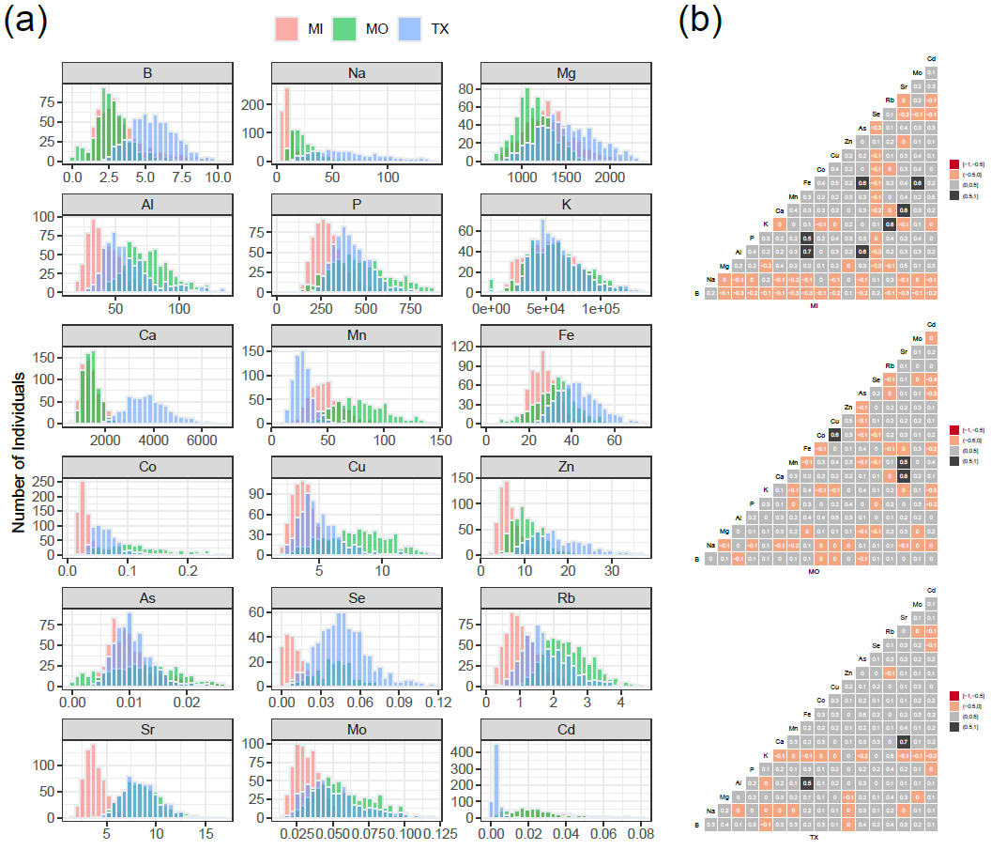

Fig. 1

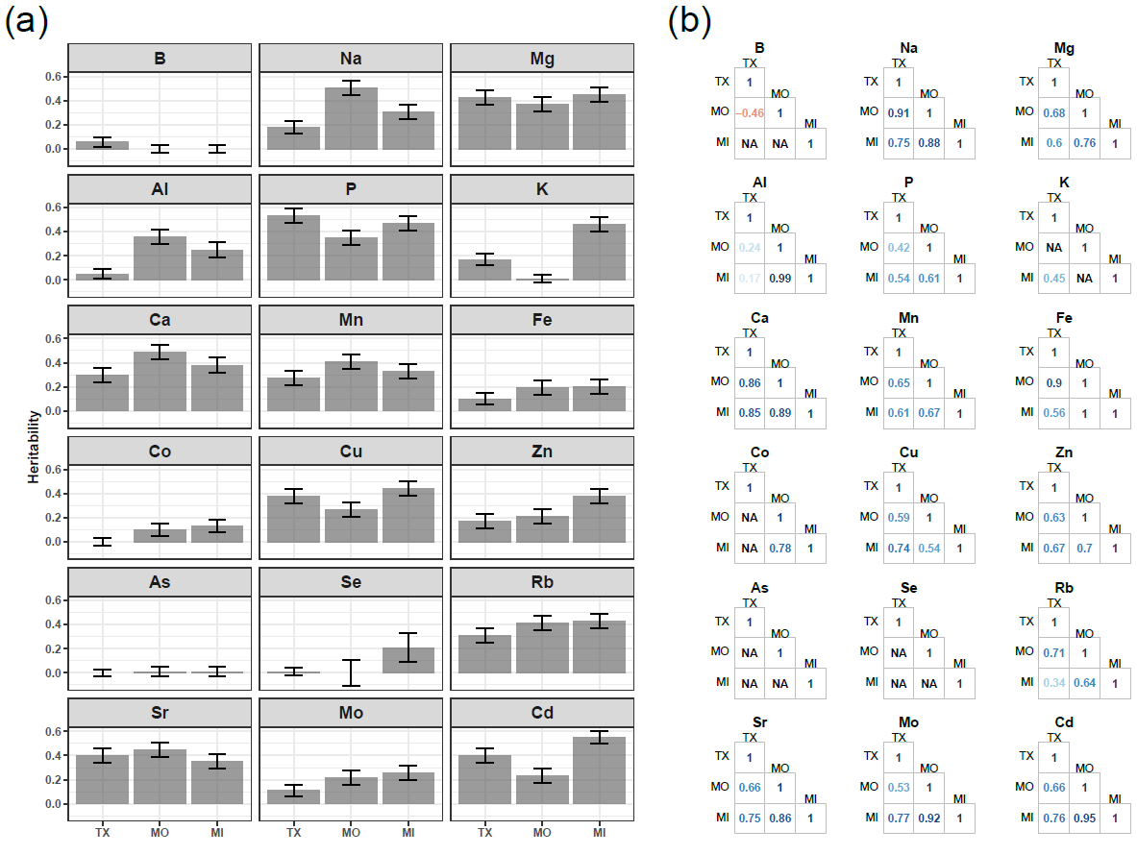

Fig. 2

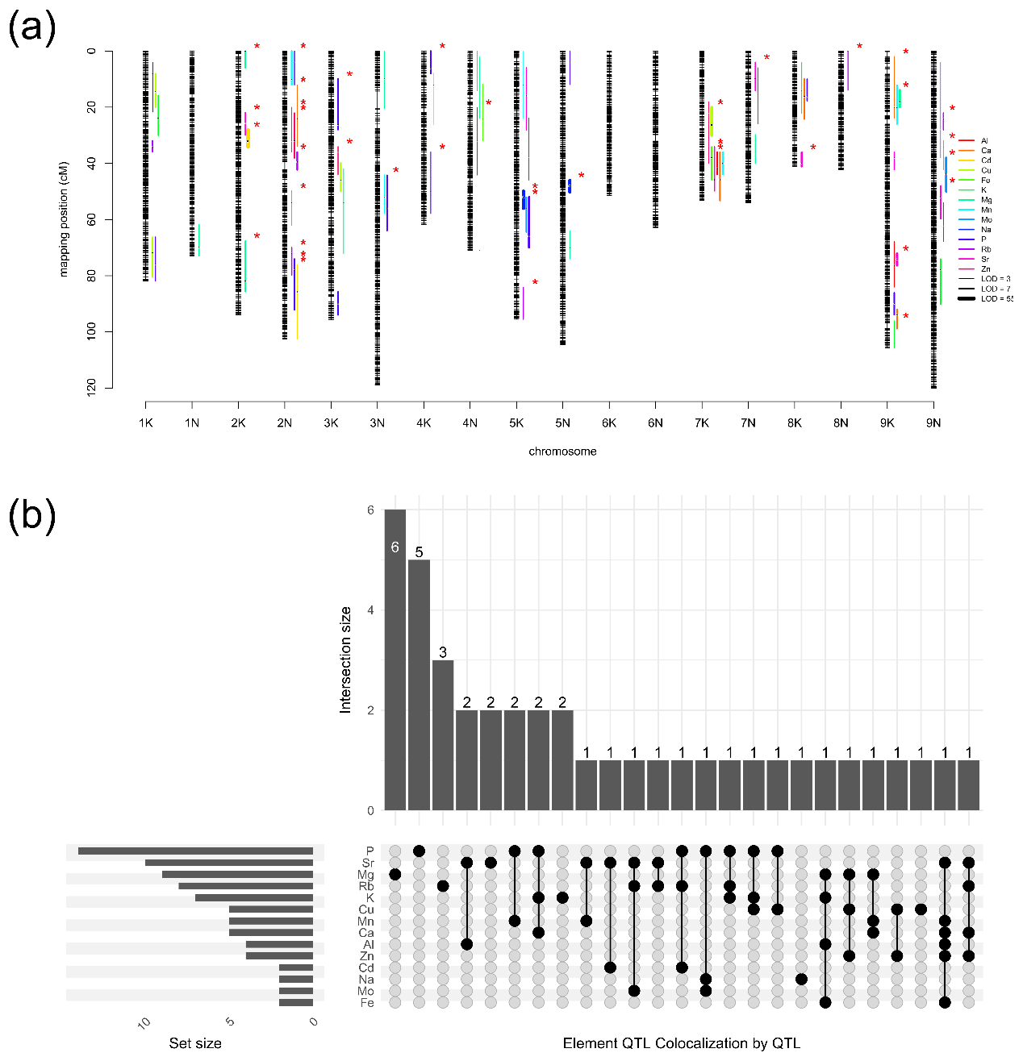

Fig. 3

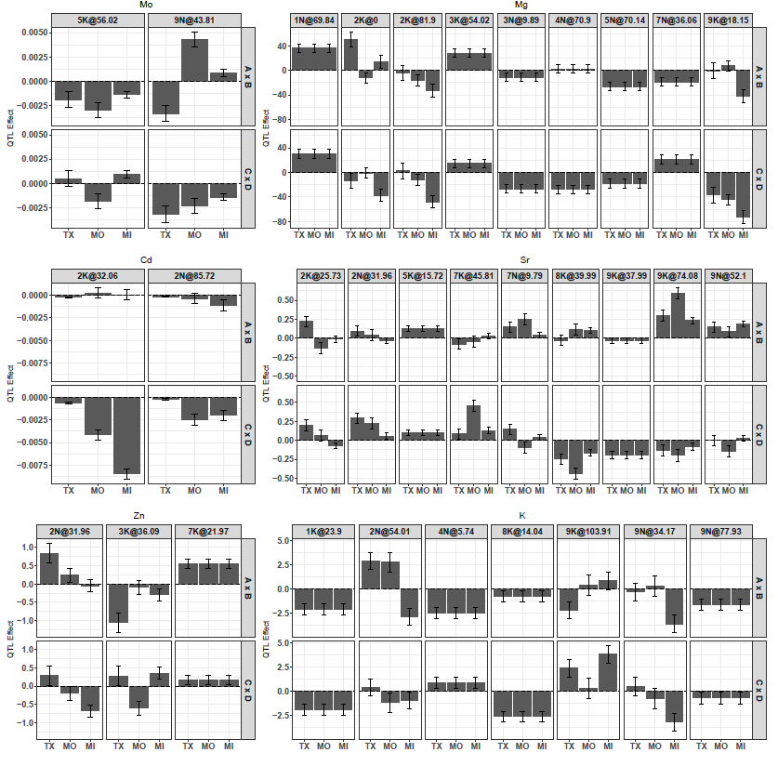

Fig. 4

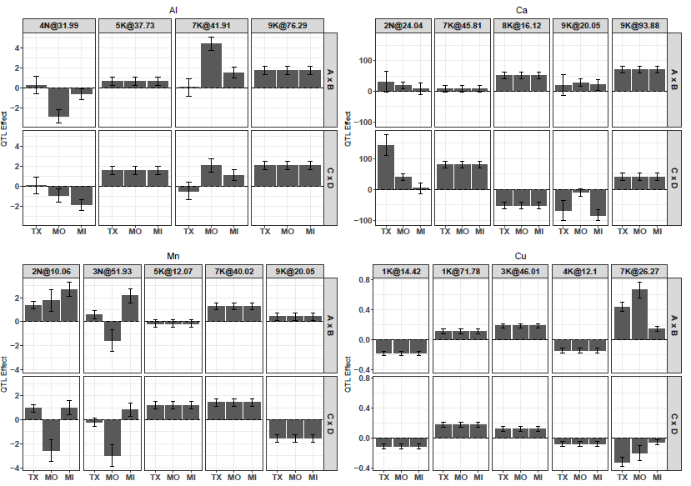

Fig. 4 Continued

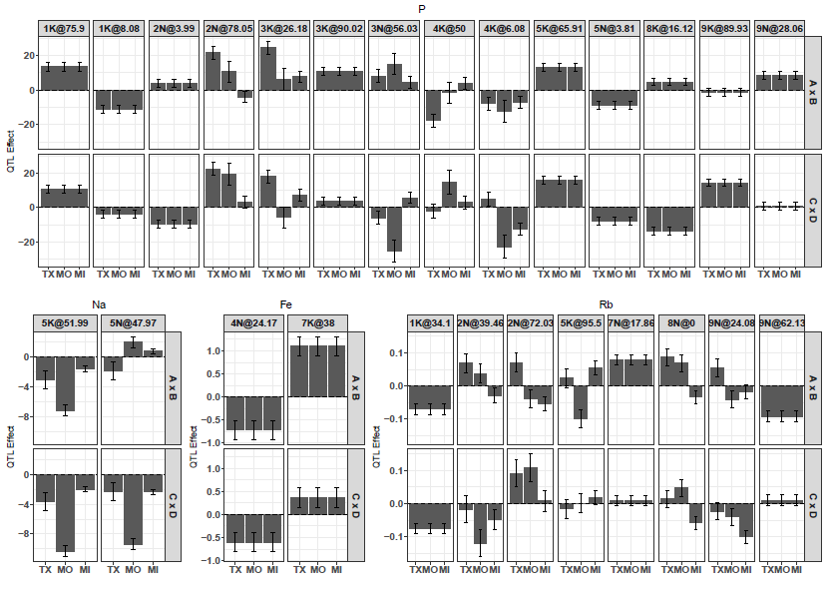

Fig. 4 Continued