**Introduction**

As the bearers of grain, grass panicles have been the target of selection for thousands of years (Doust, 2007). Panicle size and branching pattern in grasses have increased in complexity throughout the independent domestication events and modern breeding, such as in rice, wheat and barley, resulting in enormous diversity in the panicle (or inflorescences) architectures (Gelmin and Bataillon, 2009, Bommert and Whipple, 2018). Particularly, branching pattern plays an important role in wind pollination for wild grasses, as well as in affecting the number and size of grains, thus affecting seed yield (Friedman and Harder, 2004, Brown et al., 2006). Seeds are born on primary branches on panicles that sometimes iterate into secondary and tertiary branches. Evidence has shown direct association between panicle architecture and seed productivity in rice (Wang and Li, 2005; Crowell et al., 2016). Study on panicle morphology in sorghum revealed strong positive correlation between seed yield and panicle branching (Brown et al., 2006).

Furthermore, quantitative studies have shown that panicles traits variations result from the combination of environmental and genetic effects (Kovi et al., 2011; Liu et al., 2008; Adriani et al., 2016; Leng et al., 2017). For instance, the seasonal temperature and photoperiod fluctuation played a crucial role in determining panicle length in rice (Kovi et al., 2011). A few studies have identified the genetic basis for panicle architecture (Miura et al., 2010; Leng et al., 2017; Adriani et al (2016)) and found that panicle plasticity is genotype and environment dependent. Additionally, flowering time and plant height, and the genes associated with them have been shown to influence panicle traits in rice and sorghum (Yu et al., 2017; Miura et al., 2010; Komatsu et al., 2003; Brown et al., 2006). Study of panicle architecture and their genetic basis is extensively studied for staple annual food crops but studies of panicle morphology on perennial grasses important for bioenergy production are limited. It is important to understand the potential of breeding programs to increase seed and biomass production of bioenergy.

Switchgrass (*Panicum virgatum* L.) is one of the potential biofuel crops. Substantial research has been conducted after it was selected by the US DOE as a model herbaceous species for bioenergy since the early 1990s (Wright and Turhollow, 2010; McLaughlin, 1993). Switchgrass is a warm-season C4 perennial grass native to the North America, ranging west to the Rocky Mountains and South to the Texas Coastal Plain (Casler et al., 2007; Hopkins et al., 1995). Evolutionary processes and environmental gradients have shaped switchgrass significantly in phenotypes and genotypes, resulting in the classification of upland and lowland ecotypes based on the morphology and habit preference (Porter, 1966). A most recent study investigated the contribution of individual genetic locus to traits variation across a large geographic space to understand local adaptation in switchgrass, suggesting that breeding locally adapted varieties of switchgrass will be a boon to biofuel industry (Lowry et al., 2019).The potential of high biomass production on marginal land, environment-friendly ecosystem service, and genetic diversity make switchgrass an excellent material for filing biomass needs and plant breeding.

The main focus in switchgrass breeding has been for high biomass production, but panicle morphology and its relationship to seed production should not be overlooked as this is critical to meet the demand for large-scale biofuel production (Vogel, 2000; Das and Taliaferro, 2009). Panicle morphology in switchgrass has become divergent throughout evolutionary processes and modern breeding (Porter, 1966). Information on the phenotypic variation and genetic variability for panicle morphology is limited, although panicle length has been reported divergent between switchgrass ecotypes and cultivars (Porter, 1966; Esbroeck et al., 2003; Price and Casler, 2013). Furthermore, a strong relationship between panicle traits and seed yield has been identified for switchgrass cultivars ‘Summer’ and ‘Sunburst’ (Boe, 2007) and for 11 lowland switchgrass populations (Das and Taliaferro, 2009). The genetic basis underlying panicle traits, in particular how individual genetic loci contribute to panicle phenotypes across environmental gradients in switchgrass is still unknown.

Studies that combine reciprocal field experiments with quantitative trait loci (QTL) mapping have facilitated to reveal underlying genetic basis for phenotypic traits. It is not uncommon that individual loci have effects on phenotypes in one environmental condition, but not in the other alternative environments (i.e., QTL by environment interactions, Q x E; Savolainen et al., 2013, Lowry et al., 2019). Q x E analysis is similar to genotype by environment (i.e., G x E) analysis such that G x E interactions are considered as a plant-based scale since each plant is a genotype, while Q x E interactions are chromosome based (El-Soda et al., 2014). G x E interactions are indicative of which parental genotypes are suitable to specific environments, whereas, Q x E interactions are indicative of which alleles from the parental genotypes have a stronger effect in specific environments. With finer-scale analyses of genetic effects across large geographic space, it is helpful to assess the contribution of individual loci across environmental gradients.

In this study, we focus on the panicle traits by evaluating their genetic basis and the Q x E interactions in an outcrossing switchgrass population across 10 field sites in the central US. Specifically, we planted 380 progenies from a four-way outbred mapping population, along with the 4 grandparents and F1 hybrids, at all the 10 field sites. Three traits of panicle morphology data (panicle length, primary branches per panicle, and secondary branches on the panicle) were collected at each site to investigate: (1) genetic basis (QTLs) underlying the three panicle traits, (2) QTLs involved in Q x E interactions, (3) environmental factors contributing to the Q x E interactions.

**Materials and Methods**

**Field experiment and phenotyping**

The details of creation of the population are described in Milano et al. (2016). Briefly, the grandparents of the mapping population were derived from highly divergent southern lowland and northern upland ecotypes. The population was developed by initial crosses between AP13 (A) x DAC6 (B) and WBC3 (C) x VS16 (D). AP13 and WBC3 are genotypes clonally derived from lowland cultivars ‘Alamo’ (southern Texas accession) and ‘West Bee Cave’ (Central Texas accession), respectively. DAC6 and VS16 are genotypes derived from upland cultivars ‘Dacotah’ and Summer (northern upland accession), respectively. The F1 hybrids of each of those crosses were then intercrossed reciprocally to produce the four-way outbred mapping population.

The grandparents, F1 hybrid parents, and the four-way population were propagated by dividing plants manually to make 10 replicate clones, each of which was maintained in 3.8-L pot at Brackenridge Field Laboratory, Austin, TX in 2014-2015. One replicate of each of the mapping progeny genotypes, along with multiple replicates of grandparents and F1 parents, were transplanted from May to July of 2015 at 10 field sites. The 10 field sites cover 17 degrees of latitude from South Texas to South Dakota (Figure 1A). Detailed information of the 10 field sites, including latitude, longitude and soil type, is provided in Table S1. The annual mean temperature at the 10 sites ranged from 10.4 °C in the north to 20.7 °C to the south, and the total rainfall varied from 574 mm to 1440 mm in 2016 (Figure 1B). To control weeds, each field site was covered with one layer of weed barrier cloth (Dewitt, Sikeston, MO). Holes were cut into the weed cloth in a honeycomb fashion. Plants were randomized into the holes, with each plant having four nearest neighbors each located 1.56m away from each other. A row of lowland plants (AP13 or WBC3) was planted at every edge position of the field to minimize edge effects. Plants were well watered to facilitate establishment and phenotypes were measured in 2016.

Panicle length (LEN in mm), number of primary branches per panicle (PRM), number of secondary branches on the panicle (SEC) were assessed at the end of growing season. LEN was measured on the primary panicle from the base of the first primary branch to the top of the panicle. PRM was counted as the total number of branches coming out directly from the peduncle. SEC referred to the total number of branches coming out from the primary branches of the panicle.

**Genotyping and map construction**

Illumina fragment paired end libraries, representing each of the four grandparents (A: AP13, B: DAC; C: WBC; D: VS16) were aligned to the *Panicum virgatum* reference genome v5) vis bwa *mem* (Li and Durbin, 2010). Details of subsequent quality control, Kmer counting and genotype calling are described in Lovell (readme. 2019). Map polishing and fine-scale reordering results in a finalized cross-pollinated map with 1411 markers, averaged as 1cM between markers across 18 linkage groups. For computational efficiency in G x E analysis, the genetic map was reduced into 738 markers, averaged to 2cM between markers.

**Heritability and genetic correlation**

Narrow-sense heritability (*h2*) for each trait at each environment and genetic correlation (*rg*) among traits across environments were estimated using the additive kinship matrix based on marker genotypic information. The process was accomplished via the ‘sommer’ package (Covarrubias-Pazaran, 2016) in R (2018). Briefly, multivariate mixed model (mmer) takes the kinship matrix and other random incidence matrix to estimate the variance components for each trait under each environment (i.e., heritability), or among traits across environments (i.e., genetic correlation or *rg*). Information on the ‘sommer’ package and application in our other study are detailed in Covarrubias-Pazaran (2016) and Lowry et al. (2019).

**Multienvironment QTL mapping**

Details of the mapping scheme and application in the outbred four-way population are descried in Malosetti et al. (2013) and Lowry et al. (2019). In brief, ‘Single trait under multiple environments’ QTL mapping for each panicle trait in the cross-pollinated (CP) family was implanted in Genstat (VSN International, 2017The QTL approach with CP family resulted in four possible QTL alleles designated *A* and *B* corresponding to marker alleles of the first pair of grandparents (AP13 x DAC) and QTL alleles *C* and *D* corresponding to marker alleles of the second pair of grandparents (WBC x VS16). a multienvironment mixed model was fit for each trait as shown in Eq. 1:

, Eq. 1,

where *μ* is the population mean; *E* represents the environment effect; , denoting the total effect from the additive effect from the first grandparent (i.e., the difference between *A* and *B* alleles, , the second grandparent (i.e., the difference between *C* and *D* alleles, , and the dominance effect(i.e., the intralocus interaction, ; represents the QTL × environment interactions; and *e* represents the error term that was modeled by an unstructured variance–covariance matrix. The unstructured model was used to specify the data structure in the genome-wide QTL scan of simple interval mapping (SIM) and composite interval mapping (CIM). A backward selection procedure was used to retain significant fixed terms (*p*< 0.05) after three consecutive runs of CIM to confirm stability of QTLs. The QTLs with highest LOD peaks were considered as the most significant QTLs, and the Flank markers with LOD drop of 1.5 around the most significant QTLs were considered as confidence interval for the QTL peaks.

**Evaluation of the multienvironment mixed model**

The quality of the predictions from the full Genotype x Environment (G x E) model (Eq. 1) was evaluated with an independent dataset. In three of the 10 field sites (CLMB, KBSM, PKLE), 370 extra genotypes were planted and panicle morphology data were collected for these genotypes in 2016. With the effort of resequencing of the outbred mapping population, the genotypic information on these extra genotypes was obtained in 2019. With the genotypic and phenotypic data from the 370 progenies at the three field sites, the G x E model was evaluated by 1) extracting the full model from Genstat, 2) reconstructing it in R, 3) predicting the panicle traits for these genotypes at these 3 field sites, and 4) comparing the model predictions with field observations. Percentage of bias (bias%), and the prediction accuracy (r, or correlation coefficient) between the model predictions and field observations were used as statistical measures for model performance.

**Environmental drivers of G x E interactions**

For these QTLs with G x E interactions, the QTL effects were predicted using a generalized linear model (glm) with the mean temperature (Tmean), the total rainfall (Rainfall), and their interaction (Tmean*Rainfall) as predictors as shown in Equation 2.

effect = µ + Tmean + Rainfall + Tmean * Rainfall, Eq. (2).

Significant terms (*p* < 0.05) retained after best subset selection procedure (‘leaps’ and ‘bestglm’ packages in R. Lumley, 2017; McLeod and Xu, 2018; Zhang, 2016) were considered as the environmental factor(s) that interacted with QTLs, resulting in different effects at different sites.

**Candidate gene search**

The genes located in the confidence intervals of the QTLs were considered as candidate genes. All candidate genes were compared with the rice (v7) and *Arabidopsis* annotation databases (TAIR 10). The annotation file was accessed on JGI (Joint Genome Institute) Phytozome 13 website: https://njp-spin.jgi.doe.gov/.

**Results**

**Phenotypic variation and genetic correlation**

The phenotypic variation of panicle length (LEN in mm), number of primary branches (PRM), and number of secondary branches (SEC) at each site (ordered from south to north) is presented for the four grandparents and F2 generation in Figure 2. The violin plots display approximately normal distribution and transgressive behavior in the F2. Lowland genotypes (AP13 and WBC) always have higher LEN, PRM, and SEC than upland genotypes (DAC and VS16). The phenotypic correlation between traits across sites ranges from 0.50 to 0.61 (Figure S1A).

The heritability (*h2*) for LEN, PRM and SEC varies by sites. The *h2* for LEN ranges from 0.20 to 0.71, with an average of 0.46 and greater than 0.50 at 4 sites. The *h2* for PRM is between 0.45 and 0.66 for 9 out of the 10 sites. The *h2* for SEC ranges from 0.02 to 0.62, averages at 0.37, with *h2* at one site close to zero and 4 sites around 0.50 (Figure S1B). There is no genetic correlation between LEN and PRM across sites. The genetic correlation is 0.38 between LEN and SEC and 0.73 between PRM and SEC across sites (Figure S1C).

**QTL and G x E identification**

A total of 18 QTLs are identified for panicle morphology traits with the multienvironment mixed model (Figure 3, Table 1). Seven QTLs are identified for LEN distributed on 7 chromosomes. Among them, five QTLs show no genotype by environment interaction as shown by constant effect size across sites (Figure 4A); two QTLs (3N@26.26 and 6N@54.19) show interaction with environment (Q x E). QTL 3N@62.06 shows magnitude change of the additive effect across geographic regions. QTL 6N@54.19 shows magnitude change from the additive effect of C x D (WBC x VS16), it has the largest effects at the most northern and southern site, but no effect or a small effect at midlatitude sites. QTL 6N@54.19 also show trade-off pattern of allelic effect from A x B (AP13 x DAC), where the allelic effects have sign change from southern to northern sites.

Seven QTLs are identified for PRM as distributed on 7 chromosomes. Among them, four QTLs show no Q x E; three of them show (3K@38, 5K@14.06, and 7N@54.06) Q x E interactions, including both changes of magnitude (3K@38 and 7N@54.06) and direction (5K@14.06) from the allelic effect across geographic regions (Figure 4B). Four QTLs are identified for SEC. Three of them show no Q x E interaction, while QTL 9K@51.96 shows the interaction with magnitude changes from the allelic effects (Figure 4C).

We also observe that two QTLs for PRM (2K@74.02 and 9N@26.03) co-localizes with LEN QTLs on chromosome 2K and 9N (Figure 3). QTL 9N@38.02 for SEC co-localizes with the QTL of LEN and PRM on chromosome 9N (Figure 3). Additionally, we examine if the QTLs identified for panicle traits share the same QTLs with flowering (FL50) or plant height (HT). The reasons for doing this are that, flowering time and plant height have been identified to be associated with panicle branching pattern in other plants, and our previous study identified the genetic basis for flowering and plant height under the context of local adaptation (Lowry et al., 2019). Our results show that the QTL 2K@77.89 for LEN, the QTL on 2N for PRM and SEC, the QTL on 3K@38 for PRM, the QTL on 5N@84.04 for PRM, and the QTL on 9N for all panicle traits are clustering with FL50 and HT QTLs (Figure 3). Most of the clusters occur between PRM and FL50/HT QTLs.

The evaluation of the QTL and Q x E model (Eq. 1) showed prediction accuracy (*r*) of 0.34-0.62 and percentage of bias (%bias) of 0.3%-0.6% for panicle morphology traits across the three test sites (Figure 5). With the best subsets selection procedurep, the environmental factor(s) were identified for the Q x E interactions in the multienvironment mixed model (eq. 1, Table 2, *p* <0.05). The main driver of the Q x E is mean temperature for all three panicle traits, and one QTL for PRM interacts with rainfall. For example, the additive effects of QTL 6N@54.19 for the A x B (AP13 x DAC) cross of panicle length (Figure 4A) increase from southern to northern sites, correlated with the mean temperature in a negative fashion (Table 2). Some of the Q x E interactions have no environmental factor identified. This is likely related to the fact that not all the environmental factors (such as soil) are accounted for in this study.

**Candidate gene identification**

We further sought to identify genetic variations between lowland (AP13 and WBC) and upland (DAC and VS16) genotype by integrating the known candidate genes associated with panicle architecture reported in previous studies. A total of ~13,000 genes were identified in the interval of 18 panicle architecture QTLs. The annotation of candidate genes at each QTL interval was provided in Table S2.

Among these candidate genes, key transcription factors and hormone related genes associated with the development of panicles were identified in the interval of most Q x E QTLs. For example, transcription factors from SPL family (Pavir.3NG140945 as the homolog of OsSPL9 in 3N@62.06; Pavir.6NG315100 and Pavir.6NG327200 as homologs of OsSPL14 and OsSPL16 in 6N@54.19) and MADS family (Pavir.3NG140846 as the homolog of OsMADS4 in 3N@62.06; Pavir.6NG327900 as the homolog of OsMADS37 in 6N@54.19) were detected in two LEN G x E QTLs intervals. Key regulators involved in GA metabolic (Pavir.3KG352627 as the homolog of GA2ox3 in 3K@38; Pavir.5KG065800 as the homolog of GA3ox2 in 5K@14.06) and CK signaling pathways (Pavir.7NG435700 as the homolog of ARR6 in 7N@54.06; Pavir.9KG213000 as the homolog of ARR1 in 9K@51.96) were found in four branching G x E QTLs intervals. These genes could be good candidates to recurring environmental stress and modulate panicle architecture.

Furthermore, we also identified candidate genes for those pleiotropic QTLs. For example, we identified the homolog of BZR1 (Pavir.2KG507900) and OsMADS18 (Pavir.2KG531900) in the co-localization interval of LEN and PRM QTLs on Chr2K. We also detected the homolog of OsCOL10 (Pavir.9NG134200) and OsTB1 (Pavir.9NG142700) in the co-localization interval for LEN and PRM QTLs on Chr9N. The results indicated the pleiotropic functions of these candidates in spatial coordination of panicle axis and branches.

Interestingly, we found a number of key flowering genes in our panicle QTL intervals, including homologs of OsGI (Pavir.5KG060800) and OsMADS51 (Pavir.5KG092874) in PRM QTL 5K@14.06 interval; the homolog of Hd3a (Pavir.4KG289300) in PRM QTL 4K@26.26 interval; and the homolog of Ehd1 (Pavir.9KG213000) in SEC QTL 9K@51.96 interval. These genes are known to involve in photoperiod flowering pathway and control the panicle morphology in grass. However, they were not co-localized with flowering QTLs that we identified before. These results indicated the complexity functions of flowering time genes in vegetative to reproductive transition.

**Discussion**

In this study, we evaluated the genetic basis of panicle morphological traits in outcrossing switchgrass across 10 field sites in the central United States (Figure 1). Our study identified the individual loci that contribute to the panicle trait variation across geographic region. Some QTLs had significant Q x E effects, indicating the importance of environmental factors in affecting panicle traits. Overall, our results show that panicle traits across large-scale environmental gradients are controlled by a combination of genetic loci and the environment.

Consistent with the previous study of switchgrass (Lowry et al., 2019, 2014), there were large asymmetries and local adaptation in additive effects across field sites (Figure 3). Some QTLs (e.g., 3N@63.06 for LEN) had effects in one or two geographic regions but not in others (i.e., conditional neutrality, Wadgymar et al., 2017). Some QTLs (e.g., 3K@38 for PRM) showed variation in the magnitude of change but no sign change, showing differential sensitivity across geographic regions. One QTL, 6N@54.19 for LEN, had a sign change, indicating that there is antagonistic pleiotropy. This is when the allele is beneficial in some environments (or sites) but deleterious in others environments. Antagonistic pleiotropy is a genetic trade-off at an individual locus, that confers an advantage to individuals in their home environments and a disadvantage in alternative environments (Wadgymar et al., 2017). In our study, most of the QTLs are conditional neutral. This is consistent with the finding that local adaptation or QTL effect asymmetry is more often caused by conditional neutrality than trades-offs based on the studies of five biological systems (Wadgymar et al., 2017). This supports the idea that there is restricted gene flow between upland and lowland ecotypes (Merila et al., 2013; Wadgymar et al., 2017; Lowry et al., 2019).

We found a few QTLs without Q x E interaction had similar allele effects for the A x B and C x D crosses, indicating that they were consistently responsible for divergence between ecotypes. However, for QTLs with Q x E, there is little evidence that the same set of loci that showed consistent divergence between upland and lowland ecotypes, suggesting different loci on locally adaptive ecotype divergence across the range of species. The colocalization of panicle QTLs with flowering/height QTLs in switchgrass may not be surprising as other studies in rice and sorghum have showed the genes associated with flowering and plant height have a large influence on panicle traits (Yu et al., 2017; Miura et al., 2010).

The low to moderate prediction accuracy (0.34-0.62) of the multienvironment mixed model (Eq. 1) on the independent genotypes grown in three of the 10 field sites is likely due to the large variation observed in the field, and the fact that the model is only counting for the few significant QTLs while the majority of the loci may have small contribution to the trait but this is no detectable due to the sample size. In addition, our model does not count for the epistatic effects between QTLs. However, our approach provides a way of predicting the performance of new genotypes under environments similar to the tested environments, helping with suitable genotype selection for traits of interest under specific environment.

Temperature as the main driver of the ones tested for the Q x E interactions is consistent with the pattern of additive effects of most of the QTLs (Table 2), where QTLs displayed conditional neutrality with effects either in the northern sites or the southern sites or both, but not at the middle latitude sites (Figure 4. No environmental factors were detected as significant for some of the Q x E interactions, this is likely due to the fact that our model (as shown in Eq. 2) only included temperature and rainfall as independent variables for the QTL effects, but not taking into consideration of all the possible environmental factors. This study could be expanded in the future to include more field site, multiple years, and more environmental data collection such as soil and nutrients to better capture the environmental drivers underlying the Q x E interactions.

In summary, our results suggest that variation of panicles traits in switchgrass is a combination of individual locus and environment, with loci displaying variable effects across geographic regions. Future work focusing on identifying the driver of QTL by environment interactions will facilitate the suitable genotype selection under specific environment in switchgrass breeding programs.

Table 1. The identified QTLs, along with their marker name (chromosome with physical distance in mega base pair), LOD values, and flank markers (down_marker and up_marker) of LOD drop of 1.5, for panicle morphology traits (LEN: panicle length; PRM: number of primary branches; SEC: number of secondary branches). Weather there is genotype by environmental interaction or not is marked as ‘Yes’ or ‘No’ in column G x E.

|  |  |  |  |  |  |  |
| --- | --- | --- | --- | --- | --- | --- |
| trait | QTL | MARKER | LOD | down_marker | up_marker | GxE |
| LEN | 2K@77.89 | Chr02K_62.598826 | 6.18 | Chr02K_60.739957 | Chr02K_64.045891 | No |
| LEN | 3N@62.06 | Chr03N_26.099983 | 4.29 | Chr03N_24.521536 | Chr03N_30.30364 | Yes |
| LEN | 4K@26.26 | Chr04K_13.041487 | 4.66 | Chr04K_9.916183 | Chr04K_29.613196 | No |
| LEN | 5K@76.02 | Chr05K_56.620419 | 4.82 | Chr05K_44.678143 | Chr05K_58.488157 | No |
| LEN | 5N@36.27 | Chr05N_16.511689 | 3.63 | Chr05N_11.735767 | Chr05N_47.154718 | No |
| LEN | 6N@54.19 | Chr06N_48.768076 | 3.56 | Chr06N_43.871788 | Chr06N_51.935176 | Yes |
| LEN | 9N@38.02 | Chr09N_18.617122 | 5.82 | Chr09N_10.880731 | Chr09N_20.831824 | No |
| PRM | 2K@74.02 | Chr02K_59.503978 | 4.09 | Chr02K_56.436103 | Chr02K_63.664705 | No |
| PRM | 2N@66.12 | Chr02N_55.500715 | 5.52 | Chr02N_50.387752 | Chr02N_56.445418 | No |
| PRM | 3K@38 | Chr03K_17.77051 | 8.83 | Chr03K_13.323286 | Chr03K_20.786505 | Yes |
| PRM | 5K@14.06 | Chr05K_7.188103 | 4.90 | Chr05K_4.388419 | Chr05K_8.204815 | Yes |
| PRM | 5N@84.04 | Chr05N_64.047349 | 4.73 | Chr05N_60.974614 | Chr05N_65.990782 | No |
| PRM | 7N@54.06 | Chr07N_49.904749 | 4.17 | Chr07N_49.035214 | Chr07N_49.904749 | Yes |
| PRM | 9N@26.03 | Chr09N_12.531268 | 4.89 | Chr09N_7.913256 | Chr09N_21.588445 | No |
| SEC | 2N@72.03 | Chr02N_58.696003 | 9.46 | Chr02N_54.556579 | Chr02N_60.798034 | No |
| SEC | 5K@95.5 | Chr05K_60.232411 | 6.22 | Chr05K_58.583292 | Chr05K_60.232411 | No |
| SEC | 9K@51.96 | Chr09K_24.465322 | 10.37 | Chr09K_19.959778 | Chr09K_28.697896 | Yes |
| SEC | 9N@38.02 | Chr09N_18.617122 | 9.29 | Chr09N_17.684245 | Chr09N_19.333648 | No |

Table 2. The environmental factor(s) related to the genotype by environmental interaction for QTLs for panicle morphology traits (LEN: panicle length; PRM: number of primary branches; SEC: number of secondary branches). A x B and C x D denote the cross from AP13 x DAC and WBC x VS16, respectively. Tmean and Rainfall are annual mean temperature and total rainfall in 2016, respectively. Asterisk * means significance level of p < 0.05.

|  |  |  |  |  |  |
| --- | --- | --- | --- | --- | --- |
| Trait | QTL | Cross | Tmean | Rainfall | Tmean*Rainfall |
| LEN | 3N@62.06 | A x B |  |  |  |
|  |  | C x D | * |  |  |
| LEN | 6N@54.19 | A x B | * |  |  |
|  |  | C x D |  |  |  |
| PRM | 3K@38 | A x B |  |  |  |
|  |  | C x D |  |  |  |
| PRM | 5K@14.06 | A x B | * | * | * |
|  |  | C x D |  |  |  |
| PRM | 7N@54.06 | A x B |  |  |  |
|  |  | C x D | * |  |  |
| SEC | 9K@51.96 | A x B |  |  |  |
|  |  | C x D |  |  |  |

List of figures

Figure 1. The geographic location and climate at 10 field sites. (A). The 10 sites across the latitudinal gradients from southern Texas to North Dakota. The experimental sites in this study span much of the natural occurrence habitat of switchgrass (the green layer with buffered points). (B). The mean temperature and annual rainfall of the 10 sites for the study year in 2016 (ordered from south to north).

Figure 2. The phenotypic distribution of the F2 population, and the phenotypic means of the four grandparents (lowland AP13, WBC and upland DAC and VS16) for panicle length (LEN), number of primary branches (PRM), and number of secondary branches (SEC) across the 10 field sites (ordered from south to north).

Figure 3. The summary of QTLs and genotype by environment interaction (marked as * in red) identified for panicle length (LEN), number of primary branches (PRM), and number of secondary branches (SEC), along with QTLs from flowering (FL50) and plant height (HT) identified from our previous study.

Figure 4. The additive effects of each QTL identified for panicle length (LEN), number of primary branches (PRM), and number of secondary branches (SEC) across geographic regions.

Figure 5. The evaluation of the multienvironment mixed model (Eq. 1) using independent datasets from the three sites (KBSM, CLMB, and PKLE) for panicle length (LEN), number of primary branches (PRM), and number of secondary branches (SEC).

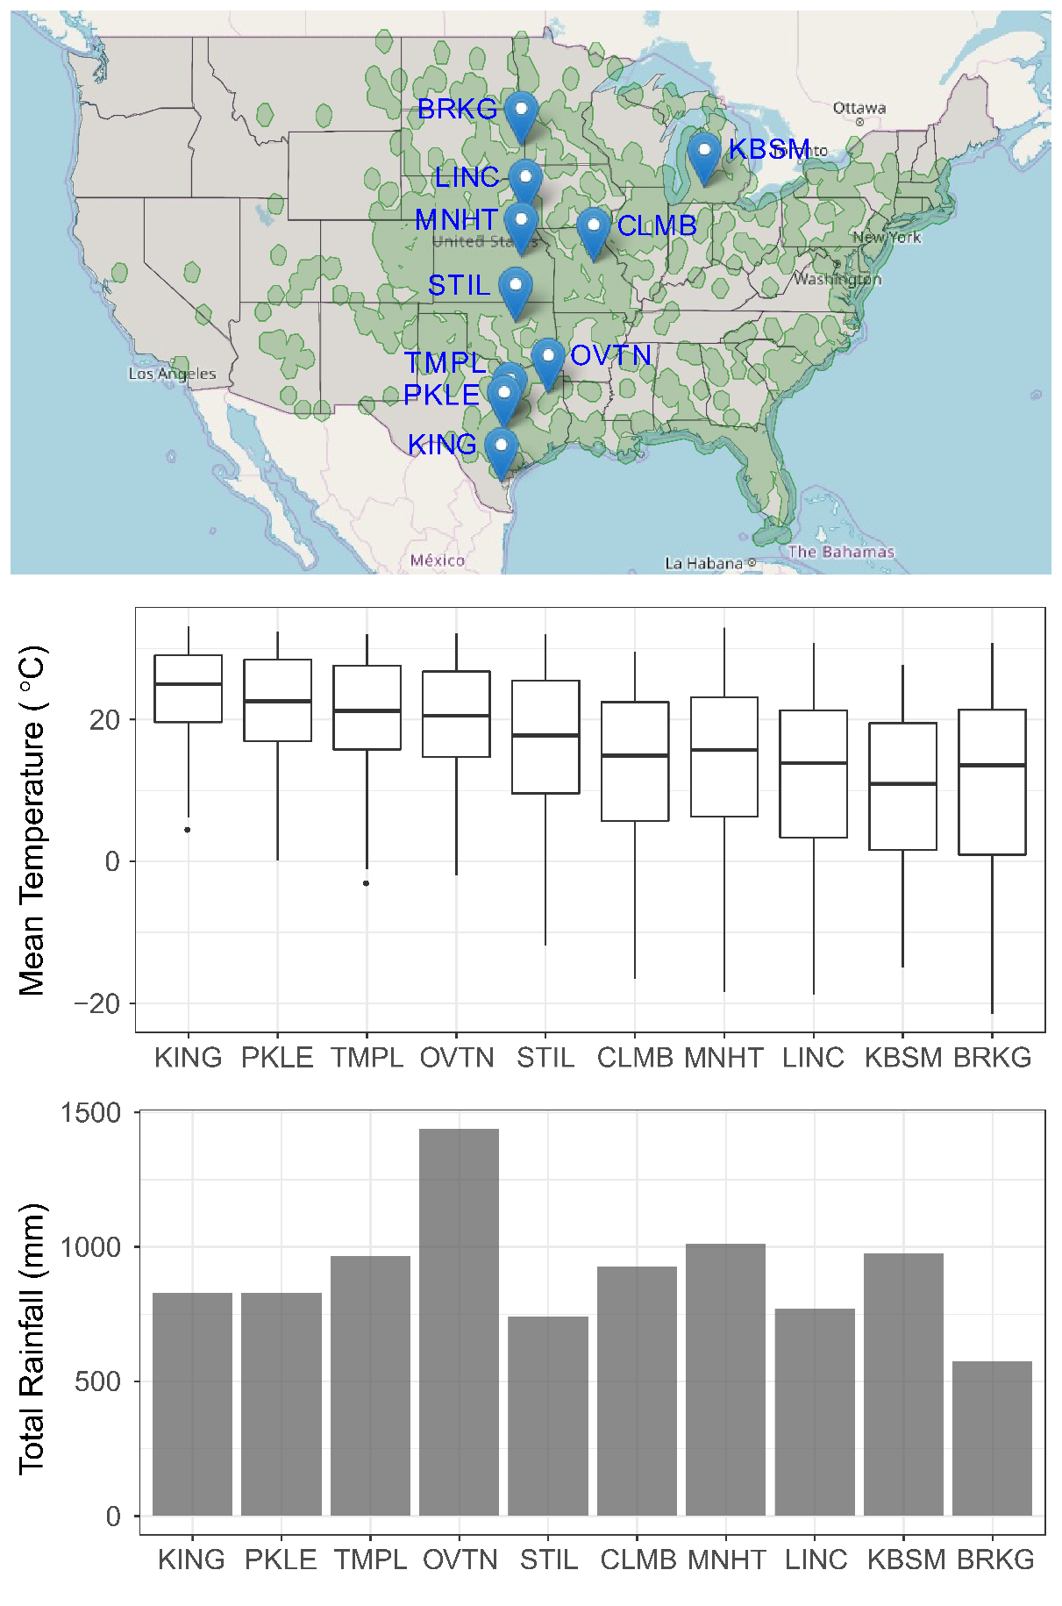

Figure 1

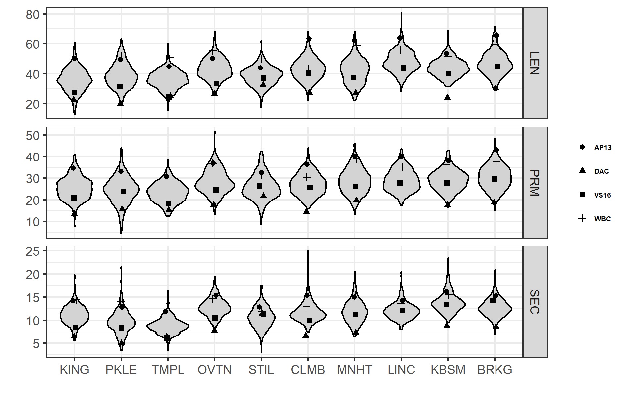

Figure 2

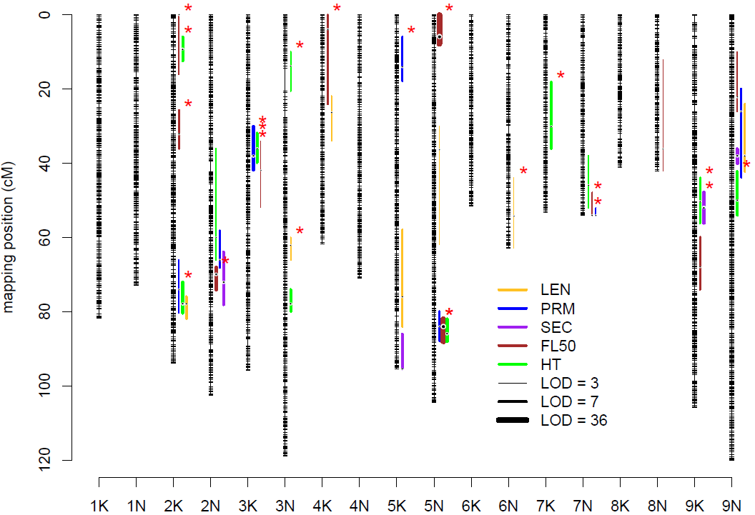

Figure 3

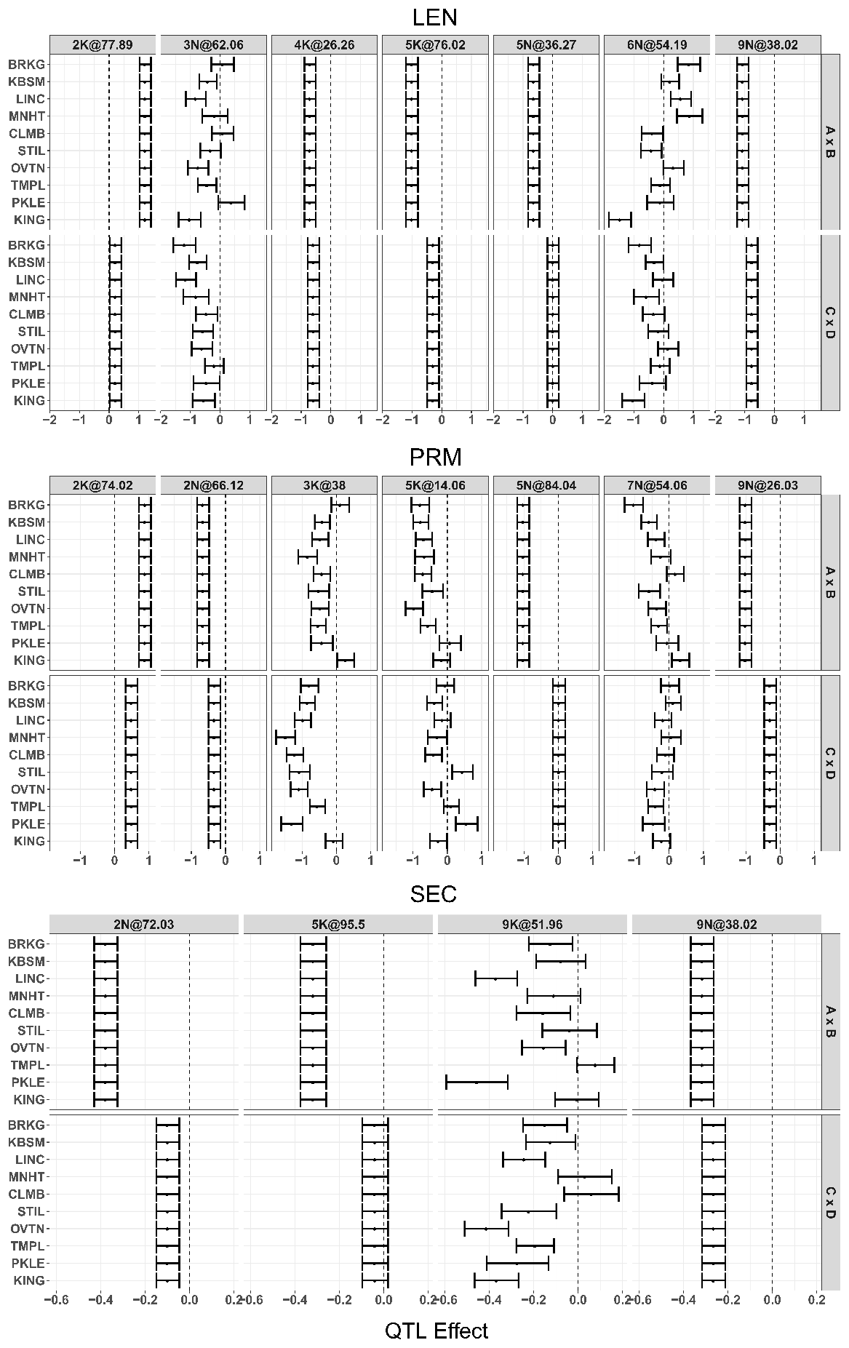

Figure 4

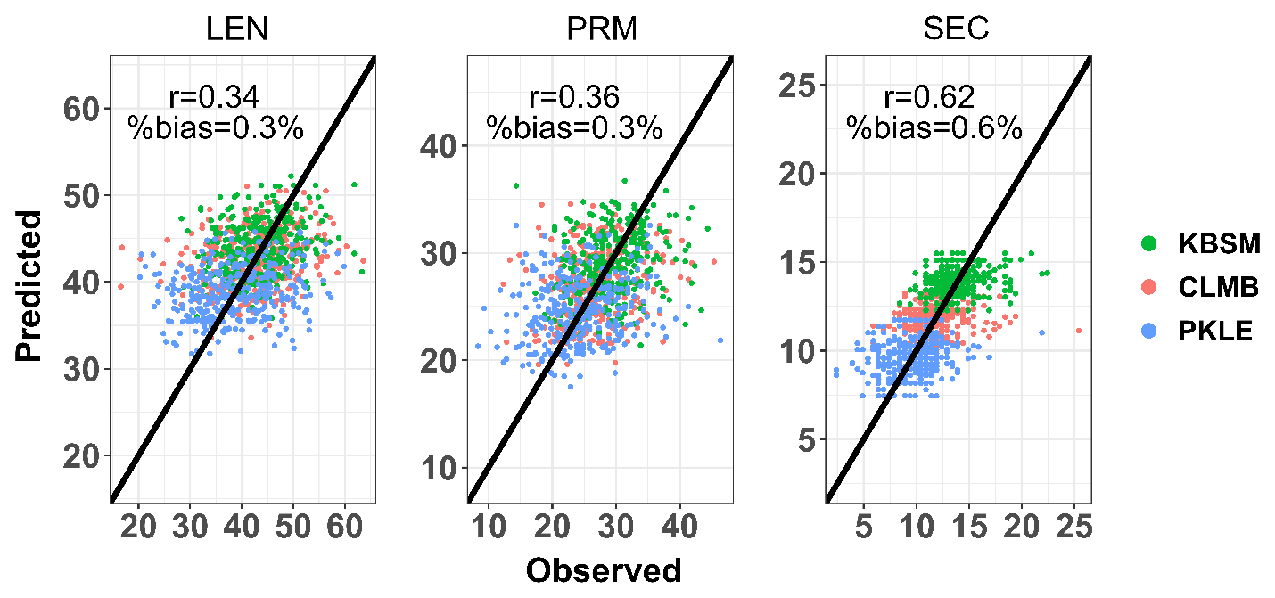

Figure 5