biomass mash

Alice MacQueen

3/12/2020

## 

covar <- enframe(get_estimated_pi(m), name = "Covariances")  
  
covar[21,2]*100

## value  
## 1 31.20369

enframe(get_estimated_pi(m), name = "Covariances") %>%  
 ggplot(aes(x = Covariances, y = value)) + geom_bar(stat = "identity") +  
 theme(axis.text.x = element_text(hjust = 1, angle = 45))

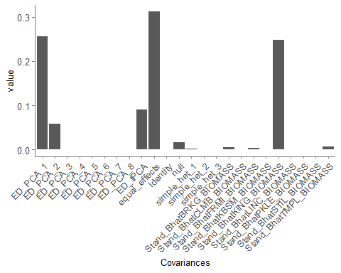

31.2% of all effects load on to the “Equal Effects” covariance matrix.

Here is the pattern of effects for ED_PCA_1. The SITES are in alphabetical order - BRKG is X1, CLMB X2, etc.

mash_plot_pairwise_sharing(corrmatrix = covariances$ED_PCA_1)

## Loading required namespace: dots

## Scale for 'colour' is already present. Adding another scale for  
## 'colour', which will replace the existing scale.

## $corr_matrix  
## [,1] [,2] [,3] [,4] [,5]  
## [1,] 0.001661567 0.007483566 0.003005904 0.005605272 0.007696227  
## [2,] 0.007483566 0.033705378 0.013538350 0.025245695 0.034663190  
## [3,] 0.003005904 0.013538350 0.005437913 0.010140372 0.013923072  
## [4,] 0.005605272 0.025245695 0.010140372 0.018909301 0.025963107  
## [5,] 0.007696227 0.034663190 0.013923072 0.025963107 0.035648220  
## [6,] 0.005492584 0.024738159 0.009936511 0.018529150 0.025441147  
## [7,] 0.007633025 0.034378532 0.013808734 0.025749895 0.035355473  
## [8,] 0.004644503 0.020918469 0.008402266 0.015668161 0.021512913  
## [9,] 0.007035717 0.031688305 0.012728158 0.023734885 0.032588797  
## [,6] [,7] [,8] [,9]  
## [1,] 0.005492584 0.007633025 0.004644503 0.007035717  
## [2,] 0.024738159 0.034378532 0.020918469 0.031688305  
## [3,] 0.009936511 0.013808734 0.008402266 0.012728158  
## [4,] 0.018529150 0.025749895 0.015668161 0.023734885  
## [5,] 0.025441147 0.035355473 0.021512913 0.032588797  
## [6,] 0.018156642 0.025232222 0.015353170 0.023257722  
## [7,] 0.025232222 0.035065130 0.021336247 0.032321174  
## [8,] 0.015353170 0.021336247 0.012982568 0.019666619  
## [9,] 0.023257722 0.032321174 0.019666619 0.029791942  
##   
## $gg_corr

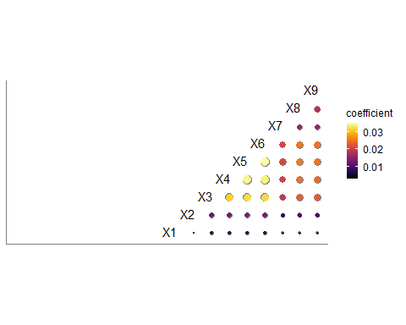

# Differential Sensitivity

length(get_significant_results(m))

## [1] 21781

mash_plot_pairwise_sharing(corrmatrix = gxe$S_DS)

## Scale for 'colour' is already present. Adding another scale for  
## 'colour', which will replace the existing scale.

## $corr_matrix  
## Stand_BhatBRKG_BIOMASS Stand_BhatCLMB_BIOMASS  
## Stand_BhatBRKG_BIOMASS 0 53  
## Stand_BhatCLMB_BIOMASS 53 0  
## Stand_BhatFRMI_BIOMASS 65 33  
## Stand_BhatKBSM_BIOMASS 29 34  
## Stand_BhatKING_BIOMASS 70 66  
## Stand_BhatLINC_BIOMASS 43 47  
## Stand_BhatPKLE_BIOMASS 46 40  
## Stand_BhatSTIL_BIOMASS 58 48  
## Stand_BhatTMPL_BIOMASS 39 39  
## Stand_BhatFRMI_BIOMASS Stand_BhatKBSM_BIOMASS  
## Stand_BhatBRKG_BIOMASS 65 29  
## Stand_BhatCLMB_BIOMASS 33 34  
## Stand_BhatFRMI_BIOMASS 0 54  
## Stand_BhatKBSM_BIOMASS 54 0  
## Stand_BhatKING_BIOMASS 90 44  
## Stand_BhatLINC_BIOMASS 71 46  
## Stand_BhatPKLE_BIOMASS 62 18  
## Stand_BhatSTIL_BIOMASS 75 7  
## Stand_BhatTMPL_BIOMASS 50 4  
## Stand_BhatKING_BIOMASS Stand_BhatLINC_BIOMASS  
## Stand_BhatBRKG_BIOMASS 70 43  
## Stand_BhatCLMB_BIOMASS 66 47  
## Stand_BhatFRMI_BIOMASS 90 71  
## Stand_BhatKBSM_BIOMASS 44 46  
## Stand_BhatKING_BIOMASS 0 60  
## Stand_BhatLINC_BIOMASS 60 0  
## Stand_BhatPKLE_BIOMASS 36 50  
## Stand_BhatSTIL_BIOMASS 42 74  
## Stand_BhatTMPL_BIOMASS 21 44  
## Stand_BhatPKLE_BIOMASS Stand_BhatSTIL_BIOMASS  
## Stand_BhatBRKG_BIOMASS 46 58  
## Stand_BhatCLMB_BIOMASS 40 48  
## Stand_BhatFRMI_BIOMASS 62 75  
## Stand_BhatKBSM_BIOMASS 18 7  
## Stand_BhatKING_BIOMASS 36 42  
## Stand_BhatLINC_BIOMASS 50 74  
## Stand_BhatPKLE_BIOMASS 0 21  
## Stand_BhatSTIL_BIOMASS 21 0  
## Stand_BhatTMPL_BIOMASS 5 10  
## Stand_BhatTMPL_BIOMASS  
## Stand_BhatBRKG_BIOMASS 39  
## Stand_BhatCLMB_BIOMASS 39  
## Stand_BhatFRMI_BIOMASS 50  
## Stand_BhatKBSM_BIOMASS 4  
## Stand_BhatKING_BIOMASS 21  
## Stand_BhatLINC_BIOMASS 44  
## Stand_BhatPKLE_BIOMASS 5  
## Stand_BhatSTIL_BIOMASS 10  
## Stand_BhatTMPL_BIOMASS 0  
##   
## $gg_corr

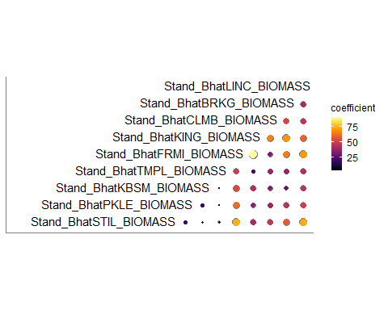

max(gxe$S_DS)

## [1] 90

min(gxe$S_DS)

## [1] 0

21781 SNPs have significant effects in the mash analysis. Of those, between 0 and 90 have differentially significant effects between pairs of conditions.

# Antagonistic Pleiotropy

mash_plot_pairwise_sharing(corrmatrix = gxe$S_AP)

## Scale for 'colour' is already present. Adding another scale for  
## 'colour', which will replace the existing scale.

## $corr_matrix  
## Stand_BhatBRKG_BIOMASS Stand_BhatCLMB_BIOMASS  
## Stand_BhatBRKG_BIOMASS 0 5  
## Stand_BhatCLMB_BIOMASS 5 0  
## Stand_BhatFRMI_BIOMASS 4 0  
## Stand_BhatKBSM_BIOMASS 1 0  
## Stand_BhatKING_BIOMASS 19 12  
## Stand_BhatLINC_BIOMASS 11 4  
## Stand_BhatPKLE_BIOMASS 12 7  
## Stand_BhatSTIL_BIOMASS 9 8  
## Stand_BhatTMPL_BIOMASS 7 1  
## Stand_BhatFRMI_BIOMASS Stand_BhatKBSM_BIOMASS  
## Stand_BhatBRKG_BIOMASS 4 1  
## Stand_BhatCLMB_BIOMASS 0 0  
## Stand_BhatFRMI_BIOMASS 0 3  
## Stand_BhatKBSM_BIOMASS 3 0  
## Stand_BhatKING_BIOMASS 43 0  
## Stand_BhatLINC_BIOMASS 2 2  
## Stand_BhatPKLE_BIOMASS 23 3  
## Stand_BhatSTIL_BIOMASS 29 0  
## Stand_BhatTMPL_BIOMASS 10 1  
## Stand_BhatKING_BIOMASS Stand_BhatLINC_BIOMASS  
## Stand_BhatBRKG_BIOMASS 19 11  
## Stand_BhatCLMB_BIOMASS 12 4  
## Stand_BhatFRMI_BIOMASS 43 2  
## Stand_BhatKBSM_BIOMASS 0 2  
## Stand_BhatKING_BIOMASS 0 9  
## Stand_BhatLINC_BIOMASS 9 0  
## Stand_BhatPKLE_BIOMASS 0 10  
## Stand_BhatSTIL_BIOMASS 0 13  
## Stand_BhatTMPL_BIOMASS 0 5  
## Stand_BhatPKLE_BIOMASS Stand_BhatSTIL_BIOMASS  
## Stand_BhatBRKG_BIOMASS 12 9  
## Stand_BhatCLMB_BIOMASS 7 8  
## Stand_BhatFRMI_BIOMASS 23 29  
## Stand_BhatKBSM_BIOMASS 3 0  
## Stand_BhatKING_BIOMASS 0 0  
## Stand_BhatLINC_BIOMASS 10 13  
## Stand_BhatPKLE_BIOMASS 0 1  
## Stand_BhatSTIL_BIOMASS 1 0  
## Stand_BhatTMPL_BIOMASS 0 1  
## Stand_BhatTMPL_BIOMASS  
## Stand_BhatBRKG_BIOMASS 7  
## Stand_BhatCLMB_BIOMASS 1  
## Stand_BhatFRMI_BIOMASS 10  
## Stand_BhatKBSM_BIOMASS 1  
## Stand_BhatKING_BIOMASS 0  
## Stand_BhatLINC_BIOMASS 5  
## Stand_BhatPKLE_BIOMASS 0  
## Stand_BhatSTIL_BIOMASS 1  
## Stand_BhatTMPL_BIOMASS 0  
##   
## $gg_corr

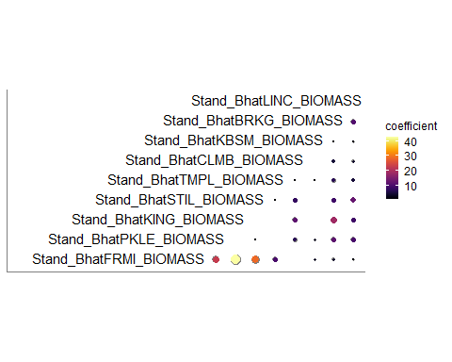

21781 SNPs have significant effects in the mash analysis. Of those, between 0 and 43 have antagonistically pleiotropic effects between pairs of conditions.

Between 40 and 16861 have effects of the same magnitude and same sign between pairs of conditions.