Working Title: The genetic basis of two flowering time cues in switchgrass (Panicum virgatum)
Authors: Alice MacQueen*, Li Zhang*, Jason Bonette, …who else? People at HA who constructed the new fourway map (unless it’s already published in the wax QTL mapping paper), hosts of the common garden sites, Tom Juenger

Intended Audience: biologists interested in GxE, plant biologists interested in flowering
Target Journal: New Phytologist, TEJ suggests: PNAS, Nature Communications
Possible Friendly Reviewers/Reviewers: Annie Schmidt, Jiaming Yu, Ben Blackman, Dan Woods
NP editor: John Stinchcombe

Abstract
Switchgrass (Panicum virgatum) is a perennial, outcrossing species native to North America which has evolved into multiple divergent populations that vary in ploidy, morphology, and phenological timing. Its potential uses have expanded in the past few decades to include biofuels. Flowering time is a key life-history trait for biofuel production, as plants cease biomass accumulation upon completion of floral development.
Here, we present evidence that photoperiodic sensitivity in switchgrass flowering time varies between two highly divergent southern lowland and northern upland genetic subpopulations using a diversity panel grown in 2019 at eight common gardens in the central United States spanning 17 degrees of latitude.
We evaluated the genetic basis of two phenological events – greenup and flowering – as functions of environmental cues (e.g. daylength, temperature). We use multivariate adaptive shrinkage (mash) to determine the prevalence of and map the genomic effects covarying with these environmental cues. We describe and genetically map other major patterns of genotype by garden effects on greenup and flowering detected by mash. Finally, we map the genetic basis of flowering time in 2019 at seven of these gardens using an independent four-way cross created from individuals from these two genetic subpopulations. We map 23 additive QTLs with significant effects on flowering, all with significant mash associations and ten with an enrichment of highly significant mash associations.
This study represents the first effort to map the genetic basis of, and assign environmental drivers to, genotype by environment interactions in an outcrossing plant species across its native environment.

Keywords: flowering time, GxE (genotype by environment interactions), switchgrass, Panicum virgatum, photoperiod
Introduction
The timing of floral development is a major component of plant fitness affected by multiple external environmental cues (e.g. temperature, daylength, and water availability) that signal existing or upcoming growing conditions. Genetic responses to these cues determine the speed, timing, and energy apportioned to reproductive growth and shape both the individual’s lifespan and its lifetime production of viable seed. Global climate forcing is increasing temperatures and causing more extreme weather events, such as droughts, heatwaves, and severe rain events (Ummenhofer and Meehl, 2017). These events will alter both the timing of reproductive development and the reliability of the environmental signals that plants use to cue flowering. It is thus of increasing importance that we understand the environmental cues driving floral development and the genetics underlying flowering responses to understand the genetic potential for adaptation to novel, changing environments.
Flowering at the right time of the year requires careful monitoring of environmental cues and correct integration of these cues with the endogenous molecular network. Day length (or photoperiod) is one of the most predictable cues in nature and plants sense day length to gauge both diurnal and seasonal time and to initiate reproductive development at the right time of the year. Photoperiod responses can be facultative or obligate, and these responses are typically classified into short day, long day, and day neutral types. Short day plant flowering is cued in day lengths below a critical maximum threshold, while long day plant flowering is cued in day lengths above a critical minimum threshold. In contrast, day neutral plants flower at the same time regardless of day length.
Extensive work on the molecular network underlying flowering has been conducted in the short day flowering model plants rice (Oryza sativa) and long day flowering model plants Arabidopsis thaliana (Wei et al., 2020; Cho et al., 2017; Shrestha et al., 2014; Brambilla and Fornara, 2013; Tsuji et al., 2013; Andres and Coupland, 2012; Tsuji et al., 2011; Wilczek et al., 2010). The genes that detect photoperiod signals and integrate this response into flowering pathways are largely conserved across species and have been well described (Amasino, 2010 ; Andres and Coupland, 2012; Kobayashi and Weigel, 2007). Photoperiod changes trigger expression of florigenic proteins – homologs of FLOWERING LOCUS T (FT) in Arabidopsis, and Heading date 3a (Hd3a) in rice - in leaves. These proteins move to the shoot apical meristem where they interact with additional genes to induce reproductive development. Though many of the same genes are involved in both long day and short day responses (Hayama et al., 2003), short day plants also possess unique genes and molecular pathways to regulate flowering (Wei et al., 2020; Brambilla and Fornara, 2013). Species with wide natural distributions can also segregate for multiple distinct photoperiod-related flowering responses: distinct populations of sunflower (Helianthus annuus) exhibit day-neutral, facultative short day, and facultative long-day responses, which vary with their environment (Blackman, 2013).
Distinct genetic responses that are detectable in different environments are known as genotype by environment interactions, or GxE. The methodology commonly employed to study natural variation in GxE include genetic studies using common gardens, reciprocal transplant experiments between contrasting environments, or environmental manipulations. These methods have been used in wild species to uncover widely varying genetic responsiveness to photoperiod-cued flowering (Brachi et al 2010; Blackman 2013; Dittmar et al., 2014; Henry et al., 2014; Agren et al 2016). In crop species, altering the timing of flowering has been a major crop improvement strategy to adapt crops for local or future environments (Jung & Müller, 2009). Changing flowering responsiveness to photoperiod cues has allowed geographic range expansion and increased yields in a number of cereal species (Turner et al., 2005; Faure et al., 2012; Hung et al., 2012; Zakhrabekova et al., 2012; Yang et al., 2013) and other crops (Pin et al., 2012; Weller et al., 2012). However, the majority of studies of flowering GxE have used inbreeding, short-lived species. It is not clear whether insights from these species can be extrapolated to species with different life histories. Plant life histories vary along two main axes: a fast-slow continuum and a reproductive strategy continuum (Salguero-Gomez et al., 2016). The positions of species along these axes are likely to affect their evolutionary dynamics, and thus far, GxE in flowering has been studied only in fast growing, semelparous species and not in outbred, perennial systems which may face a broader swath of environments over their lifetimes.
Switchgrass (Panicum virgatum) is a warm-season perennial with wide environmental adaptation across the eastern half of North America. The US Department of Energy named switchgrass a model herbaceous biofuel feedstock in 1992, and since then, cultivars have been bred that significantly outproduce ethanol relative to maize and other cellulosic feedstocks. Over the course of one season, switchgrass behaves as a determinate plant. It typically produces a single flush of tillers, which all become reproductive after a period of vegetative (leaf) development, and – critically for a biofuel crop – cease biomass accumulation upon completion of floral development (Van Esbroeck et al 2003). Switchgrass has substantial untapped genetic and morphological diversity, with tetraploid and octoploid individuals (cite), phenotypically distinct ‘upland’ and ‘lowland’ ecotypes, and three geographically distinct, deeply diverged genetic subpopulations within tetraploid individuals (Lovell et al 202X). Upland individuals are smaller in stature than lowland individuals, and have divergent leaf and whole plant morphologies (Casler et al 2007; Lowry et al 2014; Casler et al 2004; Porter 1966, McMillan 1964; McMillan 1959). Breeding for plants with earlier green up and later flowering dates may allow growers in the northern United States to take advantage of longer growing seasons, as these plants will accumulate more biomass before flowering, contributing to higher biomass yields. Genetic differences in flowering date and photoperiod response across these genetic subpopulations will be an early point of exploitation in biomass crop breeding.
Here, we grow and phenotype a diversity panel of hundreds of distinct switchgrass genotypes, clonal replicates of which were planted at eight common garden sites across 17 degrees of latitude. We use this panel to interrogate environmental mechanisms controlling greenup and flowering using multivariate adaptive shrinkage (mash). We then use an outbred F2 cross between individuals from the most distinctive subpopulations for flowering response to dissect the genetics of flowering by environment interactions in these groups. Taken together, our results allow us to describe the environmental cues, genes, and alleles affecting flowering across multiple distinct switchgrass populations.
Results
Diversity panel captures genetic and genotype by environment interactions across the common gardens
In 2019, we grew and phenotyped a switchgrass diversity panel at eight common garden sites (Figure 1A). The eight common gardens cover the majority of the latitudinal and climatic range of switchgrass and therefore capture the most comprehensive picture to date of genotype-specific environmental plasticity, or genotype-by-environment interactions, in this species. The diversity panel contained 134 sequenced, clonally propagated individuals from the Midwestern genetic subpopulation and 229 individuals from the Gulf subpopulation (Figure 1A) (Lovell et al. 2021). The four northernmost common gardens (hereafter ‘North’ gardens) were located within the natural range of the Midwestern genetic subpopulation, while the three Texas common gardens (hereafter ‘Texas’ gardens) were located within the natural range of the Gulf subpopulation, and the Oklahoma common garden was located near the natural range limits of both the Gulf and the Midwestern subpopulations. We scored plant greenup and flowering at these common gardens every two days. The Gulf and Midwest genetic subpopulations had the most distinct phenological responses across our common gardens and had distinct patterns of phenotypic correlations between common garden sites (Supplemental Figure X, Figure 1A, 1B). At the Texas gardens, Gulf genotypes typically greened up before and flowered after Midwestern genotypes, while at the North gardens, Gulf genotypes greened up and flowered after Midwestern genotypes (Figure 1A). At the Oklahoma common garden, Gulf and Midwestern individuals greened up over the same time period. These patterns led to strong negative phenotypic correlations for greenup between the North and Texas common gardens and contributed to positive phenotypic correlations for flowering time of larger magnitude at more northern gardens (Figure 1B).
We determined narrow-sense heritabilities (h²) using a genomic relationship matrix for greenup and flowering dates at single gardens and across all eight common gardens (Figure 1C). To allow for the possibility that different subpopulations had different strengths of connection between these phenotypes and the genotypes (Korte and Farlow 2013), we determined h² both within and across the Midwestern and Gulf subpopulations. At individual gardens, h² were typically quite high: 59% on average for greenup date, and 87% for flowering date. However, h² were variable across common gardens, particularly for greenup at our OK and NE gardens. Greenup dates at these sites were uncorrelated or negatively correlated with greenup dates for clonal replicates at other sites (Figure 1B). These negative and small correlations undoubtedly contributed to the low h² values for greenup and flowering date across all eight sites: h² was 0.8% for greenup and 23.2% for flowering date in models including all sites. These data indicated the presence of numerous rank-changing genotype by environment interactions for these phenotypes across these common gardens.
Though we scored greenup and flowering as functions of Julian date, flowering is more likely cued by one or more environmental factors like temperature, rainfall, or daylength signals (Brachi et al., 2010, Casler 2012, Hartman et al 2012, Hartman & Nippert 2012). To evaluate these cues as genetic triggers of flowering, we defined greenup and flowering as functions of nine environmental cues, then determined the variance attributed to genetic effects (G), genotype by environment interactions (GxE), environmental effects (E), and error for these phenology-related traits across our eight common garden sites using linear mixed models. For example, to define flowering date as a function of day length, we replaced the phenotype of flowering Julian date with the daylength at that garden on that Julian date. We reasoned that if flowering as a function of a weather cue had higher heritability than flowering as a function of Julian date, then that environmental cue was both a better predictor of flowering and was more likely to have detectable genetic variation segregating within the tested population. To allow for the possibility that different subpopulations would have different cues within or outside of their native ranges, we also determined the variance explained by G, GxE, E, and error for each subpopulation at the North and Texas set of gardens.
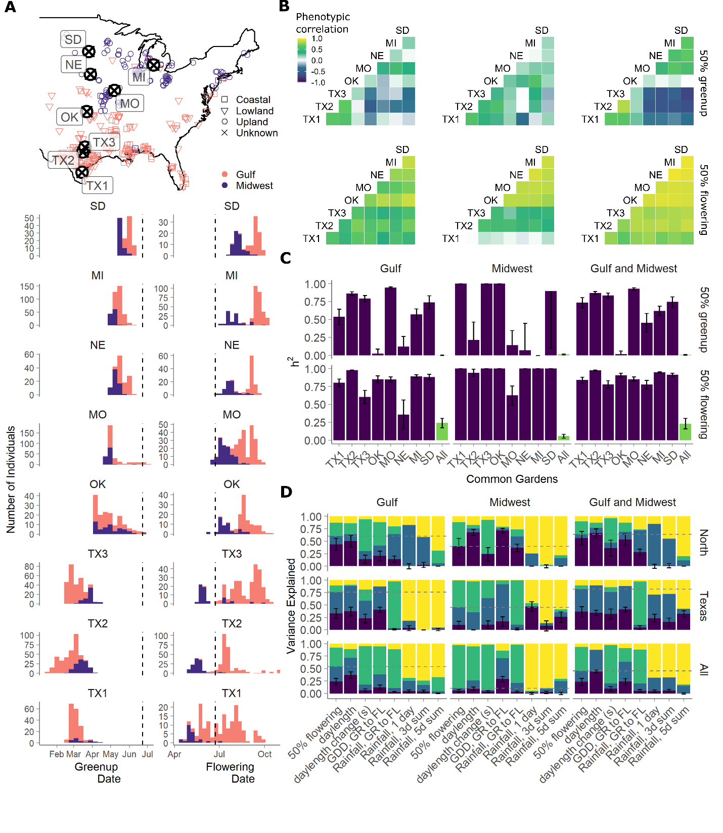
Figure 1. A) Map and trait histograms of greenup and flowering dates across two genetically distinct switchgrass subpopulations and eight common gardens. Purple represents individuals from the Midwest genetic subpopulation, and pink individuals from the Gulf subpopulation. Vertical dashed lines indicate the summer solstice. Common gardens are arranged in latitudinal order. B) Phenotypic correlations between clonal replicates planted at eight common gardens, within and between two genetic subpopulations. C) Narrow sense heritability of greenup and flowering within single common gardens (purple) and across all eight common gardens (green), within and between two genetic subpopulations. D) Variance components analysis of genetic (purple), genotype by environment (blue), environmental (green), and error (yellow) terms in models of flowering time as functions of Julian date or weather, for the four northern common gardens (North), the three Texas common gardens (Texas), and for all eight common gardens (All). Dashed lines indicate the cumulative contribution of G and GxE for flowering as a function of Julian date.
Across all eight common gardens, greenup date had low G and low GxE (<10%), and the G and GxE values were not substantially improved by defining greenup as functions of weather-based cues (Supplementary Figure/Table). This result likely indicates that the weather functions we chose are not cuing greenup. Additional signals such as soil temperatures or chilling days may influence greenup for each subpopulation within its native range; however, we did not have good proxies for these values for this experiment. G and GxE estimates for greenup date were significantly higher when the sites were restricted to either the Texas or North set of gardens (Supplemental Figure). G and GxE estimates for greenup were higher for the Gulf subpopulation than for the Midwest, and higher outside of each subpopulation’s native range than within its native range (Supplementary Figure).
In contrast to greenup date, flowering date had moderate G and GxE, and these values were significantly increased by defining flowering as functions of weather based environmental cues (Figure 1D). In the Gulf subpopulation, a daylength cue explained more G and GxE than flowering date (G = 36.8% +/- 6.4; GxE = 34.4% +/- 6.0). In the Midwest subpopulation, a cumulative GDD cue explained more G than flowering date (5.8% +/- 2.8% vs 23.8% +/- 6.1%), while three additional cues, daylength, rainfall between greenup and flowering, and rainfall in the five days before flowering, explained more G and GxE than flowering date (Figure 1D). G and GxE estimates were also higher when the common gardens were restricted to either the Texas or the North gardens. For subpopulations growing outside of their native ranges, substantial G and GxE was seen for rainfall cues, particularly for rainfall on the day of flowering. Taken together, these data indicate substantial genetic variation for a GDD-based flowering cue in the Midwest subpopulation, and similar genetic variation for a daylength cue in the Gulf subpopulation. They also suggest the presence of GxE for rainfall, GDD, and photoperiod cues for flowering, with variation for these cues more visible outside of each subpopulations’ native range.

Genotype-by-environment effects on greenup and flowering as functions of environmental cues
To further explore how GxE in greenup and flowering in these genetic subpopulations covaried with distinct environmental cues, we conducted multivariate adaptive shrinkage (mash) analyses. To do this, we generated ‘hypothesis-based’ covariance matrices derived from correlations in environmental cues in the greenup or flowering date windows for the Midwest, Gulf, or both subpopulations (Table X). These covariance matrices were derived from the same set of phenotypes defined as functions of environmental cues as previously, and represented the correlations between genotypes for these phenotypes across our common gardens. The hypothesis-based covariance matrices differed substantially by the function of environmental cue chosen and by the subgroup of genotypes for which they were calculated (Figure 2A,D).
Just as different genetic subpopulations can have different genetic covariances between phenotypes at different gardens (Figure 1B), SNPs can have different effect patterns, or covariances, on phenotypes at different gardens. Mash allows the user to include hypothesis-based covariance matrices, and also generates ‘data-driven’ covariance matrices from patterns of effects in the data. Then, mash assigns mixture proportions for each SNP onto each provided covariance matrix using maximum likelihood. Finally, mash uses Bayes’ theorem to shrink effects for each SNP towards the set of covariance matrices in accordance to their mixture proportions. For example, a SNP affecting flowering may have a high mixture proportion, or weight, on a covariance matrix created from a specific environmental cue. In that case, we can infer that the effect of that SNP on flowering is caused by a response to that environmental cue. These user-specified and data-driven covariance matrices are an important advantage mash offers for studying patterns of GxE: the user-specified covariance matrices allow hypothesis testing of specific environmental drivers for each SNP, while the data-driven covariance matrices allow exploration of additional unexplained patterns of covariation.
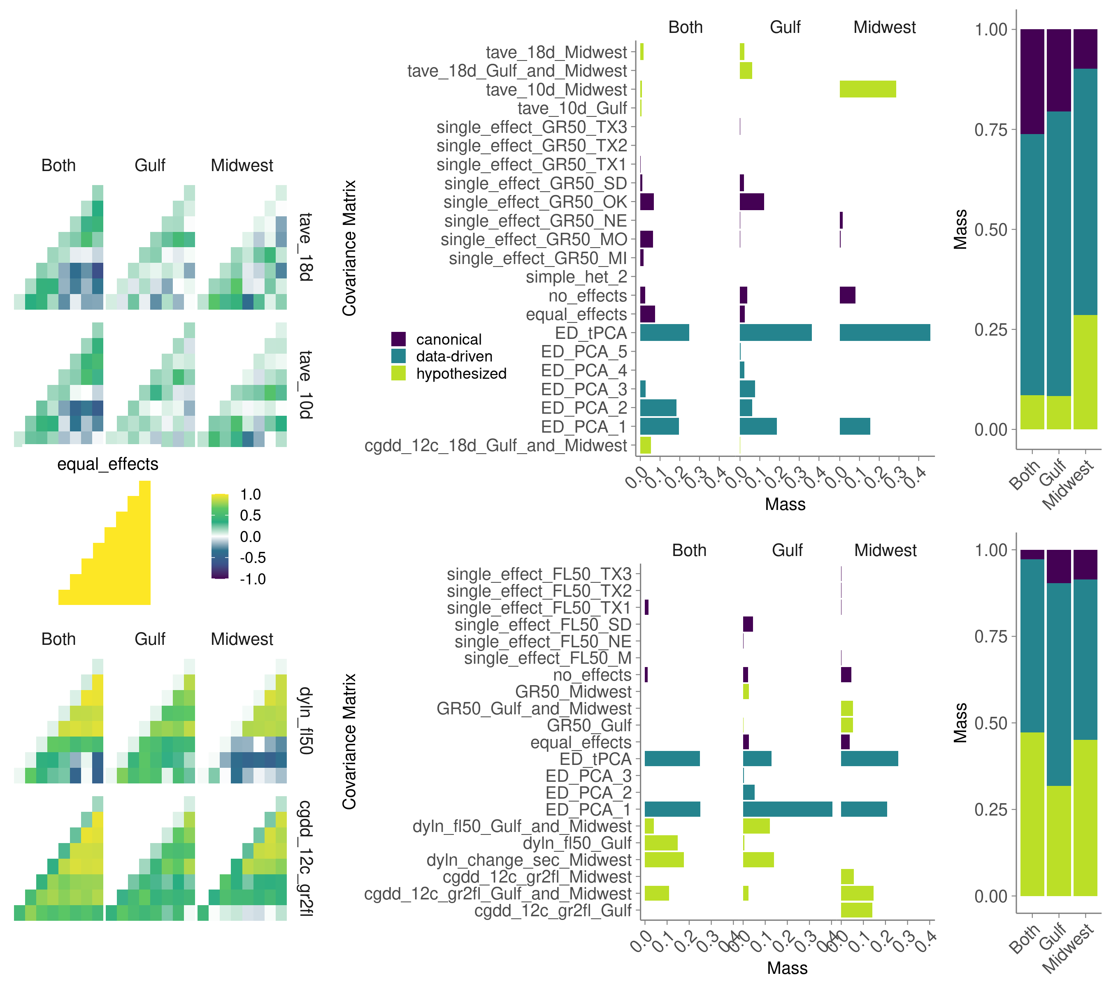
Figure 2. Example hypothesis-driven covariance matrices specified in mash and the posterior weights placed on all covariance matrices. A,D) Six example hypothesized covariance matrices specified for the A) greenup date phenotype and D) flowering date phenotype. A canonical covariance matrix of equal effects is also shown. B,E) Total posterior weight placed on each covariance matrix type specified for B) greenup date and E) flowering date mash models. Hypothesized covariance matrices (green) were created from environment-specific correlations across eight common gardens, and are described in Table X. Data-driven matrices (teal) are specific to each mash model, and canonical matrices (purple) have simple interpretations, such as equal effects across all common gardens, or effects specific to a single common garden. Covariance matrices included in mash that had zero posterior weight in all three mash runs on the genetic subgroups are not shown. C,F) Total posterior weight placed on covariance matrices that were hypothesized, data-driven, or canonical, for the C) greenup date phenotype and F) flowering date phenotype.

We used mash to examine GxE in greenup and flowering in three genetic subgroups: the Gulf, the Midwest, and both subpopulations, for a total of six mash runs. We first looked at the log-likelihoods of each of these six mash runs with and without our hypothesis-driven matrices. For mash models with both subpopulations, including the hypothesis covariance matrices significantly improved the model fit (greenup LR = 774 flowering LR = 2942). For the single subpopulations, the hypothesis covariance matrices improved the model fit for the Midwest for greenup and for the Gulf for flowering, but did not improve it for the other phenotype (Midwest greenup LR = 866; flowering LR = -3063; Gulf greenup LR = -318; flowering LR = 1279).
The hypothesis-driven matrices were created from environmental correlations during or prior to the phenological event in the Gulf, Midwest, or both subpopulations (Table X). We used distinct sets of user-specified, hypothesis-driven covariance matrices for greenup and flowering, but the same set of hypothesis-driven covariance matrices for all genetic subgroups. Thus, we could directly compare the total weight mash placed on each of these matrices between subgroups for the same phenotype. All subgroups differed in which hypothesized covariance matrices had large weights (Fig 2B,E). For greenup for the Midwest subgroup, mash placed 28.6% of the weight on the covariance matrix created by correlating the temperature average in the 10 days prior to greenup. In contrast, hypothesized matrices created by correlating average temperature and cumulative GDD over 18 days had nonzero weights in the Gulf and both subgroups. For flowering, the Midwest had the largest hypothesis-driven weights for matrices correlating cumulative GDD from greenup to flowering, while the Gulf had the largest hypothesis-driven weights for matrices correlating daylength at flowering or daylength change before flowering. Thus, distinct environmental drivers best captured SNP effects in these two genetic subpopulations. Mash on both subgroups gave large hypothesis-driven weights for all three of these matrices, indicating that mash could detect both sets of cues in the combined population. Overall, the hypothesized covariance matrices had larger weights for the flowering phenotypes than the hypothesized matrices did for the greenup phenotypes, for all three genetic subgroups (Fig 2C,F). This indicated that our hypothesized environmental drivers captured more variation in SNP effects for flowering than they did for greenup.
We were particularly interested in the linked effects for SNPs with significant non-zero effects (large Bayes factors) and moderate posterior weights on one or more hypothesized covariance matrix. These SNPs represent small genomic intervals with evidence for a phenotypic effect correlated with an environmental driver. Following our previous work, we considered SNPs with a log10-transformed Bayes Factor > 2 as having decisive evidence in favor of non-zero phenotypic effects. We considered SNPs with at least 10% of their posterior weight on a hypothesized covariance matrix. Few SNPs met these criteria and were within 20kb of a functionally annotated gene: two and four for greenup in the Gulf and in both subgroups, and four and one for flowering in the Midwest and in both subgroups (Supplementary Table X).
The two SNPs meeting these criteria for greenup in the Gulf subpopulation had high posterior weights on the cumulative GDD covariance matrix created for the 18 days before greenup for both the Gulf and Midwest subpopulation. This corresponds to the time period before and during greenup in the Gulf subpopulation. The homologs of these genes in rice were OsCPK25 and WP3. OsCPK25 is a calcium-dependent protein kinase in a gene family with high sequence similarity (Ray et al. 2007); these genes are involved in many physiological responses and developmental processes. WP3, or WHITE PANICLE 3, is a nucleus-encoded mitochondrial protein essential for proper development and maintenance of chloroplasts and mitochondria in rice (Li et al. 2018).
The four SNPs meeting these criteria for greenup in both subgroups had high posterior weights on the cumulative GDD covariance matrix created for the 18 days before greenup for both the Gulf and Midwest subpopulation. This corresponds to the time period before and during greenup in the Gulf subpopulation. Two genes within 20kb of these SNPs had homologs in rice with functional annotations: OsNAC10 and OsGRP. In rice, overexpression of OsNAC10 with a root-specific promoter increased plant tolerance to drought, high salinity, and low temperature at the vegetative stage (Jeong et al. 2010). In rice, OsGRP is a recruiting protein of geranylgeranyl diphosphate synthase that provides a mechanism to control metabolic flux toward chlorophyll biosynthesis (Zhou et al. 2017). Three genes within 20kb of two of these SNPs had homologs in A. thaliana with functional annotations: GA2OX8, HMG, and UBC2. GA2OX8 mutants had longer hypocotyls compared to wild type when grown in medium and low light conditions (Schomburg 2003). HMG encodes a component of the Facilitates Chromatin Transcription (FACT) complex, which is required for seed dormancy in A. thaliana (Michl-Holzinger, Mortensen, and Grasser 2019). UBC2 is a ubiquitin conjugating enzyme involved in the activation of FLC expression and repression of flowering in A. thaliana (Xu et al. 2009).
The four SNPs meeting these criteria for flowering in the Midwest subpopulation had high posterior weights on the cumulative GDD covariance matrix created for values for both the Gulf and Midwest subpopulation, which corresponds to the time periods before and after the Midwest subpopulation was flowering. These SNPs also had high posterior weights for the equal effects covariance matrix. The homologs of these genes in rice were OsPLS1, OsSWIB, DSM1, and Roc8, two of which have functionally validated roles in flowering in other species. In rice, deletions in OsPLS1 lead to premature leaf senescence and leaf dormancy; mutants of this homolog in A. thaliana show strong defects in male gametophyte development which impairs fruit development and increases seed sterility (Nakagawa et al. 2007). In A. thaliana, the homolog of OsSWIB, CHC1, is a protein that belongs to the chromodomain complex and is an important modulator of major developmental pathways, directly targeting the floral repressor FLC with mutants with severe defects in leaf and flower development, delayed flowering, and male sterility (Sacharowski et al. 2015; Jégu et al. 2014)The other genes had functionally validated roles in stress tolerance and leaf shape. In rice, mutations in DSM1 indicate that it may act as an early signal regulating responses to drought and oxidative stress (Ning et al. 2010, 1). In rice, Roc8 has been found to regulate the size of bulliform cells and lignin content in rice, affecting leaf curling and leaf shape (Sun et al. 2020).
The SNP meeting these criteria for flowering for both subgroups was on Chr04N at 41.2Mb, and was ~6kb from the gene Pavir.4NG180000. This SNP had high posterior weight on the daylength change (in seconds) around the time the Midwest subpopulation was flowering and before the time the Gulf subpopulation was flowering (Figure 1A). The homolog of this gene in rice is OsFTIP1, which regulates florigen transport in rice and is negatively regulated by a ubiquitin-like domain kinase (Song et al. 2017).
Major additional patterns of genotype-by-environment effects on greenup and flowering
For all six mash runs, the hypothesis-driven covariance matrices explained only a minority of SNP effects, or genotype-by-environment interactions, present in the data. Instead, most SNPs with significant effects had high posterior weights on the data-driven covariance matrices. We thus explored the SNP effect patterns in greenup and flowering described by the data-driven covariance matrices. In our data, there were five data-driven matrices (denoted ED_PCA_1 through ED_PCA_5) produced from singular value decomposition of an overall matrix, denoted ‘ED_tPCA’. While the numbered matrices typically could be described completely by garden-specific effects, the tPCA is a weighted combination of these effects. For these data-driven matrices, we could analyze both the number of SNPs with significant effects that had high posterior weight on a particular covariance matrix, and characterize the major patterns of garden-specific effects that the covariance matrix represented. Finally, we also characterized the overall patterns of differential sensitivity and antagonistic pleiotropy between all SNPs with significant effects at all pairs of gardens.
For greenup, the largest fraction of effect patterns were captured by the tPCAs, which were specific to each genetic subgroup. The majority of the variation in these tPCAs were captured by two major patterns (Figure 3a-c), similar to the patterns of the first eigenvectors of ED_PCA_1 and ED_PCA_2. For all three subgroups, this included an effect pattern characterized by large magnitude (> |0.5|) effects delaying greenup in the Texas gardens and in Oklahoma, with small (<|0.2|) to moderate (|0.2| to |0.5|) magnitude effects advancing greenup in MO and MI. Thus, the first eigenvectors of both ED_PCA_1 and ED_tPCA show antagonistic pleiotropy for greenup between the southern and the northern common gardens. These patterns are particularly common in the Gulf and in both subgroups (Figure 3d-f), where thousands of SNP effects exhibit antagonistic pleiotropy between pairs of southern and northern gardens. For the Midwest subgroup, much more differential sensitivity of effects and much less antagonistic pleiotropy between gardens was observed. The garden-specific effects of the first eigenvector of the tPCA and of ED_PCA_1 were characterized by differential sensitivity, where the magnitude of effects at the TX2 and MI gardens were much higher (Figure 3b).
For flowering, a similar fraction of effect patterns were captured by ED_PCA_1 and by the tPCA. Though these patterns were specific to each genetic subgroup, the patterns themselves were relatively consistent, with the first eigenvector of the tPCA and ED_PCA_1 characterized by large magnitude effects of consistent sign that differed in their magnitude by garden (Figure 3g-i). The first eigenvector explained over 65% of the variation in the tPCA covariance matrix for each subgroup. The second eigenvector of the tPCA and ED_PCA_2 were characterized by large magnitude effects at the southern gardens and small to moderate magnitude effects of opposite sign at the northern gardens. For all three subgroups for flowering, very little antagonistic pleiotropy was seen between pairs of gardens (Figure 3j-l). Instead, there was substantial differential sensitivity between pairs of southern gardens.
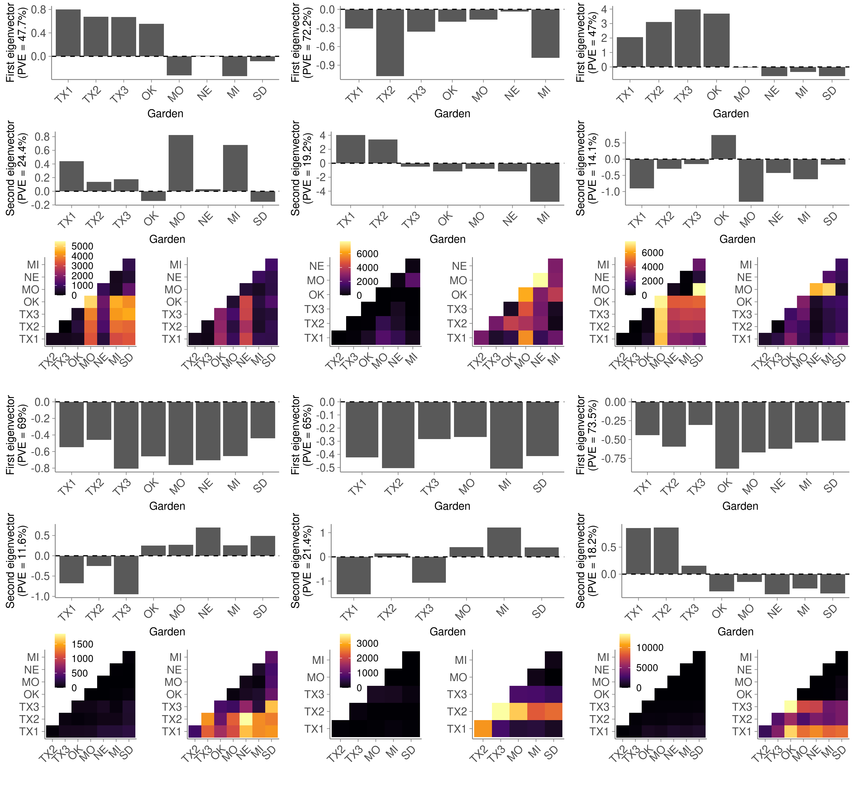
Figure 3. Effect patterns exhibited by the major data-driven matrices from Figure 2. (A,D,G,J) Gulf (B,E,H,K) Midwest, (C,F,I,L) both subgroups. (A-F) Greenup phenotype. (G-L) Flowering phenotype. (A-C,G-I) First two eigenvectors from a singular value decomposition of the ED_tPCA data-driven matrices for greenup. First eigenvector corresponds to ED_PCA_1, and second corresponds to ED_PCA_2. The percent variation explained of the tPCA by each eigenvector is shown on the y-axis. (D-F,J-L) SNPs with significant effects in both conditions that exhibit antagonistic pleiotropy or differential sensitivity between that pair of conditions
Confirmation of genotype-by-environment effects using a four-way cross
To confirm candidate genomic regions and patterns of allelic effects from mash on flowering in the Gulf and Midwest subpopulations, we analyzed flowering in an F2 cross between four individuals, two Midwest and two Gulf individuals (Milano et al 2016). The parents of this cross were DAC, an early flowering Midwest individual, VS16, a late flowering Midwest individual, AP13, an early flowering Gulf individual, and WBC, a late flowering Gulf individual (Supplementary Figure X). We made F1 crosses of the two early flowering genotypes, AP13xDAC, and the two late flowering genotypes, WBCxVS16. We then clonally propagated and planted the four parents, the two F1 genotypes (AP13xDAC, and VS16xWBC), and 801 F2 genotypes at eight field sites, then recorded greenup and flowering date for the 2019 season.
To look for dominance in flowering cues, we compared the 2019 flowering dates of the two F1 genotypes to those of the fourway parent genotypes and to the diversity panel. The F1 genotypes differed in flowering date by 17 days on average; however, both F1 genotypes flowered at similar dates as their Midwest parent genotype each year, and as Midwest subpopulation individuals in general (Supplementary Figure X; early and late F1s flowered 8.1 +/- 8.1 and 7.9 +/- 13.3 days behind their F0 parents).
To confirm associations for flowering found using mash, we conducted QTL mapping of flowering in 2019 for seven common gardens. In this analysis, we could not introduce hypothesis-driven covariance matrices. Instead, we found flowering QTL by defining flowering as functions of four variables: as a function of Julian date (‘flowering date’), as a function of cumulative GDD between greenup and flowering (‘flowering GDD’), and as a function of daylength at flowering (‘flowering daylength’), and as a function of the change in daylength at flowering (‘flowering daylength change’). There were eight QTL for flowering date and six QTL for flowering GDD, three of which overlapped with QTL for flowering date. There were ten QTL for flowering daylength, five of which overlapped with QTL for flowering date, and two of which overlapped with flowering GDD. There were eight QTL for flowering daylength change, all of which overlapped with QTL for flowering date. When multiple flowering phenotypes overlapped at a QTL, flowering daylength had the highest LOD scores in four of five cases, and flowering daylength change had the highest LOD scores in seven of eight cases (Figure 4a). Both flowering GDD and flowering daylength had unique QTL, and daylength had higher explanatory power than flowering date for the majority of QTL. All QTL for flowering overlapped one or more homologs from rice or A. thaliana with functionally validated roles in flowering. The most significant QTL were on Chr02N, Chr04K, and two positions on Chr05N.
In all 28 QTL with unique QTL boundaries, there was at least one SNP in the QTL interval either significant in one of the three mash runs at a log10-transformed Bayes Factor threshold of two, or in the 1% tail of significance, whichever was stricter. However, we also looked for enrichment of mash SNPs that were in the 1% tail of significance (the ‘mash 1% tail’) within each QTL interval. At the 5% level, half of the QTL had enrichments of SNPs in the mash 1% tail compared to expectations (given the total number of mash SNPs in the QTL interval). Overall, there were 16 significant enrichments (p < 0.05, hypergeometric test) of the mash 1% tail in the QTL intervals. We chose 1000 sets of 23 genomic regions of the same size randomly distributed throughout the genome, then calculated enrichments of the mash 1% tail in these random intervals. Our QTL intervals had more enrichments than were found for all but three of these sets of random genomic intervals (Figure 4b, p = 0.003). Thus, we were able to experimentally support our mash intervals from the diversity panel with a QTL mapping experiment using a separate mapping population.
Figure 4. Comparison of mash SNP effects from a diversity panel and effects from an outbred F2 cross on flowering across eight common gardens. (A) QTL mapping for four weather-related functions of flowering, and for greenup date, as indicated by the colors. Dotted lines indicate permutation-based significance thresholds for each weather-related function. (B) Schematic comparison of genotypes used for QTL mapping and genotypes used in mash. (C) Number of mash runs enriched for SNPs in the 1% mash tail in the 23 QTL intervals from (A) (dotted red line), compared to 1000 sets of 23 random QTL intervals of the same size (histogram). (D) SNP effects estimated using mash for SNPs with the highest Bayes factor for the three QTL with the highest LOD scores from (A) and enrichment of SNPs in the 1% mash tail. SNP genomic position and genetic subpopulation are indicated above each plot.(E) QTL effect estimates for 23 non-overlapping and partially overlapping QTLs. Colors indicate which of the four weather-related functions of flowering for which the QTL was mapped. An additional five QTLs completely overlapped the QTL displayed; in this case, the QTL with the highest lod score is shown. Solid vertical lines separate QTLs that are not overlapping. Stars indicate QTL with significant enrichment for SNPs in the 1% mash tail; B, G, and M indicate which subpopulation had enrichment, as in (B):B - both subpopulations, G - Gulf subpopulation, M -Midwest subpopulation.
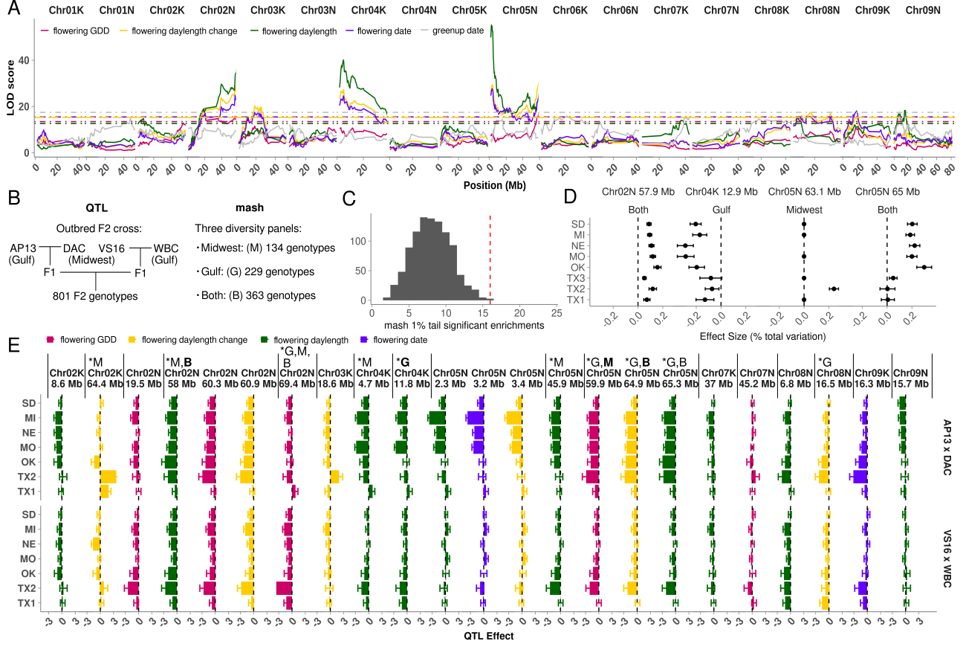
In addition, we were able to compare patterns of effects predicted by mash with patterns of effects exhibited by different contrasts of alleles in our F2 cross. To do this, we estimated the effects of alleles from all four parents as contrasts of pairs of alleles in the F2 individuals. The pairs we could contrast were the alleles received from either the AP13 x DAC F1 parent, or the VS16 x WBC F1 parent (Figure 4c). Overlapping QTL for different functions of weather differed in their LOD scores (Figure 4a). For QTL that overlapped with a cumulative GDD (CGDD) QTL, effects at northern and southern gardens tended to be of the same sign, and often of similar magnitude (Figure 4c, e.g. Chr02N 19.5 Mb, Chr02N 60.3 Mb, Chr05N 59.9 Mb). In contrast, QTL that did not overlap with a CGDD QTL tended to have moderate magnitude effects only at the southern (Figure 4c, e.g. Chr02K 64.4 Mb, Chr08N 6.8Mb, Chr09K 16.3 Mb) or northern (e.g. Chr 02K 8Mb, Chr04K 4.7 Mb, Chr04K 11.8 Mb, Chr05N 2-3Mb, Chr05N 45.9 Mb, Chr09N 15.7 Mb) gardens. Very few QTL showed antagonistic pleiotropy for effects between gardens; only QTL for daylength change had moderate antagonistically pleiotropic effects, usually between southern and northern gardens (Figure 4c, e.g. Chr02K 64.4 Mb, Chr03K 18.6 Mb).
We compared patterns of effects for the four QTL with the highest lod scores with effect patterns of the most significant SNPs in the QTL interval from mash runs enriched for SNPs in the mash 1% tail in the QTL interval. Three of the four QTL with the highest lod scores were enriched for SNPs in the mash 1% tail. These QTL included the QTL on Chr02N, Chr04K, and the two QTL on Chr05N (Figure 4d). In mash, we never observed antagonistic pleiotropy between gardens for effects of SNPs in these QTL regions. SNP effect patterns tended to have moderate magnitude effects only at northern gardens, or have effects of the same sign and similar magnitude (Figure 4c). These were also the two most commonly occurring patterns of effects seen in the QTL mapping experiment.

Discussion
As the climate and the natural environment change, it is increasingly critical to understand how patterns of gene-environment and plant-environment interactions will change in response. To do this, we must understand the current patterns of trait covariation across environments, the genetic underpinnings of these patterns, and the cases where this covariation can be altered. Here, we demonstrate that not only can genotype-by-environment interactions be mapped to specific genomic regions across a set of common gardens, but also that GxE at specific loci can be assigned to both hypothesized environmental drivers and to other, data-driven patterns not connected to known environmental drivers. If phenotypic effects can be mapped to multiple unlinked haplotype blocks, plant breeders can select for these blocks without necessarily confirming the causal loci therein. This is particularly true if breeders want to change flowering responsiveness to photoperiod cues in switchgrass, given that we have identified specific genomic regions in the Midwest subpopulation that respond to cumulative GDD cues, not photoperiod cues.
The Gulf and Midwest tetraploid genetic subpopulations of switchgrass are deeply diverged genetically and morphologically, with divergent whole plant and leaf morphologies. Here, we find that they also have distinctive phenologies correlated with distinct environmental cues. Expressing flowering date as a function of the day length at flowering increased the heritability of flowering variation in the Gulf subpopulation across all eight gardens (Figure 1d), while expressing flowering date as a function of cumulative growing degree days between greenup and flowering increased the heritability of flowering variation in the Midwest subpopulation across all eight gardens (Figure 1d). We introduced these and other environmental drivers into our multivariate analysis of flowering as hypothesis-based covariance matrices. Here, we found again that the Gulf subpopulation had SNPs with patterns of effects on flowering that corresponded to day length at flowering before and during the time period where Gulf individuals were flowering, as well as for the change in daylength in the time period shortly before Gulf individuals were flowering (Figure 2e). In contrast, the Midwest subpopulation had SNPs with patterns of effects on flowering that covaried with patterns of cumulative growing degree days both during and after the time period when Midwest individuals were flowering (Figure 2e). The Midwest subpopulation had no SNP effects that covaried with patterns of daylength or day length change, while the Gulf subpopulation had few SNP effects that covaried with patterns of cumulative GDD. Interestingly, both sets of Gulf x Midwest F1 individuals used to generate our outbred F2 mapping cross did not differ significantly in flowering date phenotype from the Midwest parent, indicating that the Midwest flowering date phenotype was dominant. Introgression from the Midwest subpopulation into Gulf individuals in our diversity panel has been observed, and could explain the limited and unequal exchange of loci covarying with different environmental cues between subpopulations. Thus, switchgrass is segregating for multiple distinct photoperiod-related flowering responses: the Midwest subpopulation is day neutral, and flowering appears to be cued by a cumulative GDD threshold; in contrast, the Gulf subpopulation is short day, and flowering appears to be cued by the transition to shortening days.
Switchgrass is considered a short-day plant that flowers when exposed to shortening days of a specific length (Benedict, 1940) and reproductive development is strongly linked to day-of-the year (Cornelius and Johnston, 1941; Eberhart and Newell, 1959; Hopkins et al., 1995a; Sanderson and Wolf, 1995a). However, switchgrass photoperiodicity has been predicted to differ by plant latitude of origin (Parish and Fike 2005). If flowering date varies as a function of GDD in some switchgrass subpopulations, this explains observations that moving southern populations northwards delays flowering, and moving northern populations south hastens flowering (Sanderson et al 1996). Indeed, in our common gardens in 2019, the average number of days from greenup to flowering for the Midwest subpopulation was 27 days shorter at our southernmost site than our northernmost site (55d vs 82d), while this value was 26 days longer for the Gulf subpopulation at the southernmost site than at the northernmost site (130d vs 104d).
The environmental drivers we selected here were based on environmental factors on the day of, or in the days just before, the phenological event. Thus, these environmental drivers depend to a large extent on the phenological timing in question. However, [there's interesting work going on to study GxE] by selecting environmental drivers at different critical periods before the phenological event occurs [e.g. summarize sorghum GxE work here]. It would be powerful to combine an approach like that with mash -building hypothesis-based covariance matrices that were not dependent on the precise timing of the phenology could give this kind of GxE mapping additional predictive power.
Our environmental-cue derived, hypothesis-based covariance matrices were able to explain some of the patterns of SNP effects, particularly for flowering date, but there were still major patterns of SNP effects present that were not explained by these functions of weather. In addition, there were many hypothesis-based covariance matrices that we tried that had environmental bases but never had significant posterior weights: for example, matrices of autocorrelation by garden distance, and matrices capturing covariation in rainfall in various periods before flowering. The data-driven covariance matrices generated by mash allowed us to understand additional patterns and potential location-specific drivers, even if we could not map these patterns of GxE to specific environmental cues at this time. For greenup, the air temperature and growing degree day cues we used only captured many SNP effects for the Midwest subpopulation, for average temperature in the 10 days before greenup. Spring growth is initiated by “adequate temperature” according to McMillan and Weiler (1959), with adequacy thought to be dependent on the cultivar (Parish and Fike 2005). However, there may be a photoperiod or vernalization mechanism rather than a temperature threshold per se that triggers spring growth (Parish and Fike 2005). In the Gulf subpopulation, our data-driven covariance matrices showed substantial antagonistic pleiotropy in effects between southern gardens and northern gardens (Figure 3a). In the Midwest subpopulation, substantially less antagonistic pleiotropy was seen, and that only between the most northern and southern gardens (Figure 3b). The major data-driven patterns seen for flowering were patterns of differential sensitivity, typically between the northern and the three Texas gardens. Thus, we saw distinct patterns of effects for each subpopulation within and outside of its native range, though the specific environmental drivers for these patterns are unclear. We speculate that one or both of these subpopulations could be responding to distinct environmental drivers within vs outside of their native ranges. Using our outbred F2 mapping panel, we saw similar SNP effect patterns for flowering in the same year and at seven of the same gardens, and an enrichment of the same genomic regions controlling flowering.
Taken together, we map the genetic basis of, and assign environmental drivers to, genotype by environment interactions in two phenological events in switchgrass across its native environment.
Methods
Diversity panel and Single Nucleotide Polymorphism Dataset
Overview of the diversity panel.
Panel collection, propagation, cultivation, and phenotyping
The formation of the diversity panel has been described previously (Lovell et al. 2021). In brief, seeds, rhizomes, and clonal propagules from natural and common gardens were collected from 2015-2018, and propagated by clonal division from 2016 to 2018 with the aim of generating > 10 clones per unique accession. Plants were grown in 1 gallon pots in the final propagation before transplanting to the field. Planting at the ten field sites occurred in the spring of 2018 and followed the methods of Lowry et al 2019, with the exception that the Blackwell cultivar was used instead of the Alamo cultivar at edge positions of the plot to control for edge effects. Plant aboveground biomass was removed in the spring of 2019 before spring tiller emergence. Plants without new growth from the crown by June 1st, 2019 were removed from the experiment and replaced with Blackwell cultivar plants in July or September 2019.
<<Paragraph about how the phenotypes of greenup, emergence, and flowering were scored. Should talk with Jason for specifics after looking in his metadata about this.>>
Panel sequencing and ecotype classification
The resequencing of the diversity panel has been described previously(Lovell et al. 2021). Briefly, 789 diversity panel samples were resequenced at a median depth of 59x (range 20 – 140x). 363 samples were used for this analysis, after filtering for missing sequence or phenotype data, outlier heterozygousity scores, and collection site discrepancies, and choosing samples from the Midwest and Gulf genetic subpopulations from the remaining samples. The reads were mapped to the V5 assembly using bwa-mem^{cite_bwa}, and SNPs were called using SAMtools mpileup⁸⁴ and Varscan V2.4.0⁸⁵ with a minimum coverage of eight and a minimum alternate allele count of four. Only SNPs with ≤ 20% missing data and minor allele frequencies > 0.05 were retained, resulting in 8.8 to 12.3 million SNPs used for genome wide association, depending on the individuals retained.
Environmental functions for greenup and flowering
Given our large number of sites with genetically identical individuals, we looked for an environmental cue that maximized narrow-sense heritability within or across subpopulations and common garden sites. Our reasoning was that, if a flowering time phenotype, as defined by a particular environmental cue, had higher heritability, it is more likely that there is detectable genetic variation segregating for that cue’s role in flowering. Ideally, heritability when defining flowering using a specific cue should be higher than heritability using Julian date; otherwise, you gain no genetic signal by defining the phenotype using that cue. We looked at heritability for nine traits associated with 50% flowering: daylength (analogous for a critical daylength for flowering), Julian date, cumulative GDD between greenup and flowering, the change in daylength from the previous day at flowering, and five measures of cumulative rainfall: cumulative rainfall between greenup and flowering, and in the two days, three days, five days, and seven days before flowering.

Because switchgrass phenology is closely correlated with growing degree days (GDD) during vegetative growth, we tested for a temperature-based environmental cue for flowering. To do this, we evaluated flowering date as a function of cumulative GDD between plant green up and flowering, using a base temperature of 12 C (Kiniry et al 2005, Behrman 2013). We then modelled GDD as a function of subpopulation and the interaction between subpopulation and latitude of origin, both as random effects. To avoid confounding with a photoperiod-based environmental cue, we removed GDD response values for genotypes predicted to have a photoperiod cue at the four common gardens south of 38°N. Including these GDD response values substantially increased the residual variance for photoperiod sensitive individuals at these sites (data not shown//in supplement). Subpopulation explained most of the variation in flowering as a function of GDD (% Var_{subpop} = 85.9%). Predicted values of GDD necessary for flowering were largest for the Gulf subpopulation (1056; 95% CI 973-1099), smallest for the Midwest (667; 95% CI 517 – 814) and intermediate for the other three groups (741 (599-1019); 776 (483-1195); 747 (573 – 1043); Supplementary table of effects). The heritability for GDD at flowering for photoperiod insensitive, sequenced individuals was 30%, while the heritability for flowering as a Julian date for the same set of individuals was 10.8% (Supplementary Table: Variance Components analysis). Thus, more phenotypic variance was explained by GDD than by Julian date for these individuals.

Genome-wide association mapping
We used the switchgrassGWAS R package (https://github.com/Alice-MacQueen/switchgrassGWAS) to allow fast, less memory intensive GWAS on the diversity panel.
Analysis of correlated SNP effects on phenotypes at multiple sites
We used the switchgrassGWAS R package to estimate and test the significance of SNP effects on phenology phenotypes measured at our common garden sites.

Multivariate adaptive shrinkage
For multivariate adaptive shrinkage (mash), we conducted univariate GWAS at each common garden for greenup and flowering, then analyzed the allelic effects of unlinked SNPs across common garden sites for the top 19K SNPs per univariate GWAS using mash. When the same SNP set is used in multiple univariate GWAS, a subsequent mash analysis shares information on patterns of effect size and direction for SNPs across these GWAS, improving the power to detect significant, shared results.
We used covariance matrices based on correlations in all three genetic subgroups as hypothesis matrices in mash on each subgroup. If these covariance matrices did not capture patterns in SNP effects, there would be little loading of SNPs onto these matrices, and thus little to no change in the mash model. However, SNPs with large Bayes factors, which summarize the overall significance of a non-zero effect, which had high mixture proportions on particular environmental covariance matrices, were good candidates for environmentally-driven SNP effects. Thus, these matrices allowed us to capture possible population-specific environmental drivers in all three genetic subgroups.
Four-way cross and Quantitative Trait Locus Dataset
Creation, propagation, cultivation, and phenotyping
A four-way population (801 F2 individuals) with their grandparents and F1 hybrid parents was clonally propagated 10 times in 3.8L pots at the Brackenridge Field Laboratory, Austin, TX in 2014-2015 and transplanted to 10 common garden sites covering 17 degrees of latitude from South Texas to South Dakota in May-July of 2015. The formation of the four-way mapping population has been described previously (Milano et al 2016). Briefly, the population was developed by initial cross between AP13 (A) x DAC6 (B) and WBC3 (C) x VS16 (D), the F1 hybrids of each of those crosses were then intercrossed reciprocally to create the four-way outbred population, 801 F2 individuals. The four grandparents were derived from highly divergent southern lowland and northern upland ecotypes: AP13, an early flowering Gulf individual, and WBC, a late flowering Gulf individual, DAC, an early flowering Midwest individual, VS16, a late flowering Midwest individual. The details of the 10 common garden sites can be found in Lowry et al. (2019). Briefly, each field was covered with one layer of weed barrier cloth, and holes were cut into the weed cloth in a honeycomb design. Plants were randomized into the holes, with each plant having four nearest neighbors located 1.56m away from each other. A row of border plants which were derived from rhizome plugs of approximately 10-year-old Alamo switchgrass were planted at every edge position to prevent edge effects. Plants were well-watered in 2015 to facilitate establishment.
Phenology data, including greenup and flowering time, have been recorded from 2016 to 2019 for the four-way population at each site. Greenup (GR50) was recorded as the day of the year when 50% of the tillers from the crown on the plant turned green, flowering (FL50) was recorded as the day of the year when 50% of the plant tillers had panicles undergoing anthesis. Additionally, cumulative growing degree days (GDD) from GR50 to FL50 was calculated as GDD = , where T_{mean} is the daily average temperature, T_{base} is the base temperature of 12 °C for switchgrass (Kiniry et al 2005, Behrman 2013). On a specific day, if T_{mean} is less than T_{base}, the GDD for that day is 0; if T_{mean} is bigger than T_{base}, the GDD for that day is the difference between T_{mean} and T_{base}. To be comparable and consistent with the diversity panel, only 2019 phenology data of the four-way population from the same seven common garden sites were used in this study.
Sequencing and QTL mapping
Illumina fragment paired end libraries, representing each of the four grandparents (A: AP13, B: DAC; C: WBC; D: VS16) were aligned to the Panicum virgatum reference genome v5) with bwa mem (Li and Durbin 2009). Details on the genetic map construction, map polishing and fine-scale reordering can be accessed on https://datadryad.org/stash/dataset/doi:10.5061/dryad.ghx3ffbjv.
Narrow-sense heritability (h2) for each phenotype (GR50, FL50, GDD) at each field site was estimated using the additive kinship matrix based on marker genotypic information. The process was accomplished via the ‘sommer’ package (Covarrubias-Pazaran, 2020) in R (2020). Briefly, we used a multivariate mixed model (mmer) that takes the kinship matrix and other random incidence matrices to estimate the variance components for each phenotype at each field, and calculates h2 as the proportion of additive genetic variance to the total variance.
QTL mapping was conducted with R/qtl2 (Broman, 2020). Specifically, we performed a genome scan with a linear mixed model accounting for the relationships among individuals (i.e., kinship matrix) and the environmental covariates (i.e., field sites). The full model can be expressed as: phenotype = µ + QTL + E + QTL x E + kinship + e, where µ is the population mean, QTL is the marker genetic effect (i.e., kinship matrix), E is the environmental effects (i.e., field sites), QTL x E is the interaction between marker genetic and environmental effects, kinship corresponds to the background polygenic variation, and e is the error term. The genome scan was accomplished through ‘scan1’ function. The statistical significance of the genome scan was established by performing a stratified (i.e., stratifying on field sites) permutation test (n=1000) using ‘scan1perm’ function. The estimated QTL effect was obtained using ‘scan1coef’ function in R/qtl2.

Data availability statement

References
Parrish DJ, Fike JH. 2005. The Biology and Agronomy of Switchgrass for Biofuels. Critical Reviews in Plant Sciences 24:423-459.

Jégu, Teddy, David Latrasse, Marianne Delarue, Heribert Hirt, Séverine Domenichini, Federico Ariel, Martin Crespi, Catherine Bergounioux, Cécile Raynaud, and Moussa Benhamed. 2014. “The BAF60 Subunit of the SWI/SNF Chromatin-Remodeling Complex Directly Controls the Formation of a Gene Loop at FLOWERING LOCUS C in Arabidopsis.” The Plant Cell 26 (2): 538–51. https://doi.org/10.1105/tpc.113.114454.
Jeong, Jin Seo, Youn Shic Kim, Kwang Hun Baek, Harin Jung, Sun-Hwa Ha, Yang Do Choi, Minkyun Kim, Christophe Reuzeau, and Ju-Kon Kim. 2010. “Root-Specific Expression of OsNAC10 Improves Drought Tolerance and Grain Yield in Rice under Field Drought Conditions.” Plant Physiology 153 (1): 185–97. https://doi.org/10.1104/pp.110.154773.
Li, Hongchang, Guobiao Ji, Yun Wang, Qian Qian, Jichen Xu, Sodmergen, Guozhen Liu, et al. 2018. “WHITE PANICLE3, a Novel Nucleus-Encoded Mitochondrial Protein, Is Essential for Proper Development and Maintenance of Chloroplasts and Mitochondria in Rice.” Frontiers in Plant Science 9. https://doi.org/10.3389/fpls.2018.00762.
Lovell, John T., Alice H. MacQueen, Sujan Mamidi, Jason Bonnette, Jerry Jenkins, Joseph D. Napier, Avinash Sreedasyam, et al. 2021. “Genomic Mechanisms of Climate Adaptation in Polyploid Bioenergy Switchgrass.” Nature, January, 1–7. https://doi.org/10.1038/s41586-020-03127-1.
Michl-Holzinger, Philipp, Simon A. Mortensen, and Klaus D. Grasser. 2019. “The SSRP1 Subunit of the Histone Chaperone FACT Is Required for Seed Dormancy in Arabidopsis.” Journal of Plant Physiology 236 (May): 105–8. https://doi.org/10.1016/j.jplph.2019.03.006.
Nakagawa, Ayami, Saori Sakamoto, Misa Takahashi, Hiromichi Morikawa, and Atsushi Sakamoto. 2007. “The RNAi-Mediated Silencing of Xanthine Dehydrogenase Impairs Growth and Fertility and Accelerates Leaf Senescence in Transgenic Arabidopsis Plants.” Plant and Cell Physiology 48 (10): 1484–95. https://doi.org/10.1093/pcp/pcm119.
Ning, Jing, Xianghua Li, Leslie M. Hicks, and Lizhong Xiong. 2010. “A Raf-Like MAPKKK Gene DSM1 Mediates Drought Resistance through Reactive Oxygen Species Scavenging in Rice.” Plant Physiology 152 (2): 876–90. https://doi.org/10.1104/pp.109.149856.
Ray, Swatismita, Pinky Agarwal, Rita Arora, Sanjay Kapoor, and Akhilesh K. Tyagi. 2007. “Expression Analysis of Calcium-Dependent Protein Kinase Gene Family during Reproductive Development and Abiotic Stress Conditions in Rice (Oryza Sativa L. Ssp. Indica).” Molecular Genetics and Genomics: MGG 278 (5): 493–505. https://doi.org/10.1007/s00438-007-0267-4.
Sacharowski, Sebastian P., Dominika M. Gratkowska, Elzbieta A. Sarnowska, Paulina Kondrak, Iga Jancewicz, Aimone Porri, Ernest Bucior, et al. 2015. “SWP73 Subunits of Arabidopsis SWI/SNF Chromatin Remodeling Complexes Play Distinct Roles in Leaf and Flower Development.” The Plant Cell 27 (7): 1889–1906. https://doi.org/10.1105/tpc.15.00233.
Song, Shiyong, Ying Chen, Lu Liu, Yanwen Wang, Shengjie Bao, Xuan Zhou, Zhi Wei Norman Teo, Chuanzao Mao, Yinbo Gan, and Hao Yu. 2017. “OsFTIP1-Mediated Regulation of Florigen Transport in Rice Is Negatively Regulated by the Ubiquitin-Like Domain Kinase OsUbDKγ4.” The Plant Cell 29 (3): 491–507. https://doi.org/10.1105/tpc.16.00728.
Sun, Jing, Xuean Cui, Shouzhen Teng, Zhao Kunnong, Yanwei Wang, Zhenhua Chen, Xuehui Sun, et al. 2020. “HD-ZIP IV Gene Roc8 Regulates the Size of Bulliform Cells and Lignin Content in Rice.” Plant Biotechnology Journal 18 (12): 2559–72. https://doi.org/10.1111/pbi.13435.
Xu, Lin, Rozenn Ménard, Alexandre Berr, Jörg Fuchs, Valérie Cognat, Denise Meyer, and Wen-Hui Shen. 2009. “The E2 Ubiquitin-Conjugating Enzymes, AtUBC1 and AtUBC2, Play Redundant Roles and Are Involved in Activation of FLC Expression and Repression of Flowering in Arabidopsis Thaliana.” The Plant Journal 57 (2): 279–88. https://doi.org/10.1111/j.1365-313X.2008.03684.x.
Zhou, Fei, Cheng-Yuan Wang, Michael Gutensohn, Ling Jiang, Peng Zhang, Dabing Zhang, Natalia Dudareva, and Shan Lu. 2017. “A Recruiting Protein of Geranylgeranyl Diphosphate Synthase Controls Metabolic Flux toward Chlorophyll Biosynthesis in Rice.” Proceedings of the National Academy of Sciences of the United States of America 114 (26): 6866–71. https://doi.org/10.1073/pnas.1705689114.
Tables & Figures, Maybe Supplementary

Phenotype | Name | Description
greenup | cgdd | Correlations in cumulative growing degree days for the five, ten, or eighteen days prior to greenup.
greenup | Temp_ave | Correlations in average temperature for the five, ten, or eighteen days prior to greenup.
flowering | greenup | Correlations in greenup.
flowering | daylength | Correlations in day length on the day of flowering.
flowering | daylength_change_seconds | Correlations in the change in daylength (in seconds) on the day of flowering.
flowering | cgdd_greenup_to_flowering | Correlations in cumulative GDD between greenup and flowering.
flowering | cumulative_rainfall | Correlations in cumulative rainfall in the one, three, or five days before flowering, or in the days between greenup and flowering.

