Title: Multivariate mapping of genotype-by-environment interactions identifies two environmental drivers of flowering in switchgrass (Panicum virgatum)

Authors: Alice MacQueen*, Li Zhang*, Jason Bonette, hosts of common gardens, Tom Juenger

Addresses: The University of Texas at Austin

Target Journal: New Phytologist (TEJ suggests: PNAS)
Possible Friendly Reviewers/Reviewers: Sarah Urbut, Annie Schmidt, Jiaming Yu, Ben Blackman, Dan Woods
NP editor: John Stinchcombe

Total Word Count: 7180 (max is 6500, need to cut ~700 words)
Introduction Word Count: 1078
Materials and Methods Word Count: 2566
Results Word Count: 2668
Discussion Word Count: 868
Number of Figures: 4
Number of Tables: 1
Supporting Information: 1 Figure (greenup variance components analysis), 1-4 Tables (SNP annotations)
Summary
- Switchgrass (Panicum virgatum) has evolved multiple divergent populations that vary in morphology and phenological timing. Here, we map the genetic basis of, and assign environmental drivers to, genotype-by-environment (GxE) interactions in phenology in two highly divergent switchgrass genetic subpopulations.
- We evaluate the genetic basis of greenup and flowering as functions of environmental cues (e.g. daylength, temperature) using a diversity panel grown at eight common gardens spanning the central United States. We use multivariate adaptive shrinkage (mash) to determine the prevalence of and map the genomic effects covarying with environmental cues and/or other data-driven effects.
- The Gulf subpopulation had SNPs affecting flowering that covaried with photoperiod cues, while the Midwest upland subpopulation had SNPs affecting flowering that covaried with cumulative growing degree days. An independent four-way cross of two Gulf and two Midwest individuals mapped 23 additive QTLs for flowering at the same common gardens, all with significant mash associations and ten with enrichment of highly significant mash associations.
- We demonstrate that we can genetically map GxE and assign loci to specific environmental drivers and/or patterns of GxE not connected to known environmental cues. We highlight loci that could change flowering responsiveness to photoperiod cues in switchgrass.
Key Words: flowering time, GxE (genotype-by-environment) interactions, switchgrass, Panicum virgatum, photoperiod

Introduction
The timing of floral development is a major component of plant fitness affected by multiple external environmental cues (e.g. temperature, daylength, and water availability) that signal existing or upcoming growing conditions. Genetic responses to these cues determine the speed, timing, and energy apportioned to reproductive growth and shape both the individual’s lifespan and its lifetime production of viable seed. Global climate forcing is increasing temperatures and causing more extreme weather events, such as droughts, heatwaves, and severe rain events (Ummenhofer and Meehl 2017). These events will alter both the timing of reproductive development and the reliability of the environmental signals that plants use to cue flowering. It is thus of increasing importance that we understand the environmental cues driving floral development and the genetics underlying flowering responses to understand the genetic potential for adaptation to novel, changing environments.
Day length (or photoperiod) is one of the most predictable environmental cues, and plants sense day length to gauge both diurnal and seasonal time and to initiate reproductive development at the right time of the year. Photoperiod responses can be facultative or obligate, and these responses are typically classified into short day, long day, and day neutral types. Short day plant flowering is cued in day lengths below a critical maximum threshold, while long day plant flowering is cued in day lengths above a critical minimum threshold. In contrast, day neutral plants flower at the same time regardless of day length. Species with wide natural distributions can segregate for multiple distinct photoperiod-related flowering responses: distinct populations of sunflower (Helianthus annuus) exhibit day-neutral, facultative short day, and facultative long-day responses, which vary with their environments (Blackman 2013; Henry, Watson, and Blackman 2014).
Distinct genetic responses that are detectable in different environments are known as genotype by environment interactions, or GxE. The methodology commonly employed to study natural variation in GxE include genetic studies using common gardens, reciprocal transplant experiments between contrasting environments, or environmental manipulations. These methods have been used in wild species to uncover widely varying genetic responsiveness to photoperiod-cued flowering (Brachi et al. 2010; Henry, Watson, and Blackman 2014; Blackman 2013; Ågren et al. 2017; Dittmar et al. 2014). In crop species, natural variation in flowering has also been mapped using these and other strategies (X. Li et al. 2018; Romero Navarro et al. 2017), and altering the timing of flowering has been a major crop improvement strategy to adapt crops for local or future environments (Jung and Müller 2009). Changing flowering responsiveness to photoperiod cues has allowed geographic range expansion and increased yields in a number of cereal species (Turner et al. 2005; Faure et al. 2012; Hung et al. 2012; Zakhrabekova et al. 2012; Yang et al. 2013) and other crops (Pin and Nilsson 2012; Weller et al. 2012). However, the majority of studies of flowering GxE have used inbreeding, short-lived species. It is not clear whether insights from these species can be extrapolated to species with different life histories.
Extensive work on the molecular network underlying flowering has been conducted in the short day flowering model plant rice (Oryza sativa) and long day flowering model plant Arabidopsis thaliana, as well as in the crop grasses maize and sorghum (Mace, Hunt, and Jordan 2013; Murphy et al. 2011; Cho, Yoon, and An 2017; Lee and An 2015; Amasino 2010; Y. Song, Gao, and Luan 2012; Amasino 2010; Andrés and Coupland 2012; Tsuji, Taoka, and Shimamoto 2011; Brambilla and Fornara 2013; Wei et al. 2020). The genes that detect photoperiod signals and integrate this response into flowering pathways are largely conserved across species and have been well described (Amasino 2010; Andrés and Coupland 2012; Kobayashi and Weigel 2007). In brief, photoperiod changes trigger expression of florigenic proteins – homologs of FLOWERING LOCUS T (FT) in Arabidopsis, and Heading date 3a (Hd3a) in rice - in leaves. These proteins move to the shoot apical meristem where they interact with additional genes to induce reproductive development. Though many of the same genes are involved in both long day and short day responses (Hayama et al. 2003), short day plants also possess unique genes and molecular pathways to regulate flowering (Brambilla and Fornara 2013; Wei et al. 2020).
Switchgrass (Panicum virgatum) is considered to be a short day plant with reproductive development strongly linked the the day of the year. It is also an obligately outcrossing, warm-season perennial with wide environmental adaptation across the eastern half of North America, and its photoperiodicity has been predicted to differ by plant latitude of origin (Parrish and Fike 2005). Over the course of one season, switchgrass behaves as a determinate plant. It typically produces a single flush of tillers, which all become reproductive after a period of vegetative (leaf) development, and cease biomass accumulation upon completion of floral development (van Esbroeck, Hussey, and Sanderson 2003). The US Department of Energy named switchgrass a model herbaceous biofuel feedstock in 1992, and since then, cultivars have been bred that significantly outproduce ethanol relative to maize and other cellulosic feedstocks (McLaughlin et al., 1999). However, switchgrass has substantial untapped genetic and morphological diversity, with tetraploid and octoploid individuals (Evans et al. 2018), phenotypically distinct ‘upland’ and ‘lowland’ ecotypes, and three geographically distinct, deeply diverged genetic subpopulations within tetraploid individuals (Lovell et al. 2021). Upland individuals are smaller in stature than lowland individuals, and have divergent leaf and whole plant morphologies (Porter 1966; McMillan 1964; 1959; Lowry et al. 2015; M. D. Casler et al. 2004; Casler et al. 2007). Flowering date has been mapped prior to the release of the switchgrass genome using diversity panels of upland individuals and using upland by lowland crosses (Tornqvist et al. 2018; Grabowski et al. 2017; Taylor et al. 2018; Lowry et al. 2019), as it has been broadly recognized that genetic differences in flowering date and photoperiod response across these genetic subpopulations will be an early point of exploitation in biomass crop breeding.
Here, we grow and phenotype a diversity panel of hundreds of distinct switchgrass genotypes, clonal replicates of which were planted at eight common garden sites across 17 degrees of latitude. We use this panel to interrogate environmental mechanisms controlling greenup and flowering using multivariate adaptive shrinkage (mash). We then use an outbred F2 cross between individuals from the most distinctive subpopulations for flowering response to dissect the genetics of flowering by environment interactions in these groups. Taken together, our results allow us to describe the environmental cues, genes, and alleles affecting flowering across two divergent switchgrass populations.

Materials and Methods
Diversity panel and Single Nucleotide Polymorphism Dataset
In 2019, we grew and phenotyped a switchgrass diversity panel at eight common garden sites also growing our outbred four-way mapping panel (Milano, Lowry, and Juenger 2016; Lowry et al. 2019). The eight common gardens cover the majority of the latitudinal and climatic range of switchgrass and therefore capture the most comprehensive picture to date of genotype-specific environmental plasticity, or genotype-by-environment interactions, in this species. The diversity panel contained 134 sequenced, clonally propagated individuals from the Midwestern genetic subpopulation and 229 individuals from the Gulf genetic subpopulation (Lovell et al. 2021). To allow for the possibility that different subpopulations had different strengths of connection between our phenotypes and genotypes (Korte and Farlow 2013), we conducted three sets of genetic analyses: on the Gulf and Midwest subpopulations separately, and on both subpopulations together (hereafter ‘Both’ subpopulations). The four northernmost common gardens (hereafter ‘North’ gardens) were located within the natural range of the Midwestern genetic subpopulation, while the three Texas common gardens (hereafter ‘Texas’ gardens) were located within the natural range of the Gulf subpopulation, and the Oklahoma common garden was located near the natural range limits of both the Gulf and the Midwestern subpopulations.

Diversity panel cultivation, phenotyping, and sequencing
The formation and planting of the diversity panel has been described previously (Lovell et al. 2021). Planting at the ten field sites occurred in the spring of 2018 and followed the methods of (Lowry et al. 2019), with the exception that the Blackwell cultivar was used instead of the Alamo cultivar at edge positions of the plot to control for edge effects. Plant above-ground biomass was removed in the spring of 2019 before spring tiller emergence. Plants without new growth from the crown by June 1st, 2019 were removed from the experiment and replaced with Blackwell cultivar plants in July or September 2019. In 2019, we scored plant greenup and flowering at these common gardens every two days. Greenup date was the day of the year when 50% of the tillers from the crown of the plant had turned green. Flowering date was the day of the year when 50% of the plant tillers had panicles undergoing anthesis.
The resequencing of the diversity panel has been described previously (Lovell et al. 2021). 363 samples were used for this analysis, after filtering for missing sequence or phenotype data, outlier heterozygousity scores, and collection site discrepancies, and choosing samples from the Midwest and Gulf genetic subpopulations from the remaining samples. Only SNPs with ≤ 20% missing data and minor allele frequencies > 0.05 were retained for subsequent analyses, resulting in 8.8 million SNPs retained for the Midwest subpopulation, 10.3 million SNPs retained for the Gulf subpopulation, and 12.3 million SNPs retained for Both subpopulations.

Narrow-sense heritability
We determined narrow-sense heritabilities (h²) for greenup dates and flowering dates at single gardens using genomic relationship matrices calculated using the van Raden method (VanRaden et al. 2009). Genomic relationship matrices were calculated within each subpopulation (Midwest and Gulf) and for both genetic subpopulations (Both). We used ASReml (VSN International) to specify mixed models of the form:
y = 1 + Zu + e
Var(u) = Gσ_{u}²
Var(e) = Iσ_{e}²
in which the vector y represents the flowering date or greenup date values for that garden, Z is the design matrix for random effects, u is the whole genome additive genetic effect, and e is the residual. Matrix G is the whole genomic relationship matrix, or kinship matrix, based on all SNPs retained for subpopulation-specific analyses. I is the rank-y identity matrix, in which y is equal to the number of flowering or greenup date values for that garden. Phenotypic variance (σ_{p}²) is σ_{u}² + σ_{e}^{2.} Narrow-sense heritability is then h² = (σ_{u}² / σ_{p}²).
These models were run for each of the eight gardens, and across all gardens by adding an additional environmental effect of site without an interaction term. This resulted in 54 models: 3 sets of populations (the Gulf, Midwest, and Both subpopulations) for 9 garden sets (all eight gardens separately, and all eight gardens together) and two phenotypes (greenup date and flowering date).

Environmental functions for greenup and flowering
Though we scored greenup and flowering as functions of Julian date, flowering is more likely cued by one or more environmental factors like temperature, rainfall, or daylength signals (Brachi et al. 2010; Hartman and Nippert 2013; Hartman, Nippert, and Springer 2012; Michael D. Casler 2012). Thus, we defined flowering as functions of eight variables: as a function of Julian date (‘flowering date’), as a function of cumulative growing degree days (GDD) between greenup and flowering dates (‘flowering GDD’), as a function of day length on the flowering date (‘flowering daylength’), as a function of the change in daylength at flowering (‘flowering daylength change’), and as functions of four measures of cumulative rainfall: cumulative rainfall between greenup and flowering, and in the one day, three days, and five days before flowering (Table 1). Cumulative GDD was calculated as GDD = , where T_{mean} is the daily average temperature, T_{base} is the base temperature of 12 °C for switchgrass, GR50 is greenup date, and FL50 is flowering date (Kiniry et al. 2005; Behrman et al. 2013). On a specific day, if T_{mean} is less than T_{base}, the GDD for that day is 0; if T_{mean} is bigger than T_{base}, the GDD for that day is the difference between T_{mean} and T_{base}. We also defined greenup as functions of seven variables: as a function of Julian date (‘greenup date’), as a function of cumulative GDD for the five, ten, or eighteen days prior to greenup, and as a function of the average air temperature for the five, ten, or eighteen days prior to greenup.

Variance components analysis
To evaluate our environmental cues as genetic triggers of flowering, we defined greenup and flowering as functions of seven and eight environmental cues, respectively, then determined the variance attributed to genetic effects (G), genotype by environment interactions (GxE), environmental effects (E), and error for these phenology-related traits across our eight common garden sites using linear mixed models. Variance components analysis was also used to partition variance between these effects. Genomic relationship matrices, or kinship matrices, were calculated as in the narrow-sense heritability section. These kinship matrices were used in mixed models of the form:
y = 1 + Z_{u}u + Z_{l}l + Z_{ul}ul + e
Var(u) = Gσ_{u}²
Var(l) = Iσ_{E}²
Var(ul) = Gσ_{uE}²
Var(e) = Iσ_{e}²
in which the vector y represents the individual plant observations of a given trait and Z are the design matrices associating trait observations with random factors. Random factors include u, the whole genome additive genetic (G) effect, l, the effect of each location (E), ul, the GxE effect, and e, the residual. Matrix G is the whole genomic relationship matrix. I are rank-y identity matrices, in which y is equal to the number of individual plant observations of a given trait.
These models were run for each phenotype as a function of various environmental cues, using three sets of gardens: all eight gardens, the North gardens, and the Texas gardens. This resulted in 135 models: three sets of populations (the Gulf, Midwest, and Both subpopulations) for three garden sets (All, North, and Texas gardens) and 15 phenotypes (seven greenup functions, and eight flowering functions).

Multivariate adaptive shrinkage
We used multivariate adaptive shrinkage (mash) to evaluate the types of covariance patterns of SNP effects across our eight common gardens. Just as different genetic subpopulations can have different genetic covariances between phenotypes at different gardens, SNPs can have different effect patterns, or covariances, on phenotypes at different gardens. Mash allows the user to include hypothesis-based covariance matrices, and also generates ‘data-driven’ covariance matrices from patterns of effects in the data. Then, mash assigns mixture proportions for each SNP onto each provided covariance matrix using maximum likelihood. Finally, mash uses Bayes’ theorem to shrink effects for each SNP towards the set of covariance matrices in accordance to their mixture proportions. For example, a SNP affecting flowering may have a high mixture proportion, or weight, on a covariance matrix created from a specific environmental cue. In that case, we can infer that the effect of that SNP on flowering is caused by a response to that environmental cue. These user-specified and data-driven covariance matrices are an important advantage mash offers for studying patterns of GxE: the user-specified covariance matrices allow hypothesis testing of specific environmental drivers for each SNP, while the data-driven covariance matrices allow exploration of additional unexplained patterns of covariation.
We first conducted univariate GWAS at each common garden for greenup and flowering date, then analyzed the allelic effects for the top 19K unlinked SNPs per univariate GWAS using mash. We used the ‘pvdiv_standard_run()’ function of the switchgrassGWAS R package (https://github.com/Alice-MacQueen/switchgrassGWAS) to conduct GWAS on genotypes from the Midwest, Gulf, and Both subpopulations, used the ‘pvdiv_bigsnp2mashr()’ function to convert univariate GWAS output to the input needed for mash, then used the ‘mash_standard_run()’ function to conduct mash.
We generated ‘hypothesis-based’ covariance matrices derived from correlations in environmental cues in the greenup or flowering date windows for the Midwest, Gulf, or both subpopulations (Table 1). These covariance matrices were derived from the same set of phenotypes defined in the environmental functions for greenup and flowering section, and represented the correlations between genotypes for these phenotypes across our common gardens. We used distinct sets of user-specified, hypothesis-driven covariance matrices for greenup and flowering, but the same set of hypothesis-driven covariance matrices for all genetic subgroups. If these covariance matrices did not capture patterns in SNP effects in the mash data, then mash would assign small mixture proportions onto these matrices using maximum likelihood, and they will have low posterior weights for all SNP effects, and thus cause little to no change in the mash model. In contrast, SNPs with high mixture proportions on particular environmental covariance matrices and large Bayes factors, which summarize the overall significance of a non-zero effect, represented small genomic intervals with strong evidence for a phenotypic effect correlated with an environmental driver.
Mash also generates ‘data-driven’ covariance matrices that explain major patterns of SNP effects present in the data that are not explained by the hypothesis-based covariance matrices. We generated six data-driven matrices per mash run, five (denoted ED_PCA_1 through ED_PCA_5) produced by singular value decomposition (SVD) of an overall matrix, denoted ‘ED_tPCA’. The numbered ED_PCA matrices could be described completely by garden-specific effects, i.e., by a SVD giving a first eigenvector of garden-specific effects that explained 100% of the variation in this matrix. The ED_tPCA matrix is a weighted combination of these numbered ED_PCA matrices and these garden-specific effects. We used SVD to present the percent variation explained (PVE) of the ED_tPCA matrix by each of the numbered ED_PCA matrices. We also used SVD to present vectors of garden-specific effects for each numbered ED_PCA matrix. We then analyzed both the fraction of SNPs with high posterior weights on the data-driven covariance matrices, and characterized the major patterns of garden-specific effects that these covariance matrices represented using SVD of each matrix into eigenvectors of garden-specific effects.
We also characterized the overall patterns of differential sensitivity and antagonistic pleiotropy between all SNPs with significant effects at all pairs of gardens. To do this, we used the ‘get_GxE’ function of the switchgrassGWAS R package to generate pairwise comparisons of SNP effects across all conditions included in mash. This function first determines which SNPs have evidence of significant effects in both conditions for all pairs of conditions using local false sign rates, which are analogous to false discovery rates but more conservative (in that they also reflect the uncertainty in the estimation of the sign of the effect) (Stephens 2017). For antagonistic pleiotropy, this function determines if the effects that are significant in both conditions are of opposite sign. For differential sensitivity, this function determines if the effects that are significant in both conditions are of the same sign, but of significantly different magnitude. Our use of local false sign rates to determine significance, and our specification that SNP effects must be significant in both conditions to be included, means that our tests for differential sensitivity, which require both effects to have the same sign and significantly different magnitudes, are more statistically conservative than our tests for antagonistic pleiotropy, which require only that both effects have different signs. This is an important advance on previous studies of antagonistic pleiotropy (e.g. (Lowry et al. 2019)), where statistical tests for antagonistic pleiotropy require two non-zero effects of different signs, and are more statistically conservative than tests for differential sensitivity, which required only non-zero effect. Previous work has likely undercounted occurrences of antagonistic pleiotropy due to this testing bias; this work does not have the same limitation.

Four-way cross and Quantitative Trait Locus mapping
To confirm candidate genomic regions and patterns of allelic effects from mash on flowering in the Gulf and Midwest subpopulations, we analyzed flowering in an outbred F2 cross between four individuals, two Midwest and two Gulf individuals. The formation of the four-way mapping population has been described previously (Milano, Lowry, and Juenger 2016). The parents of this cross were DAC, an early flowering Midwest individual, VS16, a late flowering Midwest individual, AP13, an early flowering Gulf individual, and WBC, a late flowering Gulf individual. We made F1 crosses of the two early flowering genotypes, AP13xDAC, and the two late flowering genotypes, WBCxVS16. We then clonally propagated and planted the four parents, the two F1 genotypes (AP13xDAC, and VS16xWBC), and 801 F2 genotypes at eight field sites in May-July of 2015.
The details of the 10 common garden sites can be found in (Lowry et al. 2019). Phenology data, including greenup and flowering date, was recorded from 2016 to 2019 for the four-way population at each garden using identical metrics as in the diversity panel. Additionally, we defined flowering as functions of four variables: as a function of Julian date (‘flowering date’), as a function of cumulative GDD between greenup and flowering (‘flowering GDD’), and as a function of daylength at flowering (‘flowering daylength’), and as a function of the change in daylength at flowering (‘flowering daylength change’), as in the environmental functions for greenup and flowering section above. To be directly comparable to the diversity panel data, only 2019 phenology data from the outbred F2 cross from the same seven common garden sites were used in this study.
Details on the genetic map construction, map polishing and fine-scale reordering can be accessed on https://datadryad.org/stash/dataset/doi:10.5061/dryad.ghx3ffbjv. QTL mapping was conducted with R/qtl2 (Broman et al. 2019). We performed a genome scan with a linear mixed model that accounts for the relationships among individuals and for environmental covariates (i.e., field sites). The full model can be expressed as: phenotype = µ + QTL + E + QTL x E + kinship + e, where µ is the population mean, QTL is the marker genetic effect (i.e., kinship matrix), E is the environmental effects (i.e., common garden), QTL x E is the interaction between marker genetic and environmental effects, kinship corresponds to the background polygenic variation, and e is the error term. The genome scan was accomplished with the ‘scan1’ function. The statistical significance of the genome scan was established by performing a stratified (i.e., stratifying on common garden) permutation test (n=1000) using ‘scan1perm’ function. The estimated QTL effect was obtained using ‘scan1coef’ function in R/qtl2.

Results
Diversity panel captures genetic and genotype by environment interactions across the common gardens
In our tetraploid diversity panel (Lovell et al. 2021), genotypes from the Gulf and Midwest genetic subpopulations had the most distinct phenological responses across our common gardens, and had distinct patterns of phenological correlations between common garden sites (Fig. 1a-b). At the Texas gardens, Gulf genotypes typically greened up before and flowered after Midwestern genotypes, while at the North gardens, Gulf genotypes greened up and flowered after Midwestern genotypes (Fig. 1a). At the Oklahoma common garden, Gulf and Midwestern individuals greened up over the same time period. These patterns led to strong negative phenotypic correlations for greenup between the North and Texas common gardens and contributed to positive phenotypic correlations for flowering time of larger magnitude at more northern gardens (Fig. 1b).
Narrow-sense heritabilities (h²) were variable both across common gardens and within and across the Midwest and Gulf subpopulations (Fig. 1c). At individual gardens, h² were typically quite high: 59% on average for greenup date, and 87% for flowering date. However, h² were variable across common gardens, particularly for greenup date at the OK and NE gardens. Greenup dates were uncorrelated or negatively correlated across gardens (Fig. 1b). These negative and small correlations undoubtedly contributed to the low h² values for greenup and flowering date across all eight gardens: h² was 0.8% for greenup and 23.2% for flowering date in models including all gardens. These data indicated the presence of numerous rank-changing genotype by environment interactions for these phenotypes across these common gardens.
We used variance components analysis to determine the variation in greenup and flowering date explained by genetic (G) and GxE effects. G and GxE effects explained little variation in greenup date (<10%), nor did they explain substantially more variation when greenup was defined as functions of weather-based cues (Fig. S1). However, G and GxE explained significantly higher variation in greenup date when the sites were restricted to either the Texas or North set of gardens (Fig. S1). G and GxE explained more variation in greenup date for the Gulf subpopulation than for the Midwest, and explained more variation outside each subpopulation’s native range than within its native range (Fig. S1).
In contrast to greenup date, G and GxE effects explained moderate variation in flowering date, and explained significantly more variation when flowering was defined, not as a Julian date, but as a function of an environmental cue (Fig. 1d). In the Gulf subpopulation, defining flowering as a function of daylength explained more G and GxE (G = 36.8% +/- 6.4; GxE = 34.4% +/- 6.0) than as a function of Julian date (). In the Midwest subpopulation, a cumulative GDD cue explained more G than flowering date (23.8% +/- 6.1% vs 5.8% +/- 2.8%), while three additional cues (daylength, rainfall between greenup and flowering, and rainfall in the five days before flowering) explained more G and GxE than flowering date (Fig. 1d). The variation explained by G and GxE was also higher when the common gardens were restricted to either the Texas or the North gardens. For subpopulations growing outside their native ranges, G and GxE explained a substantial amount of variation in flowering as a function of rainfall cues, particularly for rainfall on the day of flowering. Taken together, these data indicate moderate additive genetic variation for a cumulative GDD-based flowering cue in the Midwest subpopulation, and similar genetic variation for a daylength-based flowering cue in the Gulf subpopulation. They also suggest the presence of GxE for rainfall, cumulative GDD, and photoperiod cues for flowering.

Genotype-by-environment effects on greenup and flowering as functions of environmental cues
To explore how genetic variation in greenup and flowering in these genetic subpopulations covaried with distinct environmental cues, we conducted multivariate adaptive shrinkage (mash) analyses. To do this, we generated ‘hypothesis-based’ covariance matrices derived from correlations in environmental cues in the greenup or flowering date windows for the Midwest, Gulf, or both subpopulations (Table X). The hypothesis-based covariance matrices differed substantially by the function of environmental cue chosen and by the subgroup of genotypes for which they were calculated (Fig. 2a,d). We first looked at the log-likelihoods of each of these six mash runs with and without our hypothesis-based matrices. For mash models with Both subpopulations, including the hypothesis covariance matrices significantly improved the model fit (greenup likelihood ratio (LR) = 774; flowering LR = 2942). For the single subpopulations, the hypothesis-based covariance matrices improved the model fit for the Midwest for greenup and for the Gulf for flowering, but did not improve it for the other phenotype (Midwest greenup LR = 866; flowering LR = -3063; Gulf greenup LR = -318; flowering LR = 1279).
We next compared the total posterior weight mash placed on each hypothesis-based covariance matrix. We could directly compare these weights between subpopulations, as we specified an identical set of hypothesis-driven covariance matrices for all subpopulations. All subpopulations differed in which hypothesis-based matrices had large posterior weights (Fig. 2b,e). The Midwest subgroup had 28.6% of the total posterior weight on a covariance matrix created by correlating the average temperature in the 10 days prior to greenup. In contrast, the Gulf and Both subpopulations had non-zero weights on hypothesis-based matrices correlating the average temperature and cumulative GDD in the 18 days prior to greenup. For flowering, the Midwest had the largest hypothesis-driven weights for matrices correlating cumulative GDD from greenup to flowering, while the Gulf had the largest hypothesis-driven weights for matrices correlating daylength at flowering or daylength change before flowering. Thus, distinct environmental drivers best captured SNP effects in these two genetic subpopulations. In Both subpopulations, all three of these matrices had large posterior weights, indicating that mash could detect both sets of environmental cues in the combined population. Overall, the hypothesized covariance matrices had larger weights for the flowering phenotypes than the hypothesized matrices did for the greenup phenotypes, for all three genetic subgroups (Fig 2c,f). This indicated that our hypothesized environmental drivers captured more variation in SNP effects for flowering than they did for greenup.
We were particularly interested in the linked effects for SNPs with significant non-zero effects on flowering (large Bayes factors) and moderate posterior weights on one or more hypothesized covariance matrix. These SNPs represent small genomic intervals with evidence for an effect on flowering correlated with an environmental driver. Following our previous work, we considered SNPs with a log₁₀-transformed Bayes Factor > 2 as having decisive evidence in favor of non-zero phenotypic effects. We considered SNPs with at least 10% of their posterior weight on a hypothesized covariance matrix. Few SNPs met these criteria and were within 20kb of a functionally annotated gene: two and four for greenup in the Gulf and in both subgroups, and four and one for flowering in the Midwest and in both subgroups (Table S1).
The four SNPs meeting these criteria for flowering in the Midwest subpopulation had high posterior weights on the cumulative GDD covariance matrix created for values for both the Gulf and Midwest subpopulation, which corresponds to the time periods before and after the Midwest subpopulation was flowering. These SNPs also had high posterior weights for the equal effects covariance matrix. The homologs of these genes in rice were OsPLS1, OsSWIB, DSM1, and Roc8, two of which have functionally validated roles in flowering in other species. In rice, deletions in OsPLS1 lead to premature leaf senescence and leaf dormancy; mutants of this homolog in A. thaliana show strong defects in male gametophyte development which impairs fruit development and increases seed sterility (Nakagawa et al. 2007). In A. thaliana, the homolog of OsSWIB, CHC1, is a protein that belongs to the chromodomain complex and is an important modulator of major developmental pathways, directly targeting the floral repressor FLC with mutants with severe defects in leaf and flower development, delayed flowering, and male sterility (Sacharowski et al. 2015; Jégu et al. 2014)The other genes had functionally validated roles in stress tolerance and leaf shape. In rice, mutations in DSM1 indicate that it may act as an early signal regulating responses to drought and oxidative stress (Ning et al. 2010, 1). In rice, Roc8 has been found to regulate the size of bulliform cells and lignin content in rice, affecting leaf curling and leaf shape (Sun et al. 2020).
The SNP meeting these criteria for flowering for both subgroups was on Chr04N at 41.2Mb, and was ~6kb from the gene Pavir.4NG180000. This SNP had high posterior weight on flowering daylength change during Midwest subpopulation flowering (before Gulf subpopulation flowering). The homolog of this gene in rice is OsFTIP1, which regulates florigen transport in rice and is negatively regulated by a ubiquitin-like domain kinase (S. Song et al. 2017).

Major additional patterns of genotype-by-environment effects on greenup and flowering
In all six mash runs, the hypothesis-driven covariance matrices explained only a minority of SNP effects present in the data (Figure 2c,f). Most SNPs had high posterior weights on the data-driven covariance matrices. We thus explored patterns of SNP effects described by the data-driven covariance matrices. We also characterized the overall patterns of differential sensitivity and antagonistic pleiotropy between all SNPs with significant effects at all pairs of gardens.
The largest fraction of SNP effects for greenup had high posterior weights on the ED_tPCA matrices, which were specific to each genetic subgroup. 61-91% of the variation in the ED_tPCA matrices was explained by two garden-specific patterns of effects (Fig. 3a-c). These patterns corresponded to the patterns of the first eigenvectors of ED_PCA_1 and ED_PCA_2, matrices which also had non-zero posterior weights for SNP effects (Fig 2b). For all three subgroups, one of these two effect patterns was characterized by large magnitude (>|0.5|) effects delaying greenup in the Texas gardens and in Oklahoma, with small (<|0.2|) to moderate (|0.2| to |0.5|) magnitude effects advancing greenup in MO and MI. In other words, one of the two major data-driven effect patterns shows antagonistic pleiotropy for greenup date between the southern and the northern common gardens. This pattern was particularly common in the Gulf and in Both subpopulations (Fig 3d-f), where we found that thousands of SNP effects exhibited antagonistic pleiotropy between pairs of southern and northern gardens. In contrast, in the Midwest subpopulation, the garden-specific effects on greenup of the first eigenvector of the data driven ED_tPCA matrix was characterized by differential sensitivity between common gardens, with a higher magnitude of effects at the TX2 and MI gardens (Fig. 3b). In the Midwest subpopulation, we observed many more SNPs with differentially sensitive effects on greenup between common gardens, and fewer SNPs exhibiting antagonistic pleiotropy (Fig. 3e).
For flowering date, a similar fraction of SNP effects had high posterior weights on the ED_tPCA and ED_PCA_1 data-driven matrices. Though these matrices were specific to each genetic subpopulation, the patterns they captured were relatively consistent (Fig 3g-i). Over 65% of the variation in the ED_tPCA matrices was explained by the first eigenvector of this matrix, which corresponded to ED_PCA_1. The effect pattern of this matrix was characterized by large magnitude effects of consistent sign that differed in their magnitude by garden (Fig 3g-i). The second eigenvector of ED_tPCA, and ED_PCA_2, were characterized by large magnitude effects at the southern gardens and small to moderate magnitude effects of opposite sign at the northern gardens. In other words, the major data-driven effect patterns for flowering showed differential sensitivity, but no antagonistic pleiotropy, between gardens. Indeed, for all three subpopulations, very little antagonistic pleiotropy was seen between pairs of gardens; instead, there was substantial differential sensitivity between southern and northern pairs of gardens (Fig. 3j-l).

Confirmation of genotype-by-environment effects using an outbred F2 cross
We next sought independent experimental support for our mash intervals from the diversity panel using an independent F2 mapping population created from individuals from our two genetic subpopulations grown at the same common gardens (Fig. 4b). We first looked for dominance of flowering cues by examining flowering date for the F1 genotypes, each of which was a cross of distinct Midwest and Gulf genotypes. The two F1 genotypes differed in flowering date by 17 days on average; however, both F1 genotypes flowered at similar dates as their Midwest parent genotype each year (early and late F1s flowered 8.1+/-8.1 and 7.9+/-13.3 days after their Midwest parents).
We conducted QTL mapping of flowering as functions of four environmental cues that had high posterior weights in mash, and identified eight QTL for flowering date, six QTL for flowering GDD, ten QTL for flowering daylength, and eight QTL flowering daylength change. The 28 flowering QTL had 23 unique QTL boundaries, 17 of which did not overlap. Multiple flowering phenotypes tended to overlap at QTL; when this was the case, flowering daylength had the highest LOD scores in four of five cases, and flowering daylength change had the highest LOD scores in seven of eight cases (Figure 4a). Both flowering GDD and flowering daylength had QTL that did not overlap other flowering phenotypes. All QTL for flowering overlapped one or more homologs from rice or A. thaliana with functionally validated roles in flowering. The most significant QTL were on Chr02N, Chr04K, and two positions on Chr05N.
All flowering QTL intervals contained at least one SNP significant in at least one mash run at a log₁₀-transformed Bayes Factor threshold of two, or in the 1% tail of significance, whichever was stricter. We also looked for enrichments of mash SNPs in the 1% tail of significance (the ‘mash 1% tail’) within each QTL interval. At the 5% level, ten QTL had enrichments of SNPs in the mash 1% tail. Overall, there were 16 significant enrichments (p < 0.05, hypergeometric test) of SNPs in the mash 1% tail in the QTL intervals. We chose 1000 sets of 23 genomic regions of the same size randomly distributed throughout the genome, then calculated enrichments of the mash 1% tail in these random intervals. Our QTL intervals had more enrichments than were found for all but three of these sets of random genomic intervals (Fig. 4b, p = 0.003). Thus, we were able to experimentally support our mash intervals from the diversity panel with a QTL mapping experiment using a separate mapping population.
We also compared patterns of effects from mash with patterns of effects exhibited by two contrasts of alleles in the F2 mapping population. In the F2 population, we could estimate the effects of alleles from all four parents as contrasts of pairs of alleles received from either the AP13 x DAC F1 parent, or the VS16 x WBC F1 parent (Fig. 4c). QTL that overlapped with a flowering GDD QTL tended to have effects at the North and Texas gardens of the same sign, and often of similar magnitude (Fig. 4c; e.g. Chr02N 19.5 Mb, Chr02N 60.3 Mb, Chr05N 59.9 Mb). In contrast, QTL that did not overlap a flowering GDD QTL tended to have moderate magnitude effects only at the Texas (e.g. Chr02K 64.4 Mb, Chr08N 6.8Mb, Chr09K 16.3 Mb) or North (e.g. Chr 02K 8Mb, Chr04K 4.7 Mb, Chr04K 11.8 Mb, Chr05N 2-3Mb, Chr05N 45.9 Mb, Chr09N 15.7 Mb) gardens. Very few QTL showed antagonistic pleiotropy for effects between pairs of gardens; only QTL for flowering daylength change had moderate antagonistically pleiotropic effects, usually between Texas and North gardens (Fig. 4c, e.g. Chr02K 64.4 Mb, Chr03K 18.6 Mb). In mash, we also never observed antagonistic pleiotropy between gardens for effects of SNPs in these QTL regions. We compared effects for the most significant QTL with mash enrichments to the most significant SNP in the interval for the mash run with the enrichment. Three of the four QTL with the highest lod scores were enriched for SNPs in the mash 1% tail. These QTL included the QTL on Chr02N, Chr04K, and the two QTL on Chr05N (Figure 4d). SNP effect patterns tended to have moderate magnitude effects only at northern gardens, or have effects of the same sign and similar magnitude (Figure 4c). These were also the two most commonly occurring patterns of effects seen in the QTL mapping experiment.

Discussion
As the climate and the natural environment change, it is increasingly critical to understand how patterns of gene-environment and plant-environment interactions will change in response. To do this, we must understand the current patterns of trait covariation across environments, the genetic underpinnings of these patterns, and the cases where this covariation can be altered. Here, we demonstrate that not only can genotype-by-environment interactions be mapped to specific genomic regions across a set of common gardens, but also that GxE at specific loci can be assigned to both hypothesized environmental drivers and to other, data-driven patterns not connected to known environmental drivers. If phenotypic effects can be mapped to multiple unlinked haplotype blocks, plant breeders can select for these blocks without necessarily confirming the causal loci therein. This is particularly true if breeders want to change flowering responsiveness to photoperiod cues in switchgrass, given that we have identified specific genomic regions in the Midwest subpopulation that respond to cumulative GDD cues, not photoperiod cues.
The Gulf and Midwest subpopulations of switchgrass are deeply diverged genetically and have divergent morphologies and phenology. Here, we find that their divergent phenologies are driven by phenotypic effects correlated with distinct environmental cues. Expressing flowering date as a function of the day length at flowering increased flowering heritability in the Gulf subpopulation, while expressing flowering date as a function of cumulative GDD between greenup and flowering increased flowering heritability in the Midwest subpopulation (Fig. 1d). We introduced these and other environmental cues into our multivariate analysis of flowering using hypothesis-based covariance matrices in mash. Here, we found many SNP effects on flowering in the Gulf subpopulation covaried with flowering daylength when Gulf genotypes were flowering, and others covaried with flowering daylength change shortly before Gulf genotypes were flowering (when Midwest genotypes were flowering, Fig. 2e). In contrast, many SNP effects on flowering in the Midwest subpopulation covaried with flowering cumulative GDD from greenup to during and after when Midwest genotypes were flowering (when Midwest or Midwest & Gulf genotypes were flowering, Fig. 2e). SNP effects in the Midwest subpopulation did not covary with patterns of daylength or daylength change at flowering. Few SNP effects in the Gulf subpopulation covaried with flowering cumulative GDD. The dominance of Midwest flowering dates seen in our F2 cross, combined with known introgression from Midwest to Gulf genotypes, could explain the unequal penetrance of environmental cues between these two subpopulations. If flowering date varies as a function of cumulative GDD in some switchgrass subpopulations, this explains observations that moving southern populations northwards delays flowering, and moving northern populations south hastens flowering (Sanderson et al. 1996) . Indeed, in our common gardens in 2019, the average number of days from greenup to flowering for the Midwest subpopulation was 27 days shorter at our southernmost site than our northernmost site (55d vs 82d), while this value was 26 days longer for the Gulf subpopulation at the southernmost site than at the northernmost site (130d vs 104d). Overall, we find that switchgrass subpopulations are segregating for multiple distinct photoperiod-related flowering responses: the Midwest subpopulation is day neutral, and flowering appears to be cued by a cumulative GDD threshold; in contrast, the Gulf subpopulation is short day, and flowering appears to be cued by the transition to shortening days.
The environmental drivers we selected here were based on environmental factors on the day of, or in the days just before, the phenological event. Thus, these environmental drivers depend to a large extent on the phenological timing in question. However, there have been recent advances in studying GxE by determining critical environmental indices before the phenological event occurs (Li et al. 2018). It would be powerful to combine this kind of approach with mash - creating hypothesis-based covariance matrices that were not dependent on the precise timing of the phenology could give this kind of GxE mapping additional predictive power. Currently, the data-driven covariance matrices generated by mash allowed us to understand additional patterns and potential location-specific drivers, even if we could not map these patterns of GxE to specific environmental cues. These covariance matrices were particularly useful for greenup, where our hypothesis-based covariance matrices only captured many SNP effects in the Midwest subpopulation. In the Gulf subpopulation and in Both subpopulations, we saw substantial antagonistic pleiotropy in effects between the Texas and North gardens (Figure 3a). These results support theoretical models that local adaptation should involve antagonistic pleiotropy at the level of individual loci (Levene 1953; Felsenstein 1976; Kawecki and Ebert 2004; Hedrick 1986), and are the first experimental work with QTL mapping and GWAS across common gardens to find antagonistic pleiotropy to be common in small genomic regions (Savolainen, Lascoux, and Merilä 2013; Wadgymar et al. 2017; Lowry et al. 2019). Previous work has had statistical bias against detecting antagonistically pleiotropic genomic regions; our use of the local false sign rate eliminates this bias. We thus conduct a statistically unbiased assessment of antagonistically pleiotropic and differentially sensitive phenotypic effects across these environments, and find substantial antagonistic pleiotropy for greenup date in one genetic subpopulation.
Taken together, we map the genetic basis of, and assign environmental drivers to, genotype by environment interactions for two phenological events in switchgrass across its native range.

Acknowledgments
We thank the Brackenridge Field laboratory, the Ladybird Johnson Wildflower Center, and the Juenger laboratory for support with plant care and propagation. This research was supported by the US Department of Energy Awards DESC0014156 to T.E.J., DE-SC0017883 to D.B.L. Funding was provided by National Science Foundation PGRP Awards IOS0922457 and IOS1444533 to T.E.J.
Author Contribution
T.E.J. designed research. D.B.L. contributed plant material and resources. J.B., D.B.L., and T.E.J. designed and executed field experiments. A.H.M. and L.Z. conducted statistical and computational analyses. The manuscript was written by A.H.M., L.Z., and T.E.J. with contributions from all authors.

Data Availability
Whenever possible, plant material will be shared upon request. Source data to replicate these analyses are available at: https://github.com/Alice-MacQueen/pvdiv-phenology-gxe.git. SNP data to replicate these analyses are available from the UT dataverse at https://doi.org/link.

References

Ågren, Jon, Christopher G. Oakley, Sverre Lundemo, and Douglas W. Schemske. 2017. “Adaptive Divergence in Flowering Time among Natural Populations of Arabidopsis Thaliana: Estimates of Selection and QTL Mapping.” Evolution 71 (3): 550–64. https://doi.org/10.1111/evo.13126.
Amasino, Richard. 2010. “Seasonal and Developmental Timing of Flowering.” The Plant Journal 61 (6): 1001–13. https://doi.org/10.1111/j.1365-313X.2010.04148.x.
Andrés, Fernando, and George Coupland. 2012. “The Genetic Basis of Flowering Responses to Seasonal Cues.” Nature Reviews Genetics 13 (9): 627–39. https://doi.org/10.1038/nrg3291.
Behrman, Kathrine D., James R. Kiniry, Michael Winchell, Thomas E. Juenger, and Timothy H. Keitt. 2013. “Spatial Forecasting of Switchgrass Productivity under Current and Future Climate Change Scenarios.” Ecological Applications 23 (1): 73–85. https://doi.org/10.1890/12-0436.1.
Blackman, Benjamin K. 2013. “Interacting Duplications, Fluctuating Selection, and Convergence: The Complex Dynamics of Flowering Time Evolution during Sunflower Domestication.” Journal of Experimental Botany 64 (2): 421–31. https://doi.org/10.1093/jxb/ers359.
Brachi, Benjamin, Nathalie Faure, Matt Horton, Emilie Flahauw, Adeline Vazquez, Magnus Nordborg, Joy Bergelson, Joel Cuguen, and Fabrice Roux. 2010. “Linkage and Association Mapping of Arabidopsis Thaliana Flowering Time in Nature.” Edited by Trudy F. C. Mackay. PLoS Genetics 6 (5): e1000940. https://doi.org/10.1371/journal.pgen.1000940.
Brambilla, Vittoria, and Fabio Fornara. 2013. “Molecular Control of Flowering in Response to Day Length in Rice.” Journal of Integrative Plant Biology 55 (5): 410–18. https://doi.org/10.1111/jipb.12033.
Broman, Karl W., Daniel M. Gatti, Petr Simecek, Nicholas A. Furlotte, Pjotr Prins, Śaunak Sen, Brian S. Yandell, and Gary A. Churchill. 2019. “R/Qtl2: Software for Mapping Quantitative Trait Loci with High-Dimensional Data and Multiparent Populations.” Genetics 211 (2): 495–502. https://doi.org/10.1534/genetics.118.301595.
Casler, M. D., K. P. Vogel, C. M. Taliaferro, and R. L. Wynia. 2004. “Latitudinal Adaptation of Switchgrass Populations.” Crop Science 44 (1): 293–303. https://doi.org/10.2135/cropsci2004.2930.
Casler, Michael D. 2012. “Switchgrass Breeding, Genetics, and Genomics.” In Switchgrass: A Valuable Biomass Crop for Energy, edited by Andrea Monti, 29–53. Green Energy and Technology. London: Springer. https://doi.org/10.1007/978-1-4471-2903-5_2.
Casler, Michael D., Chad A. Stendal, Ludmila Kapich, and Kenneth P. Vogel. 2007. “Genetic Diversity, Plant Adaptation Regions, and Gene Pools for Switchgrass.” Crop Science 47 (6): 2261–73. https://doi.org/10.2135/cropsci2006.12.0797.
Cho, Lae-Hyeon, Jinmi Yoon, and Gynheung An. 2017. “The Control of Flowering Time by Environmental Factors.” The Plant Journal 90 (4): 708–19. https://doi.org/10.1111/tpj.13461.
Dittmar, Emily L., Christopher G. Oakley, Jon Ågren, and Douglas W. Schemske. 2014. “Flowering Time QTL in Natural Populations of Arabidopsis Thaliana and Implications for Their Adaptive Value.” Molecular Ecology 23 (17): 4291–4303. https://doi.org/10.1111/mec.12857.
Esbroeck, G. A. van, M. A. Hussey, and M. A. Sanderson. 2003. “Variation between Alamo and Cave-in-Rock Switchgrass in Response to Photoperiod Extension.” Crop Science 43 (2): 639–43. https://doi.org/10.2135/cropsci2003.6390.
Evans, Joseph, Millicent D. Sanciangco, Kin H. Lau, Emily Crisovan, Kerrie Barry, Chris Daum, Hope Hundley, et al. 2018. “Extensive Genetic Diversity Is Present within North American Switchgrass Germplasm.” The Plant Genome 11 (1): 170055. https://doi.org/10.3835/plantgenome2017.06.0055.
Faure, Sebastien, Adrian S. Turner, Damian Gruszka, Vangelis Christodoulou, Seth J. Davis, Maria von Korff, and David A. Laurie. 2012. “Mutation at the Circadian Clock Gene EARLY MATURITY 8 Adapts Domesticated Barley (Hordeum Vulgare) to Short Growing Seasons.” Proceedings of the National Academy of Sciences 109 (21): 8328–33. https://doi.org/10.1073/pnas.1120496109.
Felsenstein, Joseph. 1976. “The Theoretical Population Genetics of Variable Selection and Migration.” Annual Review of Genetics 10 (1): 253–80. https://doi.org/10.1146/annurev.ge.10.120176.001345.
Grabowski, Paul P., Joseph Evans, Chris Daum, Shweta Deshpande, Kerrie W. Barry, Megan Kennedy, Guillaume Ramstein, et al. 2017. “Genome-Wide Associations with Flowering Time in Switchgrass Using Exome-Capture Sequencing Data.” The New Phytologist 213 (1): 154–69. https://doi.org/10.1111/nph.14101.
Hartman, Jeffrey C., and Jesse B. Nippert. 2013. “Physiological and Growth Responses of Switchgrass ( Panicum Virgatum L.) in Native Stands under Passive Air Temperature Manipulation.” GCB Bioenergy 5 (6): 683–92. https://doi.org/10.1111/j.1757-1707.2012.01204.x.
Hartman, Jeffrey C., Jesse B. Nippert, and Clint J. Springer. 2012. “Ecotypic Responses of Switchgrass to Altered Precipitation.” Functional Plant Biology 39 (2): 126–36. https://doi.org/10.1071/FP11229.
Hayama, Ryosuke, Shuji Yokoi, Shojiro Tamaki, Masahiro Yano, and Ko Shimamoto. 2003. “Adaptation of Photoperiodic Control Pathways Produces Short-Day Flowering in Rice.” Nature 422 (6933): 719–22. https://doi.org/10.1038/nature01549.
Hedrick, P W. 1986. “Genetic Polymorphism in Heterogeneous Environments: A Decade Later.” Annual Review of Ecology and Systematics 17 (1): 535–66. https://doi.org/10.1146/annurev.es.17.110186.002535.
Henry, Lucas P., Ray H. B. Watson, and Benjamin K. Blackman. 2014. “Transitions in Photoperiodic Flowering Are Common and Involve Few Loci in Wild Sunflowers (Helianthus; Asteraceae).” American Journal of Botany 101 (10): 1748–58. https://doi.org/10.3732/ajb.1400097.
Hung, Hsiao-Yi, Laura M. Shannon, Feng Tian, Peter J. Bradbury, Charles Chen, Sherry A. Flint-Garcia, Michael D. McMullen, et al. 2012. “ZmCCT and the Genetic Basis of Day-Length Adaptation Underlying the Postdomestication Spread of Maize.” Proceedings of the National Academy of Sciences 109 (28): E1913–21. https://doi.org/10.1073/pnas.1203189109.
Jégu, Teddy, David Latrasse, Marianne Delarue, Heribert Hirt, Séverine Domenichini, Federico Ariel, Martin Crespi, Catherine Bergounioux, Cécile Raynaud, and Moussa Benhamed. 2014. “The BAF60 Subunit of the SWI/SNF Chromatin-Remodeling Complex Directly Controls the Formation of a Gene Loop at FLOWERING LOCUS C in Arabidopsis.” The Plant Cell 26 (2): 538–51. https://doi.org/10.1105/tpc.113.114454.
Jung, Christian, and Andreas E. Müller. 2009. “Flowering Time Control and Applications in Plant Breeding.” Trends in Plant Science 14 (10): 563–73. https://doi.org/10.1016/j.tplants.2009.07.005.
Kawecki, Tadeusz J., and Dieter Ebert. 2004. “Conceptual Issues in Local Adaptation.” Ecology Letters 7 (12): 1225–41. https://doi.org/10.1111/j.1461-0248.2004.00684.x.
Kiniry, J.R., K.A. Cassida, M.A. Hussey, J.P. Muir, W.R. Ocumpaugh, J.C. Read, R.L. Reed, M.A. Sanderson, B.C. Venuto, and J.R. Williams. 2005. “Switchgrass Simulation by the ALMANAC Model at Diverse Sites in the Southern US.” Biomass and Bioenergy 29 (6): 419–25. https://doi.org/10.1016/j.biombioe.2005.06.003.
Kobayashi, Yasushi, and Detlef Weigel. 2007. “Move on up, It’s Time for Change—Mobile Signals Controlling Photoperiod-Dependent Flowering.” Genes & Development 21 (19): 2371–84. https://doi.org/10.1101/gad.1589007.
Koboldt, Daniel C., Qunyuan Zhang, David E. Larson, Dong Shen, Michael D. McLellan, Ling Lin, Christopher A. Miller, Elaine R. Mardis, Li Ding, and Richard K. Wilson. 2012. “VarScan 2: Somatic Mutation and Copy Number Alteration Discovery in Cancer by Exome Sequencing.” Genome Research 22 (3): 568–76. https://doi.org/10.1101/gr.129684.111.
Korte, Arthur, and Ashley Farlow. 2013. “The Advantages and Limitations of Trait Analysis with GWAS: A Review.” Plant Methods 9 (1): 29. https://doi.org/10.1186/1746-4811-9-29.
Lee, Yang-Seok, and Gynheung An. 2015. “Regulation of Flowering Time in Rice.” Journal of Plant Biology 58 (6): 353–60. https://doi.org/10.1007/s12374-015-0425-x.
Levene, Howard. 1953. “Genetic Equilibrium When More Than One Ecological Niche Is Available.” The American Naturalist 87 (836): 331–33. https://doi.org/10.1086/281792.
Li, Heng, and Richard Durbin. 2009. “Fast and Accurate Short Read Alignment with Burrows–Wheeler Transform.” Bioinformatics 25 (14): 1754–60. https://doi.org/10.1093/bioinformatics/btp324.
Li, Heng, Bob Handsaker, Alec Wysoker, Tim Fennell, Jue Ruan, Nils Homer, Gabor Marth, Goncalo Abecasis, Richard Durbin, and 1000 Genome Project Data Processing Subgroup. 2009. “The Sequence Alignment/Map Format and SAMtools.” Bioinformatics 25 (16): 2078–79. https://doi.org/10.1093/bioinformatics/btp352.
Li, Xin, Tingting Guo, Qi Mu, Xianran Li, and Jianming Yu. 2018. “Genomic and Environmental Determinants and Their Interplay Underlying Phenotypic Plasticity.” Proceedings of the National Academy of Sciences 115 (26): 6679–84. https://doi.org/10.1073/pnas.1718326115.
Lovell, John T., Alice H. MacQueen, Sujan Mamidi, Jason Bonnette, Jerry Jenkins, Joseph D. Napier, Avinash Sreedasyam, et al. 2021. “Genomic Mechanisms of Climate Adaptation in Polyploid Bioenergy Switchgrass.” Nature, January, 1–7. https://doi.org/10.1038/s41586-020-03127-1.
Lowry, David B., John T. Lovell, Li Zhang, Jason Bonnette, Philip A. Fay, Robert B. Mitchell, John Lloyd-Reilley, et al. 2019. “QTL × Environment Interactions Underlie Adaptive Divergence in Switchgrass across a Large Latitudinal Gradient.” Proceedings of the National Academy of Sciences 116 (26): 12933–41. https://doi.org/10.1073/pnas.1821543116.
Lowry, David B., Samuel H. Taylor, Jason Bonnette, Michael J. Aspinwall, Ashley L. Asmus, Tim H. Keitt, Christian M. Tobias, and Thomas E. Juenger. 2015. “QTLs for Biomass and Developmental Traits in Switchgrass (Panicum Virgatum).” BioEnergy Research 8 (4): 1856–67. https://doi.org/10.1007/s12155-015-9629-7.
Mace, E. S., C. H. Hunt, and D. R. Jordan. 2013. “Supermodels: Sorghum and Maize Provide Mutual Insight into the Genetics of Flowering Time.” Theoretical and Applied Genetics 126 (5): 1377–95. http://dx.doi.org.ezproxy.lib.utexas.edu/10.1007/s00122-013-2059-z.
McLaughlin, S, J Bouton, D Bransby, B Conger, W Ocumpaugh, D Parrish, C Taliaferro, K Vogel, and S Wullschleger. n.d. “Developing Switchgrass as a Bioenergy Crop,” 18.
McMillan, Calvin. 1959. “The Role of Ecotypic Variation in the Distribution of the Central Grassland of North America.” Ecological Monographs 29 (4): 285–308. https://doi.org/10.2307/1942132.
———. 1964. “ECOTYPIC DIFFERENTIATION WITHIN FOUR NORTH AMERICAN PRAIRIE GRASSES. I. MORPHOLOGICAL VARIATION WITHIN TRANSPLANTED COMMUNITY FRACTIONS.” American Journal of Botany 51 (10): 1119–28. https://doi.org/10.1002/j.1537-2197.1964.tb06743.x.
Milano, Elizabeth R, David B Lowry, and Thomas E Juenger. 2016. “The Genetic Basis of Upland/Lowland Ecotype Divergence in Switchgrass (Panicum Virgatum).” G3 Genes|Genomes|Genetics 6 (11): 3561–70. https://doi.org/10.1534/g3.116.032763.
Murphy, Rebecca L., Robert R. Klein, Daryl T. Morishige, Jeff A. Brady, William L. Rooney, Frederick R. Miller, Diana V. Dugas, Patricia E. Klein, and John E. Mullet. 2011. “Coincident Light and Clock Regulation of Pseudoresponse Regulator Protein 37 (PRR37) Controls Photoperiodic Flowering in Sorghum.” Proceedings of the National Academy of Sciences 108 (39): 16469–74. https://doi.org/10.1073/pnas.1106212108.
Nakagawa, Ayami, Saori Sakamoto, Misa Takahashi, Hiromichi Morikawa, and Atsushi Sakamoto. 2007. “The RNAi-Mediated Silencing of Xanthine Dehydrogenase Impairs Growth and Fertility and Accelerates Leaf Senescence in Transgenic Arabidopsis Plants.” Plant and Cell Physiology 48 (10): 1484–95. https://doi.org/10.1093/pcp/pcm119.
Ning, Jing, Xianghua Li, Leslie M. Hicks, and Lizhong Xiong. 2010. “A Raf-Like MAPKKK Gene DSM1 Mediates Drought Resistance through Reactive Oxygen Species Scavenging in Rice.” Plant Physiology 152 (2): 876–90. https://doi.org/10.1104/pp.109.149856.
Parrish, David J., and John H. Fike. 2005. “The Biology and Agronomy of Switchgrass for Biofuels.” Critical Reviews in Plant Sciences 24 (5–6): 423–59. https://doi.org/10.1080/07352680500316433.
Pin, P. A., and O. Nilsson. 2012. “The Multifaceted Roles of FLOWERING LOCUS T in Plant Development.” Plant, Cell & Environment 35 (10): 1742–55. https://doi.org/10.1111/j.1365-3040.2012.02558.x.
Porter, Clyde L. 1966. “An Analysis of Variation Between Upland and Lowland Switchgrass, Panicum Virgatum L., in Central Oklahoma.” Ecology 47 (6): 980–92. https://doi.org/10.2307/1935646.
Romero Navarro, J. Alberto, Martha Willcox, Juan Burgueño, Cinta Romay, Kelly Swarts, Samuel Trachsel, Ernesto Preciado, et al. 2017. “A Study of Allelic Diversity Underlying Flowering-Time Adaptation in Maize Landraces.” Nature Genetics 49 (3): 476–80. https://doi.org/10.1038/ng.3784.
Sacharowski, Sebastian P., Dominika M. Gratkowska, Elzbieta A. Sarnowska, Paulina Kondrak, Iga Jancewicz, Aimone Porri, Ernest Bucior, et al. 2015. “SWP73 Subunits of Arabidopsis SWI/SNF Chromatin Remodeling Complexes Play Distinct Roles in Leaf and Flower Development.” The Plant Cell 27 (7): 1889–1906. https://doi.org/10.1105/tpc.15.00233.
Sanderson, M. A., R. L. Reed, S. B. McLaughlin, S. D. Wullschleger, B. V. Conger, D. J. Parrish, D. D. Wolf, et al. 1996. “Switchgrass as a Sustainable Bioenergy Crop.” Bioresource Technology, A Collection of Papers Presented at An Alternative Energy Conference - Liquid Fuels, Lubricants and Additives from Biomass, 56 (1): 83–93. https://doi.org/10.1016/0960-8524(95)00176-X.
Savolainen, Outi, Martin Lascoux, and Juha Merilä. 2013. “Ecological Genomics of Local Adaptation.” Nature Reviews Genetics 14 (11): 807–20. https://doi.org/10.1038/nrg3522.
Song, Shiyong, Ying Chen, Lu Liu, Yanwen Wang, Shengjie Bao, Xuan Zhou, Zhi Wei Norman Teo, Chuanzao Mao, Yinbo Gan, and Hao Yu. 2017. “OsFTIP1-Mediated Regulation of Florigen Transport in Rice Is Negatively Regulated by the Ubiquitin-Like Domain Kinase OsUbDKγ4.” The Plant Cell 29 (3): 491–507. https://doi.org/10.1105/tpc.16.00728.
Song, YuanLi, ZhiChao Gao, and WeiJiang Luan. 2012. “Interaction between Temperature and Photoperiod in Regulation of Flowering Time in Rice.” Science China. Life Sciences 55 (3): 241–49. https://doi.org/10.1007/s11427-012-4300-4.
Stephens, Matthew. 2017. “False Discovery Rates: A New Deal.” Biostatistics 18 (2): 275–94. https://doi.org/10.1093/biostatistics/kxw041.
Sun, Jing, Xuean Cui, Shouzhen Teng, Zhao Kunnong, Yanwei Wang, Zhenhua Chen, Xuehui Sun, et al. 2020. “HD-ZIP IV Gene Roc8 Regulates the Size of Bulliform Cells and Lignin Content in Rice.” Plant Biotechnology Journal 18 (12): 2559–72. https://doi.org/10.1111/pbi.13435.
Taylor, Megan, Carl-Erik Tornqvist, Xiongwei Zhao, Paul Grabowski, Rebecca Doerge, Jianxin Ma, Jeffrey Volenec, et al. 2018. “Genome-Wide Association Study in Pseudo-F2 Populations of Switchgrass Identifies Genetic Loci Affecting Heading and Anthesis Dates.” Frontiers in Plant Science 9. https://doi.org/10.3389/fpls.2018.01250.
Tornqvist, Carl-Erik, Megan Taylor, Yiwei Jiang, Joseph Evans, C. Robin Buell, Shawn M. Kaeppler, and Michael D. Casler. 2018. “Quantitative Trait Locus Mapping for Flowering Time in a Lowland × Upland Switchgrass Pseudo-F2 Population.” The Plant Genome 11 (2): 170093. https://doi.org/10.3835/plantgenome2017.10.0093.
Tsuji, Hiroyuki, Ken-ichiro Taoka, and Ko Shimamoto. 2011. “Regulation of Flowering in Rice: Two Florigen Genes, a Complex Gene Network, and Natural Variation.” Current Opinion in Plant Biology 14 (1): 45–52. https://doi.org/10.1016/j.pbi.2010.08.016.
Turner, Adrian, James Beales, Sébastien Faure, Roy P. Dunford, and David A. Laurie. 2005. “The Pseudo-Response Regulator Ppd-H1 Provides Adaptation to Photoperiod in Barley.” Science 310 (5750): 1031–34. https://doi.org/10.1126/science.1117619.
Ummenhofer, Caroline C., and Gerald A. Meehl. 2017. “Extreme Weather and Climate Events with Ecological Relevance: A Review.” Philosophical Transactions of the Royal Society B: Biological Sciences 372 (1723): 20160135. https://doi.org/10.1098/rstb.2016.0135.
VanRaden, P. M., C. P. Van Tassell, G. R. Wiggans, T. S. Sonstegard, R. D. Schnabel, J. F. Taylor, and F. S. Schenkel. 2009. “Invited Review: Reliability of Genomic Predictions for North American Holstein Bulls.” Journal of Dairy Science 92 (1): 16–24. https://doi.org/10.3168/jds.2008-1514.
Wadgymar, Susana M., David B. Lowry, Billie A. Gould, Caitlyn N. Byron, Rachel M. Mactavish, and Jill T. Anderson. 2017. “Identifying Targets and Agents of Selection: Innovative Methods to Evaluate the Processes That Contribute to Local Adaptation.” Methods in Ecology and Evolution 8 (6): 738–49. https://doi.org/10.1111/2041-210X.12777.
Wei, Hua, Xiling Wang, Hang Xu, and Lei Wang. 2020. “Molecular Basis of Heading Date Control in Rice.” ABIOTECH 1 (4): 219–32. https://doi.org/10.1007/s42994-020-00019-w.
Weller, James L., Lim Chee Liew, Valérie F. G. Hecht, Vinodan Rajandran, Rebecca E. Laurie, Stephen Ridge, Bénédicte Wenden, et al. 2012. “A Conserved Molecular Basis for Photoperiod Adaptation in Two Temperate Legumes.” Proceedings of the National Academy of Sciences 109 (51): 21158–63. https://doi.org/10.1073/pnas.1207943110.
Yang, Ying, Qiang Peng, Guo-Xing Chen, Xiang-Hua Li, and Chang-Yin Wu. 2013. “OsELF3 Is Involved in Circadian Clock Regulation for Promoting Flowering under Long-Day Conditions in Rice.” Molecular Plant 6 (1): 202–15. https://doi.org/10.1093/mp/sss062.
Zakhrabekova, Shakhira, Simon P. Gough, Ilka Braumann, André H. Müller, Joakim Lundqvist, Katharina Ahmann, Christoph Dockter, et al. 2012. “Induced Mutations in Circadian Clock Regulator Mat-a Facilitated Short-Season Adaptation and Range Extension in Cultivated Barley.” Proceedings of the National Academy of Sciences 109 (11): 4326–31. https://doi.org/10.1073/pnas.1113009109.

Figures

Figure 1. Characterization of greenup and flowering dates from the switchgrass diversity panel. (a) Map and trait histograms of greenup and flowering dates across two genetically distinct switchgrass subpopulations and eight common gardens. Purple represents individuals from the Midwest genetic subpopulation, and pink individuals from the Gulf subpopulation. Vertical dashed lines indicate the summer solstice. Common gardens are arranged in latitudinal order. (b) Phenotypic correlations between clonal replicates planted at eight common gardens, within and between two genetic subpopulations. (c) Narrow sense heritability of greenup and flowering within single common gardens (purple) and across all eight common gardens (green), within and between two genetic subpopulations. (d) Variance components analysis of genetic (purple), genotype by environment (blue), environmental (green), and error (yellow) terms in models of flowering time as functions of Julian date or weather, for the four northern common gardens (North), the three Texas common gardens (Texas), and for all eight common gardens (All). Dashed lines indicate the cumulative contribution of G and GxE for flowering as a function of Julian date.
Figure 2. Example hypothesis-driven covariance matrices specified in mash and the posterior weights placed on all covariance matrices. (a,d) Six example hypothesized covariance matrices specified for the (a) greenup date phenotype and (d) flowering date phenotype. Common gardens are arranged in latitudinal order. A canonical covariance matrix of equal effects is also shown. (b,e) Total posterior weight placed on each covariance matrix type specified for (b) greenup date and (e) flowering date mash models. Hypothesized covariance matrices (green) were created from environment-specific correlations across eight common gardens, and are described in Table 1. Data-driven matrices (teal) are specific to each mash model, and canonical matrices (purple) have simple interpretations, such as equal effects across all common gardens, or effects specific to a single common garden. Covariance matrices included in mash that had zero posterior weight in all three mash runs on the genetic subgroups are not shown. (c,f) Total posterior weight placed on covariance matrices that were hypothesized, data-driven, or canonical, for the (c) greenup date phenotype and (f) flowering date phenotype.
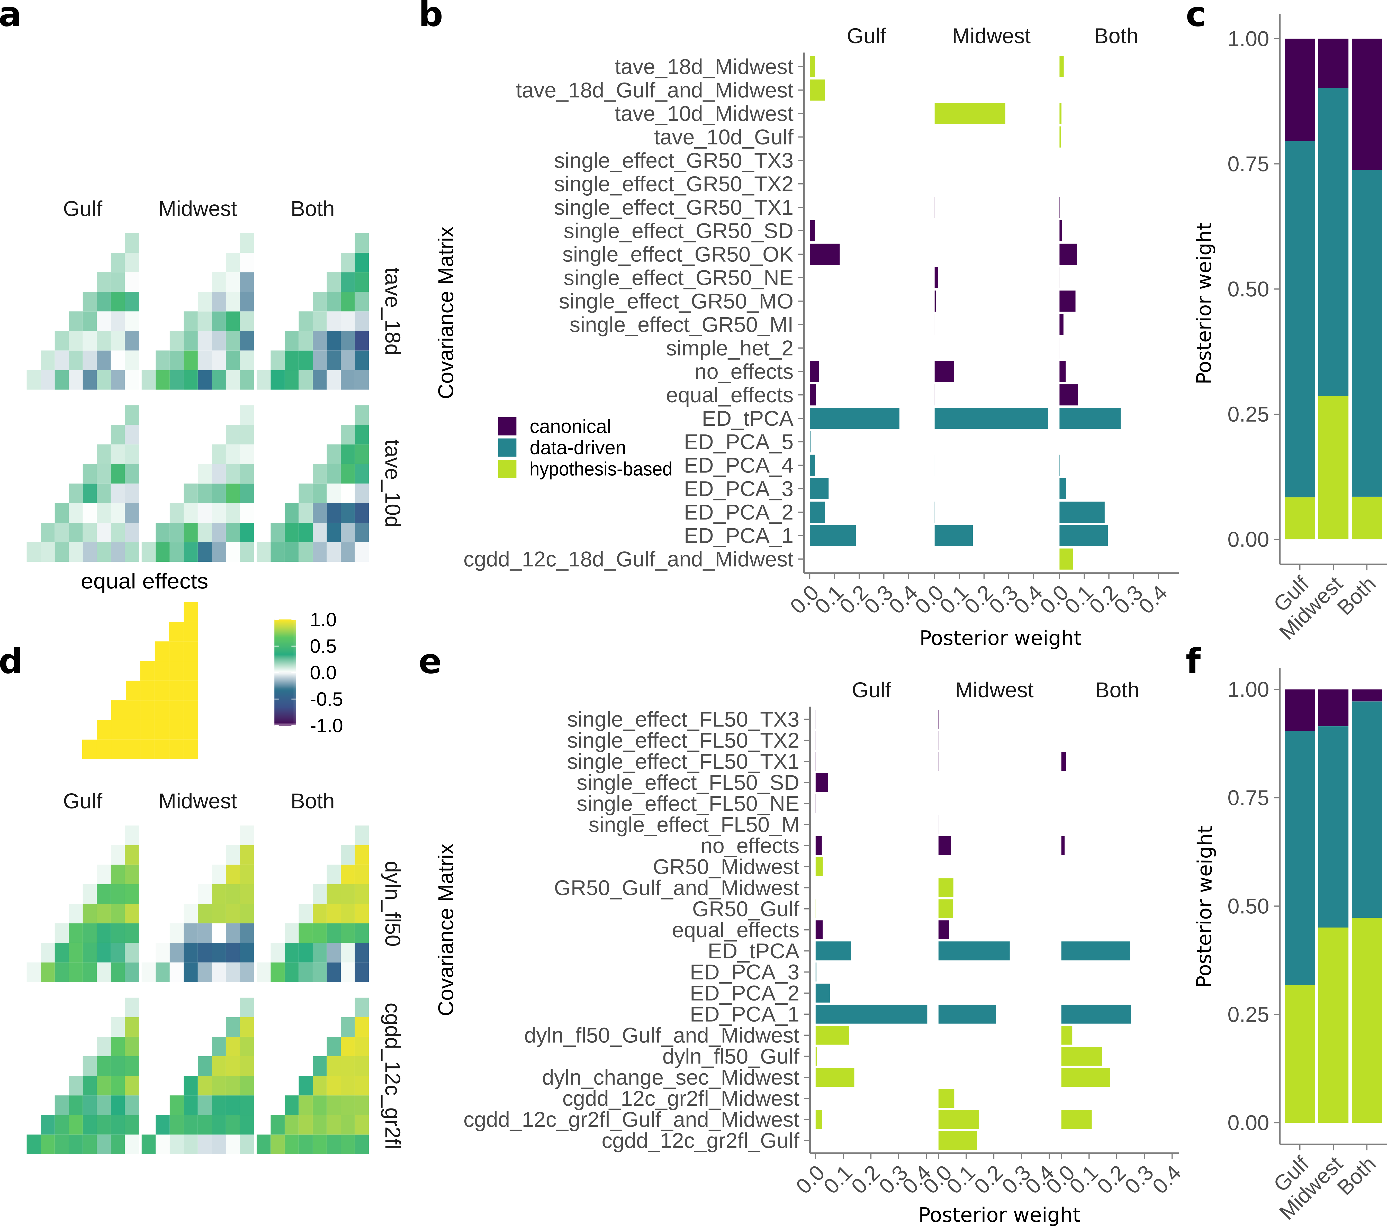
Figure 3. Effect patterns exhibited by the major data-driven matrices from Figure 2. (a,d,g,j) Gulf (b,e,h,k) Midwest, (c,f,i,l) Both subgroups. (a-f) Greenup phenotype. (g-l) Flowering phenotype. (a-c,g-i) First two eigenvectors from a singular value decomposition of the ED_tPCA data-driven matrices for greenup. First eigenvector corresponds to ED_PCA_1, and second corresponds to ED_PCA_2. Common gardens are arranged in latitudinal order. The percent variation explained of the tPCA by each eigenvector is shown on the y-axis. (d-f,j-l) SNPs with significant effects in both conditions that exhibit antagonistic pleiotropy or differential sensitivity between that pair of conditions.
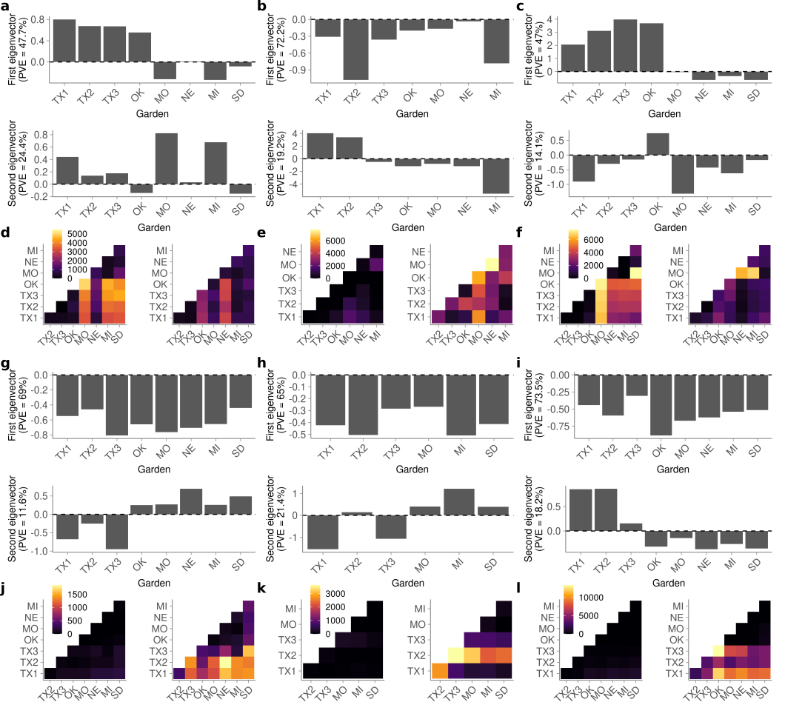
Figure 4. Comparison of mash SNP effects from a diversity panel and effects from an outbred F2 cross. (a) QTL mapping for four weather-related functions of flowering, and for greenup date, as indicated by the colors. Dotted lines indicate permutation-based significance thresholds for each weather-related function. (b) Schematic comparison of genotypes used for QTL mapping and genotypes used in mash. (c) Number of mash runs enriched for SNPs in the 1% mash tail in the 23 QTL intervals from (a) (dotted red line), compared to 1000 sets of 23 random QTL intervals of the same size (histogram). (d) SNP effects estimated using mash for SNPs with the highest Bayes factor for the three QTL with the highest LOD scores from (a) and enrichment of SNPs in the 1% mash tail. SNP genomic position and genetic subpopulation are indicated above each plot. Common gardens are arranged in latitudinal order. (e) QTL effect estimates for 23 non-overlapping and partially overlapping QTLs. Colors indicate which of the four weather-related functions of flowering for which the QTL was mapped. An additional five QTLs completely overlapped the QTL displayed; in this case, the QTL with the highest lod score is shown. Solid vertical lines separate QTLs that are not overlapping. Stars indicate QTL with significant enrichment for SNPs in the 1% mash tail; B, G, and M indicate which subpopulation had enrichment, as in (b):B - both subpopulations, G - Gulf subpopulation, M -Midwest subpopulation. Common gardens are arranged in latitudinal order.
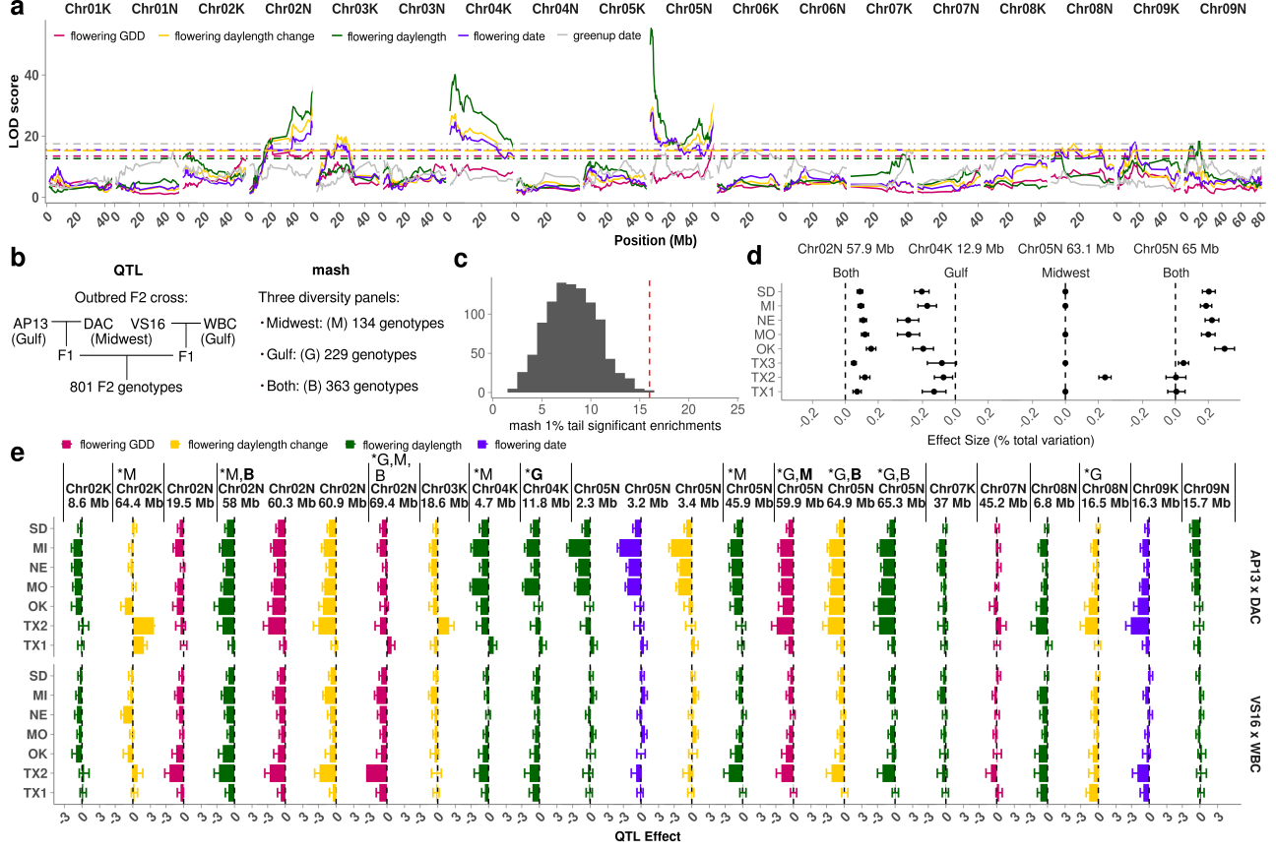
Table 1. Greenup and flowering dates as functions of environmental cues.
Phenotype | Name | Description
greenup | cgdd | Correlations in cumulative growing degree days for the five, ten, or eighteen days prior to greenup.
greenup | Temp_ave | Correlations in average temperature for the five, ten, or eighteen days prior to greenup.
flowering | greenup | Correlations in greenup.
flowering | daylength | Correlations in day length on the day of flowering.
flowering | daylength_change_seconds | Correlations in the change in daylength (in seconds) on the day of flowering.
flowering | cgdd_greenup_to_flowering | Correlations in cumulative GDD between greenup and flowering.
flowering | cumulative_rainfall | Correlations in cumulative rainfall in the one, three, or five days before flowering, or in the days between greenup and flowering.

