**PNAS Template for Main Manuscript**

This PNAS template for the Main Manuscript may be used to organize your main text source file. The template is intended to provide a clearly organized PDF to facilitate the review process. Further information is available in our [Author Center](https://www.pnas.org/authors/submitting-your-manuscript" \l "article-types).

**Using the template**

Paste the appropriate text from your manuscript into the relevant section of the template. You may maintain the template formatting, or reapply styles after pasting your text into the template.

Figures should be placed on separate pages with legends set immediately below each figure. Table titles should be set immediately above each table.

References cited in the main text should be included in a separate reference list at the end of this file. Examples of the PNAS citation style are included below.

**Notes about submission**

The following items are required on the title page: **Title, Author Line, Author Affiliations, Corresponding Author information**. Each of these items **must** be provided on the title page for us to proceed with processing your paper.

You are not required to adhere to the section order outlined below. For example, you may combine your Results and Discussion or use alternate section headings. Materials and Methods should be included after the Results and Discussion in most cases. If your paper does not include the standard section headings, please provide a brief explanation in the **Comments to Editorial Staff** field of the submission form.

You may include subheadings within the standard headings listed below. You may also include line numbers.

**Submitting your main manuscript**

Delete this first page, and then save your completed main text file as a PDF for submission, following instructions available [here](http://www.pnas.org/site/authors/procedures.xhtml" \l "preparation).

*Updated September 2020*



**Main Manuscript for**

Mapping of genotype-by-environment interactions in phenology identifies two cues for flowering in switchgrass (*Panicum virgatum*)

Alice H. MacQueen*, Li Zhang*, Jason Bonnette, Arvid Boe, Philip Fay, Felix Fritschi, David B. Lowry, Rob Mitchell, Francis Rouquette, Yanqi Wu, Thomas E. Juenger

Paste the full affiliation list here.

*Alice MacQueen, Thomas Juenger

**Email:**  [alice.macqueen@utexas.edu](mailto:alice.macqueen@utexas.edu); tjuenger@utexas.edu

PNAS strongly encourages authors to supply an [ORCID identifier](https://orcid.org/) for each author. Do not include ORCIDs in the manuscript file; individual authors must link their ORCID account to their PNAS account at [www.pnascentral.org](http://www.pnascentral.org/). For proper authentication, authors must provide their ORCID at submission and are not permitted to add ORCIDs on proofs.

**Author Contributions:** T.E.J. designed research. D.B.L. contributed plant material and resources. J.B., D.B.L., and T.E.J. designed and executed field experiments. A.B., P.F., F.F., D.B.L., R.M., F.R., Y.W., and T.E.J. hosted field experiments. A.H.M. and L.Z. conducted statistical and computational analyses. The manuscript was written by A.H.M., L.Z., and T.E.J. with contributions from all authors.

**Competing Interest Statement:** The authors declare no conflict of interest.

**Classification:** Biological Sciences; Population Biology.

**Keywords:** genotype-environment covariance, antagonistic pleiotropy, photoperiod, cumulative growing degree days, genetic variation

**This PDF file includes:**

Main Text

Figures 1 to 4

**Abstract**

Plant phenological timings are major fitness components affected by multiple environmental cues; thus, phenological traits can have important genotype-by-environment (GxE) interactions. Here, we map the genetic basis of, and assign weather-based cues to, GxE in phenology in two highly divergent switchgrass (*Panicum virgatum*) populations. We evaluate the genetic basis of the timing of vegetative growth and flowering as functions of weather-based cues (e.g. daylength, temperature) using a diversity panel grown at eight common gardens spanning the central United States. We use multivariate adaptive shrinkage (mash) to determine the prevalence of and map the genomic effects covarying with weather-based cues and/or major data-derived effect patterns. >26% of Gulf population SNPs affecting flowering covaried with photoperiod cues, while >34% of Midwest upland population SNPs affecting flowering covaried with cumulative growing degree day cues. An independent pseudo-F2 cross of Gulf and Midwest individuals mapped 23 additive QTLs for flowering at the same common gardens, all with significant mash associations and ten with enrichment of highly significant mash associations. We demonstrate that we can identify QTL with GxE and assign them to specific weather-based cues and/or data-derived patterns. Breeding for particular alleles at these loci could change flowering responsiveness to photoperiod cues in switchgrass. More broadly, this approach could be used to identify genetic marker-environment interactions in any species with related populations phenotyped in multiple environments.

**Significance Statement**

The timing of plant seasonal development (phenology) has major impacts on fitness because of the negative consequences of plant-environment mismatches. Here we map the genetic basis of two phenological events, the start of above-ground growth and flowering, in two genetically and phenologically distinct populations of switchgrass. We do this at eight field locations spanning the latitudinal range of both switchgrass populations. Our approach allows us to identify regions of the genome that covary with specific weather-related environmental features at every location. The Midwest population had genetic variation that covaried with cumulative growing degree days, a temperature-related measure, while the Gulf population had genetic variation that covaried with photoperiod, a day-length-related measure.

**Main Text**

**Introduction**

The timing of plant vegetative and reproductive development are major components of plant fitness affected by multiple external environmental cues (e.g. degree of winter chilling, day length, temperature, and water availability) that signal existing or upcoming growing conditions (1–3). Genetic responses to environmental cues determine the speed, timing, and energy apportioned to vegetative and reproductive growth and shape both the individual’s lifespan and its lifetime production of viable seed. Day length (or photoperiod) is one of the most predictable environmental cues, and genetic sensitivity to photoperiod protects plants from potentially fatal consequences of phenological responses to temperature cues at the “wrong” time of year. However, the usefulness of specific environmental cues depends on both features of the environment and the species’ adaptive strategies (4). Species with wide natural distributions can have multiple distinct environmentally-cued phenological responses: for example, populations of sunflower (*Helianthus annuus*) exhibit day-neutral, facultative short day, and facultative long-day flowering responses, which vary with their environments (5, 6). Distinct genetic responses in different environments are known as genotype by environment interactions, or GxE.

Flowering time, in particular, is a common subject of GxE research (5–11), a key output of selection driving adaptation to local environments (3, 12, 13), and a major target for crop improvement to adapt crops to local or future environments (14). Changing flowering responsiveness to photoperiod cues has allowed geographic range expansion and increased yields in a number of cereal species (15–19) and other crops (20, 21). Recent statistical advances in studying phenological GxE have involved determining critical environmental indices before the phenological event occurs, such as photothermal time within a critical growth window (10). However, most studies of flowering GxE focus on finding a single, best fitting form of genotype-environment covariance, even though we expect different genetic subpopulations, and even different genomic regions, to have evolved distinct patterns of GxE. Additionally, despite theoretical predictions that local adaptation should involve antagonistic pleiotropy, or sign-changing GxE, at the level of individual loci (22–25), previous work has found limited evidence of antagonistic pleiotropy (12, 26), but has been limited by a known statistical bias that reduced detection of antagonistic pleiotropy (26–28). Thus, despite substantial interest in the frequencies of various forms of GxE, the prevalence of antagonistic pleiotropy relative to other forms of GxE remains unknown.

Switchgrass (*Panicum virgatum*) is considered a short-day plant with reproductive development strongly linked to day of the year (29). However, as part of its wide environmental adaptation across the eastern half of North America, its photoperiodicity has been predicted to differ by plant latitude of origin (30, 31). We previously found divergent Midwest and Gulf genetic subpopulations of switchgrass which segregate for distinct sets of climate adaptations (32). The Midwest genetic subpopulation is primarily composed of individuals from the well-studied upland switchgrass ecotype (33, 34), while the Gulf subpopulation has individuals from the lowland ecotype and the phenotypically intermediate coastal ecotype (32). Here, we test if these populations differ in their phenological adaptations and hence their phenological GxE. We phenotype a diversity panel of hundreds of switchgrass genotypes from the Midwest and Gulf subpopulations for the start of vegetative development (“green-up”) and reproductive development (flowering) at eight common garden locations spanning 17 degrees of latitude. These gardens cover the majority of the latitudinal and climatic range of switchgrass and capture the most comprehensive picture to date of the environmental variation this species encounters. We determine the genetic component of variation in green-up and flowering dates, then genetically map these traits using multivariate adaptive shrinkage (mash) (35), which allows us to specify multiple ways genetic markers may covary with the environment, and does not have a statistical bias in detecting frequencies of different forms of GxE. To confirm our genetic mapping of GxE, we compare to mapping results from an outbred pseudo-F2 cross grown at the same sites. Taken together, our results allow us to describe the environmental cues and genetic variation affecting phenology in two divergent natural populations of switchgrass.

**Results**

In our diversity panel of tetraploid switchgrass (32), genotypes from the Gulf and Midwest genetic subpopulations had distinct phenological timings and distinct patterns of phenological correlations across our eight common garden sites (Fig. 1A,B). At the three Texas common gardens (hereafter ‘Texas’ gardens), located within the natural range of the Gulf subpopulation, Gulf green-up occurred before Midwestern green-up, and Gulf flowering occurred after Midwestern flowering (Fig. 1A). At the four northernmost common gardens (hereafter ‘North’ gardens), located within the natural range of the Midwest subpopulation, both Gulf green-up and flowering occurred after Midwest green-up and flowering. At the Oklahoma common garden, located near the natural range limits of both the Gulf and the Midwest subpopulations, Gulf and Midwest green-up occurred over the same time period. These patterns led to strong negative phenotypic correlations for green-up between the North and Texas gardens and contributed to positive phenotypic correlations for flowering time of larger magnitude at more northern gardens (Fig. 1B).

Narrow-sense heritabilities (h2) indicated that rank-changing GxE for these phenotypes was present across the common gardens (Fig 1C). h2 were typically high at individual gardens: 59% on average for green-up date, and 87% for flowering date. However, h2 were variable across gardens, and green-up dates were uncorrelated (r2 < 0.2) or negatively correlated between pairs of gardens (Fig. 1B). These negative and small correlations undoubtedly contributed to the low h2 values for green-up and flowering date when estimated jointly at all eight gardens: h2 was 0.8% for green-up and 23.2% for flowering date.

Genetic (G) and GxE effects explained little variation in green-up date across all gardens (<10%), but did explain substantially more variation when green-up was defined as a function of a weather-based cue (SI Appendix, Section S1, Table S1, Fig. S1). G and GxE explained more variation in green-up date (up to 60%) when the sites were restricted to either the Texas or North gardens, but in this case, defining green-up as functions of weather-based cues did not explain additional variation in green-up date (SI Appendix, Fig. S1). Interestingly, green-up G and GxE effects were larger for populations grown at gardens outside of that population’s native range.

In contrast to green-up date, G and GxE effects explained moderate variation in flowering date, and explained significantly more variation when flowering was defined as a function of a weather-based cue (Fig. 1D, SI Appendix, Section S1, Table S1). In the Gulf subpopulation, defining flowering as a function of day length explained more G and GxE than as a function of day of the year (Fig. 1D). In the Midwest subpopulation, a cumulative growing degree day (GDD) cue explained more G than flowering date, while three additional cues (day length, rainfall between green-up and flowering, and rainfall in the five days before flowering) explained more G and GxE than flowering date (Fig. 1D). The variation explained by G and GxE was higher when the common gardens were restricted to either the Texas or North gardens. For subpopulations growing at gardens outside their native ranges, G and GxE explained a substantial amount of variation in flowering as a function of rainfall cues, particularly for rainfall on the day of flowering (Fig. 1D). Taken together, these data indicate that the Midwest subpopulation has moderate additive genetic variation for a cumulative GDD-based flowering cue, while the Gulf subpopulation has a similar amount of genetic variation for a day-length-based flowering cue. They indicate that GxE is present for rainfall, cumulative GDD, and photoperiod cues for flowering.

*Mapping major patterns of genotype-by-environment effects on green-up and flowering*

We explored how genetic variation in phenology covaried with environmental cues by using mash to jointly estimate SNP-associated trait effects across all common gardens for the Midwest, Gulf, and ‘Both’ subpopulations (SI Appendix, Datasets 1-6). We included “hypothesis-based” covariance matrices in each mash model that captured the covariance of weather-based phenological cues for cloned genotypes grown at multiple common gardens (SI Appendix, Section S2). These matrices differed substantially by weather-based cue and by population of origin of the genotypes included (Fig 2A,D). For mash models estimating SNP effects for Both subpopulations, the hypothesis-based covariance matrices significantly improved the model fit (green-up likelihood ratio (LR) = 774; flowering LR = 2942). For single subpopulation mash models, the hypothesis-based covariance matrices improved model fits for Midwest green-up and for Gulf flowering, but did not improve it for the other phenotype (Midwest green-up LR = 866; flowering LR = -3063; Gulf green-up LR = -318; flowering LR = 1279).

For green-up, SNP-associated phenotypic effects covaried with different weather-based cues in the different subpopulations (Fig 2B). In total, 28.6% of the posterior weight of SNP effects in the mash model of Midwest green-up fell on a covariance matrix of average temperature in the 10 days prior to Midwest green-up. Mash models of Gulf and Both subpopulation green-up did not have high weights on this matrix; instead, they had small but non-zero weights on two other hypothesis-based matrices, average temperature and cumulative GDD in the 18 days prior to green-up.

For flowering date, we also observed that distinct weather-based cues captured SNP-associated effect patterns in the Gulf and Midwest subpopulations. 12.1% of SNP effects on flowering in the Gulf subpopulation covaried with day length in the time period when Gulf and Midwest genotypes were flowering, while 14% of SNP effects covaried with day length change shortly before Gulf genotypes were flowering (when Midwest genotypes were flowering, Fig. 2E). In contrast, many SNP effects on flowering in the Midwest subpopulation covaried with cumulative GDD from green-up to the time period during (14.6%) and after (14.0%) when Midwest genotypes were flowering (Fig. 2E). SNP effects in the Midwest subpopulation did not covary with patterns of day length or day length change at flowering. Few (2.3%) SNP effects in the Gulf subpopulation covaried with flowering cumulative GDD. Mash detected covariance with both sets of environmental cues in effects estimated using the combined population, in that all three matrices had large posterior weights in the Both subpopulation mash model. Overall, flowering posterior weights on hypothesis-based matrices were higher than green-up weights (Fig 2C,F). This indicated that our hypothesized weather-based cues for phenology captured more variation in SNP effects for flowering than for green-up.

In all six mash models, the hypothesis-based covariance matrices captured a minority of the significant SNP effects present in the data (Figure 2C,F). Most SNPs had high posterior weights on the data-derived (DD) covariance matrices specific to each mash model; we thus explored patterns of SNP effects described by these matrices. We also characterized the overall patterns of differential sensitivity and antagonistic pleiotropy for SNP effects at all pairs of gardens.

For green-up mash models, one of the two major data-derived effect patterns was a pattern of antagonistic pleiotropy between pairs of Texas and North gardens. The largest fraction of SNP effects had high posterior weights on the DD_tPCA matrices; 61-91% of the variation in the DD_tPCA matrices was explained by two garden-based patterns of effects (Fig. 3A, SI Appendix, Fig. S2A-C), corresponding to the patterns of the first eigenvectors of DD_PCA_1 and DD_PCA_2, two additional data-driven matrices which also had non-zero mash posterior weights (Fig. 2B). For all three subgroups, one of these two effect patterns was characterized by large magnitude (>|0.5|) effects delaying green-up in the Texas gardens and in Oklahoma, with small (<|0.2|) to moderate (|0.2| to |0.5|) magnitude effects advancing green-up in MO and MI. Many thousands of SNP effects on green-up exhibited antagonistic pleiotropy in Both subpopulations between pairs of Texas and North gardens (Fig. 3B); in contrast, most pairs of gardens had hundreds to a few thousand differentially sensitive SNP effects (Fig. 3C). Fewer SNPs exhibited antagonistic pleiotropy and more exhibited differential sensitivity for green-up effects in the Midwest subpopulation than in the Gulf and Both subpopulations (SI Appendix, Fig. S2D-I).

For flowering mash models, similar fractions of SNP effects had high posterior weights on the DD_tPCA and DD_PCA_1 data-driven matrices, which captured fairly consistent patterns across subpopulations (Fig. 3D, SI Appendix Fig 2J-L). This pattern was characterized by large magnitude effects of consistent sign that differed in their magnitude by garden (Fig. 3D). Only a few hundred SNP effects on flowering exhibited antagonistic pleiotropy between pairs of gardens (Fig. 3E, SI Appendix Fig. 2M-R); instead, there was substantial differential sensitivity between Texas and North pairs of gardens (Fig. 3F). In other words, the major data-derived effect patterns for flowering showed differential sensitivity, not antagonistic pleiotropy, between gardens.

*Confirmation of genotype-by-environment effects using an independent mapping population*

We sought additional experimental support for our mash intervals using an independent pseudo-F2 mapping population created from Gulf & Midwest individuals and grown at the same sites (Fig. 4A,B). We conducted quantitative trait loci (QTL) mapping of flowering as functions of four environmental cues with high posterior weights in mash, and identified eight QTL for flowering date, six QTL for flowering GDD, ten QTL for flowering day length, and eight QTL flowering day length change, all of which showed QTL by environment interactions (SI Appendix, Fig. S3). All QTL for flowering overlapped one or more homologs from rice or *A. thaliana* with functionally validated roles in flowering (SI Appendix, Dataset 7). All flowering QTL intervals contained at least one SNP significant in at least one mash run at a log10-transformed Bayes Factor > 2, or in the 1% tail of significance, whichever was stricter (SI Appendix, Dataset 8). We also looked for enrichments of mash SNPs in the 1% tail of significance (the ‘mash 1% tail’) within each QTL interval. At the 5% level, ten QTL had enrichments of SNPs in the mash 1% tail. Overall, there were 16 significant enrichments (p < 0.05, hypergeometric test) of SNPs in the mash 1% tail in the QTL intervals. Our QTL intervals had more enrichments of SNPs in the mash 1% tail than were found for all but three of these sets of random genomic intervals (Fig. 4C, p = 0.003). Thus, we were able to experimentally support our mash intervals with a QTL mapping experiment using a separate mapping population.

**Discussion**

As the climate and the natural environment change, it is increasingly critical to understand how patterns of gene-environment and plant-environment interactions will change in response. To do this, we must understand the current patterns of trait covariation across environments, the genetic underpinnings of these patterns, and the cases where this covariation can be altered. Here, we demonstrate that we can associate multiple patterns of GxE with specific genomic regions using a switchgrass diversity panel grown at eight common gardens, and also that we can assign specific SNP-associated patterns of GxE to both weather-based cues and to other, data-derived patterns. We use this approach to study GxE in both green-up and flowering phenological data in the deeply genetically diverged Gulf and Midwest populations of switchgrass.

Our analysis of green-up in the Gulf and in Both subpopulations revealed substantial antagonistic pleiotropy in effects between the Texas and North gardens (Figure 3A). This result supports theoretical models that local adaptation should involve antagonistic pleiotropy at the level of individual loci (22–25), and is the first experimental work using QTL mapping and GWAS across common gardens to find antagonistic pleiotropy to be common in small genomic regions (12, 36, 37).

Our analysis of flowering showed that the Gulf and Midwest subpopulations have two distinct photoperiod-related flowering responses: the Midwest subpopulation is day neutral, and flowering is cued primarily by a cumulative GDD threshold; in contrast, the Gulf subpopulation is photoperiod sensitive, and flowering is cued by the transition to shortening days. This result was supported by observations that expressing flowering date as a function of the day length at flowering increased its heritability in the Gulf subpopulation, while expressing flowering date as a function of cumulative GDD between green-up and flowering increased the heritability of flowering in the Midwest subpopulation (Fig. 1D). The genomic regions affecting flowering found in mash were also supported by QTL from an independent mapping population (Fig. 4C).

**Materials and Methods**

Whenever possible, plant material will be shared upon request. Source data and code to replicate these analyses are available at: https://github.com/Alice-MacQueen/pvdiv-phenology-gxe.git. SNP data to replicate these analyses are available from the UT dataverse at https://doi.org/link.

*Genotype-by-environment effects on green-up and flowering as functions of weather-based cues*

In 2019, we scored two phenological events every two days in two mapping populations of switchgrass, a diversity panel and a pseudo-F2 cross, planted at eight common garden locations (32, 34, 37). We scored green-up date as the day of the year when 50% of the tiller area of the crown of the plant cut the previous year had green growth. Flowering date was the day of the year when 50% of the plant tillers had panicles undergoing anthesis. We scored green-up and flowering as day of the year, then linked these dates to multiple weather-based environmental factors measured daily at each common garden (SI Appendix, Section S1, Table S1).

The formation and resequencing of the diversity panel has been described previously (32). The diversity panel contained 134 sequenced, clonally propagated individuals from the Midwest genetic subpopulation, and 229 from the Gulf genetic subpopulation. To allow for the possibility that different subpopulations had different strengths of connection between our phenotypes and genotypes (38), we conducted three sets of genetic analyses: on Gulf and Midwest genotypes separately, and on both subpopulations together (‘Both’). Analyses to determine narrow-sense heritability (h2) for green-up and flowering, and variance components analyses to partition variance attributed to genetic effects (G), genotype by environment interactions (GxE), environmental effects (E), and error for these phenology-related traits were done using linear mixed models and followed (32). Details on these models can be found in (SI Appendix, Section S3,S4).

*Mapping major patterns of genotype-by-environment effects on green-up and flowering*

To evaluate the prevalence and kinds of covariance patterns of SNP effects across our common gardens, we used multivariate adaptive shrinkage (mash) on SNP effect estimates from the diversity panel (35). Mash is a statistical method that allows estimation and comparison of many effects jointly across many different conditions; it improves on previous methods by allowing multiple, arbitrary correlations in effect sizes among conditions (SI Appendix, Section S5). To obtain SNP effect estimates, we first conducted univariate genome-wide association at each common garden for green-up and flowering date. We then analyzed SNP effects for the top 19K relatively unlinked (r2 < 0.2) SNPs per condition using mash, as in (32). Details on these models can be found in (SI Appendix, Section S6).

We generated hypothesis-based covariance matrices derived from correlations in environmental cues in the green-up or flowering date windows for the three subpopulations (SI Appendix, Table S1, Section S1). These covariance matrices represent the correlations between cloned genotypes for our phenotypes as functions of weather-based cues across our common gardens. Mash also generates data-derived covariance matrices corresponding to major patterns of SNP effects present in the data. We generated six data-derived matrices per mash run, five (denoted DD_PCA_1 through DD_PCA_5) produced by singular value decomposition (SVD) of an overall matrix, denoted ‘DD_tPCA’. We used SVD to present vectors of garden-specific effects for each numbered DD_PCA matrix, because the first eigenvector of a SVD explains 100% of the variation in these matrices, and each value in this eigenvector represents one garden-specific effect.

Last, we characterized the overall patterns of differential sensitivity and antagonistic pleiotropy between SNPs with significant effects at all pairs of gardens. To do this, we used the ‘get_GxE’ function of the switchgrassGWAS R package. This function first determines the set of SNPs with evidence of significant effects in both conditions for all pairs of conditions using local false sign rates (lfsr) as the significance criteria. lfsr are analogous to false discovery rates but more conservative, in that they also reflect the uncertainty in the estimation of the sign of the effect (39). For antagonistic pleiotropy, this function determines if effects significant in both conditions are of opposite sign. For differential sensitivity, this function determines if effects significant in both conditions are of the same sign and of a magnitude (not tested for significance) that differs by a factor of 0.4 or more. Our use of the lfsr to determine significance and our specification that SNP effects must be significant in both conditions to be included means that our tests for differential sensitivity and antagonistic pleiotropy carry an equal statistical burden. This is an important advance on previous studies of antagonistic pleiotropy (e.g. (37)), where statistical tests for antagonistic pleiotropy were conservative, in that they required two non-zero effects of different signs, while tests for differential sensitivity required only one non-zero effect. Previous work recognized that this testing bias could lead to undercounting occurrences of antagonistic pleiotropy (26, 27), and sought to reduce it by permutation (28); this work does not have the same limitation.

*Confirmation of genotype-by-environment effects using an independent mapping population*

To confirm candidate genomic regions and patterns of allelic effects found in the diversity panel, we analyzed flowering in an outbred pseudo-F2 cross between four individuals, two Midwest and two Gulf individuals. The formation of this mapping population has been described previously (34); additional details on QTL mapping can be found in SI Appendix, Section S6. To be directly comparable to the diversity panel data, only 2019 phenology data from the pseudo-F2 cross from the same eight common garden sites were used. To compare our QTL enrichments of significant mash associations to the null expectation, we used permutation to choose 1000 sets of 23 genomic regions of the same size randomly distributed throughout the genome, then calculated enrichments of the mash 1% tail in these random intervals.

**Acknowledgments**

We thank the Brackenridge Field laboratory, the Ladybird Johnson Wildflower Center, and the Juenger laboratory for support with plant care and propagation. This material is based upon work supported in part by the Great Lakes Bioenergy Research Center, U.S. Department of Energy, Office of Science, Office of Biological and Environmental Research under Award Numbers DE-SC0018409 and DE-FC02-07ER64494, the US Department of Energy Awards DESC0014156 to T.E.J., DE-SC0017883 to D.B.L, National Science Foundation PGRP Awards IOS0922457 and IOS1444533 to T.E.J, and the Long-term Ecological Research Program (DEB 1832042) at the Kellogg Biological Station.

**References**

1. W. L. Bauerle, *et al.*, Photoperiodic regulation of the seasonal pattern of photosynthetic capacity and the implications for carbon cycling. *Proc Natl Acad Sci USA* **109**, 8612 (2012).

2. C. Körner, D. Basler, Phenology Under Global Warming. *Science* **327**, 1461 (2010).

3. F. Andrés, G. Coupland, The genetic basis of flowering responses to seasonal cues. *Nature Reviews Genetics* **13**, 627–639 (2012).

4. C. A. Botero, F. J. Weissing, J. Wright, D. R. Rubenstein, Evolutionary tipping points in the capacity to adapt to environmental change. *Proc Natl Acad Sci USA* **112**, 184 (2015).

5. B. K. Blackman, Interacting duplications, fluctuating selection, and convergence: the complex dynamics of flowering time evolution during sunflower domestication. *Journal of Experimental Botany* **64**, 421–431 (2013).

6. L. P. Henry, R. H. B. Watson, B. K. Blackman, Transitions in photoperiodic flowering are common and involve few loci in wild sunflowers (Helianthus; Asteraceae). *American Journal of Botany* **101**, 1748–1758 (2014).

7. J. Ågren, C. G. Oakley, S. Lundemo, D. W. Schemske, Adaptive divergence in flowering time among natural populations of Arabidopsis thaliana: Estimates of selection and QTL mapping. *Evolution* **71**, 550–564 (2017).

8. B. Brachi, *et al.*, Linkage and Association Mapping of Arabidopsis thaliana Flowering Time in Nature. *PLoS Genet* **6**, e1000940 (2010).

9. E. L. Dittmar, C. G. Oakley, J. Ågren, D. W. Schemske, Flowering time QTL in natural populations of Arabidopsis thaliana and implications for their adaptive value. *Molecular Ecology* **23**, 4291–4303 (2014).

10. X. Li, T. Guo, Q. Mu, X. Li, J. Yu, Genomic and environmental determinants and their interplay underlying phenotypic plasticity. *Proc Natl Acad Sci USA* **115**, 6679–6684 (2018).

11. J. A. Romero Navarro, *et al.*, A study of allelic diversity underlying flowering-time adaptation in maize landraces. *Nature Genetics* **49**, 476–480 (2017).

12. S. M. Wadgymar, *et al.*, Identifying targets and agents of selection: innovative methods to evaluate the processes that contribute to local adaptation. *Methods in Ecology and Evolution* **8**, 738–749 (2017).

13. M. Blümel, N. Dally, C. Jung, Flowering time regulation in crops—what did we learn from Arabidopsis? *Current Opinion in Biotechnology* **32**, 121–129 (2015).

14. C. Jung, A. E. Müller, Flowering time control and applications in plant breeding. *Trends in Plant Science* **14**, 563–573 (2009).

15. A. Turner, J. Beales, S. Faure, R. P. Dunford, D. A. Laurie, The Pseudo-Response Regulator Ppd-H1 Provides Adaptation to Photoperiod in Barley. *Science* **310**, 1031–1034 (2005).

16. S. Faure, *et al.*, Mutation at the circadian clock gene EARLY MATURITY 8 adapts domesticated barley (Hordeum vulgare) to short growing seasons. *PNAS* **109**, 8328–8333 (2012).

17. H.-Y. Hung, *et al.*, ZmCCT and the genetic basis of day-length adaptation underlying the postdomestication spread of maize. *PNAS* **109**, E1913–E1921 (2012).

18. S. Zakhrabekova, *et al.*, Induced mutations in circadian clock regulator Mat-a facilitated short-season adaptation and range extension in cultivated barley. *PNAS* **109**, 4326–4331 (2012).

19. Y. Yang, Q. Peng, G.-X. Chen, X.-H. Li, C.-Y. Wu, OsELF3 Is Involved in Circadian Clock Regulation for Promoting Flowering under Long-Day Conditions in Rice. *Molecular Plant* **6**, 202–215 (2013).

20. P. A. Pin, O. Nilsson, The multifaceted roles of FLOWERING LOCUS T in plant development. *Plant, Cell & Environment* **35**, 1742–1755 (2012).

21. J. L. Weller, *et al.*, Parallel origins of photoperiod adaptation following dual domestications of common bean. *Journal of Experimental Botany* **70**, 1209–1219 (2019).

22. H. Levene, Genetic Equilibrium When More Than One Ecological Niche is Available. *The American Naturalist* **87**, 331–333 (1953).

23. J. Felsenstein, The Theoretical Population Genetics of Variable Selection and Migration. *Annual Review of Genetics* **10**, 253–280 (1976).

24. T. J. Kawecki, D. Ebert, Conceptual issues in local adaptation. *Ecology Letters* **7**, 1225–1241 (2004).

25. P. W. Hedrick, Genetic Polymorphism in Heterogeneous Environments: A Decade Later. *Annual Review of Ecology and Systematics* **17**, 535–566 (1986).

26. D. L. Des Marais, K. M. Hernandez, T. E. Juenger, Genotype-by-Environment Interaction and Plasticity: Exploring Genomic Responses of Plants to the Abiotic Environment. *Annual Review of Ecology, Evolution, and Systematics* **44**, 5–29 (2013).

27. J. T. Anderson, J. H. Willis, T. Mitchell-Olds, Evolutionary genetics of plant adaptation. *Trends Genet* **27**, 258–266 (2011).

28. J. T. Anderson, C.-R. Lee, C. Rushworth, R. Colautti, T. Mitchell-Olds, Genetic tradeoffs and conditional neutrality contribute to local adaptation. *Mol Ecol* **22**, 699–708 (2013).

29. R. B. Mitchell, K. J. Moore, L. E. Moser, J. O. Fritz, D. D. Redfearn, Predicting Developmental Morphology in Switchgrass and Big Bluestem. *Agronomy Journal* **89**, 827–832 (1997).

30. D. J. Parrish, J. H. Fike, The Biology and Agronomy of Switchgrass for Biofuels. *Critical Reviews in Plant Sciences* **24**, 423–459 (2005).

31. M. D. Casler, K. P. Vogel, C. M. Taliaferro, R. L. Wynia, Latitudinal Adaptation of Switchgrass Populations. *Crop Science* **44**, 293–303 (2004).

32. J. T. Lovell, *et al.*, Genomic mechanisms of climate adaptation in polyploid bioenergy switchgrass. *Nature*, 1–7 (2021).

33. C. L. Porter, An Analysis of Variation Between Upland and Lowland Switchgrass, Panicum Virgatum L., in Central Oklahoma. *Ecology* **47**, 980–992 (1966).

34. E. R. Milano, D. B. Lowry, T. E. Juenger, The Genetic Basis of Upland/Lowland Ecotype Divergence in Switchgrass (Panicum virgatum). *G3 Genes|Genomes|Genetics* **6**, 3561–3570 (2016).

35. S. M. Urbut, G. Wang, P. Carbonetto, M. Stephens, Flexible statistical methods for estimating and testing effects in genomic studies with multiple conditions. *Nat Genet* **51**, 187–195 (2019).

36. O. Savolainen, M. Lascoux, J. Merilä, Ecological genomics of local adaptation. *Nat Rev Genet* **14**, 807–820 (2013).

37. D. B. Lowry, *et al.*, QTL × environment interactions underlie adaptive divergence in switchgrass across a large latitudinal gradient. *PNAS* **116**, 12933–12941 (2019).

38. A. Korte, A. Farlow, The advantages and limitations of trait analysis with GWAS: a review. *Plant Methods* **9**, 29 (2013).

39. M. Stephens, False discovery rates: a new deal. *Biostatistics* **18**, 275–294 (2017).

**Figures and Tables**

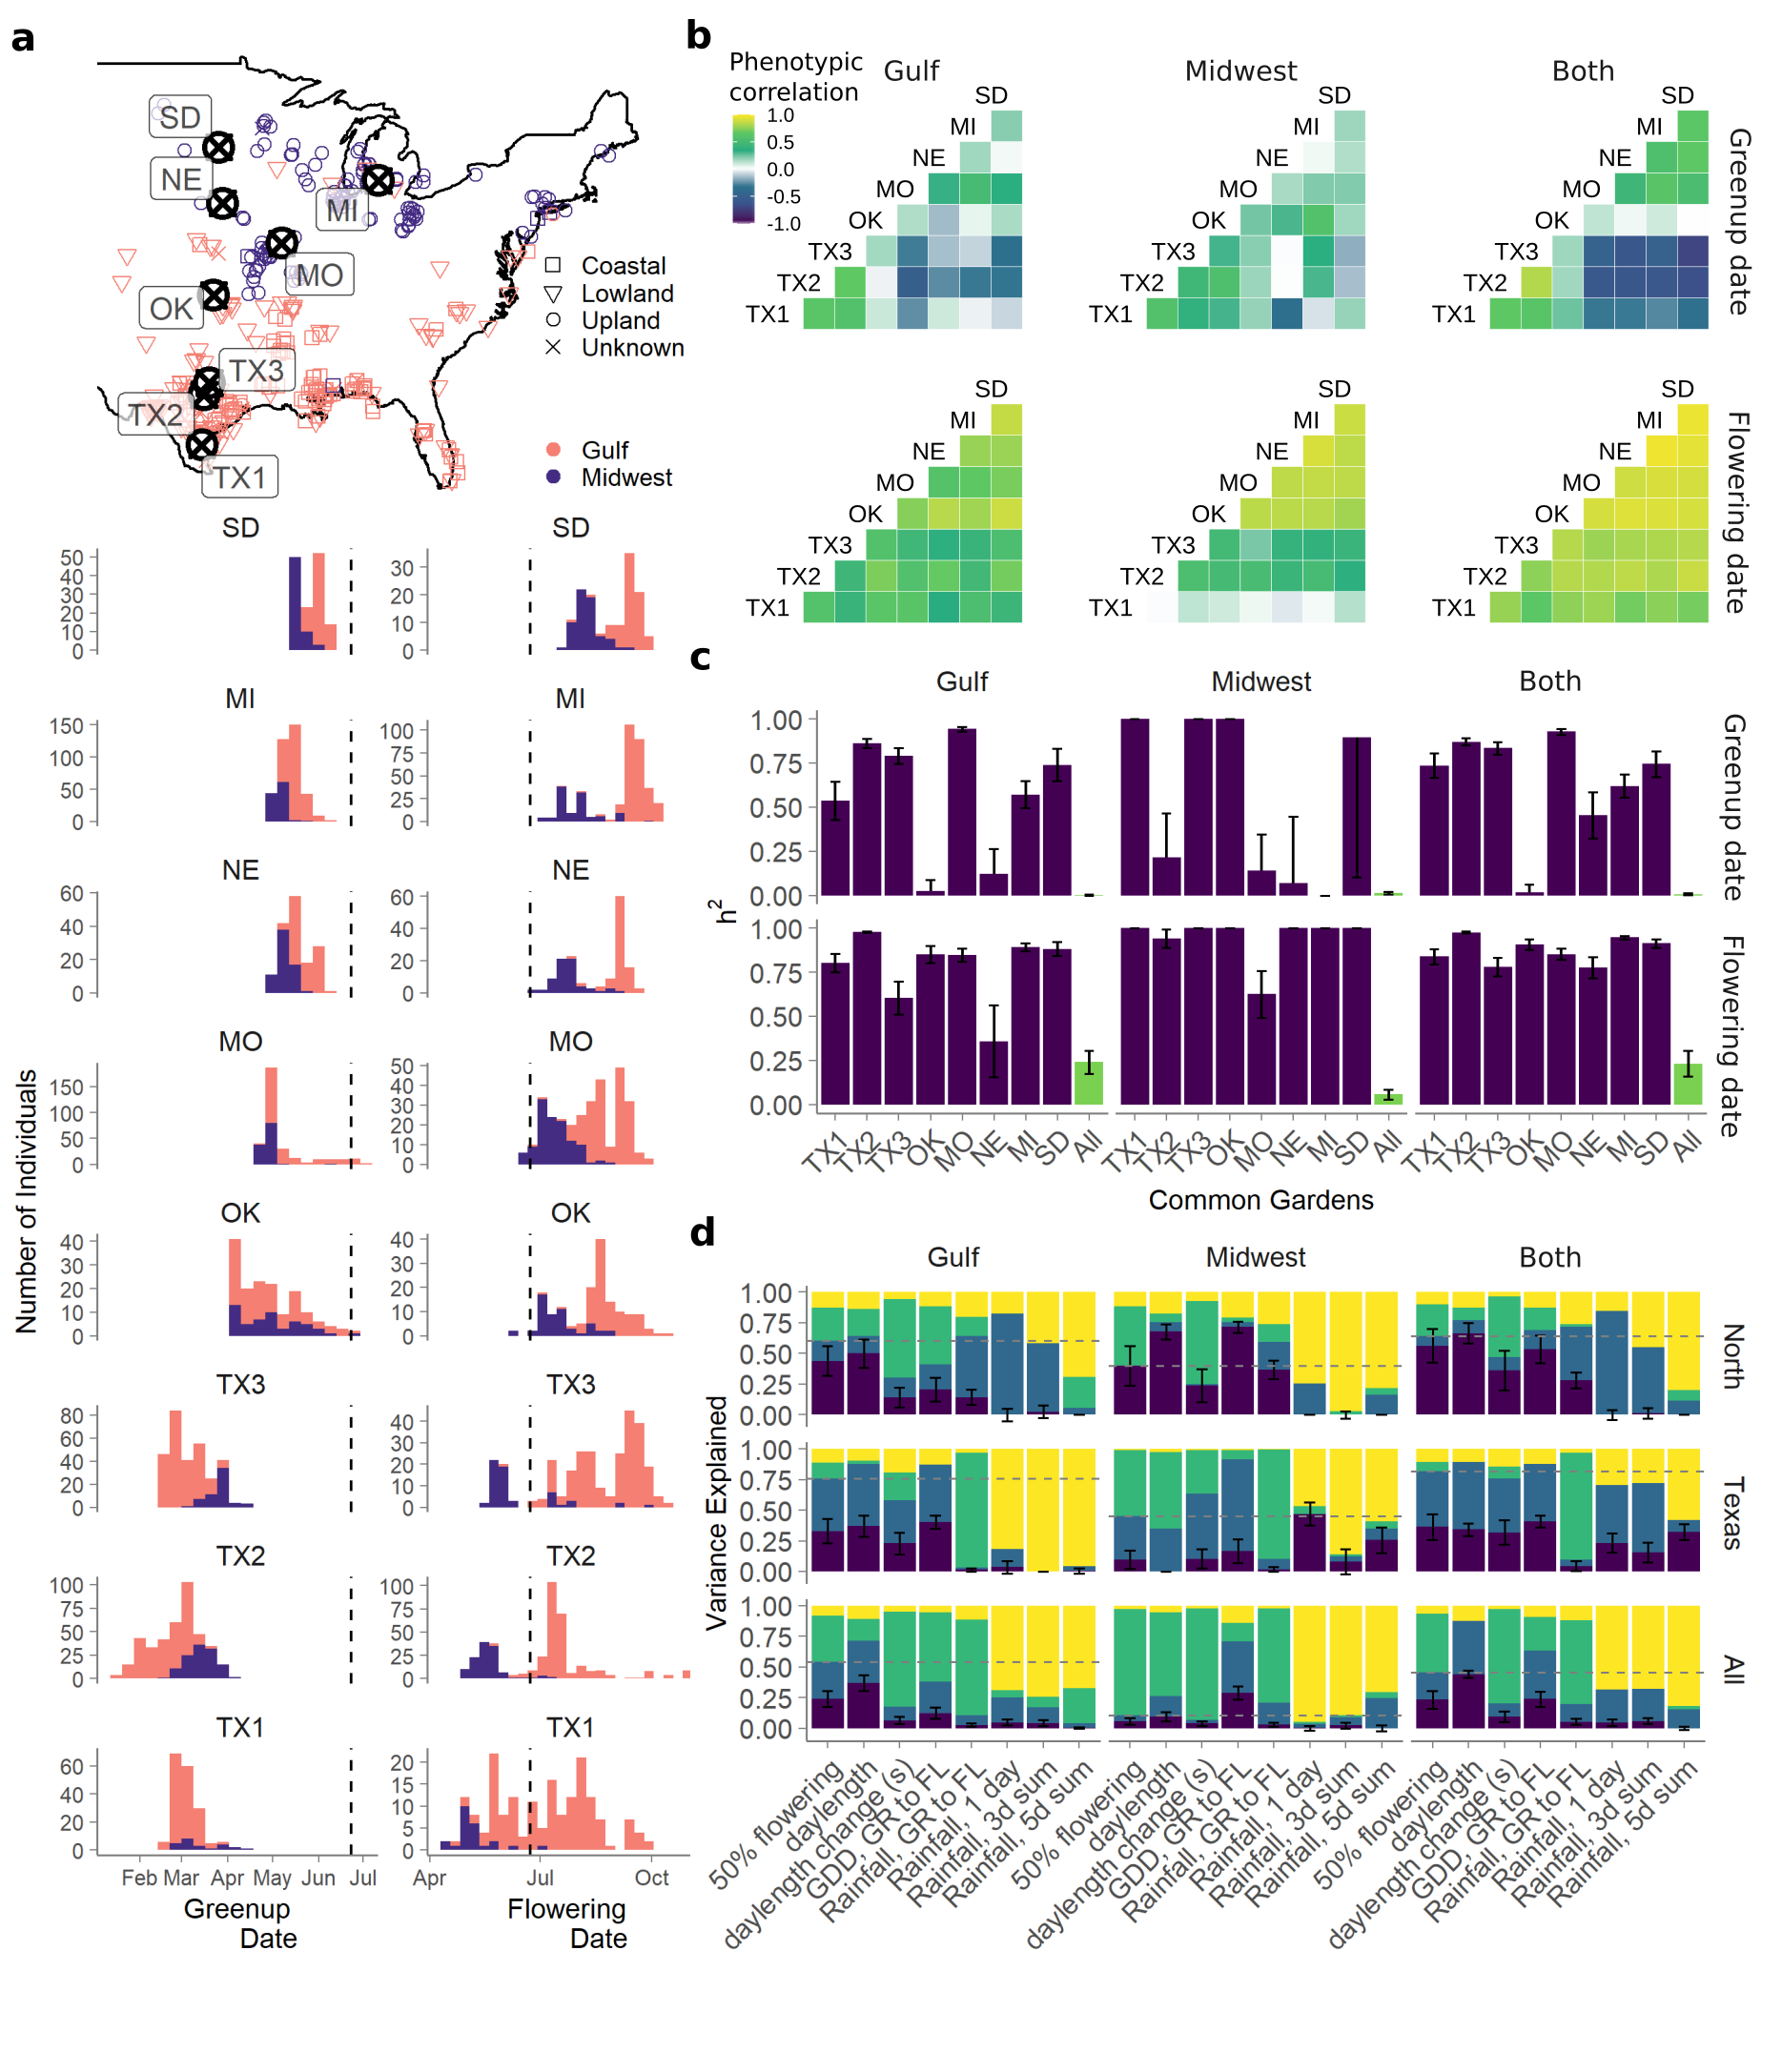**Figure 1.** *Characterization of green-up and flowering dates from the switchgrass diversity panel. (a) Map and trait histograms of green-up and flowering dates across two genetically distinct switchgrass subpopulations and eight common gardens. Purple represents individuals from the Midwest genetic subpopulation, and pink individuals from the Gulf subpopulation. Vertical dashed lines indicate the summer solstice. Common gardens are arranged in latitudinal order. (b) Phenotypic correlations between clonal replicates planted at eight common gardens, within and between two genetic subpopulations. (c) Narrow sense heritability of green-up and flowering within single common gardens (purple) and across all eight common gardens (green), within and between two genetic subpopulations. (d) Variance components analysis of genetic (purple), genotype by environment (blue), environmental (green), and error (yellow) terms in models of flowering time as functions of Julian date or weather, for the four northern common gardens (North), the three Texas common gardens (Texas), and for all eight common gardens (All). Dashed lines indicate the cumulative contribution of G and GxE for flowering as a function of day of the year.*

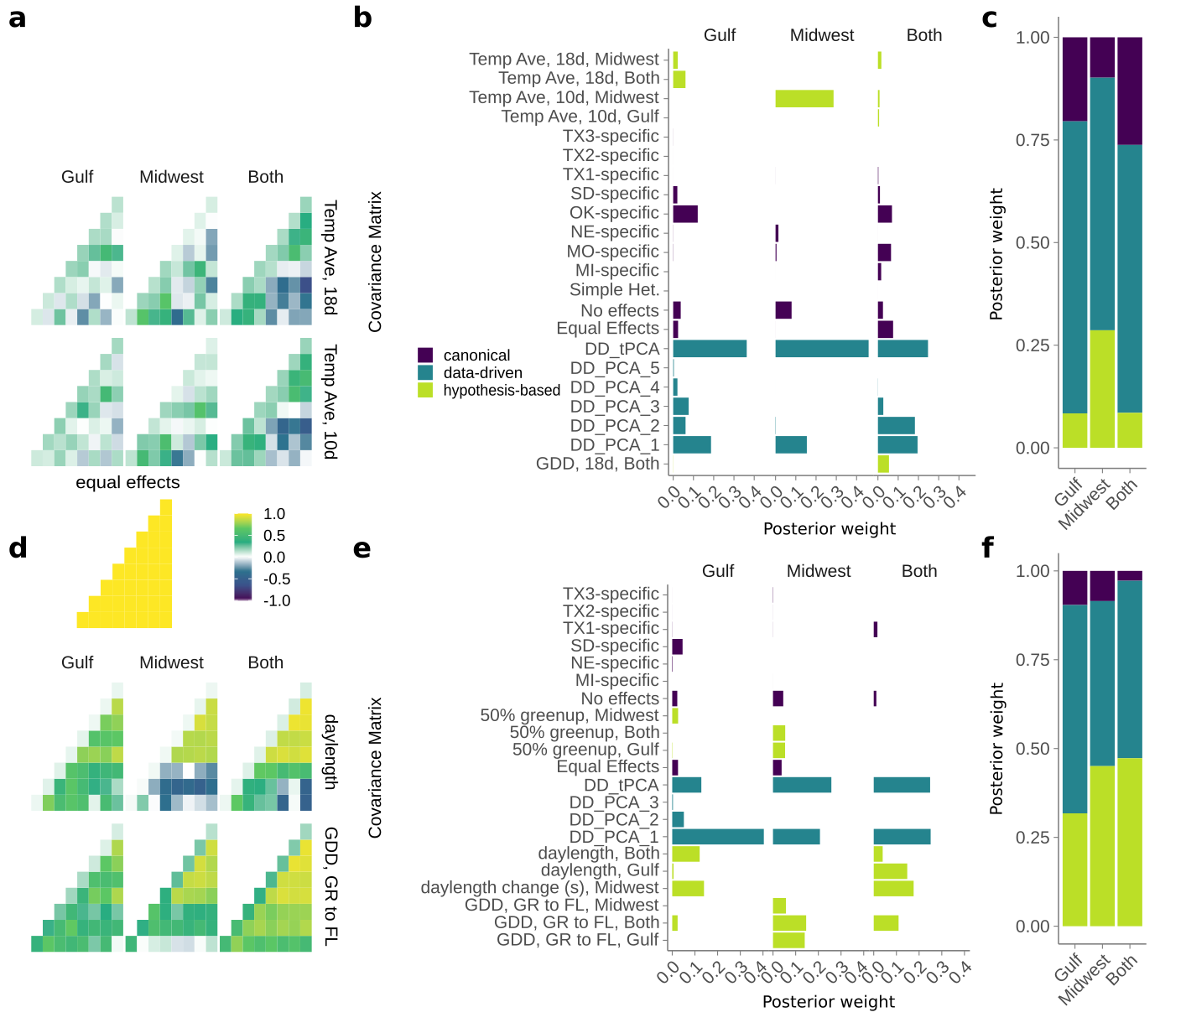

**Figure 2.** *Example hypothesis-driven covariance matrices specified in mash and the posterior weights placed on all covariance matrices. (a,d) Six example hypothesized covariance matrices specified for the (a) green-up date phenotype and (d) flowering date phenotype. Common gardens are arranged in latitudinal order. A canonical covariance matrix of equal effects is also shown. (b,e) Total posterior weight placed on each covariance matrix type specified for (b) green-up date and (e) flowering date mash models. Hypothesized covariance matrices (green) were created from environment-specific correlations across eight common gardens, and are described in Table 1. Data-driven matrices (teal) are specific to each mash model, and canonical matrices (purple) have simple interpretations, such as equal effects across all common gardens, or effects specific to a single common garden. Covariance matrices included in mash that had zero posterior weight in all three mash runs on the genetic subgroups are not shown. (c,f) Total posterior weight placed on covariance matrices that were hypothesized, data-driven, or canonical, for the (c) green-up date phenotype and (f) flowering date phenotype.*

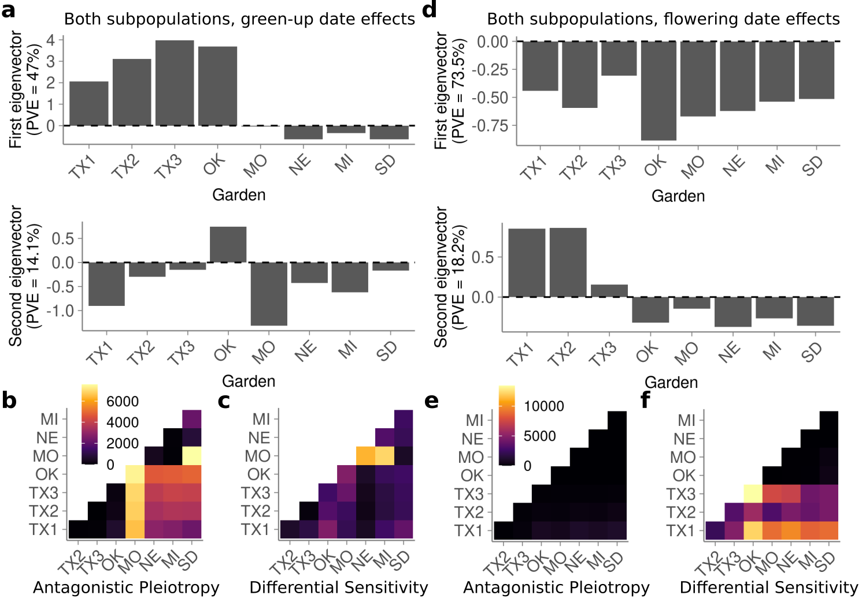

**Figure 3.** *Effect patterns exhibited by the major data-driven matrices for Both subpopulations from Figure 2. (a-c) Green-up date. (d-f) Flowering date. (a,d) Single-garden effect representations (eigenvectors) of the DD_tPCA data-derived matrices. The percent variation explained of DD_tPCA by each eigenvector is shown on the y-axis. Common gardens are arranged in latitudinal order along the x-axis. In addition, the first eigenvector corresponds to DD_PCA_1, and second corresponds to DD_PCA_2. (b,e) The number of SNPs with significant effects in both conditions that exhibit antagonistic pleiotropy between that pair of conditions. (c,f) Same as (b,e) except for differential sensitivity.*

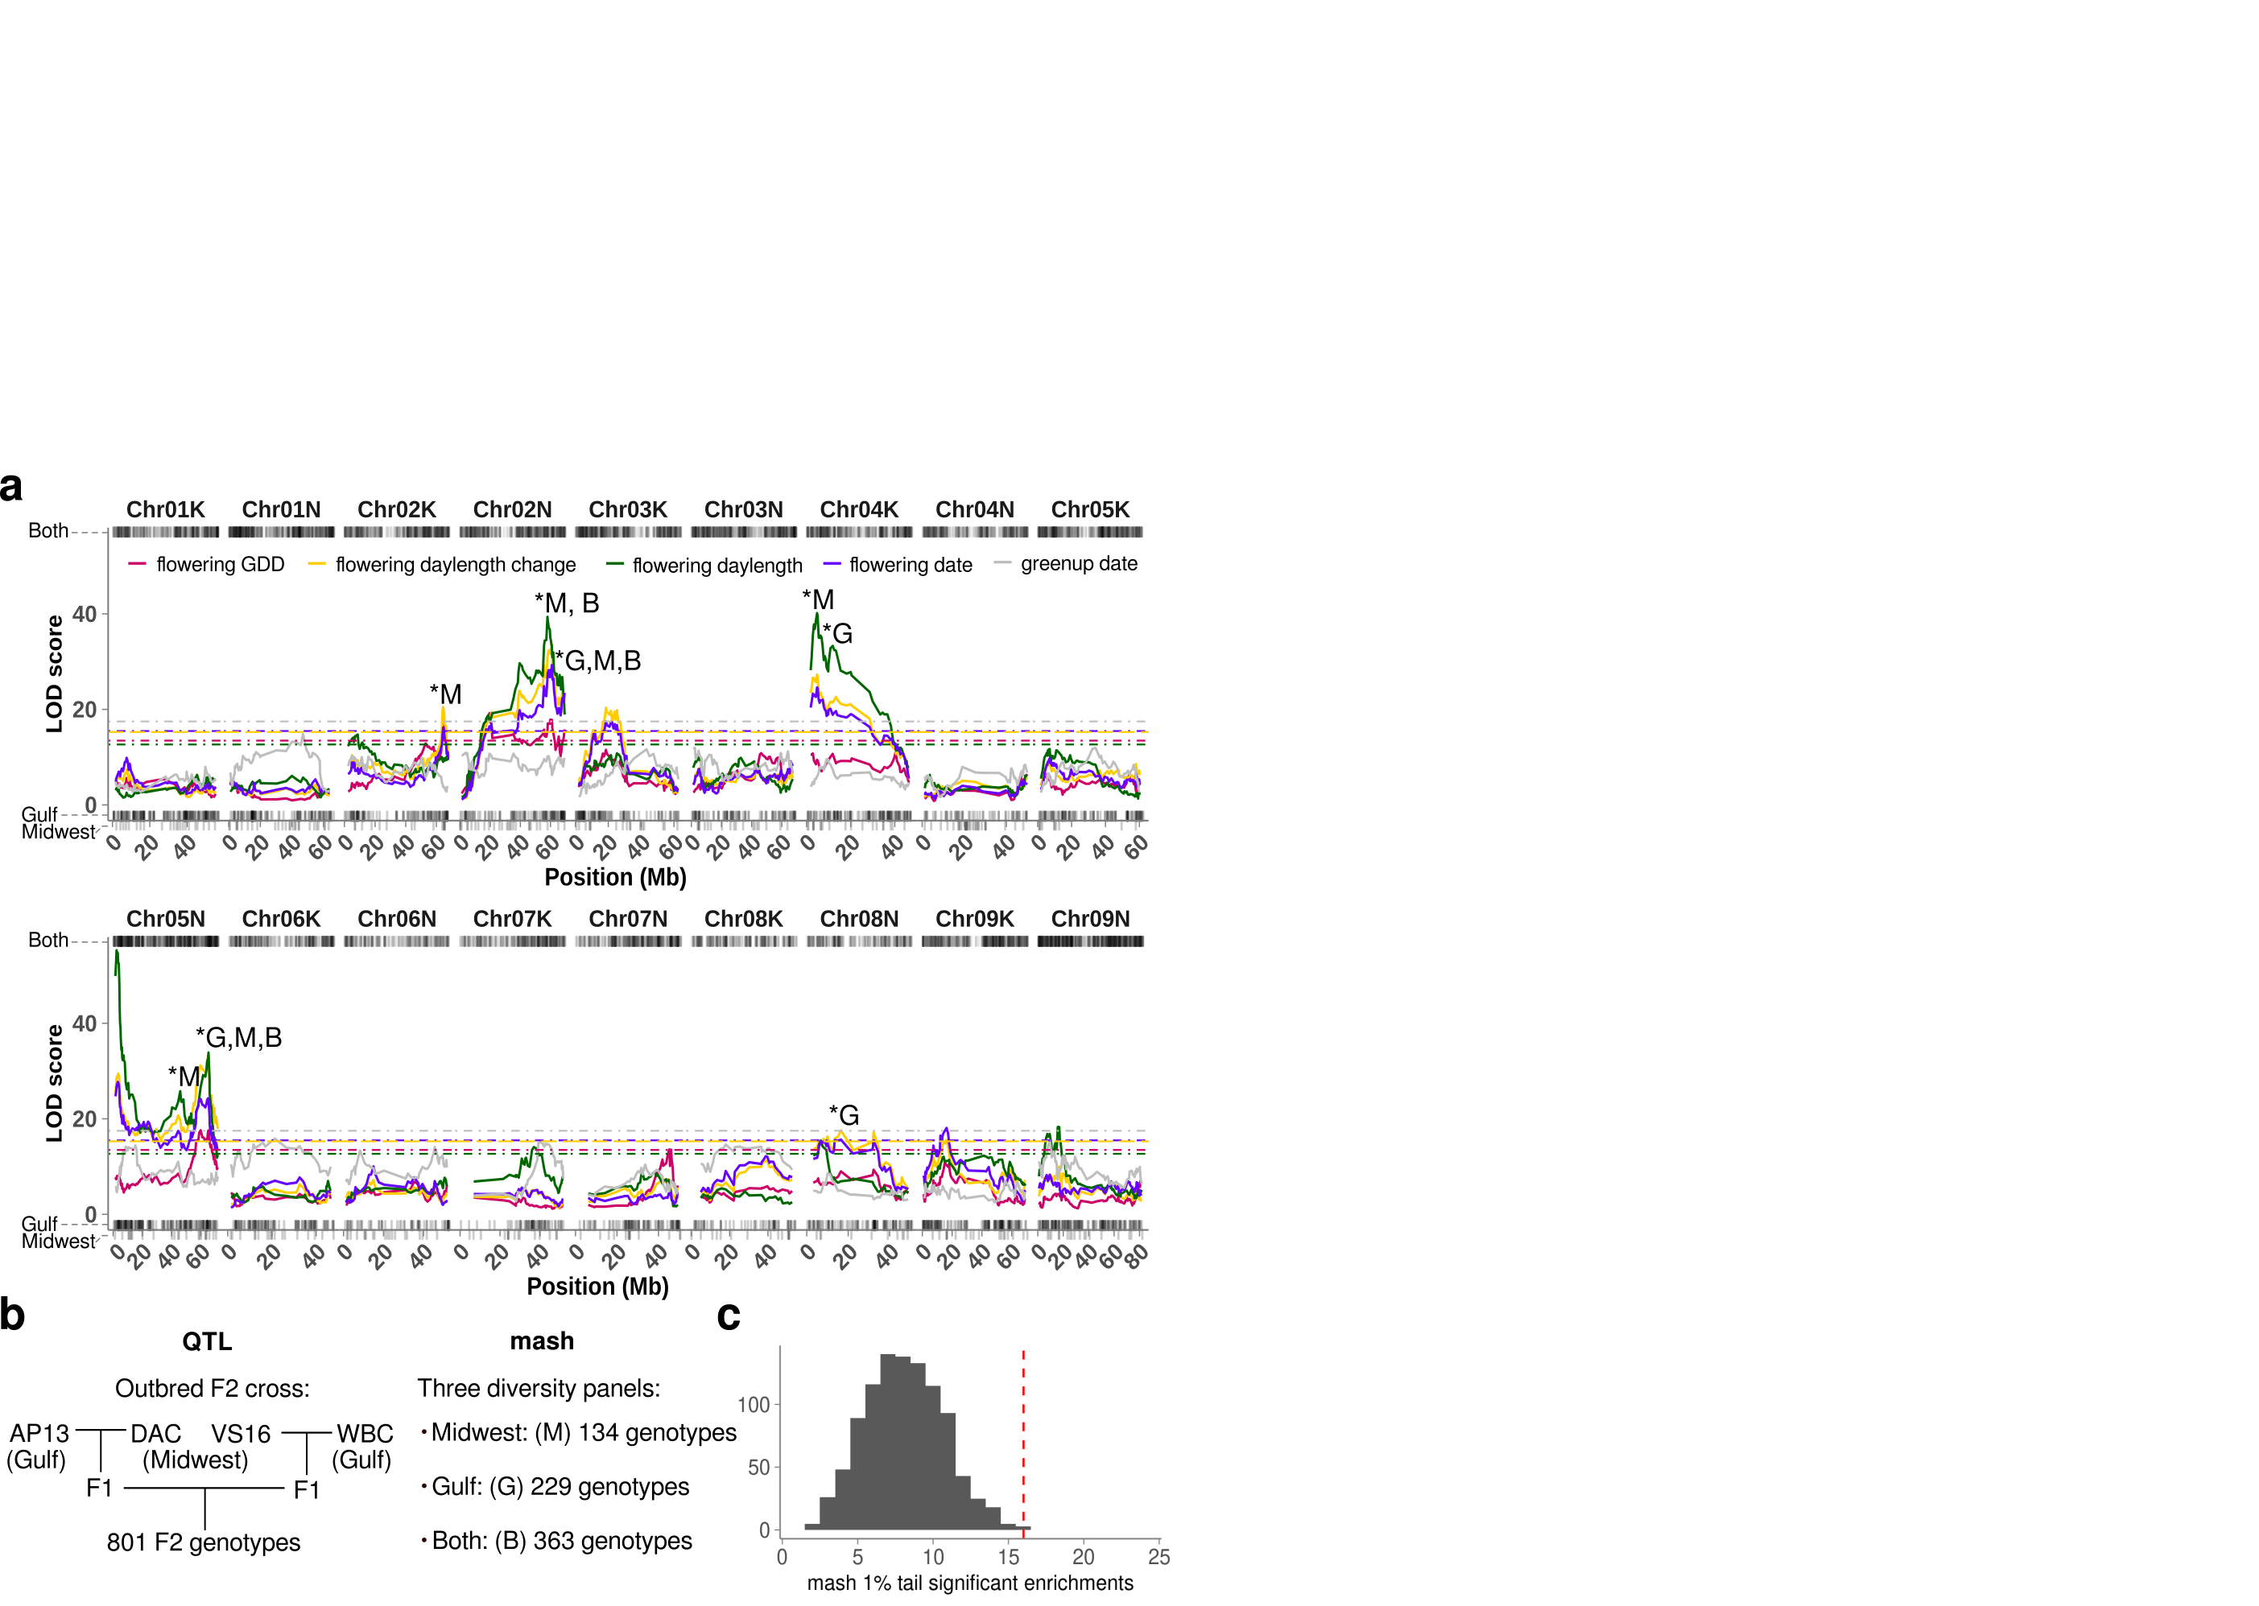

**Figure 4.** *Comparison of mash SNP effects from a diversity panel and effects from an outbred pseudo-F2 cross. (****a****) QTL mapping for four weather-related functions of flowering, and for green-up date, as indicated by the colors: pink, growing degree days (GDD) from green-up date to flowering date, yellow, day length change on the flowering date, green, day length on flowering date; purple, flowering date; gray, green-up date.**Dotted lines indicate permutation-based significance thresholds for each weather-related function. Stars indicate QTL with significant enrichment for SNPs in the 1% mash tail; B, G, and M indicate which subpopulation had enrichment: B - both subpopulations, G - Gulf subpopulation, M -Midwest subpopulation. Rug plots show genomic locations of SNPs in the 1% mash tail for flowering date for each subpopulation. (****b****) Schematic comparison of genotypes used for QTL mapping and genotypes used in mash. (****c****) Number of mash runs enriched for SNPs in the 1% mash tail in the 23 QTL intervals from (****a****) (dotted red line), compared to 1000 sets of 23 random QTL intervals of the same size (histogram).*