**Supplementary Figure 1.** *Latitude of origin correlates with flowering response to an environmental cue of shortening day length. Bars represent the number of distinct genotypes that had 50% of tillers flowering before the summer solstice (when days were lengthening) or after the summer solstice (when days were shortening). Colors represent the five categories we grouped genotypes into: tetraploid individuals in the Atlantic, Midwest, and Gulf genetic subpopulations, admixed/uncategorized tetraploid individuals, and octoploid individuals.*

Supplementary Figure. Single site heritabilities for flowering functions of weather. Dashed line indicates heritability for flowering as a function of Julian date.

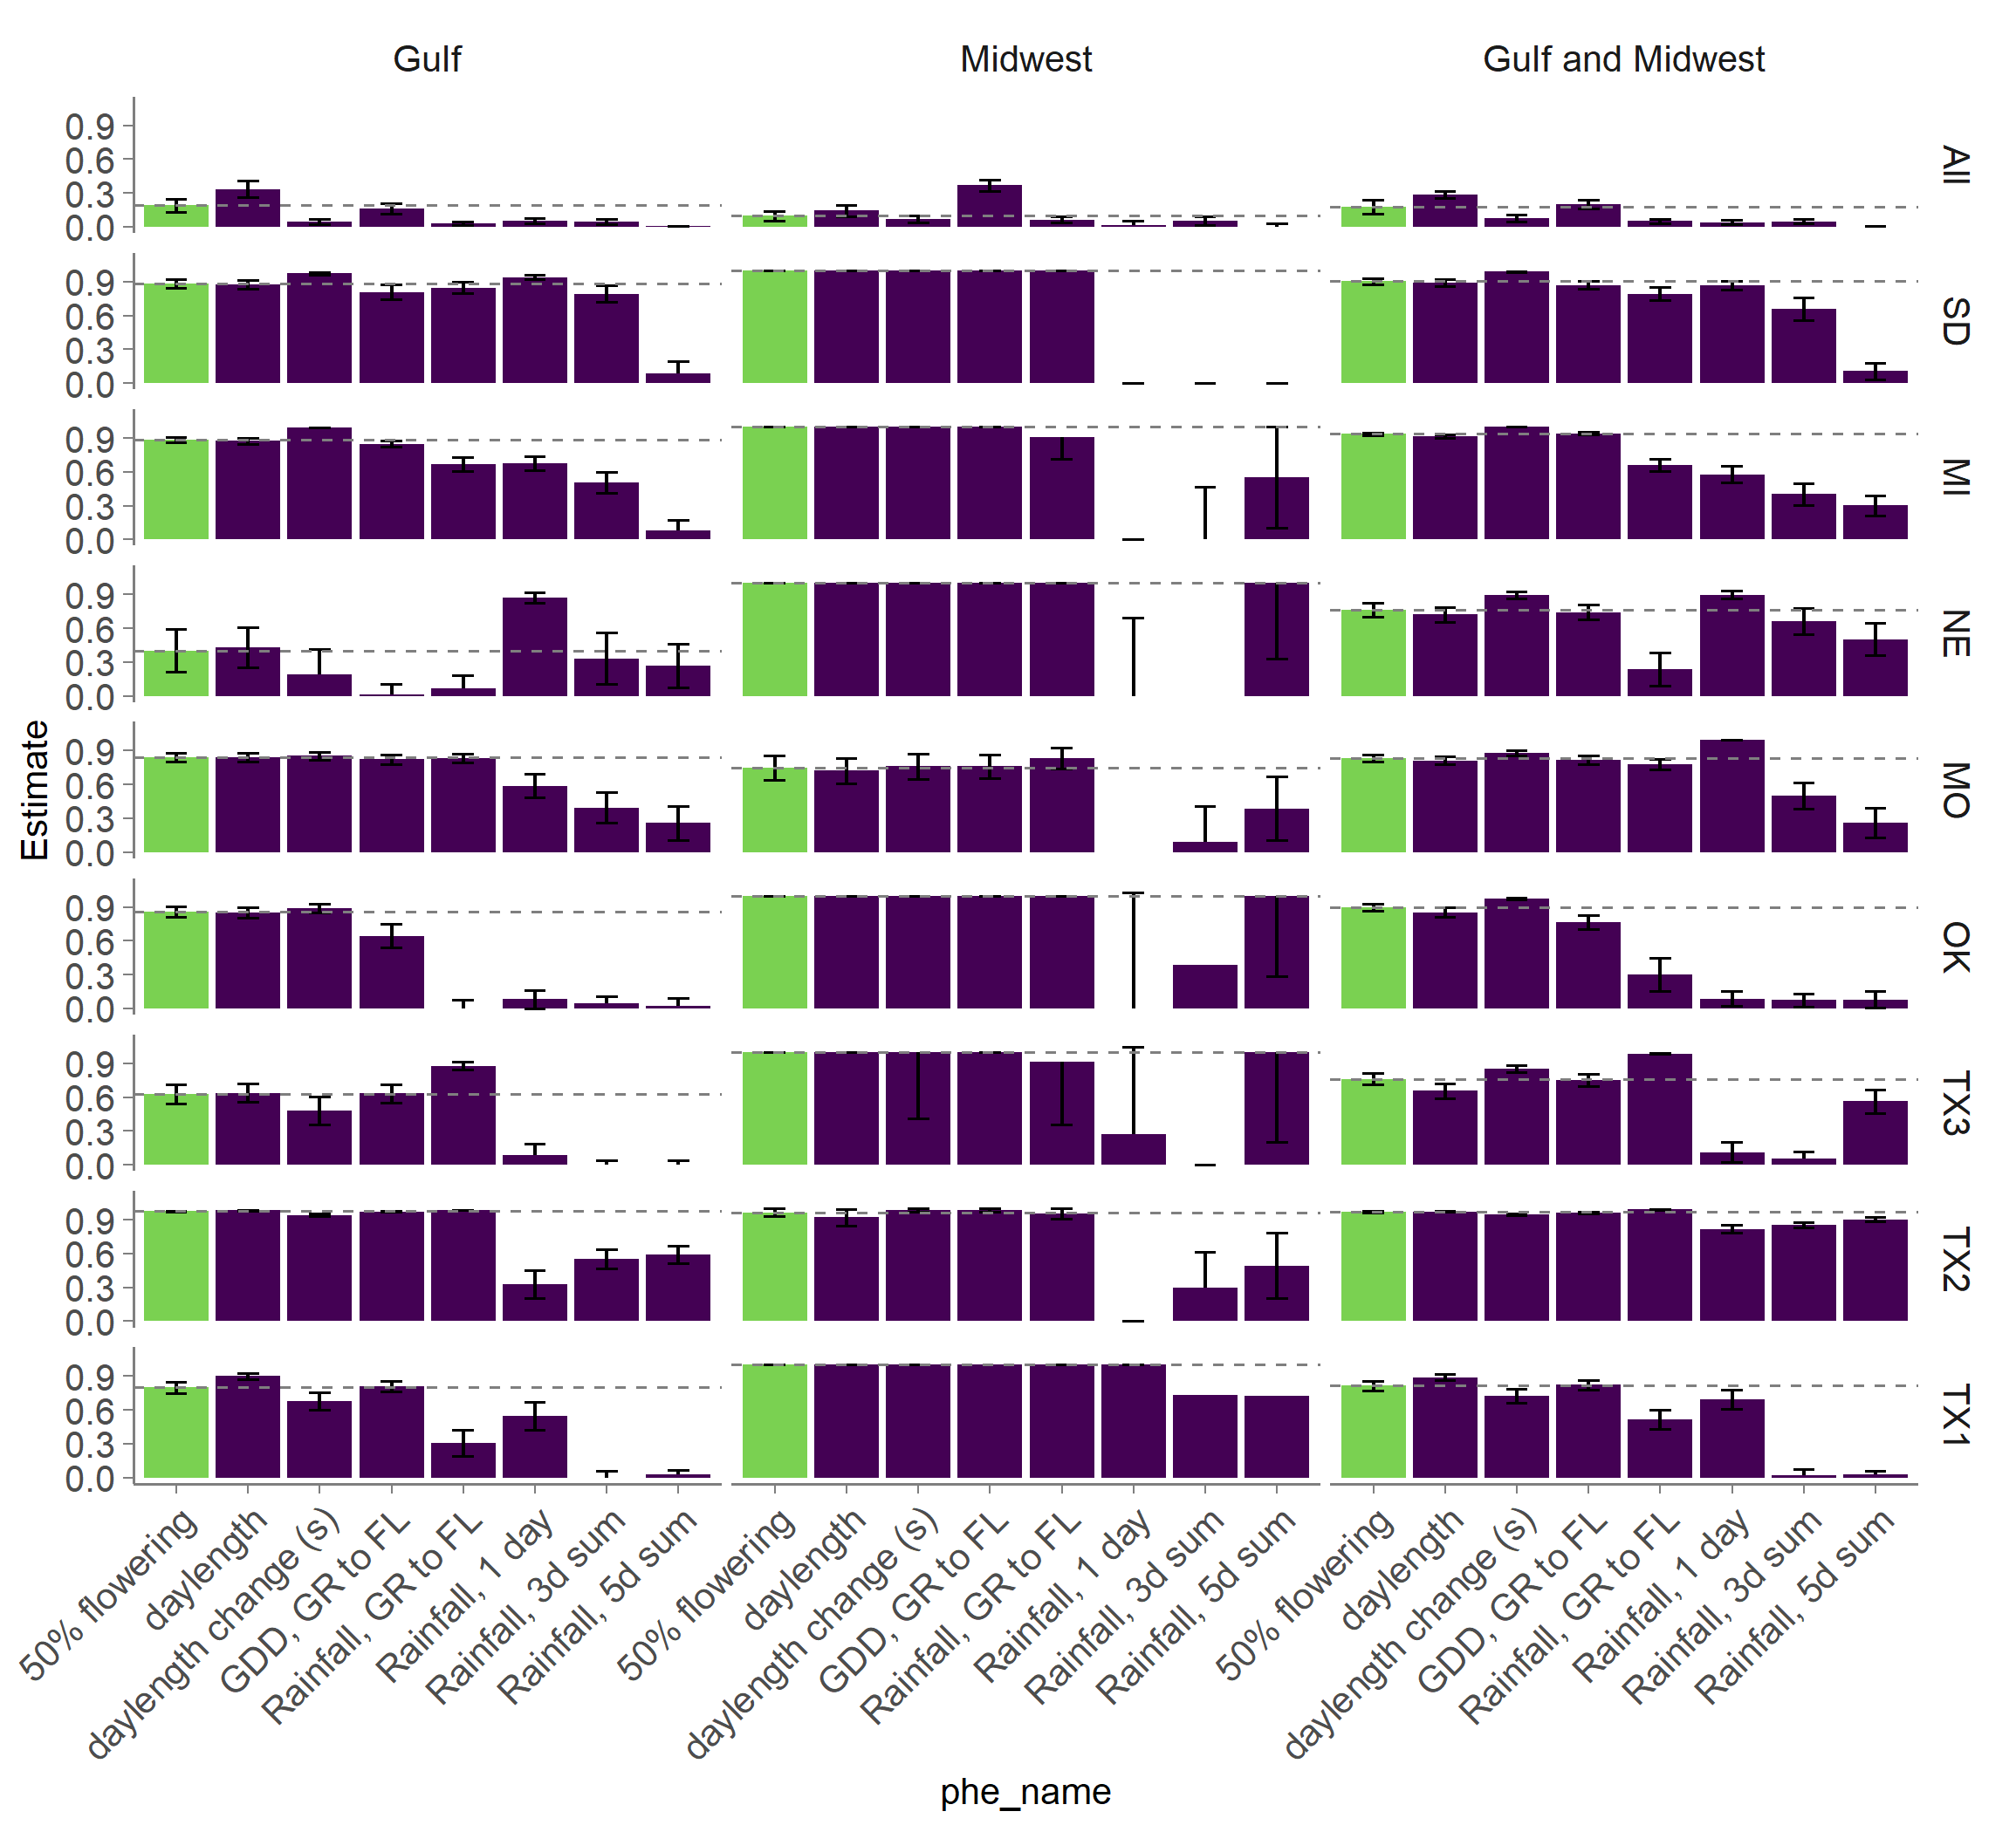

If QTL Effect is negative: lowland allele is delaying flowering - making D2F larger. Upland allele is making D2F shorter.

DAC: early flowering Midwest

VS16: late flowering Midwest

AP13: early flowering Gulf

WBC: late flowering Gulf

A = AP13, B = DAK, C = WBC, D = VS16

