|  |
| --- |
| **kill** |
|  |
| +eliminate(Blank *, int, int): virtual void  ~kill():virtual |

|  |
| --- |
| **Star** |
|  |
| +eliminate(Blank *,int,int): virtual void  ~Star():virtual |

|  |
| --- |
| **Column** |
|  |
| +eliminate(Blank *,int,int): virtual void  ~Column():virtual |

|  |
| --- |
| **Nineblock** |
|  |
| +eliminate(Blank *,int,int): virtual void  ~Nineblock():virtual |

|  |
| --- |
| **Row** |
|  |
| +eliminate(Blank *,int,int): virtual void  ~Row():virtual |

|  |
| --- |
| **MainWindow** |
| +Pre_R: int  +Pre_C : int  +type : int  +star: int  +score: int  +count: int  +isClick: bool  -Blank *b[8][8]; |
| +creat_type(int, int):int  +getStar():int  +getScore():int  +check_type(int, int):void  +gamestart():void  +load_pic():void  +check_kill(int, int):void  +set_click_pic(Blank *):void  -movedone():void  +button_clicked(int, int):void  +killzero():void |

|  |
| --- |
| **Blank** |
| +value: int  +shift : int  +row : const int  +column: const int  +*b[8][8]: Blank  +*button: QPushButton  +*time: QTimer |
| +set_pic():void  +show_pic():void  +operation+(Blank *):void  +operation-(Blank *):void  +click():void  +moveup():void  +movedown():void  +moveleft():void  +moveright():void  -Click(int, int):void  -movedone():void |

**以上為UML**

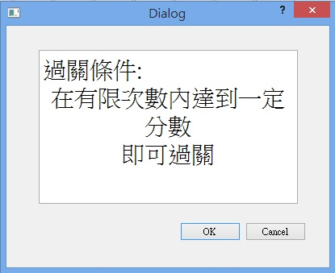**遊戲畫面**

趙珮均  
F74036221

資訊107

(遊戲主畫面)

