How to Use CoCloud?

CoCloud aims to provide a user-friendly and efficient cross-cloud file collaboration service, which currently supports four most popular cloud storage services in US and China, namely Dropbox, Microsoft OneDrive, Google Drive, and Baidu PCS. To collaboratively edit files with a Dropbox (or Google Drive) user Alice in US, there is no need for her partner Bob in China to access the (same but) blocked cloud service by VPN or HTTP proxy. Instead, Bob can easily make file collaboration through the locally available services (like OneDrive and Baidu PCS) with the help of CoCloud.

Now CoCloud can work as a background service software for Windows, and it will support Linux and iOS in the near future. The following is the specific usage as well as some instructions about CoCloud:

1. Registration and Login

The initial UI is *Login* frame (Fig. 1). A user who subscribes CoCloud service for the first time can click *Register* button to register first and then login the system.

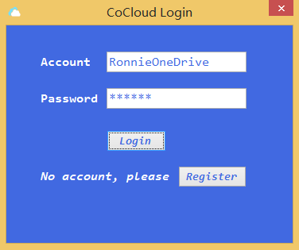

Fig. 1 Login Frame

Next are some specific instructions for registration (Fig. 2).

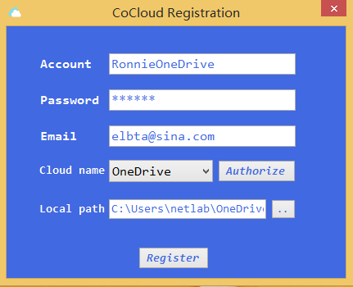

Fig. 2 Registration Frame

1. Besides *Account* and *Password*, *Email* is required for confirmation of collaboration invitation (the adding collaborator process is illustrated in “Collaborator Management”).
2. The user is asked to select a cloud service from the combo list (Dropbox, OneDrive, Google Drive, Baidu PCS) and then authorized by the selected cloud. For management and security consideration, currently one account belongs to only one cloud in CoCloud. Registering an account per cloud is the advice for users who are willing to leverage the service to backup files among his multiple clouds.

The cloud authorization process is just based on the OAuth 2.0 framework which is widely supported by almost all cloud services. The returned token will be then recorded as metadata for inter-cloud data transfer.

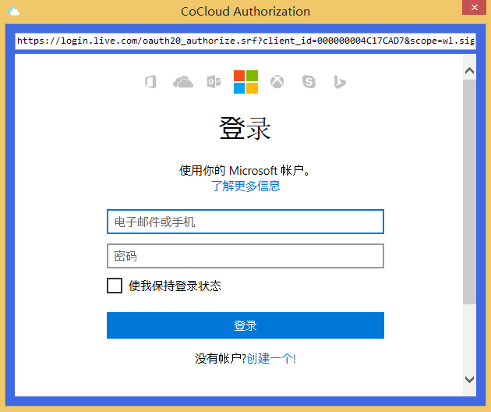

Fig. 3 Authorization Frame

Note that sometimes the cloud authorization may be failed (caused by temporarily OAuth server failure, as well as web content response failure for Dropbox). Please exit current registration frame and re-register then.

1. The user should also choose the **right** sync folder of currently used cloud service (e.g., *C:\Users\<system user name>\Dropbox*) into *Local Path* by File Dialog, and then CoCloud will automatically create a folder under the cloud client directory, named “CoCloud” by default (accordingly *C:\Users\<system user name>\Dropbox\CoCloud* is filled into the block and recorded as metadata when successfully finishing registration), as the collaboration folder. Otherwise, CoCloud cannot monitor the collaborative file update correctly.
2. Collaborator Management

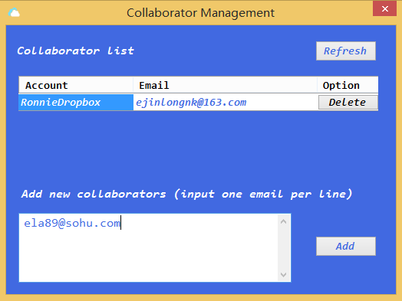

Fig. 4 Collaborator Management Frame

After a user logins CoCloud, *Collaborator Management* frame (Fig. 4) will come out to show his current collaborator list (*Account*, *Email*), and prompts the user to add collaborators when he does not have one. Collaborators can be added by printing some email addresses (one email per line) into the block and click *Add*, after which confirmation emails will be sent to the corresponding addresses. When a collaboration invitation is confirmed, the collaborator will be shown in the list after clicking *Refresh*. In addition to that, the user can also delete a collaborator by clicking *Delete* in the shown collaborator list, after which file update of these two users will no more be notified to each other.

Note that Collaborator Manager frame can be also accessed by clicking *Collaborators* in the pop-up menu (by right clicking the mouse) of the CoCloud icon on the taskbar (Fig. 5). By the way, when holding the mouse on the icon, the current account and the cloud service that it belongs to are shown then. This is very friendly for those who login the service for two different clouds.

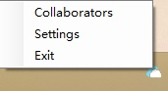

Fig. 5 CoCloud Icon and Pop-up Menu

1. CoCloud Settings

A user can set parameters of CoCloud by *Settings* frame (Fig. 6), which is also in the pop-up menu of the CoCloud icon (Fig. 5). Basically, there are two types of parameters, performance and preference respectively.

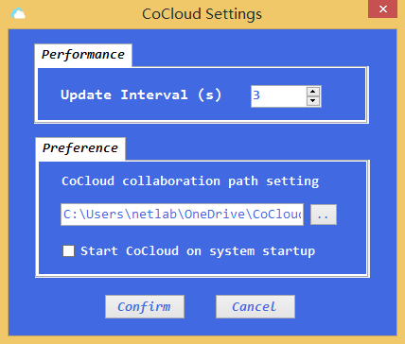

Fig. 6 Settings Frame

For performance consideration, CoCloud allows the user to set the file update notification interval. That is to say, CoCloud client can cache file update messages and upload a batch of messages periodically (3 seconds by default), to avoid too frequent request to the server.

As for preference, the user can change the collaboration folder to another path (e.g., a certain child directory of CoCloud path or any other directory under the cloud client sync folder). It is preferred by users who sometimes do not anticipate collaboration on all files under the whole CoCloud path.

1. File Collaboration

After two or more users have become collaborators among each other, a user’s file update (either creation, revision or deletion) under the collaboration folder will influence that of his collaborators. The current collaboration folder can be accessed by double clicking the CoCloud icon. (*For management simplicity, the provided demo adopts pear to pear collaboration mode, i.e., sub-folders are created for all collaborators of a user and then a file added to a certain file will be synced to the corresponding target collaborator.*)

Here we take two users Alice and Bob (belonging to Dropbox and OneDrive respectively) as an example. Several kinds of file operations can be done by Alice and Bob (any of which will influence the counterpart): creating a new file, copying a file from other place outside collaboration folder, delete a file or a child folder, copying a folder with a batch of files inside, modifying a file in the collaboration folder…

Note that CoCloud also creates a folder named “CoCloud_Backup” when a user successfully finish registration, for handling more than one user work on the same file concurrently. Specifically, only the earliest file update will be synced to the counterparts, while other conflicting update versions will be renamed and backed up to the “CoCloud_Backup” folder, prompting the source user to handling the conflict.

Note that as Baidu PCS client no more provides an auto-sync folder currently (so we only test the relevant cloud-to-cloud but not end-to-end performance in the paper), the collaboration can be only finished through the provided automatic backup folder functionality for uploading, and the client software for viewing and manually downloading files instead. Admittedly, the auto-backup can hardly achieve real-time sync, which will influence the user experience to a large extent. Therefore, you’d better use other three clouds in the current demo, and the updated version would well support Baidu PCS once it recovers the auto-sync functionality.