A Framework for Attacks on privacy-preserving Record Linkage

Student: Ke Ran (u7261338)
Supervisor: Dr. Anushka Vidanage
Dr. Ranbaduge Thilina

Requirements
- Report (due on 22/05/2023)
- Artefact (due on 13/05/2023)
- A Poster for presentation（due on 26/05/2023)

The project is to develop a Python package for running different PPRL attacks on different databases. A user of this package could simply use UI to input their sensitive database and select which encoding methods to use and what attack they would like to run on their database. The software will then run the attack and provide the results to the user.

General flow
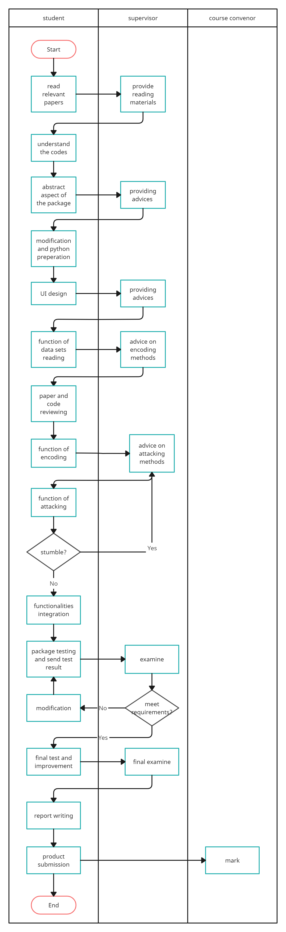
Brief Time plan
Week1 read relevant publications
Week2 understand corresponding code
Week3 basic idea of package implement
Week4 UI design
Week5 datasets reading and review the papers
Week6 implement data encoding function

Mid break (03/04/2023 - 16/04/2023)
implement data encoding function
implement attacks

Week7 implement attacks
Week8 integration
Week9 test and modification
Week10 final product submission
Week11- week12 report writing

Library reference
