1. What is the Operating System？List 3-4 examples of OS.
2. Describe five Process states.描述阶段含义
3. Please illustrate processes states transitions by diagram.
4. What is process? Try to compare process and program.
5. What is critical resource and critical section?
6. Describe two kinds of relationship between processes.
7. Realize the cooperation relationship between s1,s2,s3,s4,s5,s6 in the following graph by using semaphore.



1. Realize the cooperation relationship between s1,s2,s3,s4,s5,s6 in the following graph by using semaphore.原题

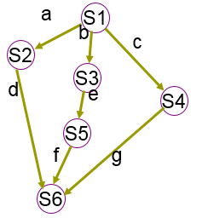

1. Please write down the multiple producers and multiple consumers processes synchronization model programs within bounded-buffer (N buffers) condition by using semaphore technique.原题

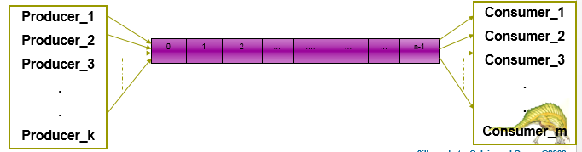

There is an empty plate capable of one fruit on the table. Father can put apple into the plate. Mother can put orange into the plate. Son is waiting for the apple, daughter is waiting for the orange. Please use semaphore tool to realize the synchronization among the three processes: father, mother, son and daughter.

1. A ticket office, capacity of 20 persons, when the number of persons <20, a new person is permitted to enter, otherwise, he should wait outside. If we view a person as a process, try to solve the critical section problem using semaphore.

pi(){//i=1,2,3…n

while(true){

enter the ticket office;

buy a ticket;

leave;

}

}

1. Suppose there are 2 processes, one buffer( buffer capable of one item) 。

P1 produces an item and puts it into buffer, P2 takes the item from buffer and consume it.

Try to use semaphore to solve the cooperation problem of P1 and P2.

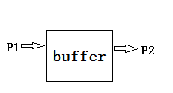

P1()

{

While (TRUE)

{ wait(empty1);

Produce an item；

Put the item into buf1；

Signal(full1);

}

}

P2（）

{

While（TRUE）

{ wait(empty2);

Take an item from buf1；

Consume the item;

Signal(full2);

}

|  |  |  |
| --- | --- | --- |
| 16110100406 | 黄洋洋 | 1,7 |
| 16110100407 | 娄培杰 | 2,8 |
| 16110100410 | 李柃锋 | 3,9 |
| 16110100411 | 商泓梁 | 4,10 |
| 16110100420 | 刘梓涛 | 5,11 |
| 16110100421 | 姜正冬 | 6,12 |
| 16110100422 | 傅豪 | 2,7 |
| 16110100423 | 任悦豪 | 3,8 |
| 16110100426 | 张晨曦 | 4,9 |
| 16110100427 | 陈萱妮 | 5,10 |
| 16110100430 | 白思源 | 6,11 |
| 16110100502 | 吴佳晟 | 1,12 |
| 16110100503 | 程锐 | 3,7 |
| 16110100505 | 周浩楠 | 4,8 |
| 16110100506 | 田伟宏 | 5,9 |
| 16110100512 | 聂启航 | 6,10 |
| 16110100514 | 陈渤元 | 1,11 |
| 16110100515 | 陆思杰 | 2,12 |
| 16110100516 | 陆永均 | 4,7 |
| 16110100517 | 梅伟琪 | 5,8 |
| 16110100518 | 刘建平 | 6,9 |
| 16110100529 | 常靖怡 | 1,10 |
| 16110100602 | 杜旭 | 2,11 |
| 16110100612 | 王文韬 | 3,12 |
| 16110100613 | 孙浩东 | 5,7 |
| 16110100614 | 王新源 | 6,8 |
| 16110100615 | 杨雨鑫 | 1,9 |
| 16110100618 | 曲贵显 | 2,10 |
| 16110100619 | 赵元铭 | 3，11 |
| 16110100621 | 王松雪 | 4，12 |
| 16110100624 | 王姝玮 | 6,7 |
| 16110100718 | 何劲 | 1，8 |
| 16110100719 | 陈蹊 | 2，9 |
| 16110100726 | 戴铭慧 | 3，10 |
| 16110100727 | 方依雯 | 4，11 |
| 16110100822 | 陈彦虎 | 5，12 |
| 16110100823 | 赵佳琪 | 2，8 |
| 16110100828 | 曹茹 | 3,12 |
| 16110100912 | 李科 | 4,11 |
| 16110100915 | 张强 | 5,9 |
| 16110100930 | 张琼文 | 6,10 |