二、简答题文字描述相关题型

1、What is the Operating System？List 3-4 examples of OS.

(1) An operating system is a program程序 that manages the computer hardware.

It also provides a basis for application应用程序 programs and acts as an intermediary 中介between the computer user and the computer hardware.

(2) Windows 10 , Linux , Android, Unix.

2、What is System Calls？系统调用

System call is a programming interface to the services provided by the OS,

系统调用是操作系统提供的服务的编程接口

typically it is written in a high-level language (C or C++).

3、what is process？Describe Process states and illustrate these transitions by diagram.

（1）(1) A process is a program in execution.

It consists of text section、data section and PCB.

//program is a static entity.

process is a dynamic entity.Process has its own life period.

（2）The process has 5 following states:

new: The process is being created

running: Instructions 指令are being executed

waiting（block）: The process is waiting for some event to occur

ready: The process is waiting to be assigned分配 to a processor

terminated: The process has finished execution

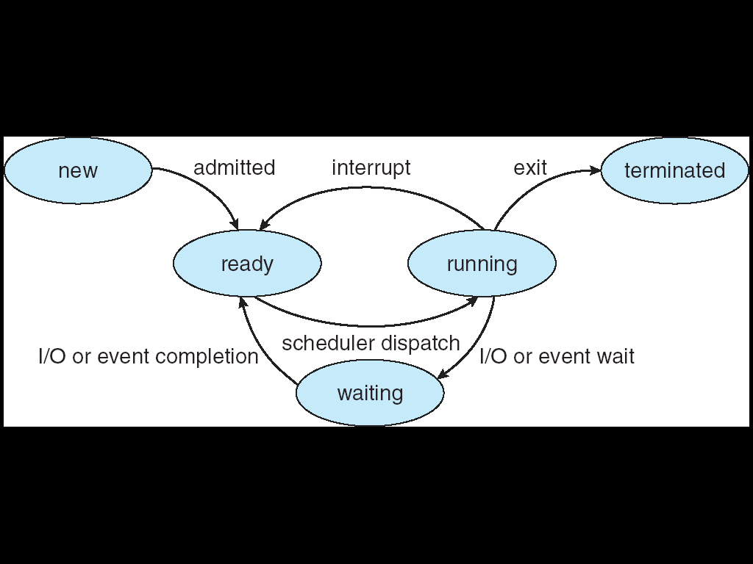

4、Please describe the concept of Deadlock？

等待进程再也不能更改状态，因为它所请求的资源由其他等待进程持有

A waiting process is never again able to change state,

because the resources it has requested are held by other waiting processes.

This situation is called a deadlock.

**please write down conditions of Deadlock?**

Mutual exclusion互斥

Hold and wait占有和等待

No preemption没有抢占

Circular wait环路等待

5、List 4-5 kinds of memory management techniques.（存储器管理方式）

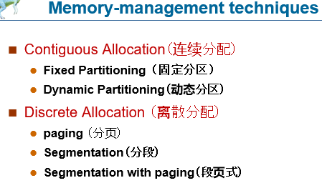

文字

Partitioning(固定分区，动态分区)

Paging（基本分页）

Segmentation（基本分段）

Segmentation with paging（段页式）

**Demand paging（请求分页）-虚拟内存的管理技术**

6、How are disk blocks allocated for files (describe file allocation methods )?

如何把磁盘分配给文件？(磁盘空间分配法)

（1）Contiguous allocation 连续空间分配

（2）Linked allocation 链接式分配

（3）Indexed allocation索引分配

7、Illustrate the Free-Space Management methods. 文件存储空间管理

（1）Bit vector or Bit map位示图

（2）Linked list (free list) 链表(空闲列表)

（3）Grouping

8、List I/O control methods. Can Busy-wait exist in which control methods?

（1）Pooling轮询

（2）Interrupt 中断

（2）DMA直接存储访问

Busy-wait can exist in pooling method

三、算法分析题5题*10分=50分

1、信号量（生产者消费者类型题目）（第六章）

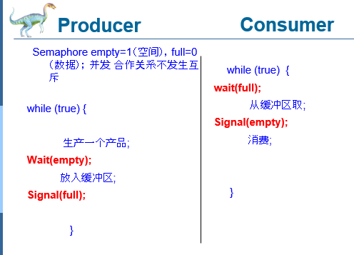

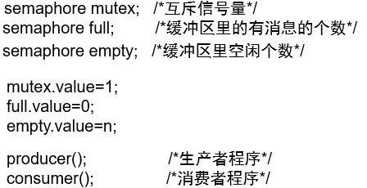

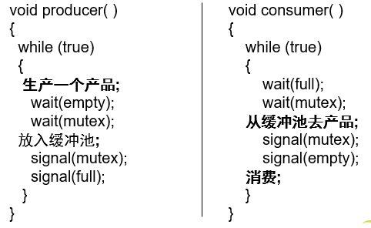

综合题：

P10-2

Realize the cooperation relationship between s1,s2,s3,s4,s5,s6 in the graph (a),(b) by using semaphore.

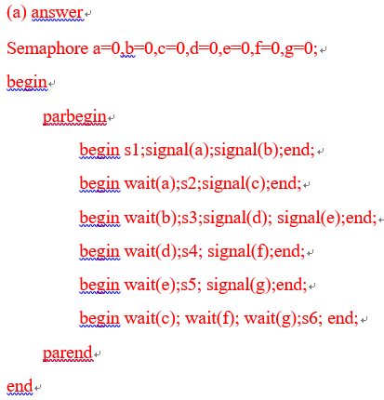

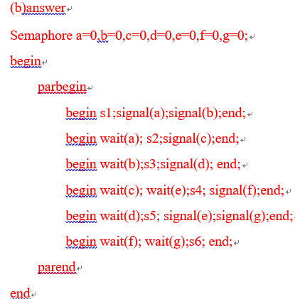

综合题P12-6

Suppose three processes, two buffers(each buffer capable of one item) 。

P1 produces an item and puts it into buffer1, P2 takes the item put by P1 and puts it into buffer2, P3 takes the item from buffer2 and consume it.

Requirement:

Producer cannot put data into a full buffer;

Consumer cannot take data from an empty buffer.

Try to use semaphore to solve the cooperation problem of the three processes.

You should define semaphores, give the initial value of them and add wait and signal operation at the proper position of the program.

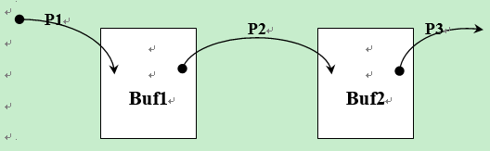

Semaphore e1=1,f1=0,e2=1,f2=0;

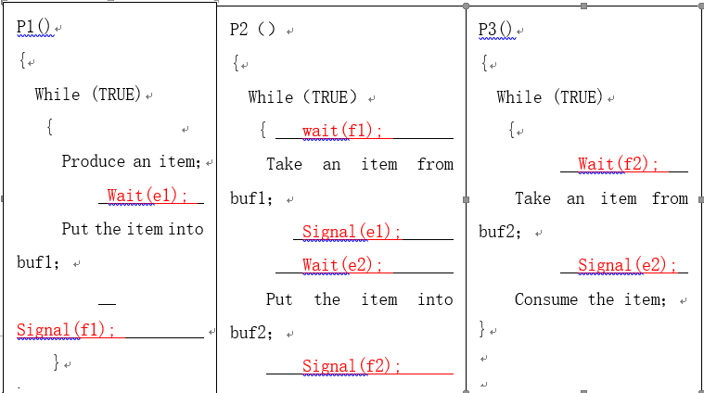

**Empty=n（空间），full = 0（数据）；buffer是缓冲池**

**《当》**

**此时**

**Producer（）{**

**Produce an item；**

**Wait（empty）**

**Wait（mutex）；**

**Put an item into the buffer；**

**Signal（mutex）；**

**Signal （full）；**

**}**

**Consumer（）{**

**Wait（full）；**

**Wait（mutex）；**

**Take an item from the buffer；**

**Signal（mutex）；**

**Signal （empty）；**

综合题P13-8

8、There are three processes named A,B,C. they share a buffer F. capacity of F is one number. Process A produces one random number R and put the number into F. if the number is a multiple of 5, this number can be gotten by process B ,then process B print it; else the remainder of the number divided by 5 can be gotten by process C, then process C print it. Please user semaphore technology to ensure the synchronization of A B C. fill in the blanks in the following programs.

Requirement: initial state of F is empty.

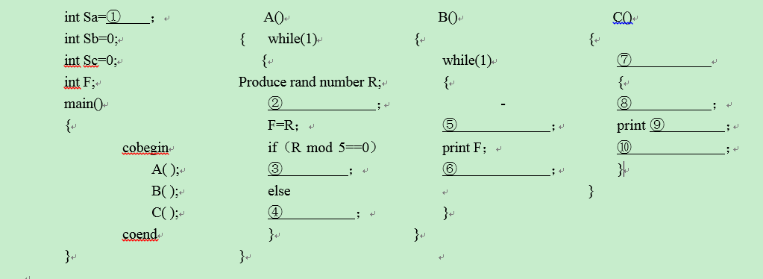

（1） 1

（2） Wait（sa）

（3） Signal（sb）

（4） Signal（sc）

（5） Wait（sb）

（6） Signal（sa）

（7） While（1）

（8） Wait（sc）

（9） R%5

（10） Signal(sa);

综合题P13-9

9、In a store, there is a shelf(capacity of 100 items).There is a salesman who can put the item into the shelf. There are multiple customers who can take the item from the shelf.

Requirements:

（1）the initial state of shelf is full.

（2）only one person can be permitted to do his work for the shelf.

（3）when the shelf is full, the salesman should wait, when the shelf is empty, the customers should wait.

Q:use the Producer & consumer principle to solve the salesman and customers problem.You need fill the wait and signal operation into the proper position in the following programs.

**Semaphore full=100, empty=0, mutex=1;**

void customer（int i）；

{

walk to the shelf；

**wait(full);**

**wait(mutex);**

take an item from the shelf；

**signal(mutex);**

**signal(empty);**

leave；

}

void salesman（）

{

while(TRUE)

{

**wait(empty);**

**wait(mutex);**

put an item into the shelf;

**signal(mutex);**

**signal(full);**

}

}

main()

{

cobegin

{

customer（1）；

customer（2）；

……；

customer（n）；

salesman（）；

}

}

（2）CPU调度算法（FCFS（先来先服务）非，SJF（短进程优先）非，HRRN抢占式（高优先权优先），RR抢占式（时间片轮转））**chapter5，调度和**

Available – need + max = Available – Allocation判断state是否safe

当序列改变的时候，比较需求和need还有available是否小于这两个

**7、死锁**

（3）银行家算法

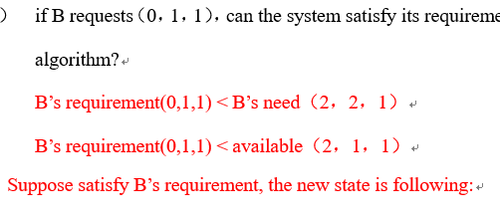

（4）虚存页面置换算法（OPT，FIFO，LRU）

Chapter8 logical address 转换 physical address P26-29

Chapter9 virtual memory

**Frequently-used algorithms:**

Optimal algorithm（最佳置换算法）后面

替换将来再也不用的页或者未来长时间内不用的页。

FIFO algorithm（先进先出页面置换算法）前面

替换最先进入内存的页面。

LRU algorithm（最近最久未使用页面置换算法）前面

（5）磁盘移臂调度算法（FCFS，SSTF，SCAN，CSCAN CLOOK）

Chapter12磁盘管理P36-37

FCFS—first come first serve

SSTF---shortest seek time first最短寻道时间优先算法

SCAN——磁臂从磁盘的一端向另一端移动，当磁头移过每一个柱面时，处理位于该柱面上的请求服务。当到达另一端时，改变方向继续处理。

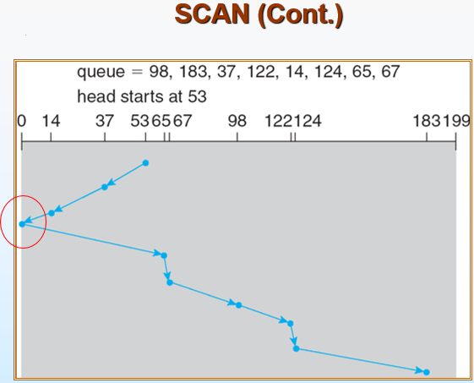

C-SCANC-SCAN也是将磁头从磁盘一端移到另一端，随着移动不断的处理请求。但是，当磁头移到另一端时，会马上返回到磁盘开始，返回时不处理请求

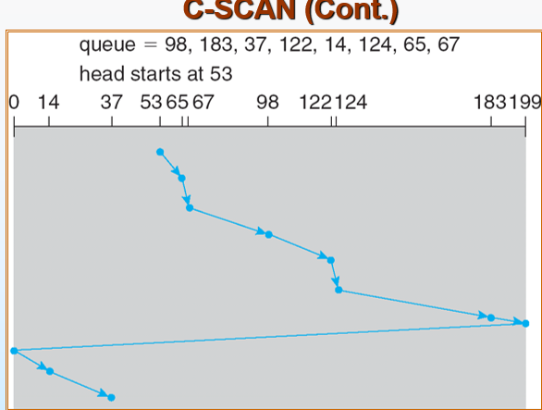

C-LOOK

磁头只移动到一个方向上最远的请求为止，接着马上返回，而不是移动到磁盘的尽头

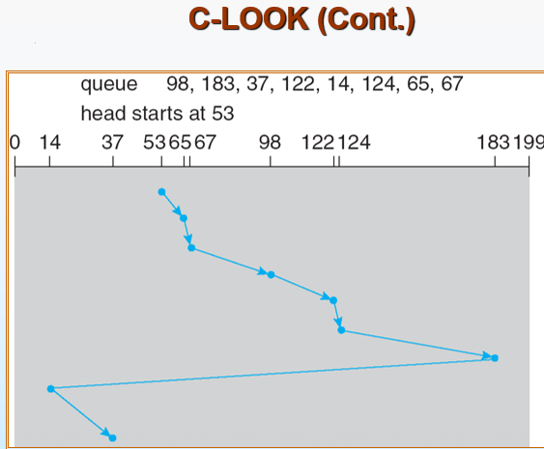

3-6

Relationships between these processes

Mutual exclusion互斥 and cooperation合作