DIFFUSION OVER A NETWORK WITH SHORT AND LONG RANGE INTERACTIONS

Here we investigate diffusion of heat over a given network. First we consider heat transfer through short range interactions and later introduce long range interactions by tuning the conductance,
x [0 <= x< 0.4]
Consider a simple network (shown in Fig below) with 10 nodes and initial heat quantities Q_0 = [3.0, 0.0, 8.0 ,0 .0, 5.0 , 2.0 , 0.0 ,0.0 ,0.0, 2.0]. Let the diffusion constant, C= 1. We then find out how long it takes for all nodes in the network to reach equilibrium for different values of conductance x.

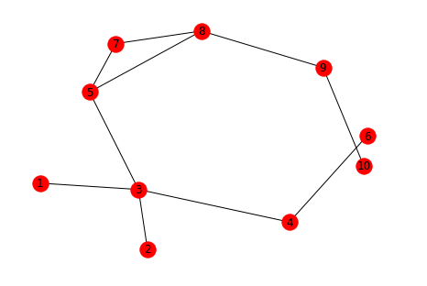

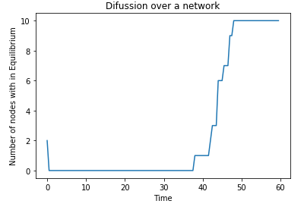
x=0
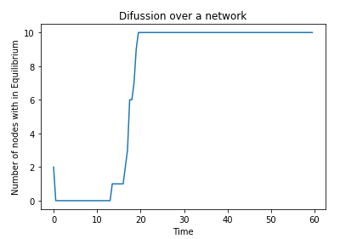
x=0.1

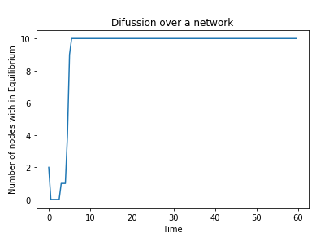
x =0.3
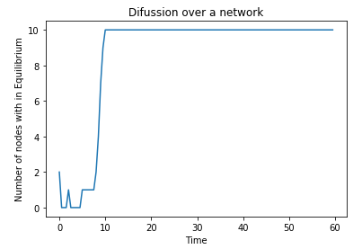
X=0.2

From the Figures above we observe that, considering only short range interactions among nodes, equilibrium is reached at T=48. As we introduce long range interactions, at x=0.1, Equilibrium is reached much faster , T= 20 ( less then half the time it takes when only short range interactions are considered). As we increase the conductance we observe faster diffusion process that is to say at x=0.2 and x=0.3, equilibrium is obtained at T=10 and T=5 respectively. For every increase in conductance by 0.1, the time at which equilibrium is achieved is halved.

Lets investigate the impact of the structure of a network on the diffusion of heat over a network for different values of conductance.

Path Network (shown in Figure below ) has 10 nodes and same initial heat distribution as the network above. Nodes 1,3,5,6,and 10 are assigned initial quantities of 3, 8, 5, 2 and 2 respectively while the rest of the nodes are assigned 0.
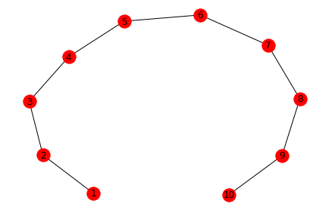

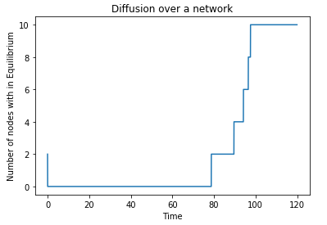
x=0
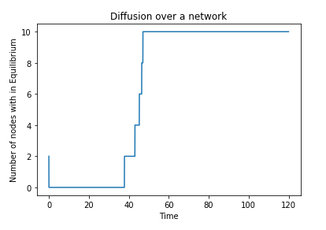
x=0.1

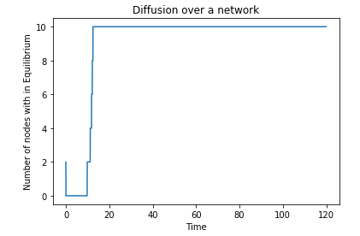
x=0.3
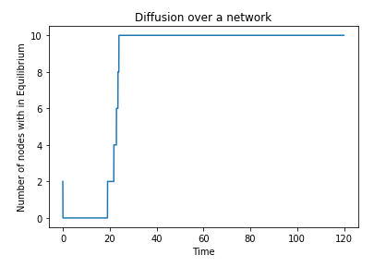
x=0.2

At conductance, x=0, Equilibrium is reached time T=100 ( far longer than in the previous network), and as we vary the conductance from 0.1 through 0.3, there is a reduction in the time required for equilibrium to be attained i.e. 45, 25 and 15 respectively.

STAR NETWORK:

Consider a star graph of the same size (10) as the previous graphs and with similar initial heat allocations. The figure at the right illustrates different times at which equilibrium of all nodes is attained at varying conductance values.

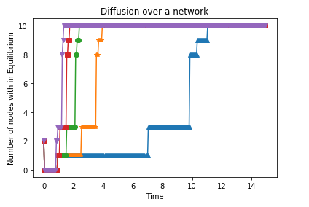
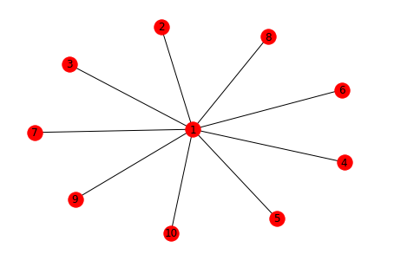
With only short range interactions (at x=0), equilibrium is reached faster than in path network (i.e at T=11). This is very fast compared to the two networks discussed before. As the conductance is increased, the time rapidly reduces to T=4, T=2.5, T=2.0 and T=1.5 for x=0.1,0.2,0.3 and 0.4 respectively.

LATTICE:

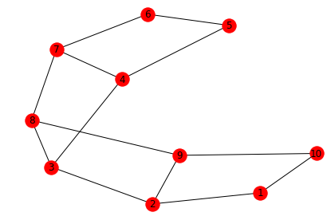

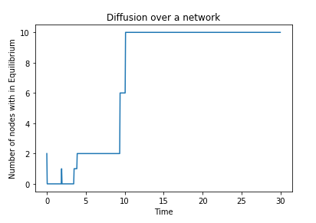
x = 0.1
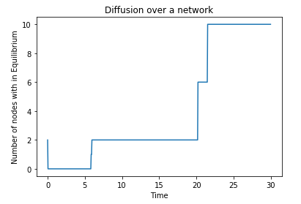
x=0

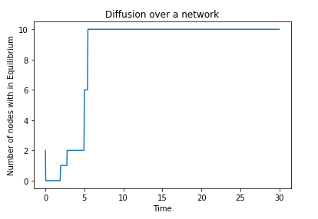
x=0.2
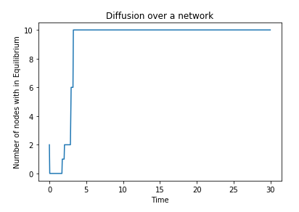
x=0.3

Diffusion over a lattice occurs quite faster than in a path network, We see from the above illustrations that at x=0, equilibrium is attained at T= 22 compared to that of the path network which was at T=100. However, this is slower compared to star network. As conductance increases to x=0.1, we observe a drop in time to T=10 followed by T=6 and T= 4 for x= 0.2 and x=0.3 respectively.

Comparisons:
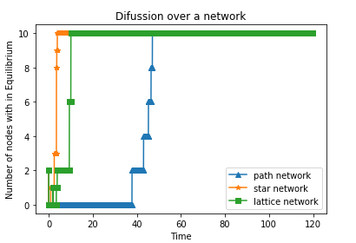
x=0.1
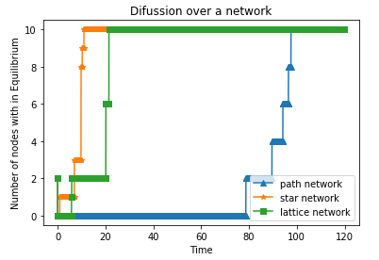
x=0

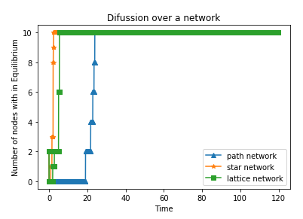
x=0.2
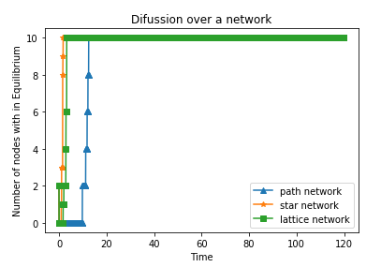
x=0.3

BARABASI Network

Using networkx, we create the Barabasi with 100 number of nodes and 2 edges to attach from a new node to existing nodes.
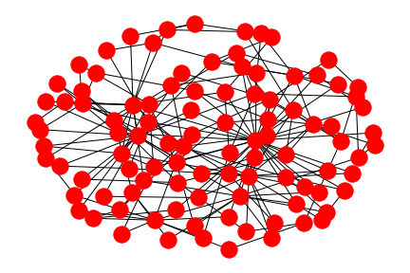

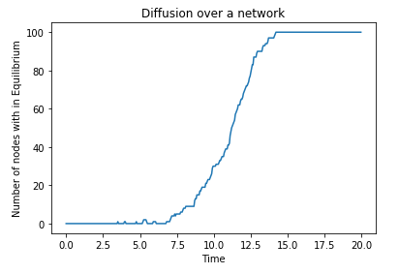
x=0.0
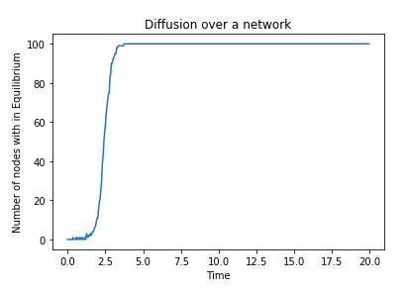
x=0.1

x=0.2
x=0.3

