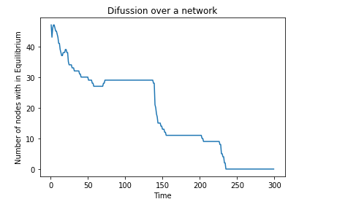
Considering 100 nodes of the Barabasi network, we assign randomly generated initial quantities of heat to each of the nodes. Let the Equilibrium value be Q( set Q-0.01), we then plot number of nodes with heat quantities of heat less than Q against time.

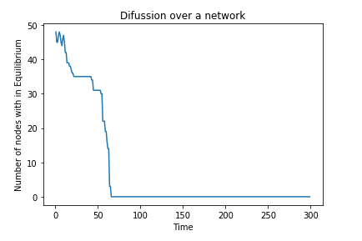
Setting the threshold to (Q-0.1)

Plot of average quantities of heat per each time step

