Our game “Happy 2048!” is a game which tells people the food calories while they are playing it. The game mode is similar to the common 2048, just that the numbers are switched to the food images in our game, with corresponding calories.

For our final project, we transformed the code from numbers to images on board. To successfully do this work, we need the package of pygame which provides operations on images.

Although we have already wrote a complete code of the game 2048, it is still not easy to transform it directly with pygame codes, since pygame is a new package to all of us, it cost us several time to learn it.

First using pixels of the screen, we created a basic mode of food 2048, a big square with sixteen little squares in it as figure 1 shows.

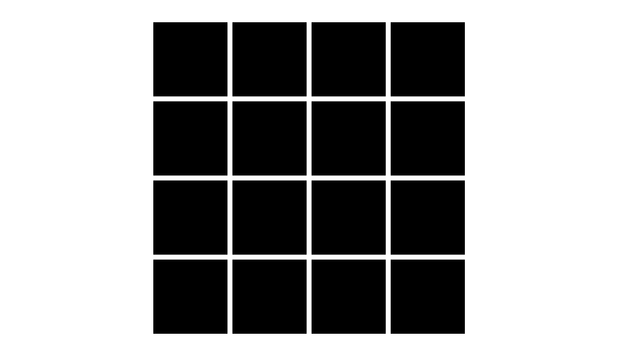

Figure 1. the basic mode of our game

After this step, we fell into a long-time frustration of not knowing what to do next, but after figuring out the operation to put image in and call the keyboard, we finally wrote the code out.

I was responsible for the structure building and debugging. Since I used pygame before once, I transformed the code using pygame operations to make them pop out on the screen. I also wrote the code of refreshing, screen size, quit code, and image showing.

For example, to detect the keyboard events, I wrote operations shown below to make sure the press-downs of the keyboard can be related to the moves.

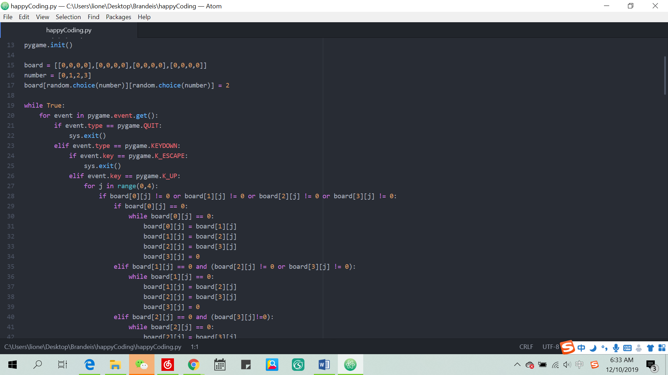

Figure 2. keyboard detecting

Besides, I learnt the basic pygame operations to make sure the game is shown on screen. The code is shown in figure 3. The operations determined the resolution of the screen, the caption of the game, and also gives the numbers of different colors, which will be used later in the code.

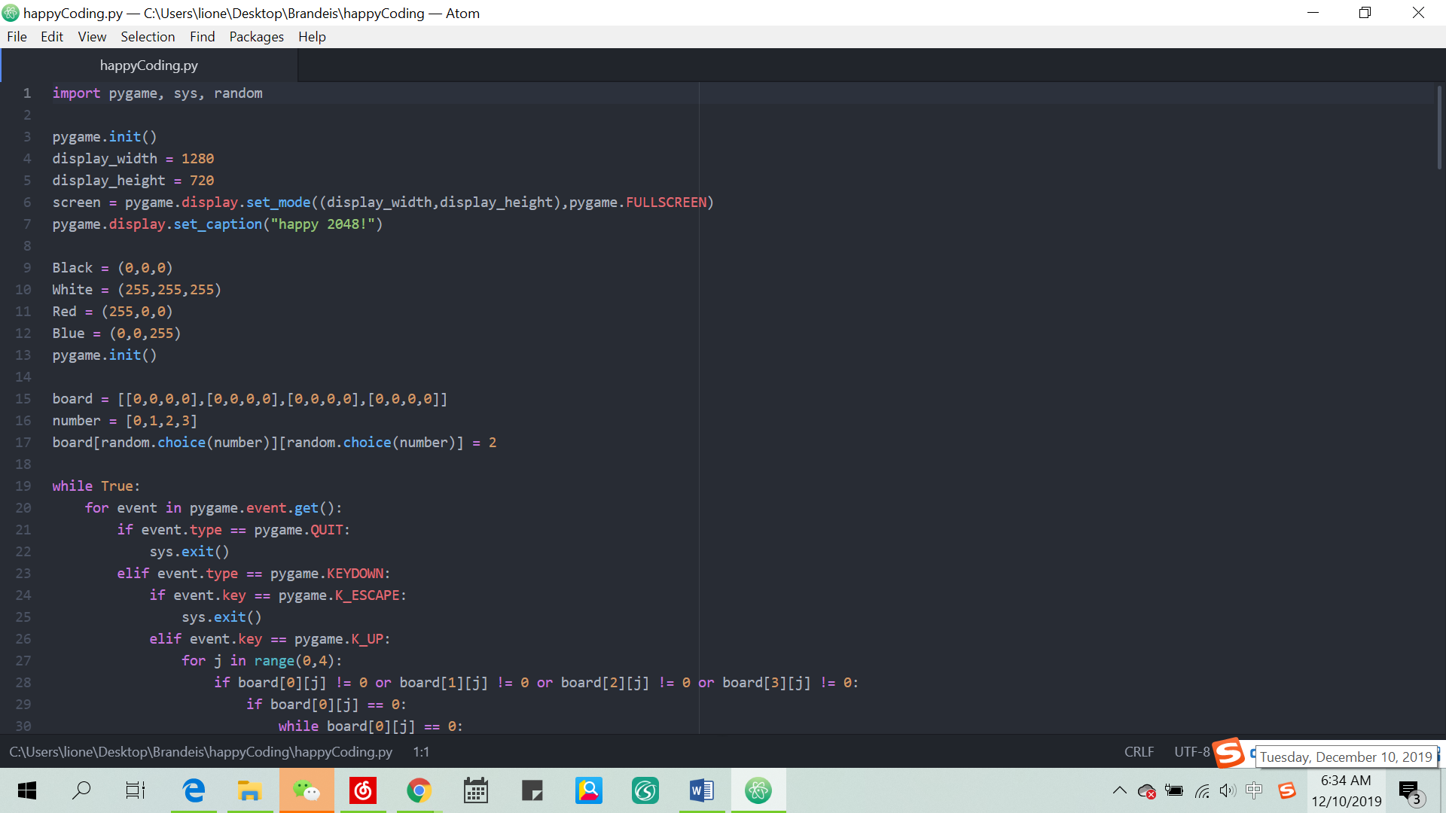

Figure 3. basic pygame operations

I also checked the sequence and indent of the code to make sure it can work successfully.

We hope that this game can help people build a recognition of food calories, so we searched food images online to fit into the squares.