METexpress

User’s Guide

Version 3.0.0

October 1, 2020

Contents

List of Figures 3

1. Overview of METexpress 4

1.1. The METplus suite 4

1.2. METexpress Features 5

2. General Interface Description 6

2.1. Home Page 6

2.2. User Interface Layout Common to Each App 7

2.3. Plot Types 9

2.3.1. Curve Data Parameters 9

2.3.2. Plot Parameters 12

2.3.3. Saving and Restoring Settings 13

2.3.4. Generating a Plot 13

2.3.5. User controls on plot screen 15

3. METexpress Apps 19

3.1. Upper Air App 19

3.2. Anomaly Correlation App 25

3.3. Surface App 27

3.4. Air Quality App 29

3.5. Ensemble App 31

3.6. Precipitation App 37

4. METexpress System Requirements, Installation and Support 40

5. METexpress Metadata 42

5.1. What is metadata for METexpress? 42

5.2. Generating metadata for a MySQL database 42

Appendix A – Public Deployments of METexpress 44

# List of Figures

Figure 1‑1 Schematic diagram of the structure of METplus, including METexpress 4

Figure 2.1‑1 METexpress Home Page 6

Figure 2.2‑1 Upper Air User Interface screen before any curves have been defined 7

Figure 2.2‑2 Upper Air User Interface screen after Curve0 has been added, showing the addition of the area for Defined Curves above the Curve Data Parameters 8

Figure 2.3‑1 Interface screen after defining a single curve with default values, then selecting Add Curve 11

Figure 2.3‑2 Interface screen after defining 2 curves and selecting Add Curve after each 12

Figure 2.3‑3 Plot of Time Series for a single curve with default values 14

Figure 2.3‑4 Same plot as shown in Figure 2.3-3, but with Hide Gaps selected. 14

Figure 2.3‑5 Plot with Multiple Curves for Time Series, including Error Bars and Difference Curves. The yellow curve shows the difference between the red and blue curves. 15

Figure 2.3‑6 Detail of plot controls from figure above 16

Figure 2.3‑7 Beginning of text screen for plot in Figure 2.3‑5 18

Figure 3.1‑1 User Interface screen after selecting plot type of DieOff. 20

Figure 3.1‑2 Upper Air DieOff plot 21

Figure 3.1‑3 Anomaly Correlation DieOff plot 21

Figure 3.1‑4 The user interface for histogram plots. 23

Figure 3.1‑5 Plot generated from selections in Figure 3.1‑4 23

Figure 3.1‑6 Upper Air profile, as a contour plot 24

Figure 3.2‑1 Anomaly Correlation app user interface 25

Figure 3.2‑2 Anomaly Correlation sample plot. 26

Figure 3.3‑1 User Interface for the Surface app 27

Figure 3.3‑2 Surface app ValidTime plot 28

Figure 3.4‑1 Air Quality app Threshold plot 30

Figure 3.5‑1 The Ensemble app user interface for Ensemble Histogram plots. Note the selector for Histogram Type which is unique to this plot type. 33

Figure 3.5‑2 Ensemble Histogram plot type with Histogram Type of Rank Histogram. 34

Figure 3.5‑3 Ensemble Histogram plot type with Histogram Type of Probability Integral Transform Histogram. 34

Figure 3.5‑4 Ensemble Histogram plot type with Histogram Type of Relative Position Histogram 35

Figure 3.5‑5 Ensemble App Reliability Plot for data defined in Figure 3.5‑1 . The 1:1 diagonal gray line represents perfect skill between forecast probability and observation frequency. The diagonal line with the lower slope indicates the point above which the forecast becomes more skillful than climatology, and the vertical and horizontal lines indicate climatology. 36

Figure 3.5‑6 Ensemble app ROC plot for the same data set defined in Figure 3.5 1. 36

Figure 3.6‑1 User interface screen for a Threshold plot in the Precipitation app 38

Figure 3.6‑2 Threshold plot in the Precipitation app produced from selections in Figure 3.6-1 39

Figure 3.6‑3 GridScale plot in the Precipitation app produced from selections in Figure 3.6-1 39

# Overview of METexpress

## The METplus suite

METexpress is an easy-to-use interface that displays plots of statistical verification metrics for the data that a user defines interactively. The foundational metrics must first be generated from model output and “truth” data (usually observations or gridded model analyses) produced by the MET verification tool and the output files produced by MET must then be loaded into a MET database. It allows a model developer to explore metrics about their model runs quickly and flexibly without relying on someone else producing pre-generated plots. The developer can slice and dice data in the way that best gives them insight into how their model performed.

METexpress is one component of the METplus verification tool suite, which is created and managed by the Developmental Testbed Center (DTC) and is the official verification tool for NOAA’s Unified Forecast System. Figure 1‑1 shows a graphic of the entire METplus package and how METexpress integrates with the other tools.

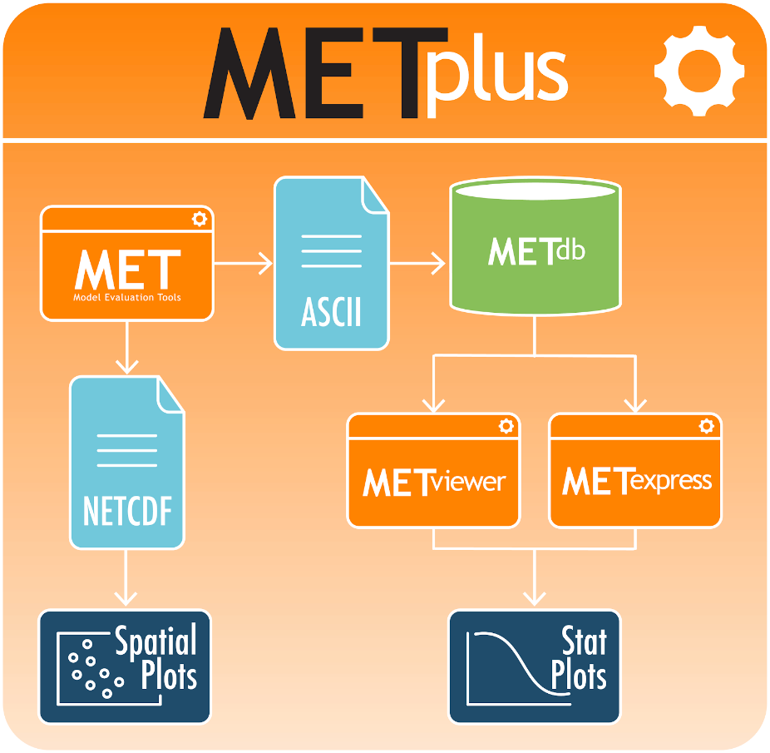

Figure ‑ Schematic diagram of the structure of METplus, including METexpress

In the simplest workflow for verifying model outputs, the model output data and “truth” or observation data are input into the MET software package which outputs statistical information in an ASCII format. That statistical information is then read into and stored in the METdatadb database using the METdbload tool. METexpress allows the user to specify various parameters for the plot they want to create and then queries the database to get the relevant information and creates a plot.

## METexpress Features

METviewer performs a similar functionality of querying the database and producing a plot. However, METviewer has a lot more flexibility and many options that the user must know to specify, with the result that it requires more training to fully understand it and use it effectively and accurately. METexpress provides an alternative simplified, more intuitive interface, which guides the user through selection of parameters needed in order to produce a given type of plot. The expectation is that METviewer would be used by expert users who understand its extensive capabilities and advanced features, but that METexpress would provide an interface for users to quickly generate commonly used plots without having to gain the expertise needed to run METviewer. METexpress guides the user to define each parameter that is needed to produce a given type of plot, with default parameter values available also.

METexpress was developed at NOAA/OAR Global Systems Laboratory (GSL) based on a verification system developed in-house at GSL named the Model Analysis Tool Suite, or MATS. METexpress uses the basic framework of MATS but it has been modified to work with the METplus database.

It is very important to understand that METexpress can only produce plots based on the data that has been loaded into the METdatadb database.

The verification measures or statistics produced by METexpress follow definitions set by the MET package with input from the mathematical expertise within the Developmental Testbed Center (DTC). To learn more about the metrics and how to interpret them, please see the MET User Guide at <https://dtcenter.github.io/MET/Users_Guide/index.html> particularly Appendix C about Verification Measures and additional material at [https://dtcenter.org/community-code/model-evaluation-tools-met/documentation](https://dtcenter.org/community-code/model-evaluation-tools-met/documentation%20).

One of the features of METexpress is that, generally, it only presents the user with choices for data parameters that are valid for the data sets that the user has selected. For example, if the user selects the model “GFS”, the choices available for “variable” will be only the variables that have been loaded into the database for the GFS model. In this way, the user will not go through the process to select variables, heights, statistics, etc that don’t exist in the database and cannot be plotted. This is achieved in the interface by creating metadata (data that describes the data) in the database that describe the available parameters for each data set. The generation of metadata will be discussed later.

# General Interface Description

METexpress is a web space that includes various apps for specific purposes. The current list of apps includes:

* MET Upper Air
* MET Anomaly Correlation
* MET Surface
* MET Air Quality
* MET Ensemble
* MET Precipitation

Future development of METexpress is likely to add more apps.

Each app can have multiple plot types, such as time series and vertical profiles. The available plot types include those appropriate to each app.

Note that each app will have a similar layout for selecting parameters and interacting with plots. These general features are described in detail here using the Upper Air app as an example. Individual apps are then described only in terms of their specific information and functionality.

## Home Page

The METexpress home page is shown in Figure 2.1‑1. The home page has a button for each available app. Each app lets the user create certain types of plots for a certain type of data. The user must begin by selecting the app they want to use.

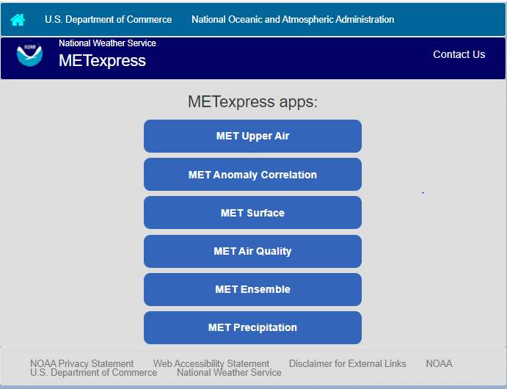

Figure ‑ METexpress Home Page

## User Interface Layout Common to Each App

The Upper Air app is used as an example here to describe the general layout that is carried through on all apps. The Upper Air user interface before any curves have been defined is shown in Figure 2.2‑1. There are 3 parts to this screen:

* Plot Type
* Curve Data Parameters
* Plot Parameters

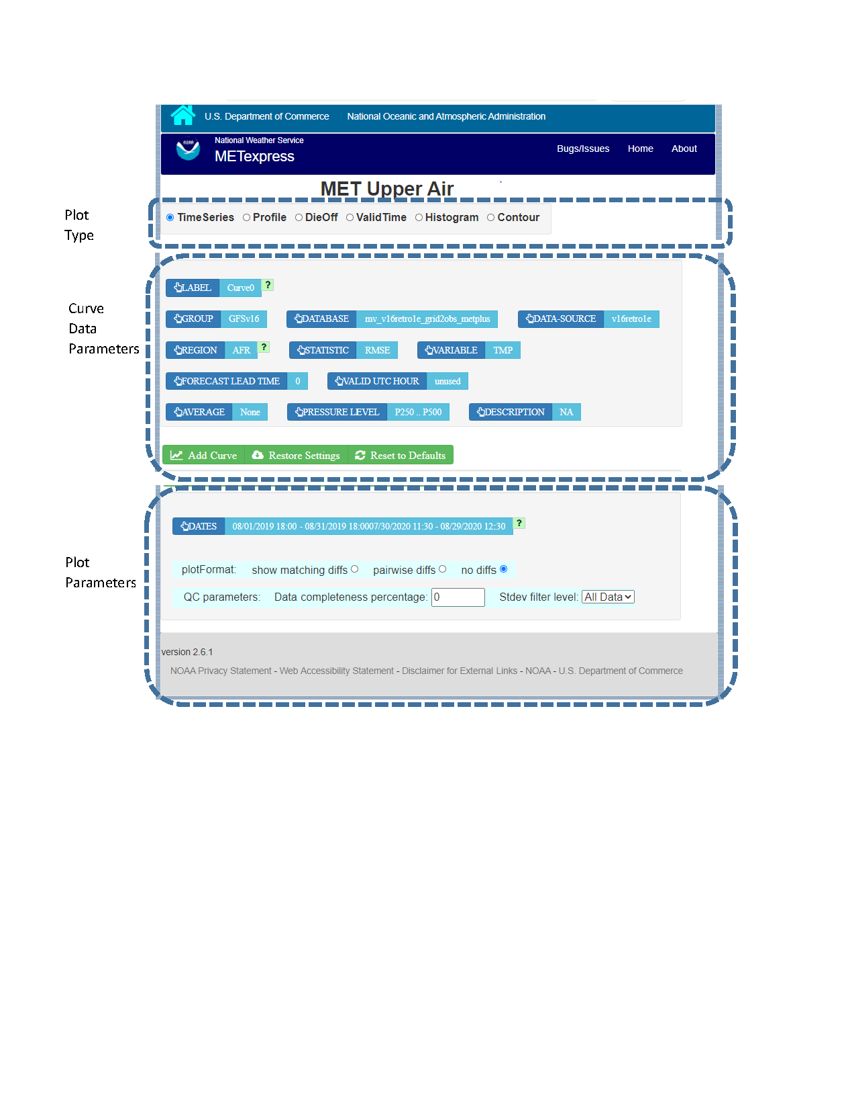

Figure ‑ Upper Air User Interface screen before any curves have been defined

After any curves have been added, the user interface screen includes a fourth area, as shown in Figure 2.2‑2, that shows what curves have already been defined. The section for the Curve Data Parameters then allows the user to create additional curves to be added to the plot.

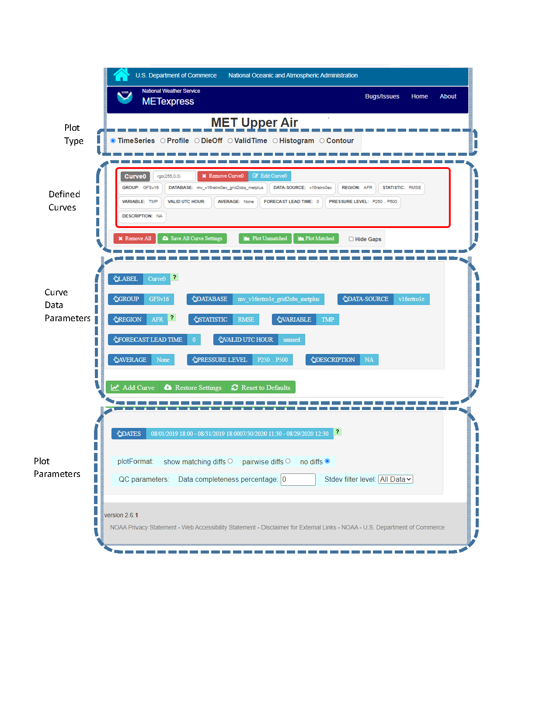

Figure ‑ Upper Air User Interface screen after Curve0 has been added, showing the addition of the area for Defined Curves above the Curve Data Parameters

## Plot Types

Immediately below the name of the app is a bar that allows selection of the plot type. Available types for Upper Air include Time Series, Profile, DieOff, ValidTime, Histogram, and Contour. Other apps include some plot types specific to that application domain, such as Reliability plots in the Ensemble app or GridScale plots in the Precip app. The section for each app below will describe the available plot types for that app.

The user will first want to decide what type of plot they want to produce initially. Most apps default to Time Series, but the user should change to the type of plot they want to create. If the plot type is changed after curves have been defined, the user will be prompted whether to keep all existing defined curves or to remove all the existing curves.

### Curve Data Parameters

In the central area of the screen is a box to define the data parameters associated with each curve to be plotted. Blue fields are selectors and green fields are action buttons.

A default set of selections for each parameter (in blue boxes) will be shown, which will define the data to be plotted. The user can change any of these selectors. The values available for most selectors depend on what data is stored in the database, and on the values selected for other fields. For example if the DATA-SOURCE selected is GFS, the values available for REGION will be only the regions that are stored in the database for GFS.

For these parameters there is a superior-dependent relationship. For example DATA-SOURCE (which is most typically the name of a model) is superior to VARIABLE and REGION because only certain variables and regions are available for a given DATA-SOURCE. It is recommended that a user change parameters starting at the top left and progressing across then down the page in typical reading order. This ordering generally keeps the superior-dependent relationship intact. If a dependent parameter is set and the superior parameter is subsequently changed, the program attempts to maintain the dependent parameter value if it is still available for the new superior value. If the dependent value is not available for the new superior then a default value is automatically set for the dependent. This maintains consistency and prevents invalid parameter choices.

In the example Upper Air app, the selectable values are derived from the data for these parameters:

* Group (as defined in the MET database)
* Database (name of user database)
* Data-Source (usually a model name)
* Region
* Variable
* Forecast lead time
* Pressure level
* Description
* Dates – date range that applies to all curves, used for plot types like time series
* Curve-dates – range of dates used to filter data for a particular curve, such as seen in vertical profiles, where each curve may potentially be based on data from different date ranges

Static fields:

Some fields are not dependent on data. In the Upper Air app, these are Statistic, Valid UTC Hour, and Average, but these will vary for each app. Choices for Statistic mostly depend on the app in question, except for in the MET Ensemble app, where they depend on the MET line types available for the chosen Data-Source. Average and Valid UTC Hour tend to have standardized choices available across many apps.

Valid UTC Hour

This can be set to any whole number 0 to 23 for all of the apps.

Average: If the value for AVERAGE is none, then all points available will be plotted. Otherwise, all points in the selected interval are averaged into a single value. Available choices are as follows for all of the apps:

* None
* 1hr
* 3hr
* 6hr
* 12hr
* 1D
* 3D
* 7D
* 30D
* 60D
* 90D
* 180D

After selecting all data parameters as desired, the user would click the Add Curve action button inside the green bar, and the area outlined in red in Figure 2.3‑1 would be added to show the parameters selected for Curve0. The color for Curve0 has been given the default value of red and will also be shown with a red line and/or symbols in the plot. The color assigned to this curve can be changed within the outlined box with the button labeled “rgb(255,0,0)”.

Note that the user has the option to supply whatever label they prefer to use for each curve, but the default is to create labels “Curve0”, “Curve1”, etc

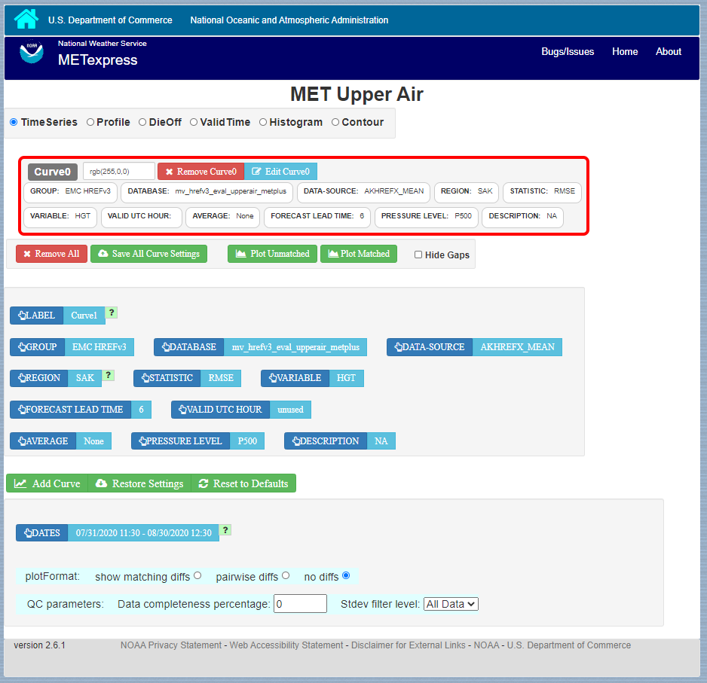

Figure ‑ Interface screen after defining a single curve with default values, then selecting Add Curve

**Editing a Curve:** Once a curve is added, a user can go back and change any of its parameters. There are two ways to do this: by clicking directly on the selector value to be changed within the red outlined area, or by clicking “Edit Curve” inside the red outline. The user would then set any selectors to their updated values. If “Edit Curve” was used, or if the value of a multi-select (a selector that can have multiple values chosen) was altered, the user must finish the edit by clicking “Save Curve Changes”.

**Defining Multiple Curves:** In Figure 2.3‑1 “Curve0” has been defined. The user can then repeat the selection of curve data parameters followed by Add Curve for as many curves as they wish to show on the plot. Each new curve will be assigned a new color.

An example of the interface screen with 2 curves defined is shown in Figure 2.3‑2. Curve0 data parameters are shown in the red box and Curve1 data parameters are shown in the blue box.

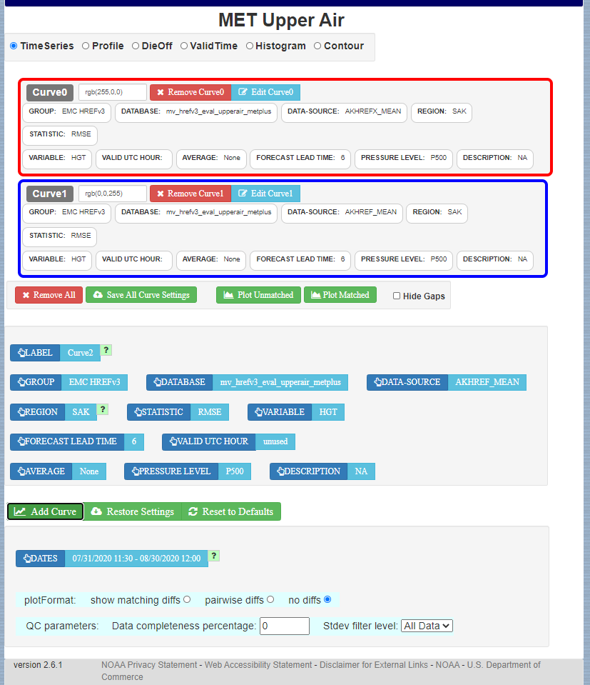

Figure ‑ Interface screen after defining 2 curves and selecting Add Curve after each

### Plot Parameters

The Plot Parameters appear in the box below the Curve Data Parameters box and apply to all curves defined in the Curve Data Parameters. The user can select the dates to be included in the plot, plus the plotFormat. Note that MATS also has an option to define QC parameters, but these are not readily supported from the METviewer database.

The plotFormat defines whether or not to show differences between curves. It has 3 options: “show matching diffs”, “pairwise diffs” or “no diffs”.

Show matching diffs takes the difference of each of the curves from Curve0. For example, if a user had defined Curve0, Curve1, Curve2, and Curve3, and selected "Show matching diffs", the plot would have three difference curves: Curve1-Curve0, Curve2-Curve0, and Curve3-Curve0.

Pairwise diffs takes the difference of each pair of adjacent curves. So, if a user had defined Curve0, Curve1, Curve2, and Curve3, and selected "pairwise diffs", the plot would have two difference curves: Curve1-Curve0, and Curve3-Curve2.

All difference curves calculate differences only where the data is matching.

No diffs is the default and will not include any difference curves in the plot.

### Saving and Restoring Settings

When all parameters have been set as desired – including curve data parameters, plot parameters, and plot types - the user has an option to Save All Curve Settings. If selected, the user will be prompted to provide a name for the saved settings. In future the user has the option for “Restore Settings”. If selected, they will be prompted for the saved-settings name. After selecting saved-settings, all curve definitions, plot parameters, and plot type will be reset from the saved-settings definitions.

### Generating a Plot

When the user is ready to generate a plot, the user would click either the “Plot Unmatched” or the “Plot Matched” action button directly below the outlined boxes with curve definitions.

Plot Unmatched will plot points for all data available for each defined curve.

Plot Matched will only plot points at x-axis values (y-axis for vertical profiles) where data values exist for all defined curves. In addition, only database values that exist at the same time period and same vertical level for all defined curves will be considered when computing y-axis values (x-axis for vertical profiles).

Hide Gaps: Note that when data points are missing, by default a line is not shown connecting the surrounding points. The user can force METexpress to draw lines between points in all cases, by selecting Hide Gaps.

Figure 2.3‑3 shows the plot screen after the user selects Plot Unmatched or Plot Matched with a single curve defined. Figure 5b shows the same plot but with Hide Gaps selected. The same curve data as defined in Figure 2.3‑3 is used to generate the plot in Figure 2.3‑4, but with Hide Gaps selected.

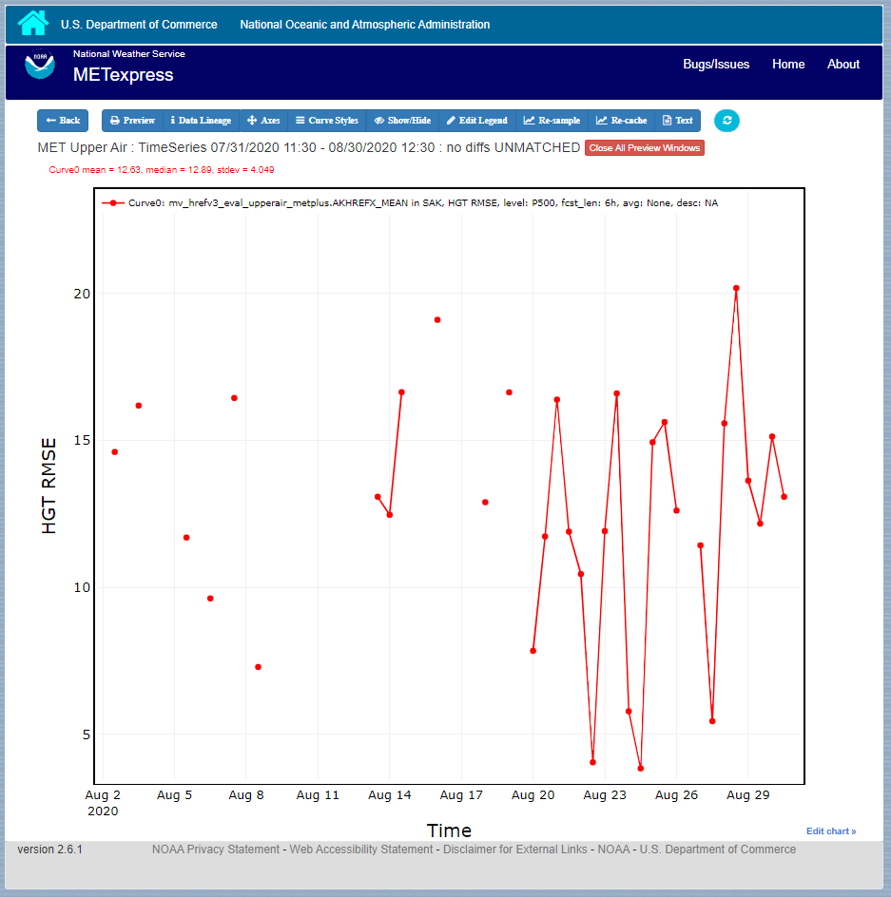

Figure ‑ Plot of Time Series for a single curve with default values

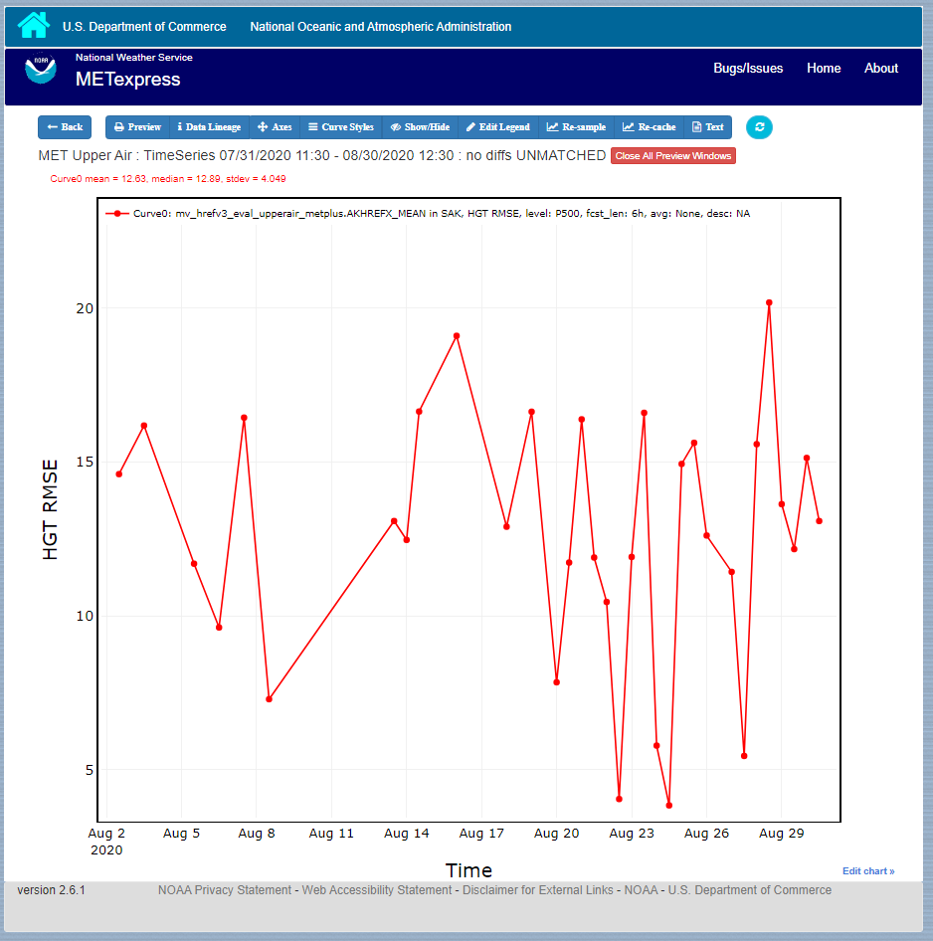

Figure ‑ Same plot as shown in Figure 2.3-3, but with Hide Gaps selected.

Figure 2.3‑5 shows a sample plot with 2 curves: Curve0 and Curve1 in red and blue, and has also added a difference curve in yellow showing the difference between Curve0 and Curve1 and error bars on all curves.

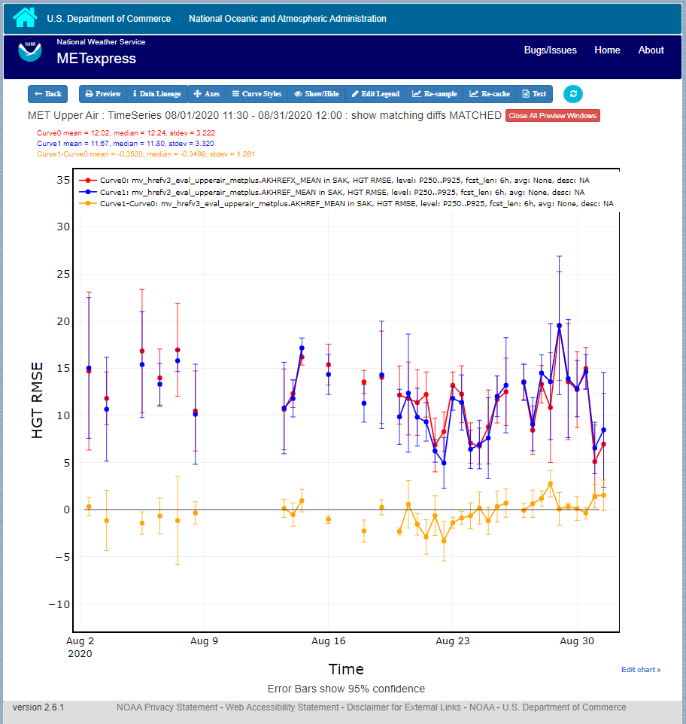

Figure ‑ Plot with Multiple Curves for Time Series, including Error Bars and Difference Curves. The yellow curve shows the difference between the red and blue curves.

### User controls on plot screen

After the plot has been produced, the user can interact with the plot in various ways. For example, the user might want to focus on one particular area of the plot to examine more detail, or the user might want to change titles, line widths, etc to produce a plot suitable for publication. Figure 2.3‑6 highlights the tools available to interact with a plot.

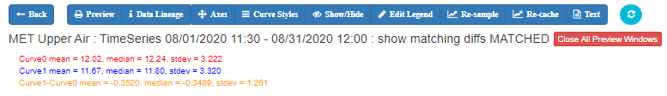

Figure ‑ Detail of plot controls from figure above

The user can choose to dynamically zoom in and out on the plot. In order to zoom in on a plot, the user can click and drag a box over the area of interest on the graph, and the zoom level will be automatically adjusted to reflect the bounds of the box. To zoom back out, the user should double click on the plot or click the blue refresh button to the far right the dark blue toolbar.

METexpress plots are produced with the graphing package Plotly, and as such inherit a suite of basic graph controls from Plotly. These tools appear in the upper right corner of the plot when a user hovers their cursor over the graph area. From left to right, the Plotly tools allow a user to:

* Icon 1) Save a low-resolution PNG of the plot (METexpress has a separate capability to save high-resolution PNGs, as described below).
* Icons 2-3) Toggle between clicking to zoom (default) and clicking to pan.
* Icons 4-5) Toggle between using a box to zoom or pan (default) and using a lasso.
* Icons 6-7) Zoom in or out while maintaining the current center point of the graph.
* Icon 8) Have Plotly guess what the appropriate zoom level is to best frame the plot contents.
* Icon 9) Reset the x- and y- axes to their original zoom and pan settings.
* Icon 10) Turn on/off lines that trace the cursor’s position on the x- and y- axes.
* Icons 11-12) Toggle between only displaying the data tooltip when the cursor is over a point (default), or always displaying the nearest tooltip to the user.
* Icon 13) Visit Plotly’s website.

Beyond the inherited Plotly controls, a number of buttons on the plot screen allow the user to interact with the displayed plot.

The Back button will return the user to the main app page, where the curve parameters were defined. This would allow the user to modify the plot definitions and re-plot.

The Preview button will copy the interactive plot into a separate window, to store it for comparison with future plots. The plot preview window also has the functionality to save each plot as a PDF or PNG.

The Data Lineage button displays all of the plot parameters, data queries, point values, and other metadata in a JSON format.

The Axes button allows users to customize the plot axes. This includes options to change the x- and y-axis limits, labels, label font sizes, and tick font sizes, as well as the plot legend font size and font color, and the grid line weight and color. These modifications all occur instantly, without the user having to regenerate the plot.

The Y Linear/Log button appears for profile plots, and allows users to toggle between having a linear vertical scale (the default), and a logarithmic one.

The Equi-space X button appears for threshold plots, and allows users to toggle between having a linear x-axis scale (the default), and equally spacing all of the returned threshold values.

The Curve Styles button allows users to customize the appearance of the curves in the plot. Here, users can change each curve’s color, line style, line weight, marker style, and marker weight.

The Colorbar button appears for contour plots, and allows users to customize the appearance of the contours. Here, users can change the colorbar label, colorbar range, colorbar stride, colormap being used, the direction of the chosen colormap (normal or reversed), and whether to interpolate over any null points in the graph.

The Show/Hide button allows users to show/hide individual curves, the markers on individual curves, the error bars on individual curves (if applicable), the bars of individual histograms (if plotting histograms), the mean/median/stdev annotation corresponding to individual curves, and the entry for each curve in the plot legend.

The Edit Legend button allows users to customize the legend text for each curve. By default, the legend displays the curve label, followed by each of the curve parameters contributing to that plot trace.

The Re-sample button allows users to change the zoom level of the x-axis and then re-query the database with the new x-axis limits. This has two advantages. Firstly, if the user initially asked for too narrow a time period on a time series, they can increase the x-axis limits to their new time range of interest, click the Re-sample button, and receive a new plot with the full time range, all without having to return to the main app page. Secondly, if the user initially requested a large time period, METexpress will downsample the returned data with the Largest Triangle Three Buckets algorithm, in order to prevent huge datasets from slowing down the user’s web browser. The user can zoom in on a time period of interest, click Re-sample, and receive the full, un-downsampled dataset for that smaller time range.

The Re-cache button forces METexpress to re-query the database in the event of new data being ingested. For the most part, METexpress will cache requested plots for eight hours, and if another user requests the identical curve/plot parameters within that eight hours, METexpress will return its cached plot, instead of re-generating it. Re-cache forces it to actually re-retrieve the data from the database and remake the plot.

The Text button changes from the plot page to a text page, which displays all of the data on the graph in tables, along with statistics relating to each point, as shown in Figure 2.3‑7 for the plot in Figure 2.3‑5. These data tables can be exported as CSV files by clicking the “Export” button at the top (next to the “Data Lineage” button), so that users have the option of creating their own plots from the queried data.

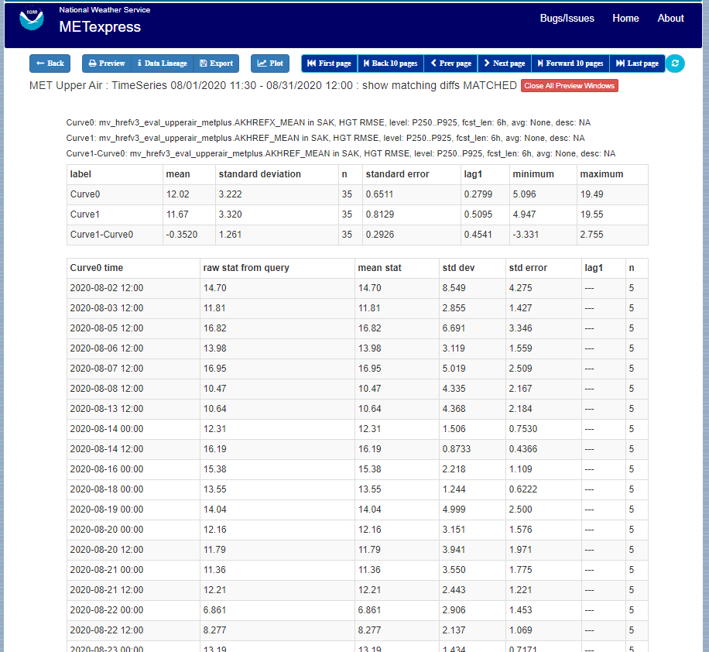

Figure ‑ Beginning of text screen for plot in Figure 2.3‑5

The blue refresh button to the right of the text button will reset the graph to its original pan and zoom settings, as well as reverting any customization that the user has done to the axes or curves.

Tool-tips: On the graph itself, each point on each curve has an interactive tool-tip. When a user mouses over a point, the tool-tip pops up, providing details about that point’s x- and y-value and statistics.

Error bars: When the user clicks the “Plot Matched” action button instead of “Plot Unmatched”, the points on the graphs will display error bars, which are useful for comparing multiple curves. It should be noted, however, that error bars will not display if each point only has one database value contributing to it, as error bars are based on standard deviation, and the standard deviation of one value is zero.

# METexpress Apps

This section includes a description of the unique feature of each app.

## Upper Air App

The user interface for Upper Air follows the general description from above. Choices specific to this app are shown below.

Choices for Statistic:

* RMSE
* Bias-corrected RMSE
* MSE
* Bias-corrected MSE
* ME (Additive bias)
* Multiplicative bias
* Forecast mean
* Observed mean
* Forecast stdev
* Observed stdev
* Error stdev
* Pearson Correlation

The Upper Air app includes functionality for these types of plots:

* Time Series
* Profile
* Dieoff
* ValidTime
* Histogram
* Contour

The Upper Air app includes the following plot types.

Time Series: The default plot type is Time Series, which has date on the x-axis and the mean value of the selected parameter for that date on the y-axis.

Profile: The Profile plot type displays pressure level on the y–axis and the mean value of the selected parameter on the x-axis.

Die-off: Die-off plots show how skill (or the inverse, error) changes with increasing lead time. Figure 3.1‑1 shows the user interface page after selecting the plot type of DieOff. Note that another selector is included for DIEOFF TYPE, which has the following possible values:

1. Dieoff
2. Dieoff for a specific UTC cycle start time
3. Single cycle forecast

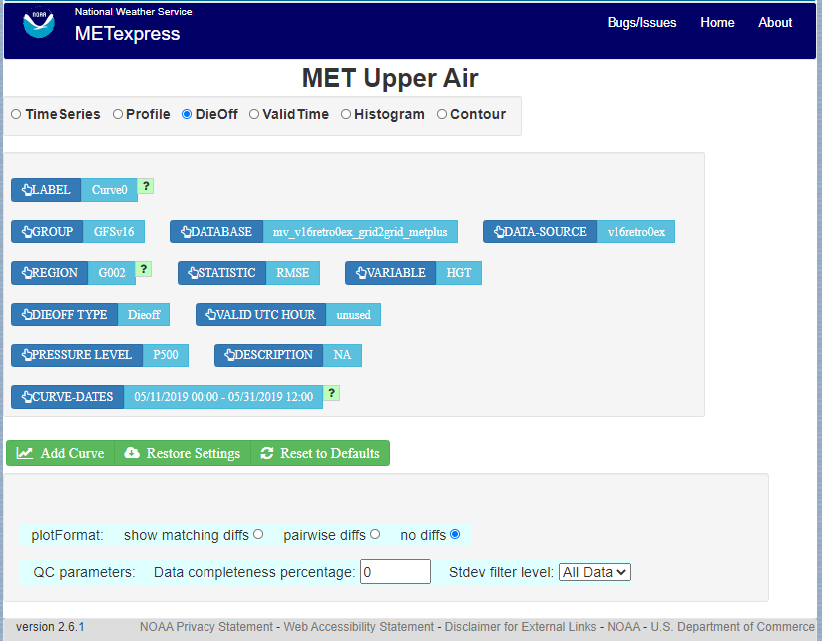

Figure ‑ User Interface screen after selecting plot type of DieOff.

Figure 3.1‑2 shows a sample of a DieOff plot in METexpress. This looks more like a familiar die-off curve when plotting skill, such as anomaly correlation as plotted in Figure 3.1‑3 using the Anomaly Correlation app, rather than error as is plotted with the Upper Air app.

The option “dieoff” for Dieoff Type uses all data at each given forecast hour within the specified date range. The option for “Dieoff for a specific UTC cycle start time” filters data to only use those at a specified cycle initialization time, such as 0 or 12. The option “Single cycle forecast” uses only the forecasts from the first cycle in the specified date range.

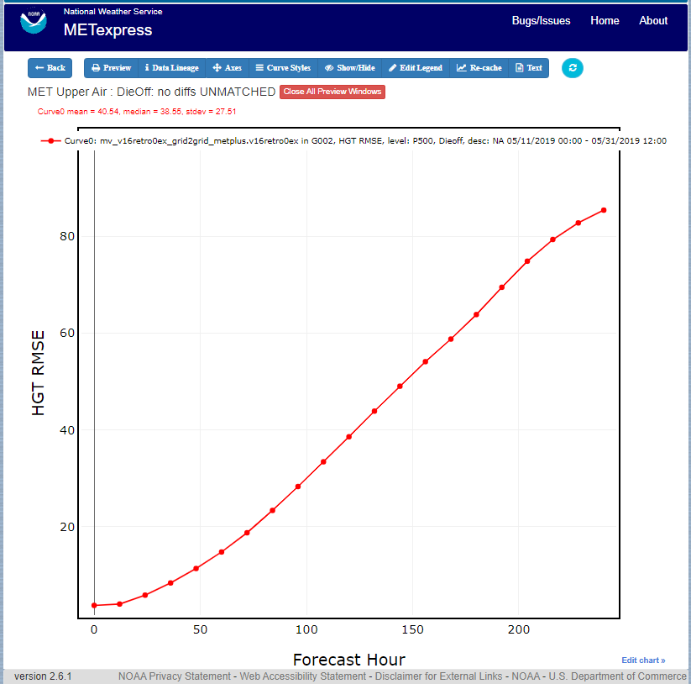

Figure ‑ Upper Air DieOff plot

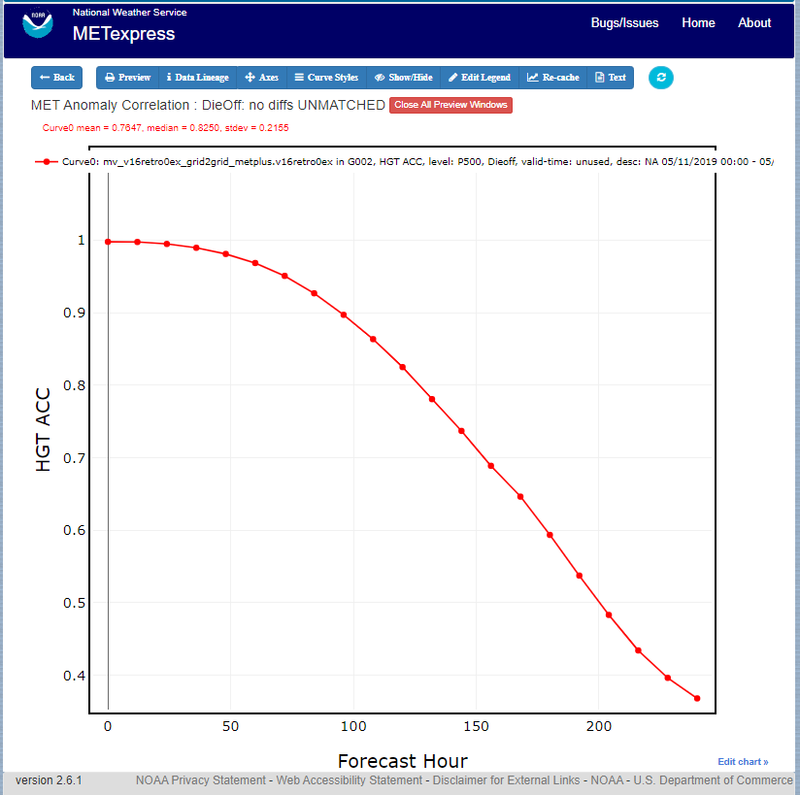

Figure ‑ Anomaly Correlation DieOff plot

ValidTime: The ValidTime plot type (also sometimes known as diurnal cycle plots) displays valid UTC hour on the x–axis and the mean value of the selected parameter on the y-axis.

Histograms: Histograms allow users to visualize the distribution of a given statistic over a specified time period. For example, if a user requested a histogram of RMSE for 144-h GFS forecasts over the global domain for a month, they would see the frequencies of specific RMSE values produced by individual GFS runs over that month. Histograms have statistical value bins on the x-axis, and number or frequency counts on the y-axis.

Histograms have a number of additional selectors that control their appearance:

* Y-axis mode: Can be set to either “Relative frequency” or “Number”, depending on whether a user wants the frequency of a given statistic displayed as a fraction of 100, or as a raw count.
* Customize bins: With this selector, the user can choose one of the following options to customize their x-axis bins:
  + Default bins
  + Set number of bins
    - Has sub-selector “Number of bins”
  + Make zero a bin bound
  + Choose a bin bound
    - Has sub-selector “Bin pivot value”
  + Set number of bins and make zero a bin bound
    - Has sub-selector “Number of bins”
  + Set number of bins and choose a bin bound
    - Has sub-selectors “Number of bins” and “Bin pivot value”
  + Manual bins
    - Has sub-selector “Bin bounds”
  + Manual start, number, and stride
    - Has sub-selectors “Number of bins”, “Bin start”, and “Bin stride”

Figure 3.1‑4 shows the user interface for histogram plots and Figure 3.1‑5 shows a sample plot.

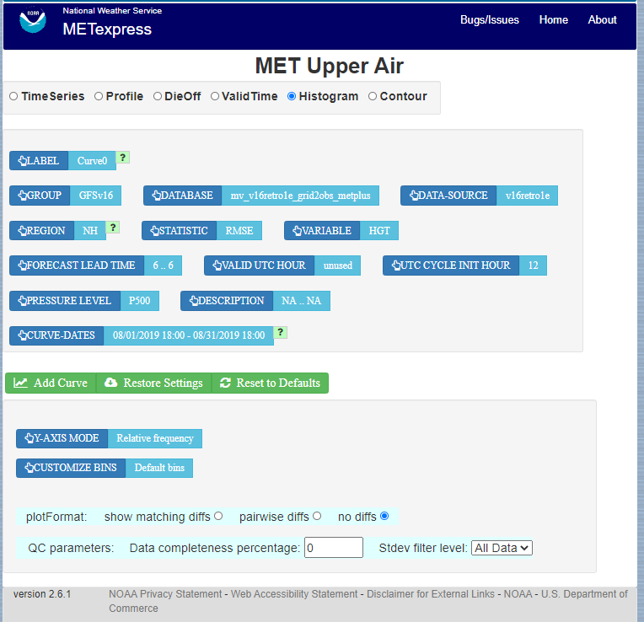

Figure ‑ The user interface for histogram plots.

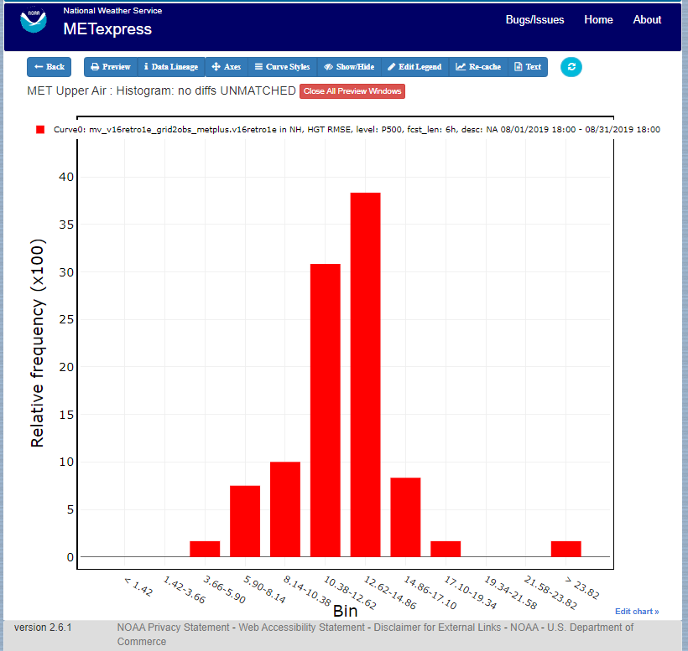

Figure ‑ Plot generated from selections in Figure 3.1‑4

Contour: Contour plots can be used in many ways. One can illustrate data with respect to height, as in plots seen at <http://www.emc.ncep.noaa.gov/gmb/STATS_vsdb/>, which have height on the y-axis and forecast hour (as in lead time) on the x-axis. These VSDB stat plots can be easily replicated in METexpress by using the contour plot type, except that the plot in METexpress will have only one pane, not two. In addition, METexpress users are not bound to have only pressure level / height on the y-axis or forecast lead time on the x-axis. They can reverse the two, place valid or init UTC hour on one of the axes, create Hovmoller diagrams, and many other combinations.

Contour plots have two additional selectors, x-axis-parameter and y-axis-parameter. With these, a user can decide which field to place on the x-axis (e.g. forecast lead time), and which to place on the y-axis (e.g. pressure level or valid UTC hour).

Figure 3.1‑6 shows an example of an Upper Air profile plotted as a contour plot.

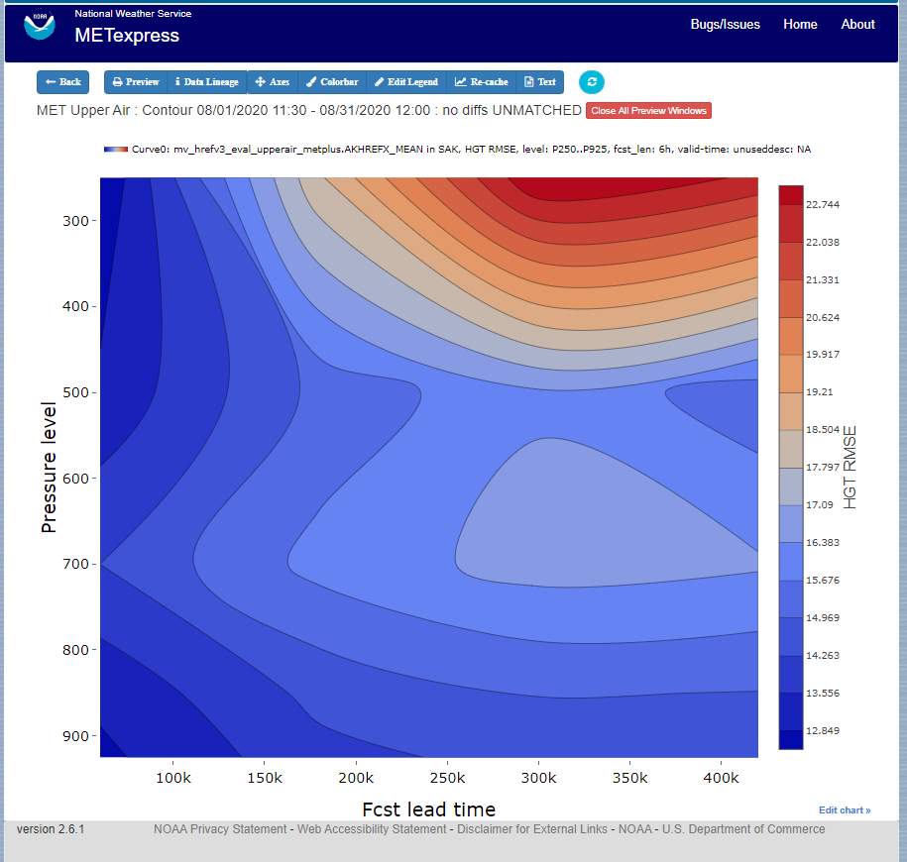

Figure ‑ Upper Air profile, as a contour plot

## Anomaly Correlation App

An example of the Anomaly Correlation app user interface is shown in Figure 3.2‑1. This interface is similar to the one for Upper Air but has fewer selectable parameters.

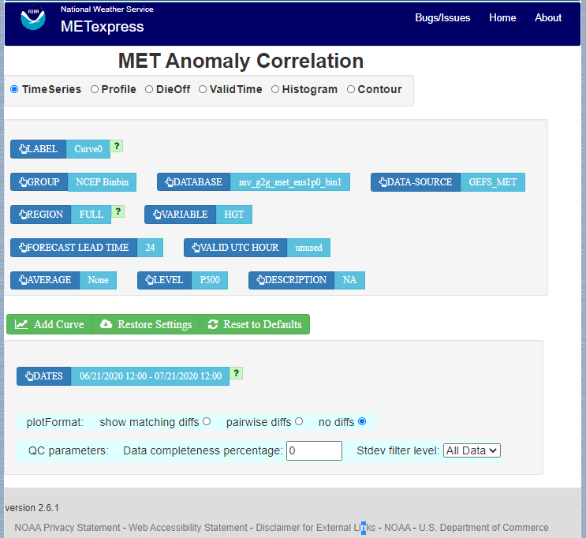

Figure ‑ Anomaly Correlation app user interface

In this application, the selectable values are derived from the data for these parameters:

* Group
* Database
* Data-Source
* Region
* Variable
* Forecast lead time
* Level
* Description
* Dates
* Curve-dates

METexpress Anomaly Correlation does not have a Statistic selector, as it displays anomaly correlation as its only statistic.

Plot types available include

* Time Series
* Profile
* DieOff
* ValidTime
* Histogram
* Contour

All plot types function the same here as they do in MET Upper Air described above.

A sample anomaly correlation plot is shown in Figure 3.2‑2.

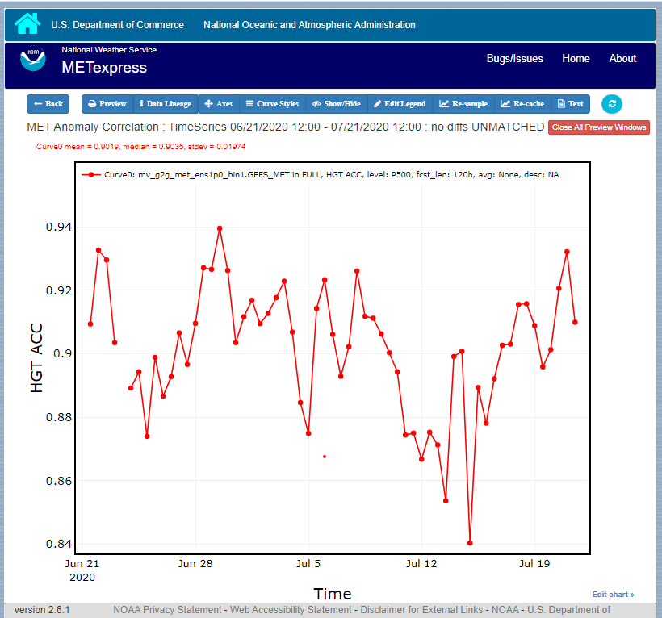

Figure ‑ Anomaly Correlation sample plot.

## Surface App

The user interface for the Surface app is shown in Figure 3.3‑1.

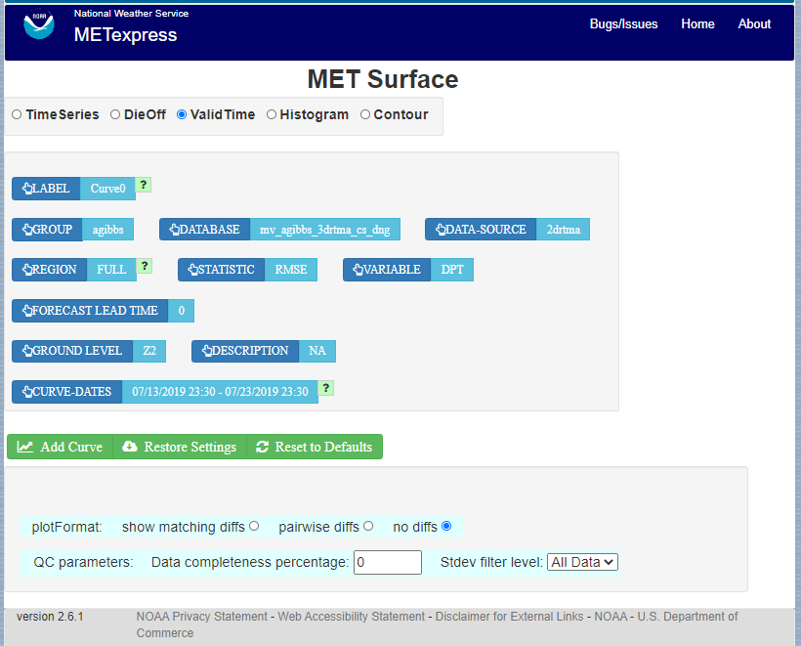

Figure ‑ User Interface for the Surface app

For this app, the following parameters have choices derived from the data.

* Group
* Database
* Data-source
* Region
* Variable
* Forecast lead time
* Ground level
* Description
* Dates
* Curve-dates

The selector for the Statistic has these possible choices:

* RMSE
* Bias-corrected RMSE
* MSE
* Bias-corrected MSE
* ME (Additive bias)
* Multiplicative bias
* Forecast mean
* Observed mean
* Forecast stdev
* Observed stdev
* Error stdev
* Pearson Correlation

Plot types available include:

* Time Series
* DieOff
* ValidTime
* Histogram
* Contour

Plots in the Surface app for Time Series, DieOff, ValidTime, Histogram, and Contour are the same as in Upper Air. An example of a Valid Time plot is shown in Figure 3.3‑2.

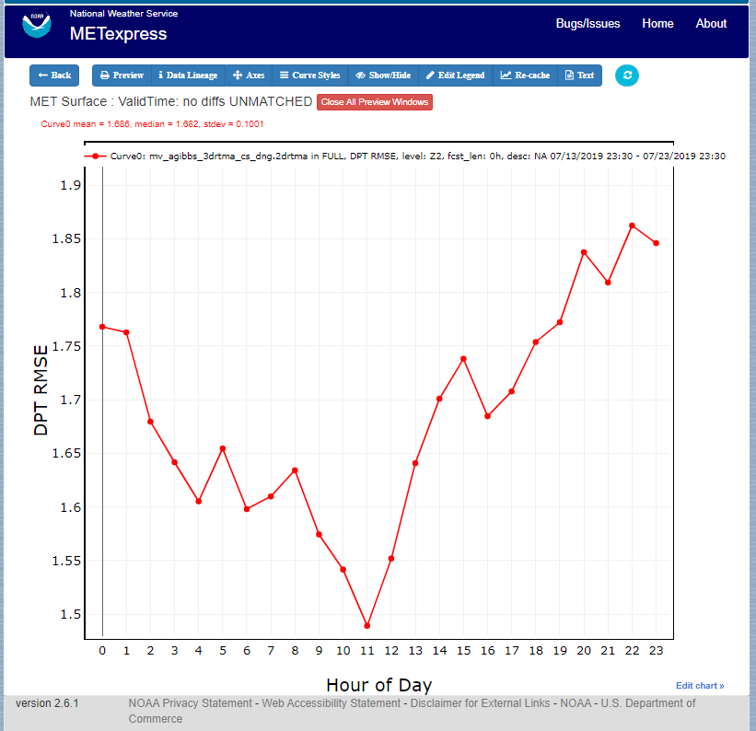

Figure ‑ Surface app ValidTime plot

## Air Quality App

For this app, the following parameters have choices derived from the data.

* Group
* Database
* Data-source
* Region
* Variable
* Threshold
* Forecast lead time
* Ground level
* Description
* Dates
* Curve-dates

The selector for the Statistic has these possible choices:

* CSI
* FAR
* FBIAS
* GSS
* HSS
* PODy
* PODn
* POFD
* RMSE
* Bias-corrected RMSE
* MSE
* Bias-corrected MSE
* ME (Additive bias)
* Multiplicative bias
* Forecast mean
* Observed mean
* Forecast stdev
* Observed stdev
* Error stdev
* Pearson Correlation

Plot types available include

* Time Series
* DieOff
* Threshold
* ValidTime
* Histogram
* Contour

Plots in the Air Quality app for Time Series, DieOff, ValidTime, Histogram, and Contour are the same as in Upper Air.

An additional plot type, Threshold, is available in this app. Threshold plots display threshold on the x-axis, and the mean value of the selected parameter on the y-axis.

Figure 3.4‑1 shows an example of an Air Quality Threshold plot.

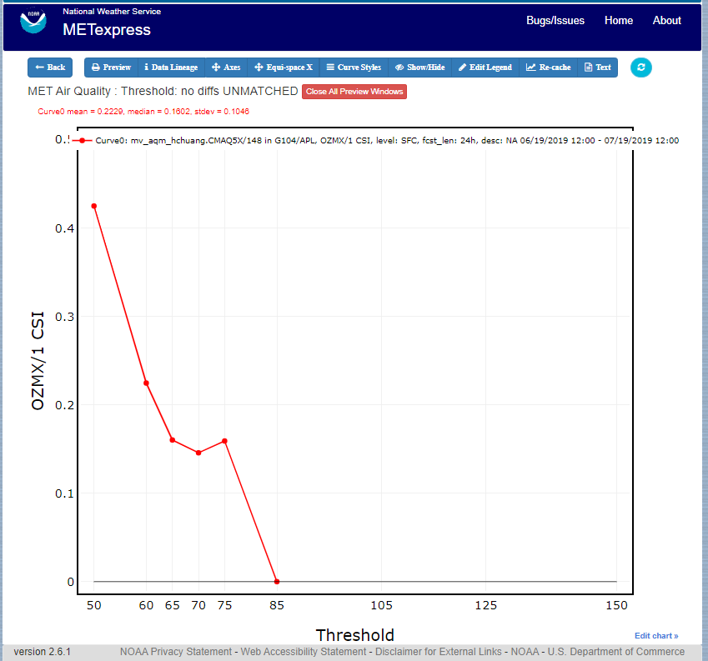

Figure ‑ Air Quality app Threshold plot

## Ensemble App

For this app, the following parameters have choices derived from the data.

* Group
* Database
* Data-source
* Region
* Statistic
* Variable
* Forecast lead time
* Level
* Description
* Dates
* Curve-dates

Unlike in the other apps, statistics for MET Ensemble are not static, but depend on the MET line types loaded into the database. Available statistics can include:

* RMSE
* RMSE with obs error
* Spread
* Spread with obs error
* ME (Additive bias)
* ME with obs error
* CRPS
* CRPSS
* MAE
* ACC
* BS
* BSS
* BS reliability
* BS resolution
* BS uncertainty
* BS lower confidence limit
* BS upper confidence limit
* ROC AUC
* EV
* FSS

Plot types available include

* Time Series
* DieOff
* ValidTime
* Histogram
* Ensemble Histogram
* Reliability
* ROC

Plots in the Ensemble app for Time Series, DieOff, ValidTime, and Histogram are the same as in Upper Air.

Three plot types are specific to this app: Ensemble Histogram, Reliability, and ROC.

Ensemble Histograms are controlled by the Histogram type selector that appears at the bottom of the main app page when the plot type of Ensemble Histogram is selected. This can be set to Rank Histogram, Probability Integral Transform Histogram, or Relative Position Histogram. Selecting one of these will produce the corresponding plot, with bins pre-calculated in the MET verification process. As with regular histogram plots, the user has the option of setting the Y-axis mode to either “Relative frequency” or “Number”.

Reliability plots produce a single curve for the chosen parameters (probabilistic variables only), with Forecast Probability on the x-axis, and Observed Relative Frequency on the y-axis. Four additional lines will be displayed on the graph, denoting perfect skill, no skill, x climatology, and y climatology.

ROC plots can display multiple curves (probabilistic variables only), with False Alarm Rate on the x-axis, and Probability of Detection on the y-axis. An additional diagonal line will be displayed on the graph, denoting no skill.

Figure 3.5‑1 shows the user interface for defining an Ensemble Histogram and Figure 3.5‑2 through Figure 3.5‑4 show examples of the 3 types of Ensemble Histograms.

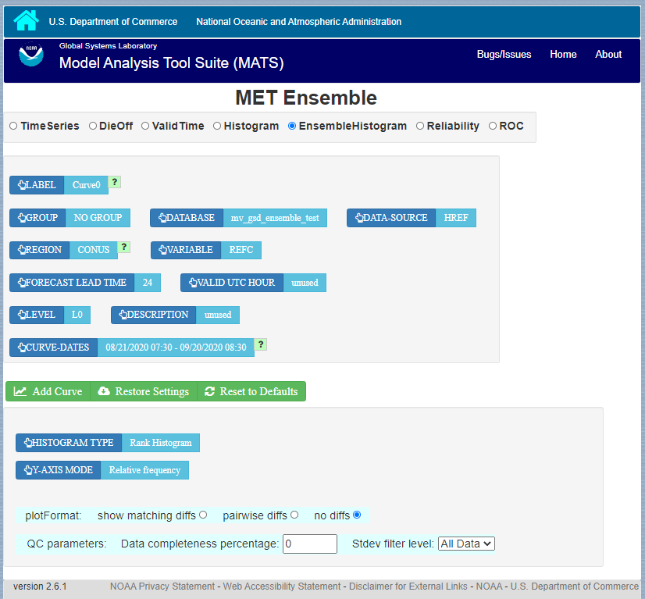

Figure ‑ The Ensemble app user interface for Ensemble Histogram plots. Note the selector for Histogram Type which is unique to this plot type.

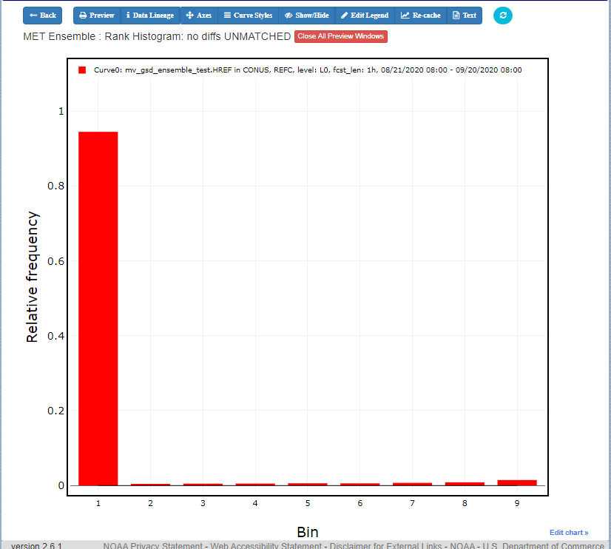

Figure ‑ Ensemble Histogram plot type with Histogram Type of Rank Histogram.

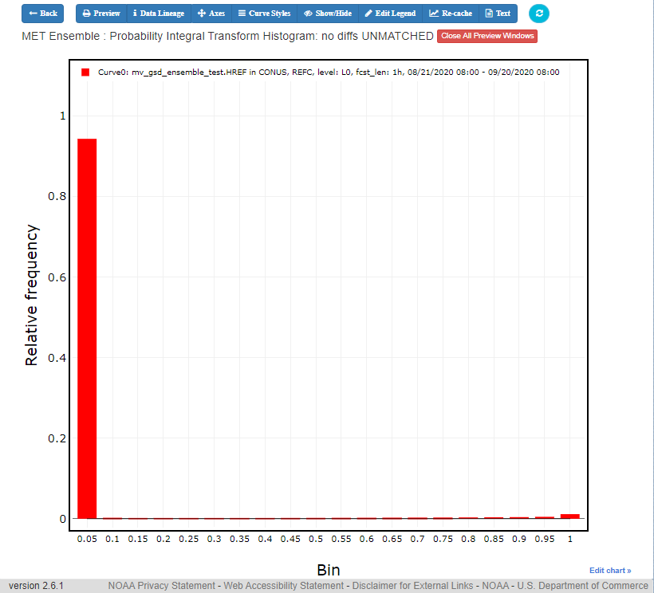

Figure ‑ Ensemble Histogram plot type with Histogram Type of Probability Integral Transform Histogram.

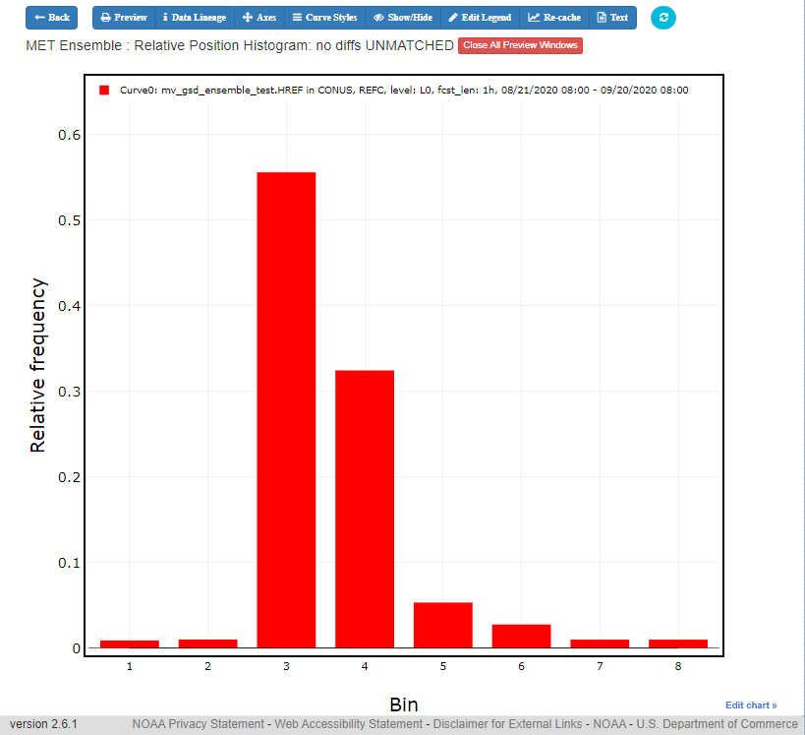

Figure ‑ Ensemble Histogram plot type with Histogram Type of Relative Position Histogram

Figure 3.5‑5 shows an example Reliability plot and Figure 3.5‑6 shows an example ROC plot, both for the same data set.

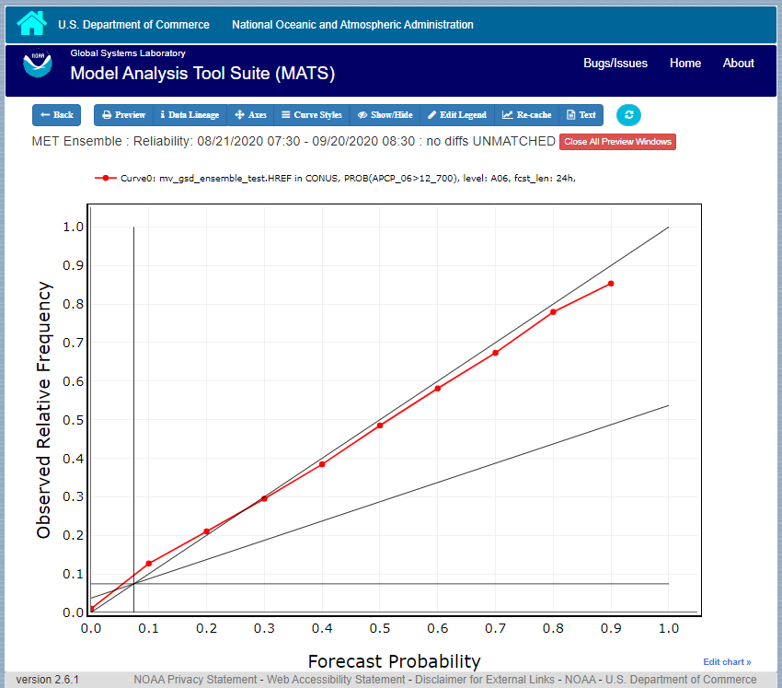

Figure ‑ Ensemble App Reliability Plot for data defined in Figure 3.5‑1 . The 1:1 diagonal gray line represents perfect skill between forecast probability and observation frequency. The diagonal line with the lower slope indicates the point above which the forecast becomes more skillful than climatology, and the vertical and horizontal lines indicate climatology.

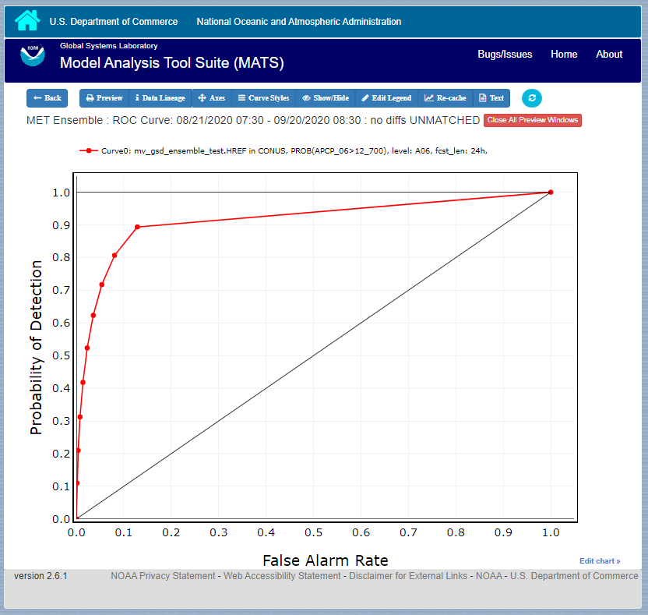

Figure ‑ Ensemble app ROC plot for the same data set defined in Figure 3.5-1.

## Precipitation App

For this app, the following parameters have choices derived from the data.

* Group
* Database
* Data-source
* Region
* Variable
* Threshold
* Scale
* Obs type
* Forecast lead time
* Level
* Description
* Dates
* Curve-dates

The selector for the Statistic has these possible choices:

* CSI
* FAR
* FBIAS
* GSS
* HSS
* PODy
* PODn
* POFD
* FSS
* RMSE
* Bias-corrected RMSE
* MSE
* Bias-corrected MSE
* ME (Additive bias)
* Multiplicative bias
* Forecast mean
* Observed mean
* Forecast stdev
* Observed stdev
* Error stdev
* Pearson Correlation

Plot types available include

* Time Series
* DieOff
* Threshold
* ValidTime
* GridScale
* Histogram
* Contour

Plots in the Precipitation app for Time Series, DieOff, ValidTime, Histogram, and Contour are the same as in Upper Air.

A different plot type, Threshold, is present in this app. Threshold plots display threshold on the x-axis, and the mean value of the selected parameter on the y-axis.

Another unique plot type, GridScale, is included in this app. GridScale plots display grid scale on the x-axis, and the mean value of the selected parameter on the y-axis.

Figure 3.6‑1 shows an example of the user interface for the Precipitation app, Figure 3.6‑2 shows an example Threshold plot, and Figure 3.6‑3 shows an example GridScale plot.

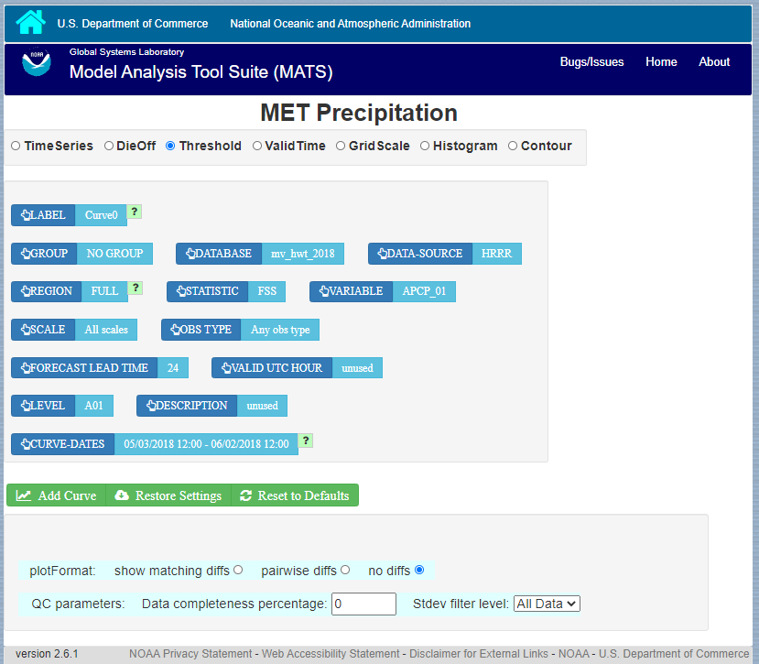

Figure ‑ User interface screen for a Threshold plot in the Precipitation app

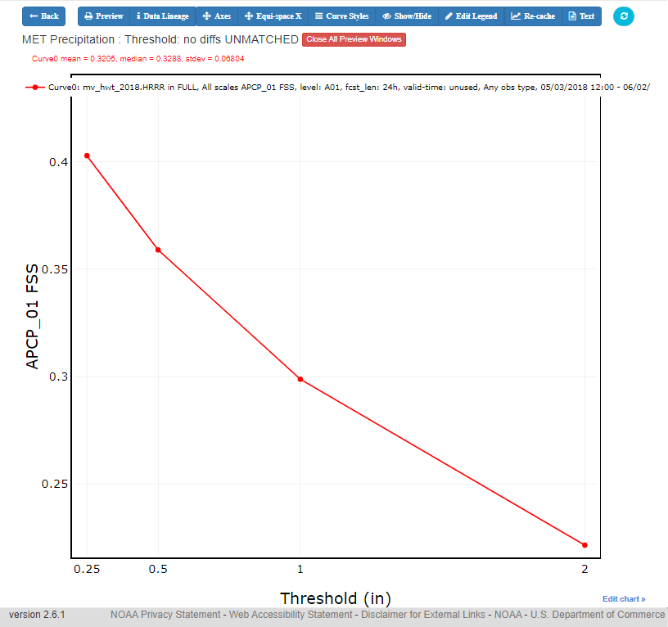

Figure ‑ Threshold plot in the Precipitation app produced from selections in Figure 3.6-1

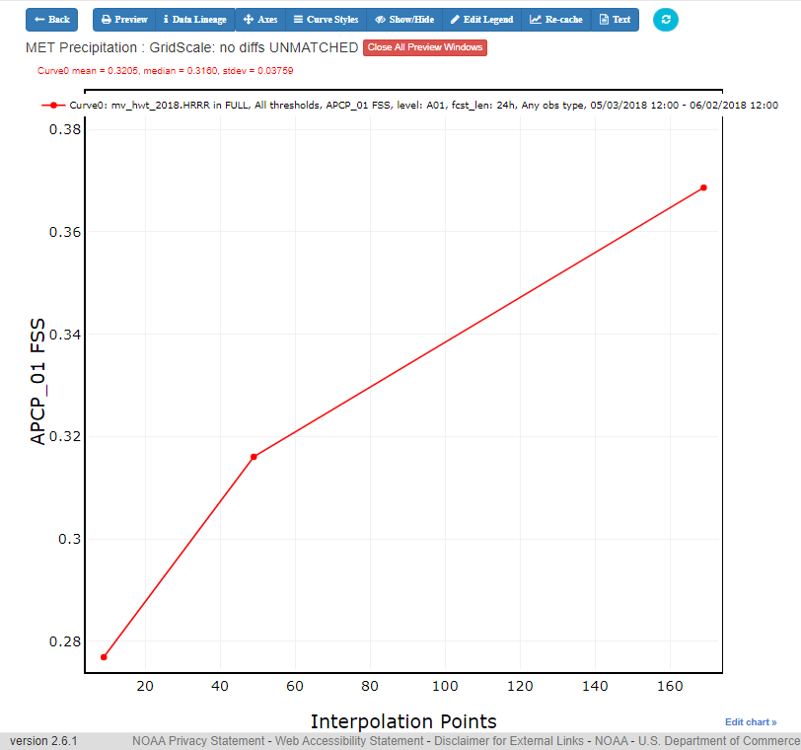

Figure ‑ GridScale plot in the Precipitation app produced from selections in Figure 3.6-1

# METexpress System Requirements, Installation and Support

**Repository**: METexpress is a community software package managed by the Developmental Testbed Center (DTC) and is available through Github at

<https://github.com/dtcenter/METexpress>

This repository includes a readme file at the top-level that covers an overview and build instructions, with further links to installation instructions.

**System requirements:**

* Hardware: Metexpress runs on Docker. It can successfully run on a system with four cores, 8 GB of memory and 10GB of free disk space. METexpress has been tested on Linux and MAC systems. It may run on Windows but this has not been tested and the configuration and management scripts are written in bash.
* Software: You must have docker, docker-compose, httpaswd, and jq installed. You should have a certificate installed in /etc/ssl/certs, although you can deploy a simple system on localhost without certificates for testing. A simple testing system can be deployed by answering yes to the question "Are you setting up a simple test environment?" in the configure program.
* Python3: There is a dependency on python3 which should be accessible in /usr/bin/python3, and requires a number of python modules to be installed, including pymysql, abc.abstractmethod, urllib.request, traceback, ssl, getopt, and json. These may need to be added to your python environment with a package manager.

Meteor Framework: METexpress is built on the Meteor free and open-source JavaScript web framework. You must install Meteor from this location:<https://www.meteor.com/install> if you intend to build METexpress. Meteor is not required to deploy METexpress containers.

**Database requirements:** METexpress must have access to a METdatadb database and must have read/write privileges. For further information about installation of this database please see <http://dtcenter.ucar.edu/met/metviewer/doc/install.html>

**Configuration:** In order to install METexpress you must run a configuration script which will prompt you to provide information specific to your installation. Some of the information you will usually need to provide includes:

* Networking information**:** 
  + The domainName of the deployment server.
    - METexpress uses this to configure its own proxy service that fronts the apps.
  + Fully qualified proxy hostname, defaulting to the domainName
    - Your deployment might be behind a redirection proxy with redirection to a different path than what is actually on the host. For example, the METexpress server might be deployed on a server with an internal URL "[https://something.subnet.esrl.noaa.gov](https://something.subnet.esrl.noaa.gov/)" and have a landing page location of "/", while the public URL is a proxy redirect like "<https://www.esrl.noaa.gov/gsd/mats>".
      * In this case the fully qualified proxy hostname is [www.esrl.noaa.gov](http://www.esrl.noaa.gov/) and the proxy_prefix_path needs to be set to "/gsd/mats".
  + Proxy redirection path
    - This allows you to serve a different path than "/"
* Database credentials:

Building on the architecture of MATS, METexpress has a construct for a database role. Within METexpress the only role that is used is one named “sums_data”. METexpress requires that a user exist in the MET database that has database read and write. Write permissions are needed to create metadata entries. During the installation, it will be necessary to provide the username and password for this user.

Username and password for each role required for each app.

* SSL certificates:

An SSL certificate is required to run METexpress. This is usually an externally acquired certificate for your domain, which you will need to place in a directory as instructed by the setup script. Alternatively, you can use a no-cost certificate provided by traefik using lets-encrypt software from within METexpress containers. Instructions for this option are available at

<https://doc.traefik.io/traefik/https/overview/>.

Be aware, however, that this option requires modifications to the server’s firewall by someone with network administrative privileges.

**Building METexpress:** It is only necessary to build METexpress if you require a custom build; otherwise it is recommended that METexpress be installed directly from the provided docker images. The direct link for the overview and build readme is:

<https://github.com/dtcenter/METexpress/blob/master/README.md>

**Installation:** METexpress can only be installed from Docker images. The most recent images are maintained by METexpress developers and are available in the dockerhub repository here:

<https://hub.docker.com/r/dtcenter/metexpress-production>

Installation guidance is provided at:

<https://github.com/dtcenter/METexpress/blob/master/container_deployment/README-INSTALL.md>

**Support:** For support for METexpress, please email mats.gsd@noaa.gov.

# METexpress Metadata

## What is metadata for METexpress?

Generally, the term metadata refers to data about the data. METexpress stores metadata about each data set in the database to describe parameters such as the model (or data source), regions, variables, levels, dates, etc that are included in that data set.

This metadata is then used to populate the selectors displayed on the initial page of each METexpress app, so that only valid data combinations are presented to the user for plotting. For example, if you select a data-source of GFSFV3, the selections that are listed for Regions will only include regions actually produced and stored with the GFSFV3 data set.

## Generating metadata for a MySQL database

**You must run the metadata scripts at least once before attempting to run METexpress with a new database, or the apps will fail to start.**

The scripts can be run from any host (with UNIX) that has access to the MET database, but must be run by a user with write permissions to that database. This is because after generating the metadata required by each app, the metadata scripts will create a new schema within the MySQL database called mats_metadata, and store the metadata within it. The scripts will never write to any other location.

The metadata scripts are written in python3, and require a number of python modules, including pymysql, abc.abstractmethod, urllib.request, traceback, ssl, getopt, and json, which may need to be added to your python environment with a package manager.

**To run the metadata scripts for the first time:**

* The scripts are located in the METexpress repo at <https://github.com/dtcenter/METexpress/tree/master/scripts/matsMetaDataForApps/createMetaData/mysql/metexpress>.
* After cloning this repo, link the contents of the scripts/matsMetaDataForApps/createMetaData/mysql directory to your preferred run directory (e.g., something like /home/metexpress/scripts).
* You will need a .my.cnf file with the login credentials for your mysql database. Remember, the credentials must be for a user with write permissions.
* cd to your run directory. Remember, the contents of this run directory should be identical to the contents of scripts/matsMetaDataForApps/createMetaData/mysql. Please note that this is ONE LEVEL ABOVE the directory where the metadata scripts actually are.
  + (e.g.    cd /home/metexpress/scripts).
* Set the python path to your run directory
  + (e.g.    export PYTHONPATH=”/home/metexpress/scripts”).
* Run the scripts from the command line. You will need to pass in the path to your .my.cnf file and the URL where METexpress will be available as arguments. The URL <metexpress_url> is the actual access url of your metexpress installation, e.g. `https://yourdomain/metexpress`. The URL is necessary so that the metadata scripts can inform METexpress that new metadata is available.
  + (e.g.    /home/metexpress/scripts/metexpress/MEmetadata_update.py -c /home/metexpress/.my.cnf -u <metexpress_url>).
* The scripts should generate the necessary metadata and store it in the database.
* You should now be able to run a METexpress instance that looks at this database.

Once the apps are up, any new MET data loaded into the database will not appear in METexpress until the metadata scripts are run again. Because of this, we recommend running the following steps from the write access user’s crontab, either once daily or at another interval that you prefer. The metadata scripts can also be run manually at any time.

**To run the metadata scripts subsequent times (such as from the crontab):**

* Set the python path to your run directory
  + (e.g.    export PYTHONPATH=”/home/metexpress/scripts”).
* Run the scripts from the command line. You will need to pass in the path to your .my.cnf file and the URL where METexpress is available as arguments.
  + (e.g.    /home/metexpress/scripts/metexpress/MEmetadata_update.py -c /home/metexpress/.my.cnf -u <metexpress_url>).
* The scripts should generate the necessary metadata and store it in the database.
* The scripts will then briefly connect to each app at the provided URL, triggering a metadata update and causing the selectors to display the latest information.

**Having mv_load or METdbload trigger a metadata update:**

In addition to running the metadata scripts from the crontab at a given interval, it is also possible to invoke the metadata script when any new data is loaded into the database. To do this you can insert a metadata script invocation (the steps given in the previous section) into the end of the METviewer mv_load.sh script. Be sure to set the PYTHONPATH in your script invocation.

# Appendix A – Public Deployments of METexpress

For NWS/NCEP/EMC, METexpress is currently running on the Amazon Web Services cloud and is available at:

[metexpress.nws.noaa.gov](https://metexpress.nws.noaa.gov)