**INSTITUTO TECNOLOGICO DE TIJUANA**

**CARRERA**

**INGENIERÍA EN SISTEMAS COMPUTACIONALES**

**MATERIA**

**MINERÍA DE DATOS**

**TAREA**

**PRÁCTICA #4, UNIDAD #3**

**FECHA ENTREGA**

**23/05/2022**

**ALUMNO(A)**

**HOWARD HERRERA ERWIN #18210716**

**PÉREZ LÓPEZ ALICIA GUADALUPE #18210514**

**DOCENTE**

**JOSE CHRISTIAN ROMERO HERNANDEZ**

Import of the dataset and we will specify the range of columns that we will use (3 to 5)

|  |
| --- |
| *# Importing the dataset* dataset = read.csv('Social_Network_Ads.csv') dataset = dataset[3:5] |

We change the value of the “Purchased” column as a factor type to be able to use it later

|  |
| --- |
| *# Encoding the target feature as factor* dataset$Purchased = factor(dataset$Purchased, levels = c(0, 1)) |

.

We divide the dataset into 2 parts, training and testing with a ratio of 0.75, and the seed is specified to have randomness.

|  |
| --- |
| *# Splitting the dataset into the Training set and Test set* *# install.packages('caTools')* library(caTools) set.seed(123) split = sample.split(dataset$Purchased, SplitRatio = 0.75) training_set = subset(dataset, split == TRUE) test_set = subset(dataset, split == FALSE) |

We will scale the training and test values ​​to model them for use in the KNN algorithm.

|  |
| --- |
| *# Feature Scaling* training_set[-3] = scale(training_set[-3]) test_set[-3] = scale(test_set[-3]) |

. We send the test and training data to the KNN algorithm, in addition, the variable k is set as 5 to seek to obtain a better classification

|  |
| --- |
| *# Fitting K-NN to the Training set and Predicting the Test set results* library(class) y_pred = knn(train = training_set[, -3],  test = test_set[, -3],  cl = training_set[, 3],  k = 5,  prob = TRUE) |

We make the confusion matrix using the predictor variable created from the knn algorithm and sending the test data.

|  |
| --- |
| *# Making the Confusion Matrix* cm = table(test_set[, 3], y_pred) |

Visualization of the results

|  |
| --- |
| *# Visualising the Training set results* install.packages('ElemStatLearn') library(ElemStatLearn) set = training_set X1 = seq(min(set[, 1]) - 1, max(set[, 1]) + 1, by = 0.01) X2 = seq(min(set[, 2]) - 1, max(set[, 2]) + 1, by = 0.01) grid_set = expand.grid(X1, X2) colnames(grid_set) = c('Age', 'EstimatedSalary') y_grid = knn(train = training_set[, -3], test = grid_set, cl = training_set[, 3], k = 5) plot(set[, -3],  main = 'K-NN (Training set)',  xlab = 'Age', ylab = 'Estimated Salary',  xlim = range(X1), ylim = range(X2)) contour(X1, X2, matrix(as.numeric(y_grid), length(X1), length(X2)), add = TRUE) points(grid_set, pch = '.', col = ifelse(y_grid == 1, 'springgreen3', 'tomato')) points(set, pch = 21, bg = ifelse(set[, 3] == 1, 'green4', 'red3')) |

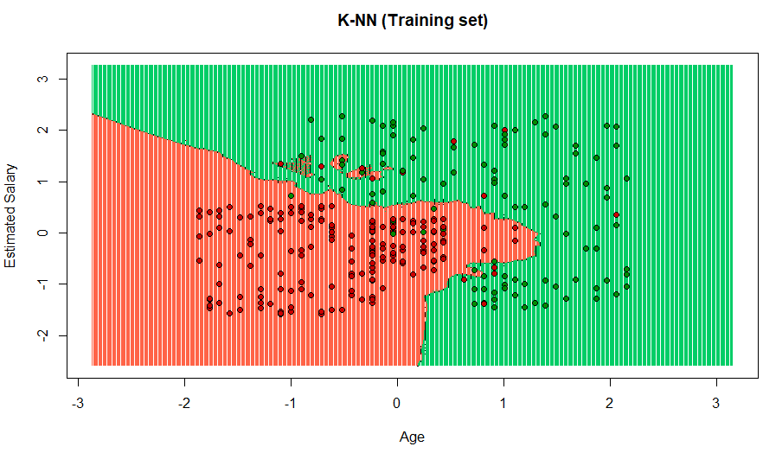

Visualization of the results using the test values ​​of the algorithm.

|  |
| --- |
| *# Visualising the Test set results* library(ElemStatLearn) set = test_set X1 = seq(min(set[, 1]) - 1, max(set[, 1]) + 1, by = 0.01) X2 = seq(min(set[, 2]) - 1, max(set[, 2]) + 1, by = 0.01) grid_set = expand.grid(X1, X2) colnames(grid_set) = c('Age', 'EstimatedSalary') y_grid = knn(train = training_set[, -3], test = grid_set, cl = training_set[, 3], k = 5) plot(set[, -3],  main = 'K-NN (Test set)',  xlab = 'Age', ylab = 'Estimated Salary',  xlim = range(X1), ylim = range(X2)) contour(X1, X2, matrix(as.numeric(y_grid), length(X1), length(X2)), add = TRUE) points(grid_set, pch = '.', col = ifelse(y_grid == 1, 'springgreen3', 'tomato')) points(set, pch = 21, bg = ifelse(set[, 3] == 1, 'green4', 'red3')) |

