Predicting treatment response using shallow whole genome sequencing of cell-free DNA using in patients with metastatic Her2+ve breast cancer.

Alistair Martin and Emma Beddowes and Mario Ortega Duran and others and Carlos Caldas

28 May, 2019

## 'select()' returned 1:many mapping between keys and columns

# Abstract

# Introduction

# Methods

# Results

# Discussion

# Conclusion

# Tables

|  |  |  |
| --- | --- | --- |
| Measure | value | N |
| Age at primary diagnosis | (0,40] | 4 |
|  | (40,50] | 10 |
|  | (50,60] | 17 |
|  | (60,70] | 9 |
|  | (70,120] | 8 |
| Race | White | 47 |
|  | Unknown | 1 |
| Primary receptor status | ER Negative, HER2 Positive | 8 |
|  | ER Positive, HER2 Positive | 36 |
|  | Indeterminate | 3 |
| Grade at primary diagnosis | I | 1 |
|  | II | 17 |
|  | III | 27 |
|  | Unknown | 3 |
| Vital status | Alive | 13 |
|  | Deceased | 35 |

Measure Comparison

Time Dependent Cox Model

Progression Free Survival

ichorCNA.default

0.860***

1.370***

(0.210)

(0.437)

t.Mad

0.503***

-0.645

(0.161)

(1.240)

ichorCNA.low

0.383***

0.366

(0.126)

(0.517)

z.OR

0.444***

-0.358

(0.162)

(0.730)

absolute

0.432***

0.122

(0.165)

(0.258)

AIC

135.1

143.9

145

145.7

146.1

140.6

Concordance

0.809

0.767

0.798

0.704

0.607

0.772

R2

0.092

0.043

0.036

0.032

0.030

0.106

Log Likelihood

-66.600

-71.000

-71.500

-71.800

-72.000

-65.300

Wald Test

16.800***

9.750***

9.180***

7.490***

6.830***

19.700***

LR Test

16.000***

7.220***

6.160**

5.480**

5.060**

18.600***

Score (Logrank) Test

30.200***

15.800***

15.400***

9.590***

8.240***

31.200***

Note:

*p<0.1;* ***p<0.05;*** p<0.01

# Figures

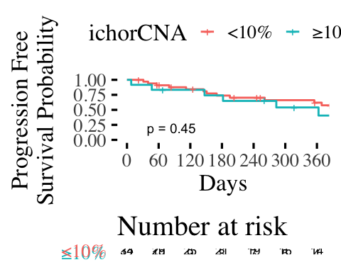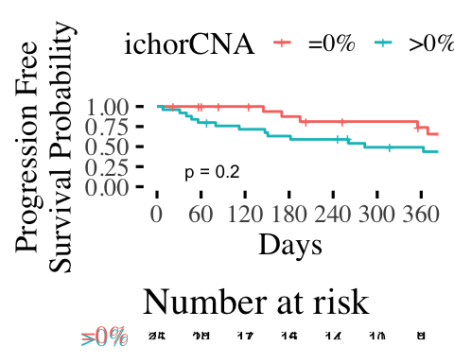

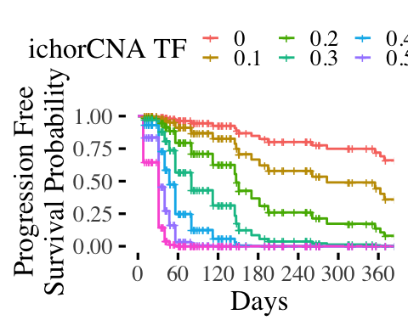

(#fig:survival.AG.ichor.cont.plot)Time-dependent Cox regression using ichorCNA as a predictor

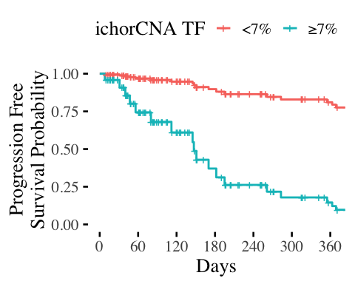

(#fig:survival.AG.ichor.cut.plot)Optimal thresholding of a time-dependent Cox regression using ichorCNA as a predictor

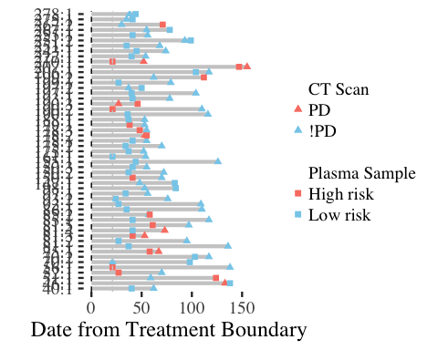

(#fig:boundaries.overview.plot)Overview of treatment boundaries within DETECT Her2+ve cohort

