Security of Computer Systems

Project Report

Authors:
Alicja Sobiech, 188861

Version: 1.0

Versions
Version | Date | Description of changes
1.0 | 04.04.2026 | Creation of the document
1.1 | … | …

- Project – control term
  - Description
Content

  - Results
Content
Content and content.
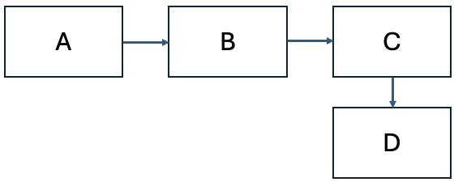
Fig. 1 – Block diagram.
Final content.

  - Summary
Content

- Project – Final term
  - Description
Content

  - Code Description
Content
/*!
* A list of events:
* <ul>
* <li> mouse events
* <ol>
* <li>mouse move event
* <li>mouse click event<br>
* More info about the click event.
* <li>mouse double click event
* </ol>
* <li> keyboard events
* <ol>
* <li>key down event
* <li>key up event
* </ol>
* </ul>
* More text here.
*/
List. 1 – Code listing [2].
  - Description
Content

  - Results
Content

  - Summary
Content

- Literature
[1] Article.
[2] Online Doxygen documentation, https://www.doxygen.nl/manual/lists.html, (accessed on 01.02.2025).
[3] Book.

