Do Zastosowań autoenkoderów
https://www.v7labs.com/blog/autoencoders-guide

3. Generation of image and time series data
Variational Autoencoders can be used to generate both image and time series data.
The parameterized distribution at the bottleneck of the autoencoder can be randomly sampled to generate discrete values for latent attributes, which can then be forwarded to the decoder,leading to generation of image data. VAEs can also be used to model time series data like music.

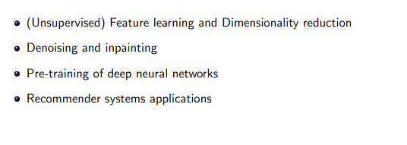
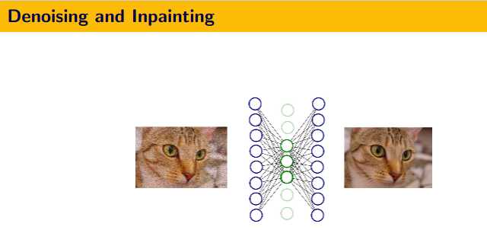
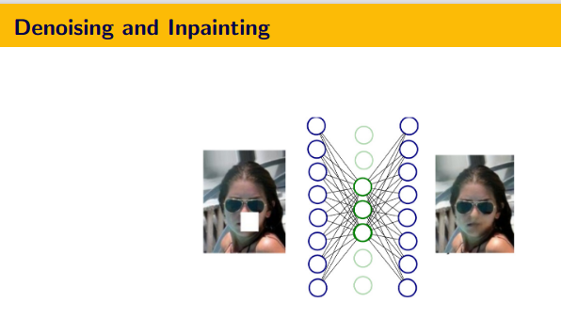
Do rodzajów AE
AE stochasytczny
https://www.cse.iitk.ac.in/users/piyush/courses/ml_autumn18/material/autoencoders.pdf

Do zastosowań lub do przykładów praktycznych
http://ceur-ws.org/Vol-2845/Paper_5.pdf

Do zastosowań: semantic hashing https://arxiv.org/pdf/2005.04321.pdf

