Selected Design Issues

Topic: School language - Lingus

Authors: Alicja Tomaszewska, Patrycja Zych, Julita Bussler

- System logical architecture
<Subsystem diagram distinguishing subsystems (layers and partitions) the system is composed of and identifying dependencies between them; Description of subsystems; Assignment of classes (from class diagram) to subsystems.>
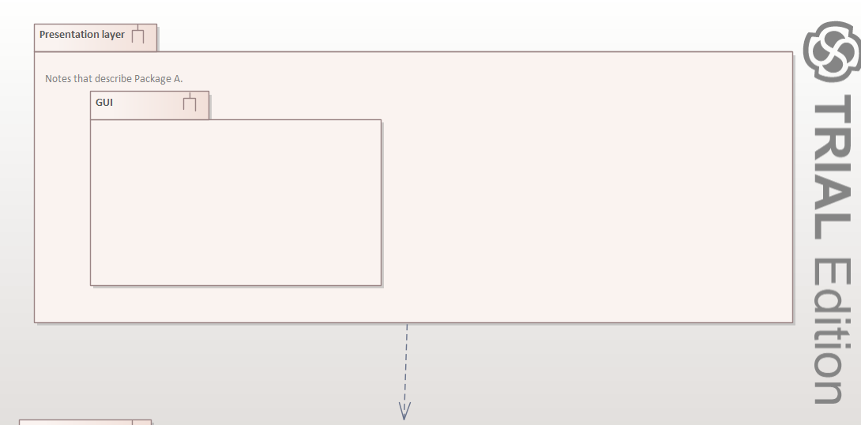
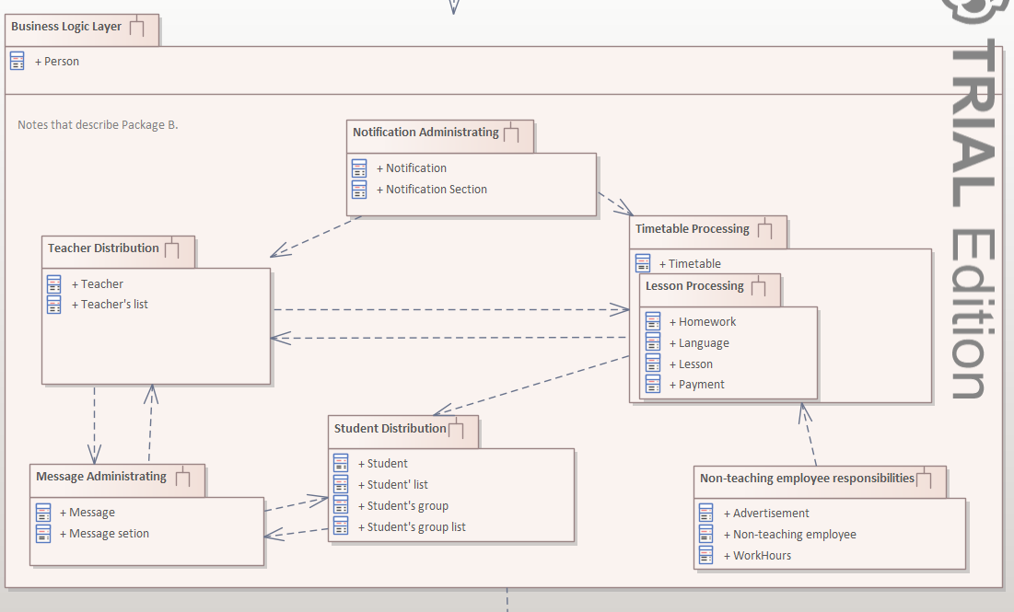
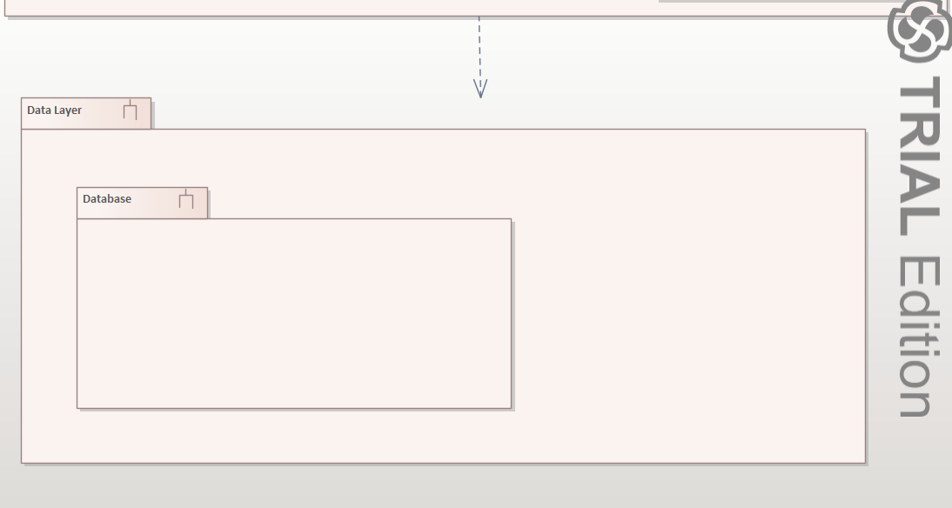
- Selection of technologies
<Description of technologies to be used in development (programming language, development environment, components, libraries, frameworks). Description of runtime environment.>

* programming language -
--> backend = c++ - high performance, low-level = getting close to computing
--> networking = python - good with working with a lot of data, high automation of administration tasks
--> database = Microsoft SQL Server - a very powerful tool that enables you to perform many functions at high efficiency and speed. It is supported by a large community with lots of resources.

* development env,
—> Microsoft SQL Server Management Studio
—>Microsoft Visual Studio

* libraries -
--> c++ - WT (Wt is a web GUI library in modern C++. Quickly develop highly interactive web UIs with widgets, without having to write a single line of JavaScript. Wt handles all request handling and page rendering for you, so you can focus on functionality.)
--> python - Paramiko(lib that can be used to test connectivity) , Pytest(lib for automated testing - unit_tests/component_tests/integration_tests)

* frameworks -
→ c++: sadf
--> python: Flask(Flask is a lightweight Python web framework that provides useful tools and features for creating web applications in the Python Language. It gives developers flexibility and is an accessible framework for new developers because you can build a web application quickly using only a single Python file. Flask is also extensible and doesn’t force a particular directory structure or require complicated boilerplate code before getting started.)
→ SQL: Microsoft SQL Server
—>grafana - statistics, visualisations, graphs about usage of particular features

* operating system - windows, mac OS, iOS, android OS, linux

- Physical architecture
<UML deployment diagram showing the planned deployment of subsystems/components on particular nodes (computers, devices, etc.).>

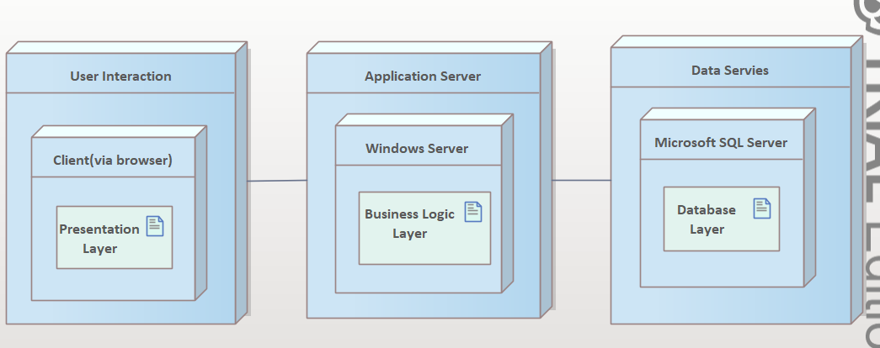

- Database design
<For the entire system (all subsystems): design an ERD diagram (or database tables diagram) based on analytical class diagram. This can be done using Enterprise Architect or some other CASE tool e.g. the one known from Databases course.>

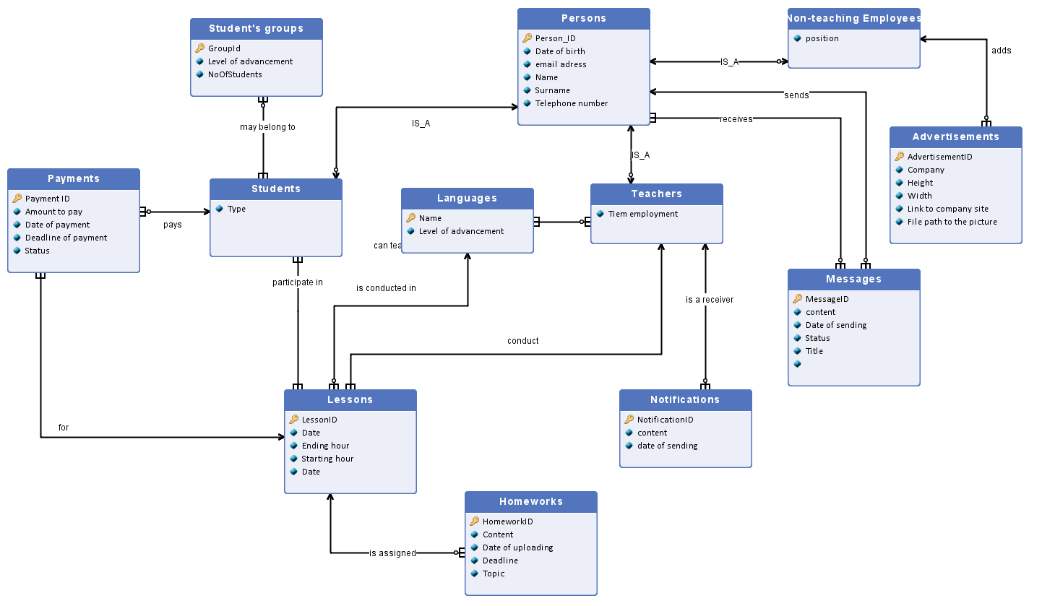
- User interface design
< For one selected subsystem: design a navigation map showing transitions between particular screens; design user interface prototypes covering the functionality of the selected subsystem. Any choice of technique/tool is allowed.>

Navigation through Message Administrating ( from the student point of view)
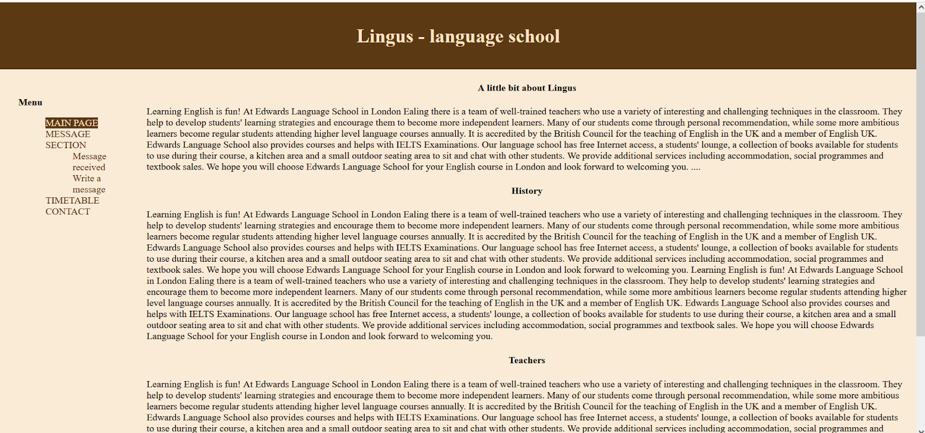
- We are at the main page. At the left part we have navigation menu which makes easier moving between subpages. We click on the message section, and automatically we are there.
- The system displays the message section, we can choose a particular message to see its content by clicking it.
- Also we have 3 buttons - write a message, draft versions, sent messages.
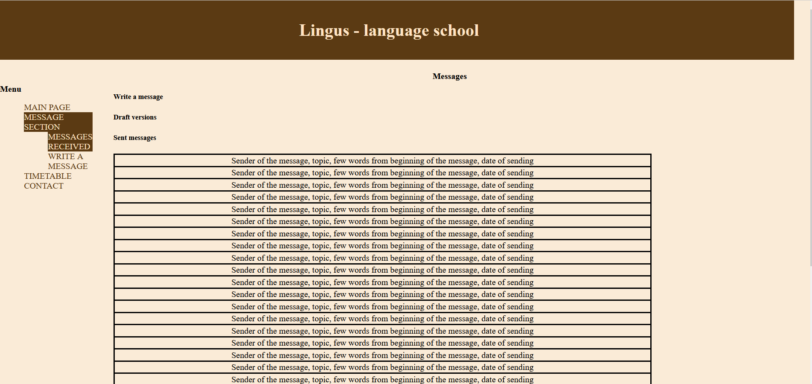
- If we want to write a message we can either click on the WRITE A MESSAGE placed in menu or Write a message at the upper part of the page.

- “Write a message” screen looks as follow: we have a place to enter the topic of the message, list of the available contacts to choose from, place for text, files, send reset button. After writing and sending the message we are moved to the message section with received messages.
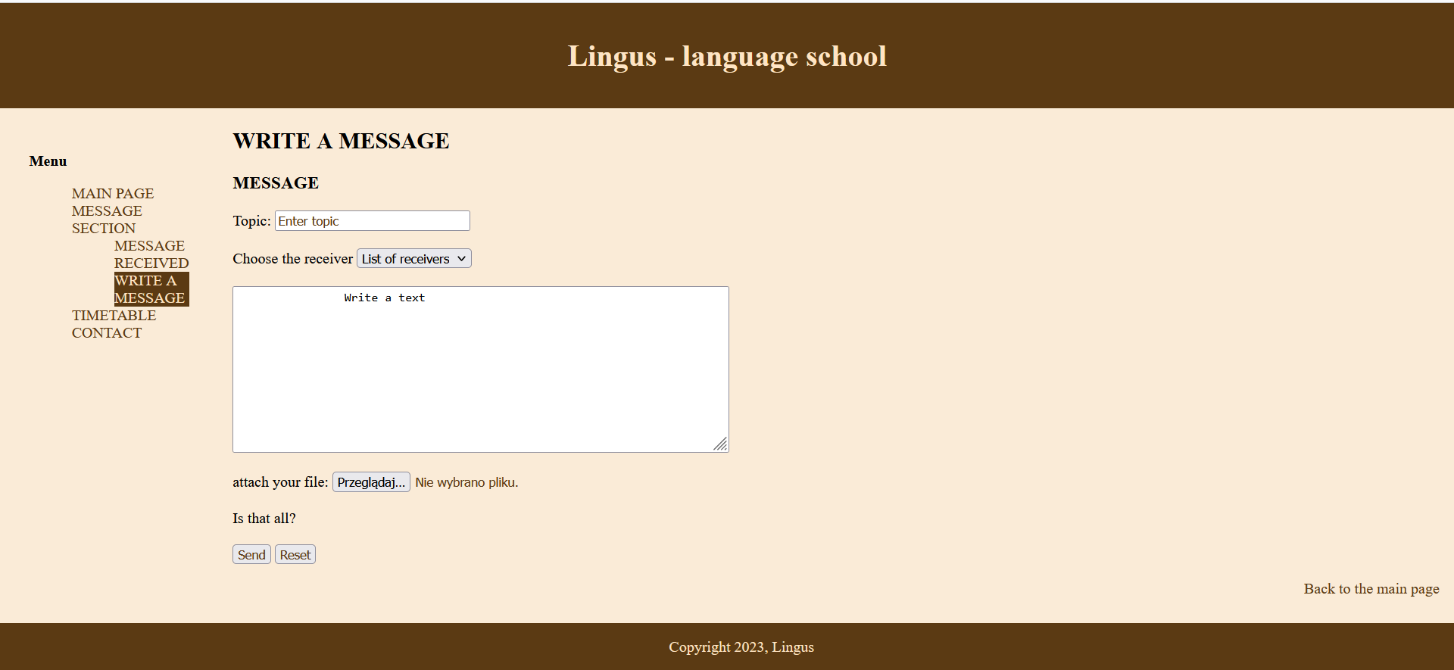
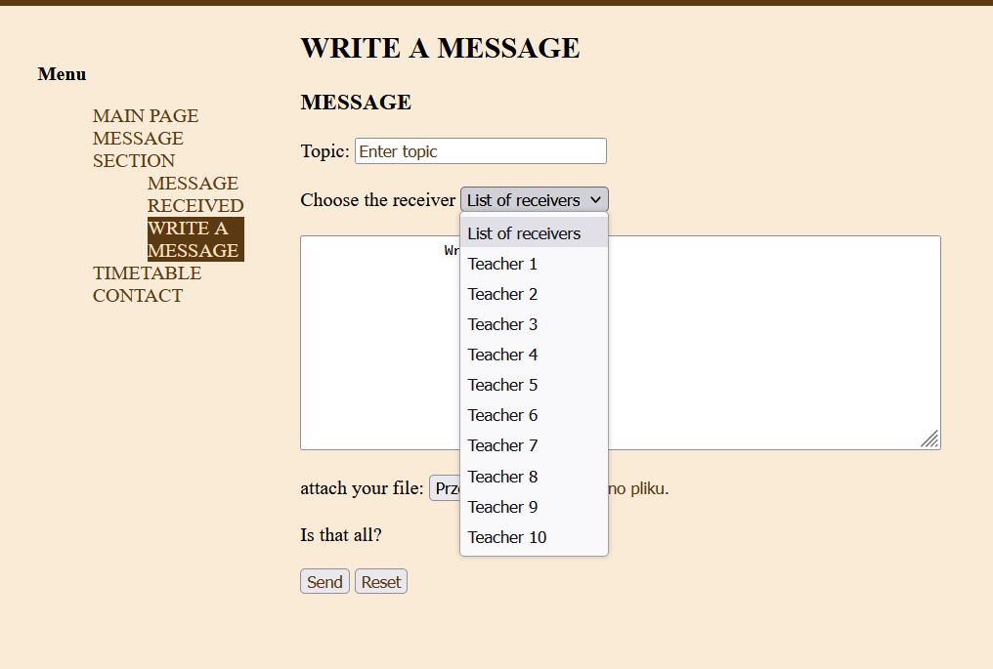

- When we are in the message section we can choose a particular message to see its content. The system displays topic, sender, date of sending, text of message and possible attached files. The user can respond to the message or leave.

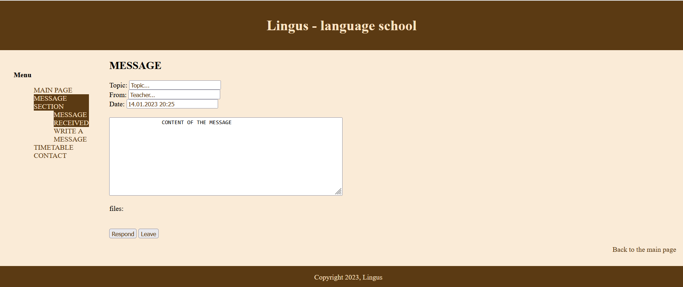
- After clicking the “Respond” button the similar screen to “Write the message” is displayed. We fill all the data needed and press “Send”. After that we are moved to the message section page.
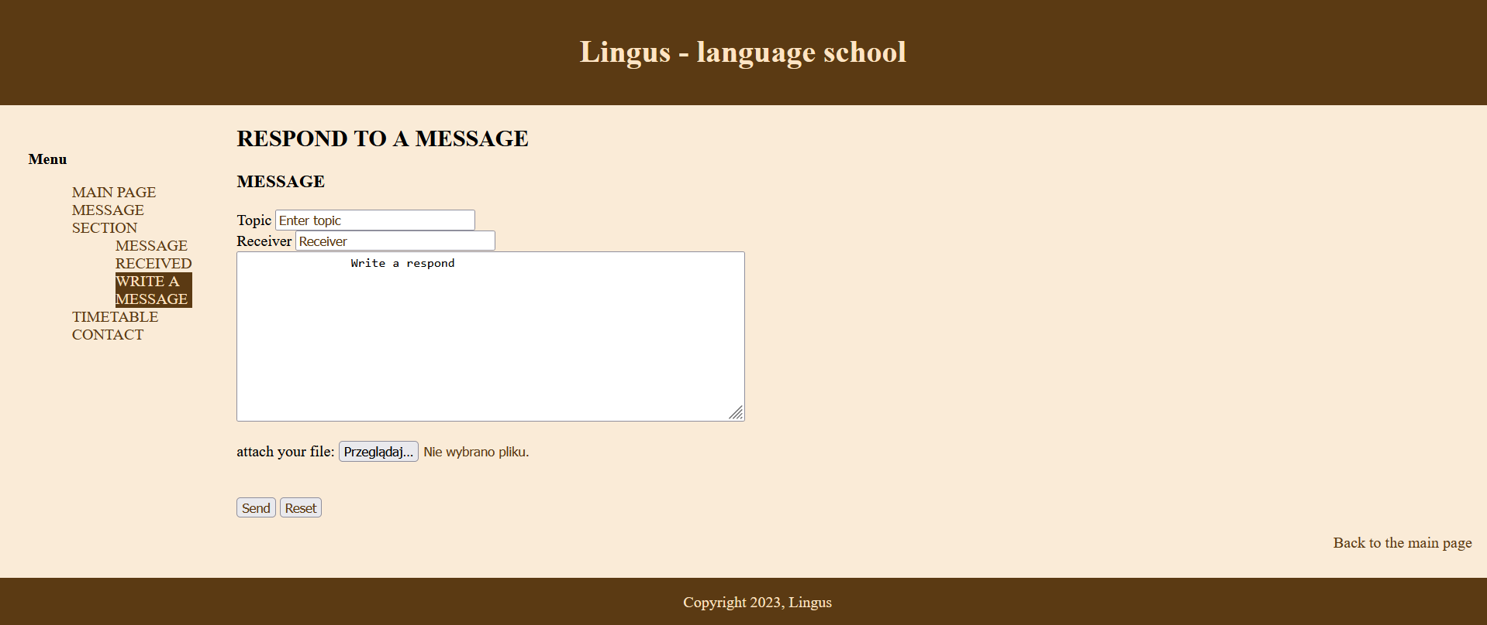
- Draft versions screen. The system displays screen with drafted versions of messages.
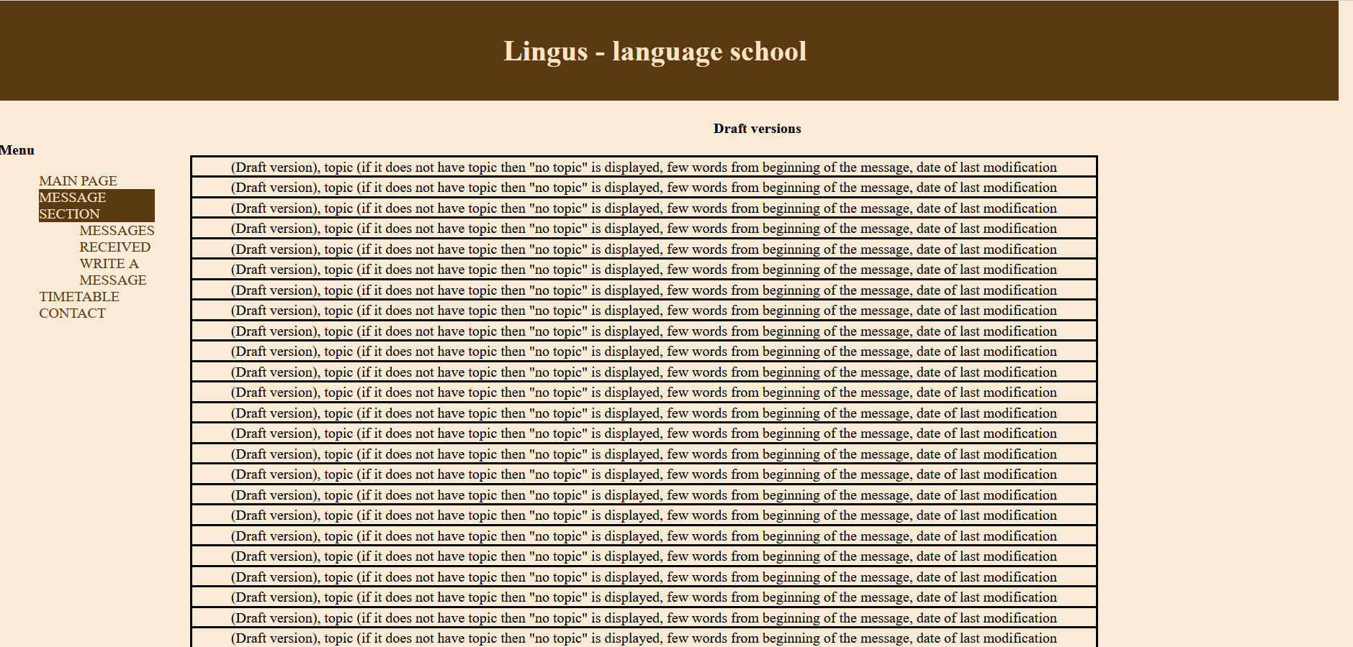
- Sent messages screen. We can click on the particular sent message and see it whole content, that screen looks similar to the “received messages” but instead of “From:” is “To:”.
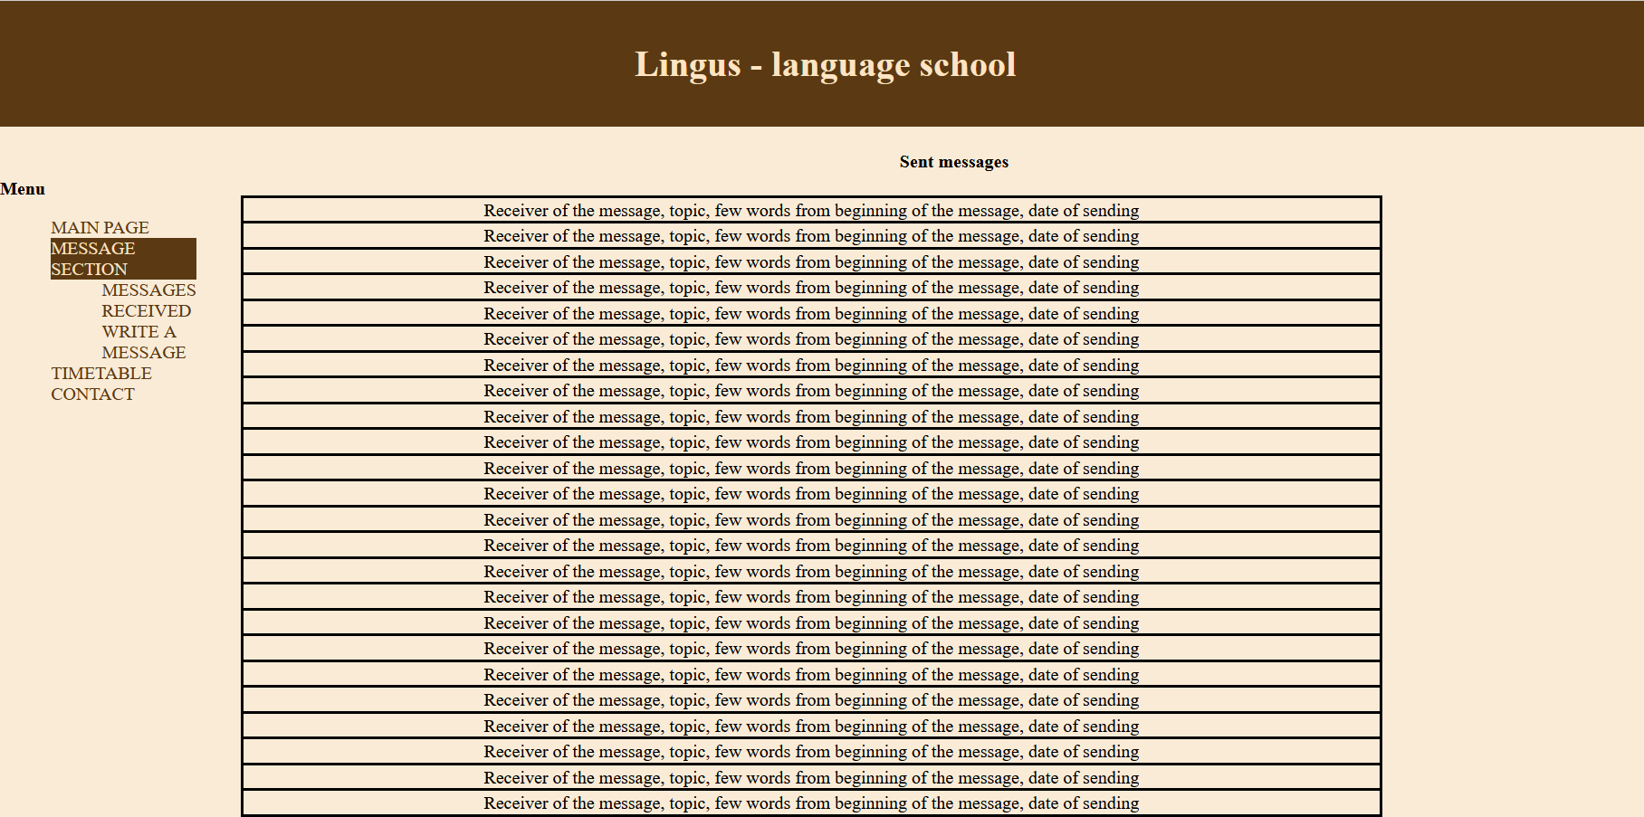
- Screen for editing draft versions look similar as the one “Write the message” but it is filled with previously entered data.

