Assignment 2

Q1. Find the topic name of the pose (position and orientation) of turtlesim and its message type. Display the content of message of the pose.

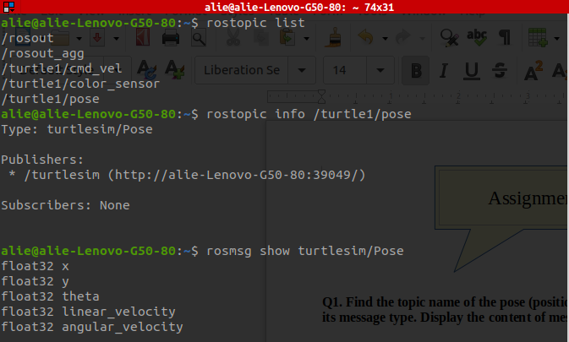

Q2. Find the topic name of the velocity command of turtlesim and its message type. Display the content of message of the velocity command.
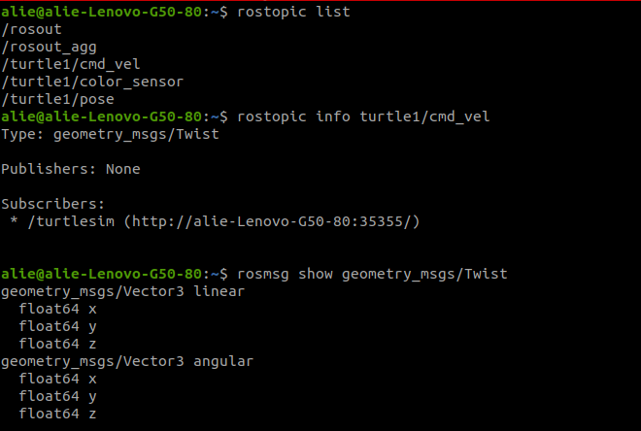

Q3. Write a simple ROS node in a script file called turtlesim_pose.py, which subscribes to the topic of the
pose, and then prints the position of the robot in the callback function.

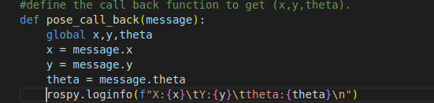

Q4. Complete the previous code in turtlesim_pose.py to add a publisher to the velocity and make the robot
move for a certain distance. Hint: you can use the rule
Distance = linear_speed * time
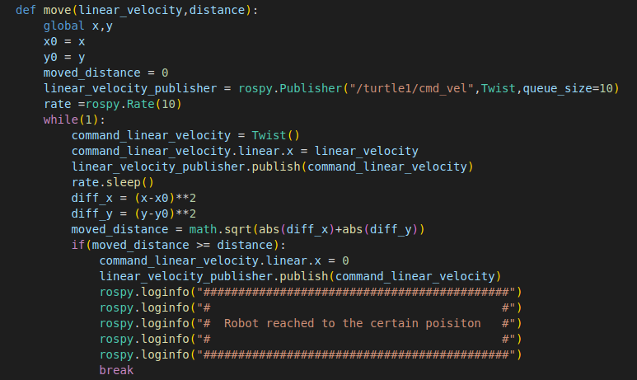
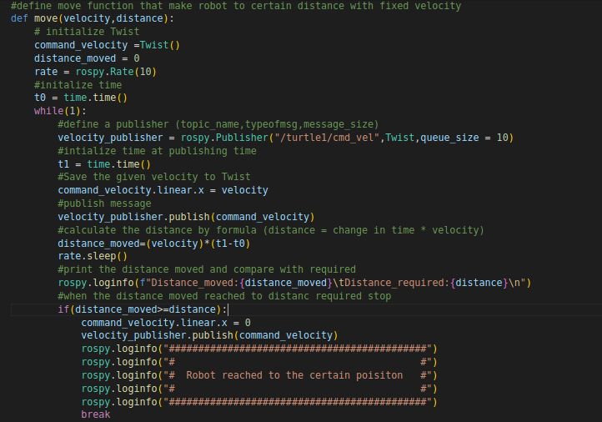
Q5. Complete the previous code in turtlesim_pose.py to add a publisher to the velocity and make the robot
rotate in place for a certain angle. Hint: you can use the rule
Angle = angular_speed * time

Method1
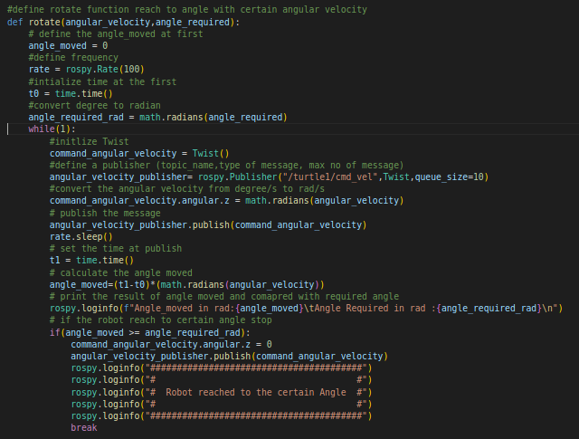
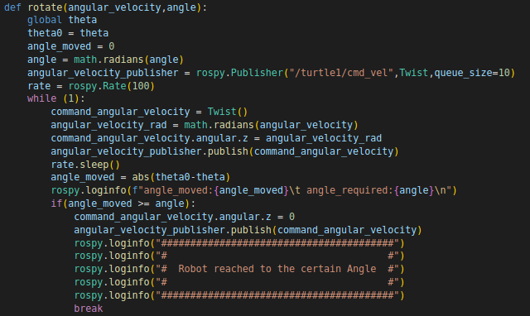
Method2
Q6. Use your code above to make the robot move 1 meter and rotate 90 degrees.

Attached
- move1.py
- move2.py

