Assignment 1

- What is ROS? Why would we use it?
ROS is a middle-ware or framework used for writing software for robots. We use it because it contains several packages and tools that help us to simplify the task of creating robot’s software.

- Mention one useful package in ROS.
Turtlesim : Used for Teaching ROS for beginners.
Rqt_graph: Used for visualizing ROS computation graph.

- What is turtlesim package? explain it in your words
Turtlesim package is used for teaching ROS for beginners by visualizing an object or more and seeing the position on the screen in the form of linear or angular (x,y,z). Also we can connect it with other node to control the motion of the object to move it and see the change happened in position or velocity.

- What is the difference between rostopics and rosnodes?
Rostopics : it the link connect between the publisher and subscriber that show the type of message.
Rosnode : is the program script that written by programming language like c++ , python ,.. that perform some kind of task

- If the response for rostopic list was only /rosout and /rosout_agg (See screenshot 1) How many nodes are running ? Which node is running?
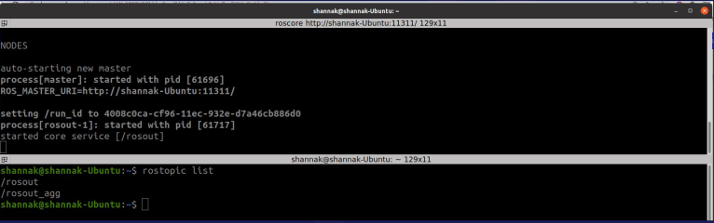

One Node : /rosout
- After writing rostopic in the terminal and pressing Tab twice I got this response(screenshot 2) Pick three commands and explain their usage.

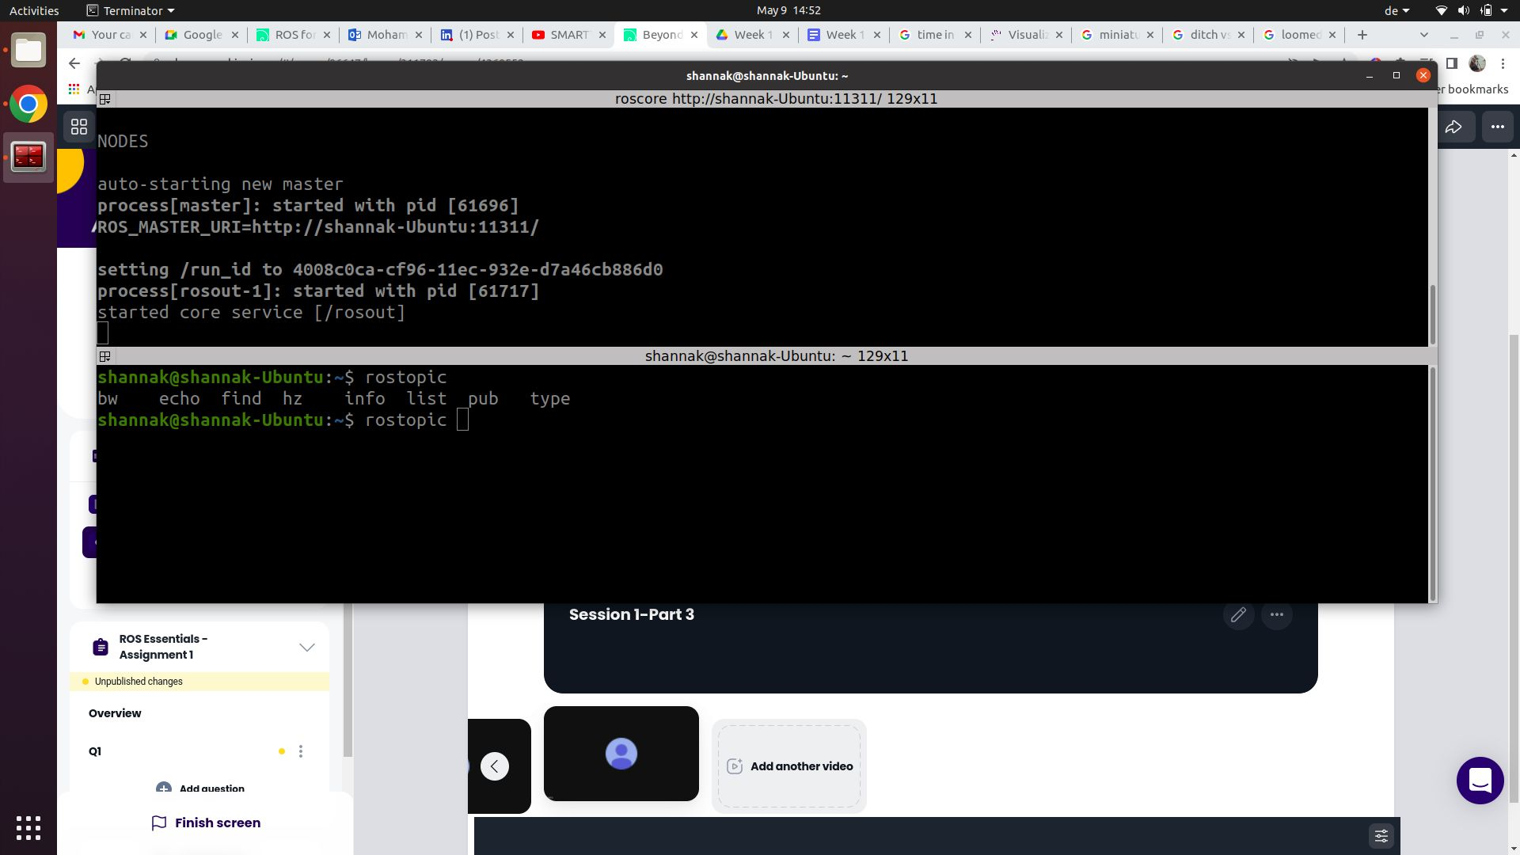

Rostopic
bw | Display bandwidth used by topic
echo | Print messages to screen
find | Find topics by type
info | Print information about active topic
list | List active topics
pub | Publish data to topic
type | Print topic or field type

- Mention at least two informations you could get from the command rosnode info
Rosnode info shows information about the node
- Publication
- Subscription
- Services
- Do the following :
In the first terminal : Run → roscore
In the second terminal Run the turtle sim node →rosrun turtlesim turtlesim_node
Question:
What shall you write in a third terminal to make the turtle draw a circle

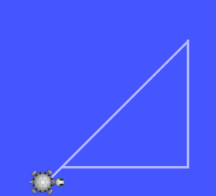

For drawing triangle
rostopic pub -r 10 /turtle1/cmd_vel geometry_msgs/Twist '{linear: {x: 0.5, y: 0.0, z: 0.0}, angular: {x: 0.0, y: 0.0, z: 0.0}}'
rostopic pub -r 10 /turtle1/cmd_vel geometry_msgs/Twist '{linear: {x: 0.0, y: 0.5, z: 0.0}, angular: {x: 0.0, y: 0.0, z: 0.0}}'
rostopic pub -r 10 /turtle1/cmd_vel geometry_msgs/Twist '{linear: {x: -0.5, y: -0.5, z: 0.0}, angular: {x: 0.0, y: 0.0, z: 0.0}}'

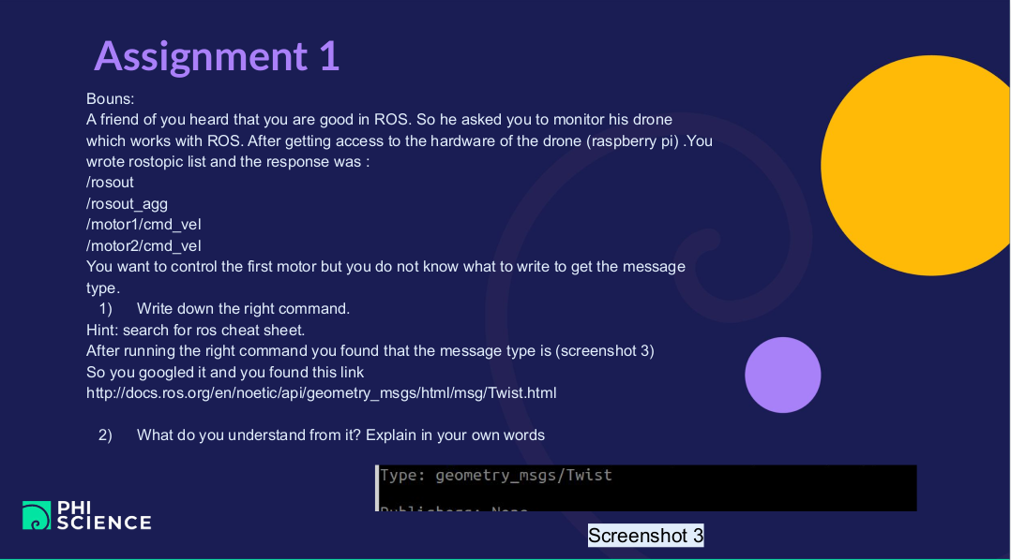
- rostopic type motor1/cmd_vel
- geometry_msg/Twist express velocity in 3d space and it divides into two parts
  - Linear velocity
    - Vx
    - Vy
    - Vz
  - Angular velocity
    - Wx (Roll)
    - Wy (Patch)
    - Wz (Yaw)

