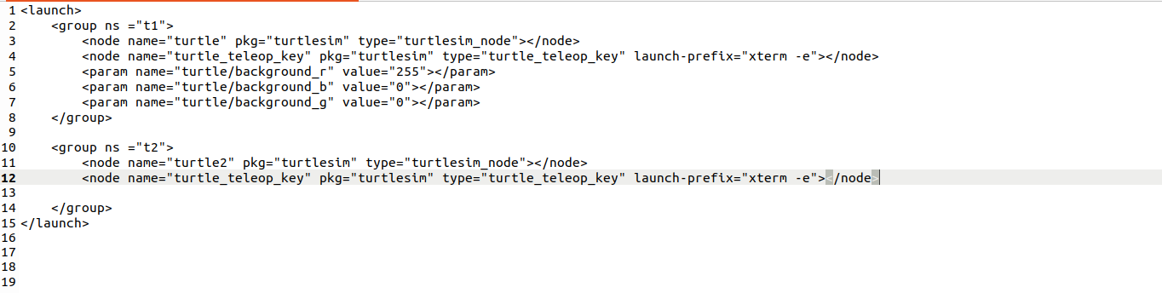
Assignment 4
Launch file for controlling two different turtles in two different screen with two different keyboard
For changing
Background
color to
Red
RQT GRAPH
Launch file for controlling two different turtles in one screen with two different keyboard

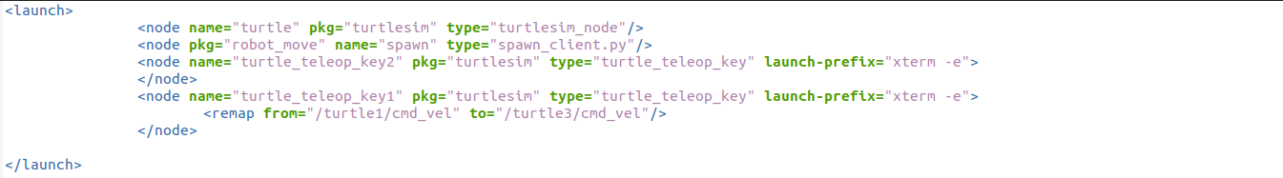
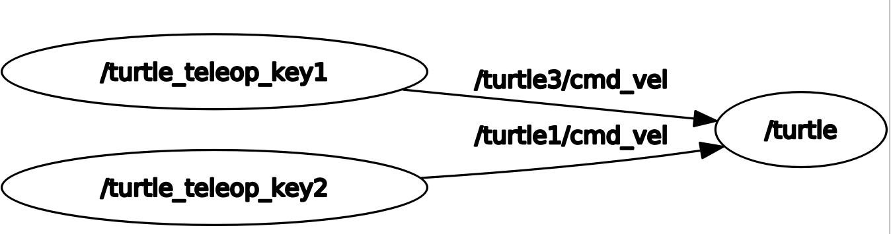
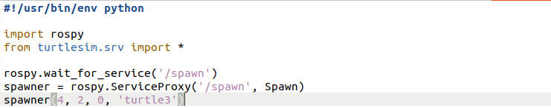
RQT GRAPH
Spawn_client.py

