ABSTRACT
The retail industry operates in a dynamic environment where daily sales are influenced by complex factors ranging from consumer behavior to seasonal trends. Accurate sales forecasting is a critical component of effective supply chain management, inventory optimization, and financial planning. Overestimating demand leads to surplus inventory and holding costs, while underestimating results in stockouts and lost revenue.
Traditional forecasting methods often rely on simple moving averages or intuition, which fail to capture the stochastic nature of daily sales data. The Autoregressive Integrated Moving Average (ARIMA) model provides a robust statistical framework for modeling time series data by capturing linear trends and autocorrelations.

INTRODUCTION
To analyze the statistical properties of the daily sales data, including stationarity, trend, and seasonality.
To transform the time series data into a stationary series using differencing or transformation techniques (e.g., Log-transform).
To identify the optimal ARIMA parameters based on Autocorrelation (ACF) and Partial Autocorrelation (PACF) functions and Information Criteria (AIC/BIC).
To evaluate the model's accuracy using Mean Absolute Error (MAE) and Root Mean Squared Error (RMSE).To generate a 30-day forecast of daily sales revenue to assist in inventory planning.

OBJECTIVES:
(1) To analyze retail performance patterns using metrics such as daily sales revenue, website visitor traffic, and inventory fluctuation trends.
(2) To evaluate the relationship between operational inputs and financial outcomes through the analysis of marketing spend efficiency and its correlation with daily revenue generation.
(3) To assess the impact of external and temporal factors on purchasing behavior by examining the effects of average temperature, day-of-week seasonality, and weekend variances.
(4) To construct a predictive time-series model using ARIMA to forecast future sales trajectories, identifying underlying trends and seasonal irregularities.
(5) To provide data-driven insights to guide the optimization of inventory management and marketing budget allocation for improved business profitability.

DATA
The dataset used in this analysis was compiled from a self-administered survey conducted among local small business owners. To ensure consistency, the variables were patterned after typical indicators commonly reported in real-world business analytics: daily sales revenue, marketing expenditures, website traffic, average temperature, inventory levels and day-of-week characteristics.

METHODOLOGY
This study investigates the relationship between daily retail sales revenue and marketing spend through a time series approach using the ARIMA model. The dataset contains daily observations including sales revenue, marketing expenditures, website traffic, weather conditions, inventory levels, and temporal indicators. Only the sales revenue series is modeled, and ARIMA is used without any exogenous regressors.
Data Preparation: The dataset was first arranged chronologically by date. Missing values, if present, were assessed and handled using appropriate imputation or removal based on their impact on continuity. The Daily_Sales_Revenue column was then converted into a univariate time series object in R with the correct frequency (daily).
Exploratory Analysis: Initial diagnostics were performed to understand the properties of the sales revenue series. Line plots were used to inspect trends, seasonal patterns, and variability. Summary statistics were computed to evaluate distributional characteristics and potential outliers.
Stationarity Assessment: Stationarity was evaluated using visual inspection, rolling statistics, and the Augmented Dickey–Fuller (ADF) test. When non-stationarity was detected, the series was differenced accordingly. Additional differencing was considered until both the visual diagnostics and the ADF test indicated stationarity.
Model Identification: Autocorrelation (ACF) and partial autocorrelation (PACF) plots were analyzed to determine candidate ARIMA(p, d, q) specifications. Several plausible combinations of autoregressive and moving-average terms were selected based on the patterns observed after differencing.
Model Estimation: Candidate ARIMA models were estimated using the arima() or auto.arima() function in R with exogenous variables disabled. Model parameters were assessed for statistical significance, and standard diagnostics were used to confirm adequate fit.
Diagnostic Checking: Residual diagnostics included checking autocorrelation of residuals (Ljung–Box test), examining ACF plots of residuals, and assessing normality and variance stability. Models failing diagnostic criteria were refined or discarded in favor of more appropriate specifications.
Model Selection: Competing ARIMA models were compared using information criteria such as AIC and BIC. The model with the lowest information criterion and acceptable diagnostic performance was selected as the final specification.
Forecasting and Interpretation: The final ARIMA model was used to generate short-term forecasts for Daily_Sales_Revenue. Forecast accuracy was evaluated using measures such as RMSE or MAE. Although the model itself does not incorporate marketing spend directly, the findings were interpreted in the context of observed correlations and exploratory patterns to discuss how marketing expenditure relates to revenue over time.
Findings
figure 1: grade levels
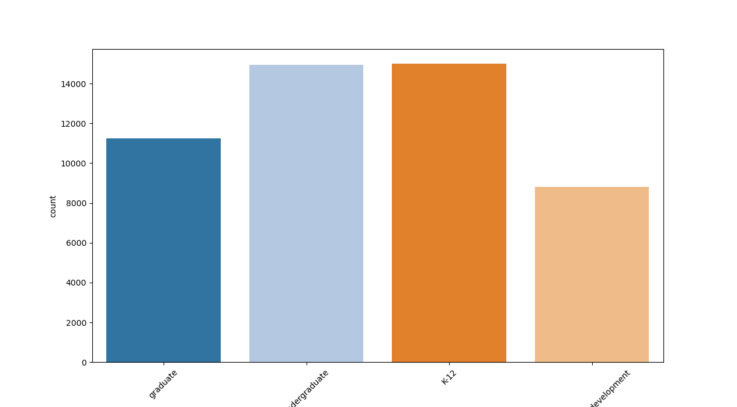
This bar graph shows that there’s more Ai users on K-12(Orange) and undergraduate(light blue) level. This suggests that AI tools are more commonly adopted among students in K-12 and undergraduate levels, possibly due to easier access, greater integration in learning activities, or higher curiosity and willingness to try new technology at these stages.
Figure 2: T test result

T-test result shows that Ai Usage among students mostly have a positive impact on their final scores. With the mean difference of 7.722 and p value of almost 0.
Source
Case Study Source Codes.
https://github.com/AlieeLinux/case-study2

