Northern University Bangladesh



**Lab report:** 01

**Department:** CSE

**Course title:** Digital Electronics & Pulse Technique Lab Work

**Experiment no:** CSE 2366

**Experiment name:** Implement AND, OR and NOT gate in Tinkercad

**Submitted by** **Submitted to**

Name of teacher: Nizia Nahyan

Designation: Lecturer

Signature:

Name: Fardeen Ahmed

Id: 41210301615

Date of Experiment: 3/6/2024

Date of submission: 3/6/2024

AND gate

Circuit diagram:

P1+

IC

74HC08

S1 S2

R1

P1

LED1

P1-

Circuit screenshot:

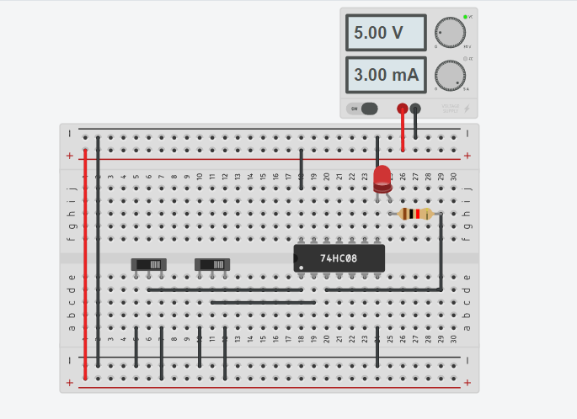

Tinkercad circuit link:

<https://www.tinkercad.com/things/cMO2F16jWek-and-gate-1615?sharecode=Bf7fQX4rZQaGjXvr8GRnfMw_s8wQrqe_v6YBAvTmWXI>

OR gate

Circuit diagram:

P1+

IC

74HC32

S1 S2

R1

P1

LED1

P1-

Circuit screenshot:

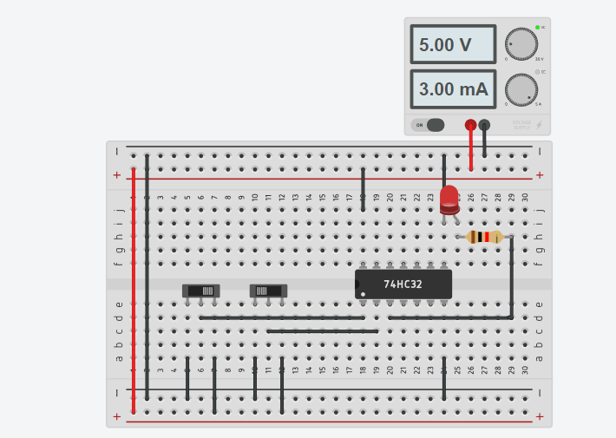

Tinkercad circuit link:

<https://www.tinkercad.com/things/a1XhmYFNm9v-or-gate-1615?sharecode=bGgPStD59hM37zsLt38L_QhhYzmx0WAd3rqrOW3HdYc>

NOT gate

Circuit diagram:

P1+

IC

74HC04

S1 S2

R1

P1

LED1

P1-

Circuit screenshot:

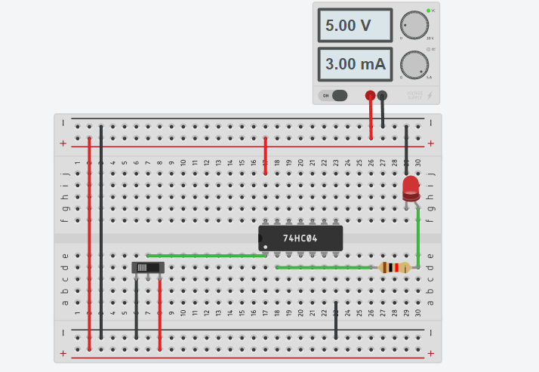

Tinkercad circuit link:

<https://www.tinkercad.com/things/axeoEeOVJ0U-not-gate-1615?sharecode=g2UUwyTXcXgMHfIDZiw1tBMJ43tL_HUvjOVTh8waoYI>