# Shark Minecraft Mod Development Logbook

# Objective

To create a mod for Minecraft which puts a shark NPC into the game.

# Tools / config. Etc.

Forge 14.4

IntelliJ

## Forge

Using Forge as a framework to help development.

<https://files.minecraftforge.net/>

Following their starter guide

<https://mcforge.readthedocs.io/en/latest/gettingstarted/>

DL’d IntelliJ IDE

Having problems building the project with gradle in IntelliJ. It is really slow or is getting stuck.

IntelliJ ran after restarting a few times, presume it was setting up initial once off stuff.

Ran gradlew commands in starter guide from powershell within shark mod directory.

Moving to the next section of the guide

<https://mcforge.readthedocs.io/en/latest/gettingstarted/structuring/>

Next forge guide suggests making a unique package name

Alien2080.mcmods.sharkMod

Made a .info file in src/resources called mcmod. It contains meta data like name and version number.

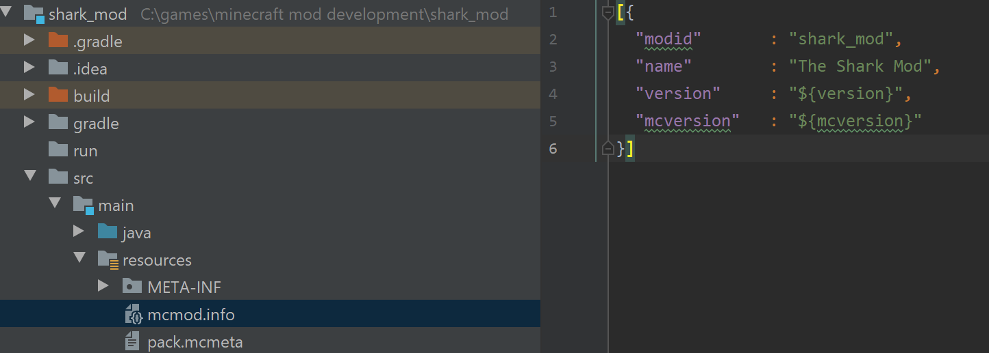

Copied the example mod into my new package

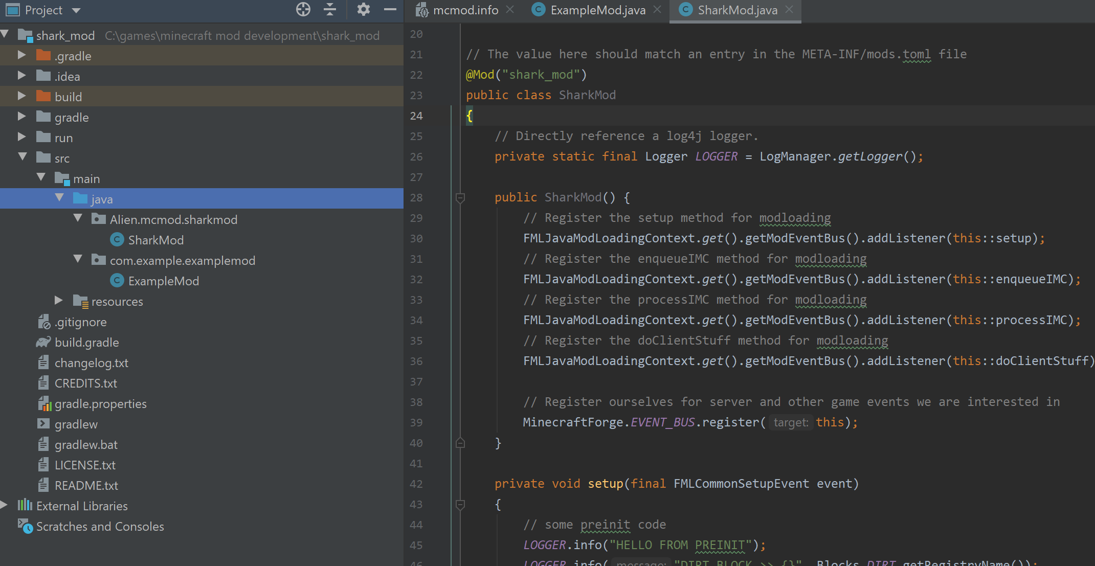

Changed name parameter of @Mod to shark_mod to match mcmod.info

Built from IntelliJ, then ran from inteiiJ. Choose runClient and pointed the config at shark_mod.main

It didn’t work



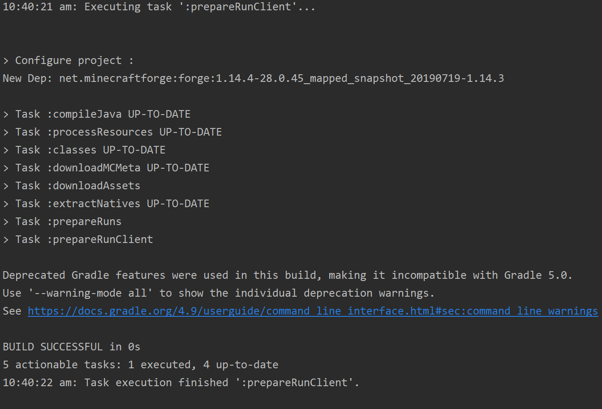

Seems it was stuck on load assests.

Running .\gradlew –refresh—dependancies

Found that run config was pointing to java 12, not java 8 which forge needs

Changing this config setting fixed it

BUT NOW there is a new problem, Minecraft now opens briefly before crashing due to empty mods list and other null pointer exception for details like that

Same error when I build and then move mod.jar file to mod folder of forge install

Ok, it seemed to be a problem with the file structure and meta data

I copied needed files from forge files to new folder and can successfully run Minecraft with example demo from runClient command within IntelliJ!

# The mod

Watching this vid

<https://www.youtube.com/watch?v=DgY6kKf5rGU>

they check the snapshot in gradle file

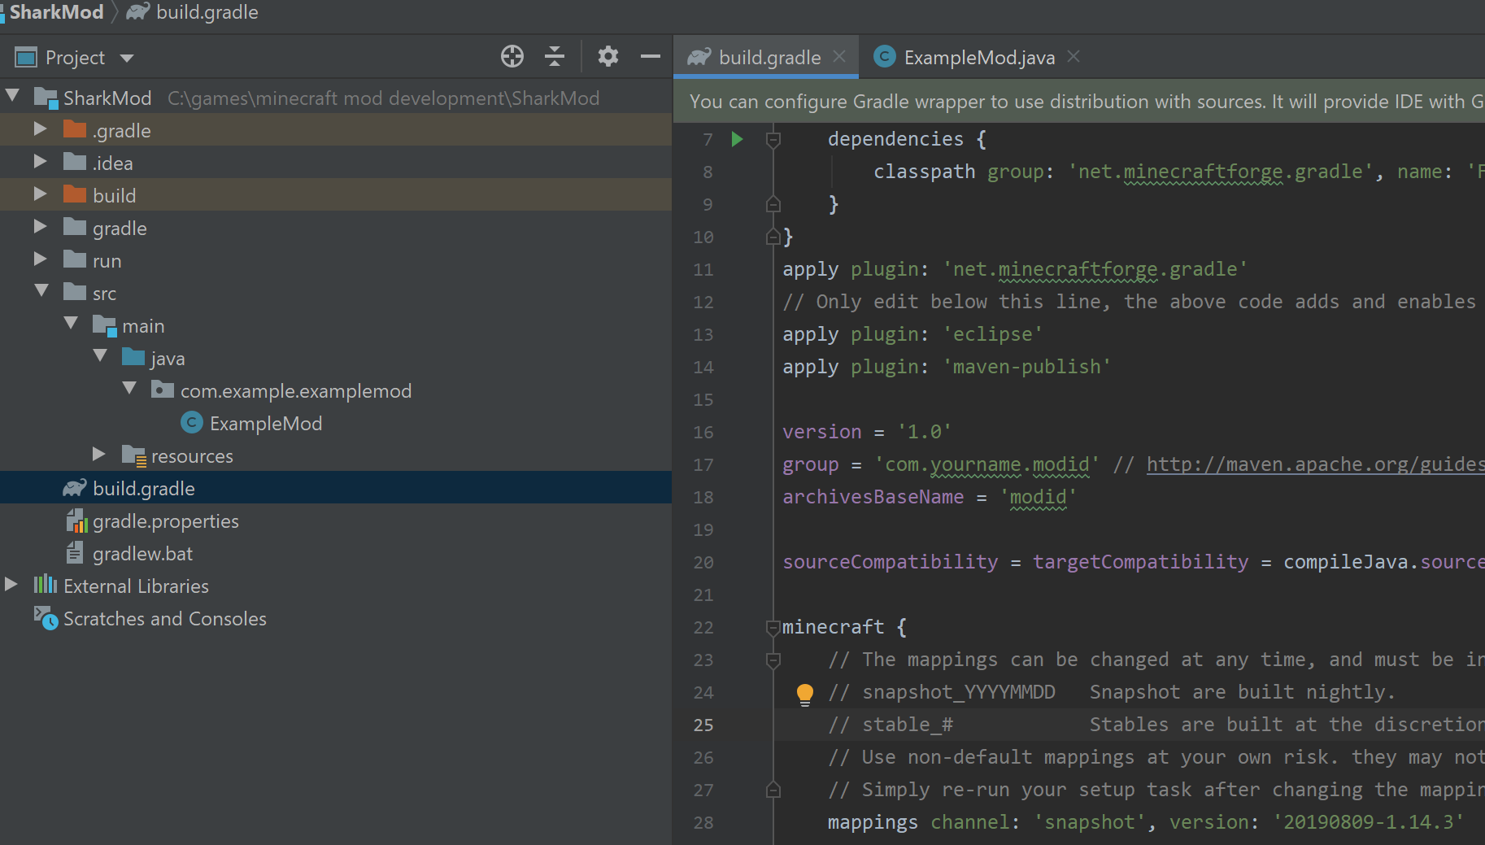

Change snapshot number to version on

<http://export.mcpbot.bspk.rs/>

changed:

pack.mcmeta – mod name from example to SharkMod

gradle.build the group name and archive base name and snapshot mentioned above

mods.toml – mod name, several locations

over details like description

then use gradle refresh properties function from IntelliJ to apply changes

having issues with renaming, getting invalid name error, going to remove spaces from upper directory and see if it helps

it now loads Minecraft…but I cant see sharkmod in mod list, only forge and Minecraft

I found that I needed to use gradlew build on sharkmod, the build project function in IntelliJ doesn’t seem to work the same

Still cant get it working, it either fails to start Minecraft or it crashes straight away from null pointer in mod list and version number, sae error as earlier, before I started that utube tutorial

# Sunday, 11 August 2019

Going to go back to clean install an run the example mod and go slowly from there

Turns out it was the capital letter in sharkMod, modid must be all lowercase it seems…

Making git repository of this directory, and looking into how to post a nice tutorial on github

# Monday, 12 August 2019

Installed Jeykll to use with gitpages to make a website for shark mod.

Following this site

<https://help.github.com/en/articles/setting-up-your-github-pages-site-locally-with-jekyll>

installing ruby 2.5.5, needed by jeykll

# Tuesday, 13 August 2019

Following this guide to set up git page for shark mod

<http://jmcglone.com/guides/github-pages/>

and this one

<https://help.github.com/en/articles/setting-up-your-github-pages-site-locally-with-jekyll>