2026年浙江省中考英语试题
C 篇
Ayi is a 22-year-old girl from Kashgar, Xinjiang. She became well-known in a new season of the TV programme, which tells people how young people build their careers after leaving school. The programme followed 12 students who studied Traditional Chinese Medicine (TCM). As the youngest one, Ayi at first was unnoticed. By the end of the season, however, she surprised all with her great progress.
Ayi was not from a family of doctors. Her earliest interest in traditional medicine was awakened in her old town. In that place, people believed mutton soup cured illness faster than seeing doctors in hospital. When her grandmother died of illness, she realized good doctors are needed in this place. That was when she decided to become one to serve the people there.
In 2018, thanks to an education program for Xinjiang middle school students, Ayi had a chance to study in a Shenzhen high school. Three years later, she was accepted by Guangzhou University of Chinese Medicine.
However, the road to becoming a TCM doctor was never easy. For her, it’s especially difficult to understand ancient Chinese medical books. “Terms (术语), like yin and yang, were totally a new way of thinking. So I was always half a step behind my classmates,” Ayi said. To catch up, she put in more time and developed a study method of her own. Along with her schoolwork, Ayi got practical experience by taking part in more than 13 volunteer activities.
Ayi’s greatest dream is to return to Xinjiang and use her TCM knowledge to serve local people. “Back in Kashgar, I know many people don’t look for medical care, so I believe it’s deeply meaningful to use TCM, which is simple, cheap and works well,” Ayi said.
8．Why did Ayi become famous in the TV programme?
A．Because she made great progress. B．Because she learned TCM by herself.
C．Because she is the youngest one. D．Because she got best scores in the school.
9．What made Ayi decide to be a doctor?
A．The dream of her family. B．The medical needs in her hometown.
C．The advice from her grandmother. D．The visit to the local hospital.
10．Which word can best describe Ayi?
A．Honest. B．Friendly. C．Hard-working. D．Humorous.
11．What is the best title of the text?
A．A Journey into TCM. B．The changes in TCM.
C．A Programme About Dreams. D．The Meaning of Volunteer Work.

D篇

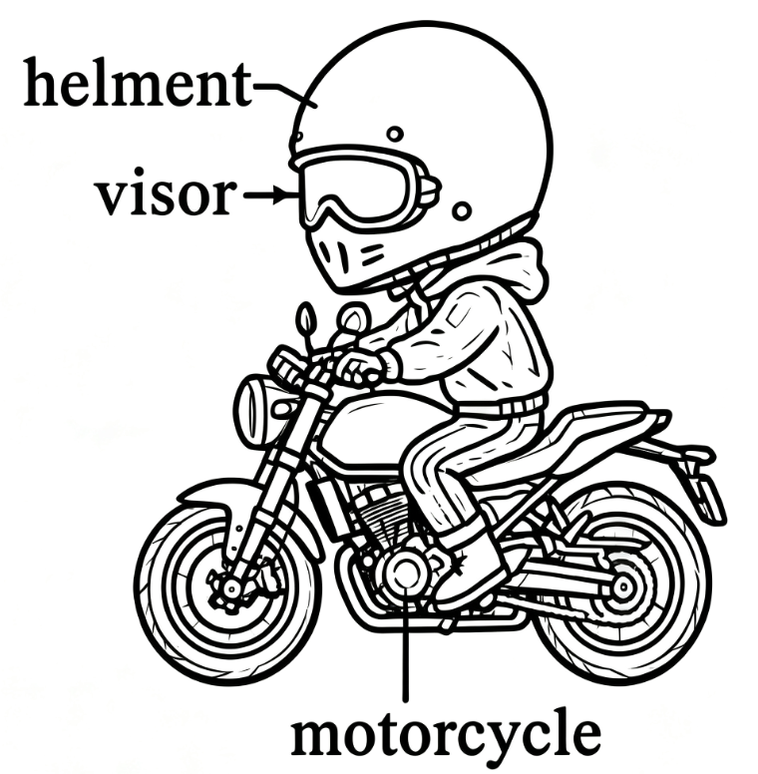
Motorcycle helmets are important. They protect riders from getting hurt. Last year, about 1872 riders in the US were saved because of helmet use. Effective helmets do more than protect people in accidents. They also help keep wind and small flying pieces off riders’ faces.
Before the 1970s, motorcycle helmets were made of plastic, offering little protection. Today, they are made of carbon-fibre (碳纤维), much lighter and stronger than before. Now, they are safer and more comfortable.
With the development of technology, modern helmets are smarter. Through Bluetooth connected speakers, riders can make telephone calls as they travel along the road. Cameras are also found in modern helmets. They can record what is happening ahead like the cameras in cars and they are easy to control through voice. The visors in certain helmets are able to change their colour. They become dark when the sun shines too brightly or when strong light from cars and trucks hit riders’ faces. In this way, riders can avoid strong light and see better.
These days, AI is changing people’s way of life. For motorcycle riders, AI can now be placed inside helmets to achieve greater safety. One such example is the iC-R smart helmet. This helmet can show the objects around the motorcycle. The riders don’t need to turn their heads or take their eyes off the road ahead to get a better sense of the road situation. The helmet can also receive all the important information, such as speed, direction and traffic accidents. When a rider decides where to go, the helmet shows different ways to get there on the inside of the visor. It can even warn the rider when necessary, like when a motorcycle gets too close to a car.
12．Why does the writer mention the number “1872” in Paragraph 1?
A．To show the fun of riding motorcycles.
B．To explain the influence of strong wind.
C．To tell the importance of wearing helmets.
D．To point out the danger of fast motorcycling.
13．What does the underlined word “They” in Paragraph 3 refer to?
A．Riders. B．Cameras. C．Speakers. D．Visors.
14．What is special about the iC-R smart helmet?
A．It speeds up the motorcycle.
B．It sends warnings to other riders.
C．It offers riders traffic information.
D．It clears the flying pieces on the road.
15．What’s the main idea of the text?
A．Motorcycle riders are learning AI skills.
B．Motorcycle helmets with AI are in great need.
C．Motorcycling is becoming more and more popular.
D．Motorcycle helmets are getting smarter and safer.

