2026年北京市中考英语试题
学校:___________姓名：___________班级：___________考号：___________

C篇
While the size of Arctic sea ice has dropped by about 40 percent over 40 years, until recently, the size of the sea ice around Antarctica was slowly increasing. Then, after 2015, Antarctic ice extent (范围) fell from a record high to several record lows, losing an area as large as Greenland.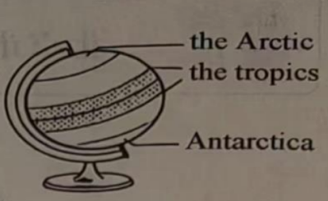
Some research has suggested that higher air temperatures may be the cause. However, two new studies show that ocean warming played a bigger role in this dramatic change. As part of global ocean circulation (全球海洋环流), warm saltwater moves southward from the tropics and circles Antarctica 200 metres below the surface. But temperature and saltiness records of the past 20 years suggest that this warm deep saltwater has been rising towards the surface, where it can melt (融化) sea ice.
Antarctica is encircled by a belt of strong winds and storms. Climate change has pushed this storm belt southward, bringing more rain and snow into the sea ice area, according to a study by Earle Wilson and other researchers at Stanford University. The rain and snow create a layer (层) of fresh surface water that better protects the bottom of the sea ice from warm deep saltwater, allowing it to grow to its 2014 record high. But the same southward-moving storm belt also brings stronger winds. These winds blow surface water and ice forward. As this happens, warm deep saltwater rises up to fill the empty space.
Between 2014 and 2016, this wind-driven rising began to get the upper hand against the protective layer of increased rain and snow, and sea ice began to melt away. When the researchers input the recorded ocean data (数据) into a computer model, it projected that sea ice would grow and then become smaller, as it did in the real world.
The researchers plan to study and model other things, which also likely play roles throughout Antarctica. Examples include changes in sea ice movement and increases in ocean mixing resulting from more storms. By studying the ocean data, they hope to build a model to project changes in Antarctic sea ice in the years to come.
27．Which of the following best shows the Antarctic sea ice changes around 2015?
A．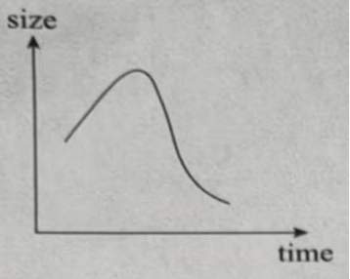 B．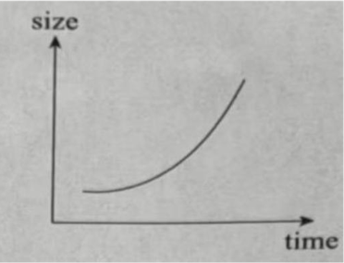
C．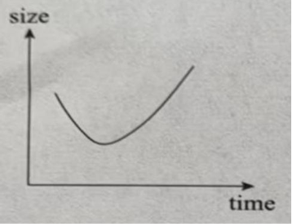 D．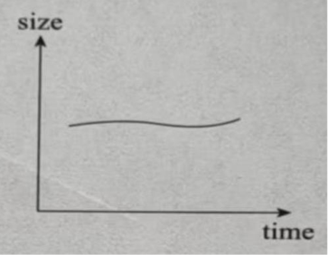
28．In which order are the following events discussed in Paragraph 3?
①Warm deep saltwater rises to the surface.
②A layer of fresh surface water is created.
③Surface water and ice are blown forward.
④More rain and snow are brought into the sea ice area.
A．②④①③ B．②④③① C．④②①③ D．④②③①
29．Which of the following is the best title for this passage?
A．Where is Antarctic sea ice loss taking us?
B．Is this the cause of Antarctic sea ice loss?
C．Will a new model explain Antarctic sea ice melting?
D．How does fresh surface water protect Antarctic sea ice?

D篇
The internet has provided us with unmatched ways to get information but it is also sounding alarms. Some experts argue that the internet will produce forgetfulness in the minds of those learning to use it, because they won’t practise their memory.
Is the internet really doing harm to our memories—or will our doubtful experts be proven wrong? After all, the brain’s attention system (系统) and preferences for novel experiences were already there long before the digital age, and our ability to remember is nearly inexhaustible (无穷尽的). According to Michael Merzenich, a brain researcher, every brain is a work in progress; it keeps changing throughout our lives, depending on how we use it.
But our brains don’t work well when we’re not focused. When we repeatedly check text messages and social media during work, we are weakening our ability to form both short-and long-term memories, experts say. The flooding of information influences our ability to remember, too. Though our brains are designed to look for new data, too much of it may be causing this natural drive to go wild. The compulsion to continuously take in information means we often check social media when we should be doing “memory housekeeping” by giving our brains some rest. Another problem: the effortless way of receiving information online. Trying to actively recall (回忆) data is a good workout for the brain, but today we are using online search tools instead.
However, the internet may be changing only what we remember, not our ability to do so, suggests Columbia University psychologist (心理学家) Betsy Sparrow. In fact, the internet is becoming an outside hard drive for our memories. Some worry that this is having a negative effect on society, but Sparrow suggests this will change our way of learning from a focus on remembering facts to one on understanding ideas.
As is shown in a 2008 study, using the internet exercised the brain more than reading among older adults with strong computer skills. And two Harvard psychologists argue that not needing to remember facts might free our minds to focus on more meaningful tasks.
“There may be costs caused by our increased dependence on the internet, but generally the benefits are going to outweigh those costs,” says Benjamin Storm, a psychologist. “It seems pretty clear that memory is changing, but is it changing for the better? At this point, we don’t know.”
30．What does the word “compulsion” in Paragraph 3 most probably mean?
A．Longing. B．Ability. C．Chance. D．Promise.
31．What can we learn from the passage?
A．Internet users remember facts better than non-users.
B．Novel experiences improve the brain’s attention system.
C．Checking social media can give the brain proper breaks.
D．The internet may produce a change of focus in learning.
32．How does Benjamin Storm feel about the effects of the internet on memory?
A．Uneasy and doubtful. B．Positive but still uncertain.
C．Negative but still hopeful. D．Encouraged and confident.
33．What is the writer’s main purpose in writing this passage?
A．To argue for a belief. B．To challenge a solution.
C．To present different views. D．To examine causes and effects.

