武汉市

C篇
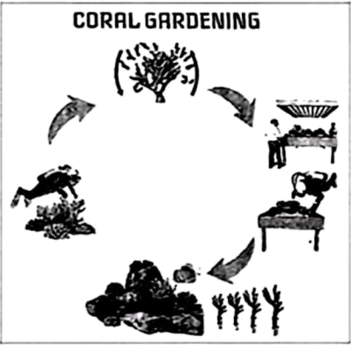
The ocean covers most of our planet, yet we know very little about it. Our ocean is as mysterious as it is beautiful. In fact, we have better maps of Mars than we do of the ocean floor. Why? Exploring (探索) the ocean is a really hard job. There’s a lot of ocean—about 1.4 billion trillion litres (升). That’s 1,400,000,000,000,000,000,000!
★ . One of their most important goals is to learn about coral reefs (珊瑚礁), which are home to lots of sea plants and animals.
Do you know that coral is an animal, not a plant? Tiny animals called polyps (珊瑚虫) build the hard part of the coral as a home to live in. They are called “architects” in the ocean.
However, many coral reefs around the world are in danger. That’s where a clever method called “coral gardening” comes in—giving reefs a second chance. Here’s how it works in four steps:
First, scientists collect small pieces of coral from coral reefs. Then they break them into even smaller ones—tiny pieces grow faster. After that, they place the pieces in lab-controlled or underwater nurseries (苗圃), where tiny pieces are taken good care of. Finally, once strong enough, they are planted onto rock or man-made reefs so that they can grow on their own.
A typical example is the L-shaped Reef. Since 1982, scientists have placed old subway cars into the sea. These strange “homes” have created a huge man-made reef. Now, polyps and fish are moving in!
To know more about the ocean, a volunteer, Paul Green started the Big Bag Project in 2025. It calls on beach visitors to help collect information on plastics and water temperature through a bag which is connected with an app. Next time you go to the beach, take a bag, pick up some rubbish, and have a closer connection with the ocean.
36．What does the number in paragraph 1 tell us about the ocean?
A．How much salt there is. B．How cold the deep ocean is.
C．How large the ocean is. D．How many sea plants there are.
37．Which of the following can be put in ★ ?
A．Some sea animals are making a comeback
B．The ocean is full of wonders to be discovered
C．But many scientists are taking on this challenge
D．So protecting the ocean is everyone’s responsibility
38．What does the underlined word “architects” mean?
A．People who build houses. B．Machines that carry things.
C．Workers who collect coral. D．Animals that live in the sea.
39．In the picture CORAL GARDENING, what is the third step?
A．Breaking. B．Nursing. C．Planting. D．Collecting.
40．What’s the writer’s main purpose in writing this passage?
A．To introduce the Big Bag Project.
B．To show the hidden beauty of the ocean.
C．To teach us how to become an ocean biologist.
D．To encourage more people to explore the ocean.

