2026年陕西省中考英语试题

C篇
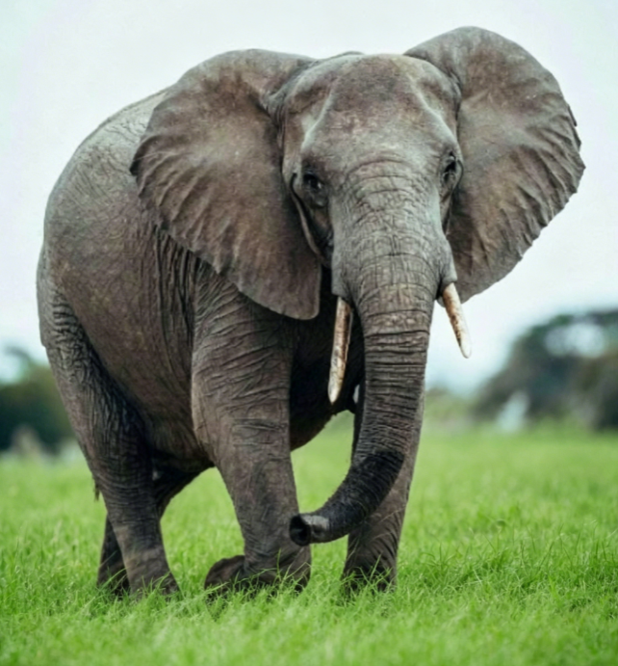
This is a true story of a four-legged hero as well as animal friendship and care. Everything took place in Nairobi, Kenya—a country in East Africa.
When she was just a few weeks old, a small elephant sadly lost her mother to a poacher attack (盗猎袭击). Luckily, the little elephant was found by a farmer and taken to an elephant orphanage* where she was named Natumi. There, at the David Sheldrick Wildlife Trust, Natumi was safe, but very scared and shy. Soon, however, new orphaned baby elephants began to arrive at the shelter. At first, Natumi hid behind her keeper’s legs, but it soon became clear that the other baby elephants needed someone to depend on. They were very young and many of them had injuries (外伤；损伤) like wounds and scratches. To everyone’s surprise, shy little Natumi stepped up to the task. She began to act like a big sister to the seven other elephants, keeping them calm and playing with them in the surrounding bush (周边的荒野). Guided by Natumi, the elephants had soon formed their own loving family. In the end, the new family of elephants was strong and healthy enough to return to the wild—but the workers at the shelter would never forget a little elephant named Natumi who made it possible.

