2026年湖南省长沙市中考英语试题

B篇
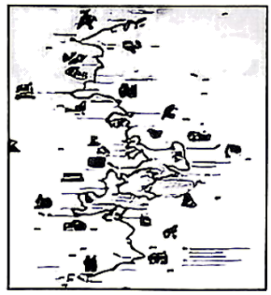
Do you read fairy tales (童话)? Have you ever dreamed of stepping into a fairy tale? If so, in Germany, your dream will come true. Here, the German Fairy Tale Route can take you through ancient castles (城堡), thick forests and unusual villages—just like those in the stories we all know and love.
This special route (路线), a 600-kilometer road, was set up in 1975 to remember the Brothers Grimm, two famous German storytellers—Jacob Grimm and his younger brother Wilhelm. Together, they collected and wrote hundreds of stories, and then published (刊登) them in a book called Grimm’s Fairy Tales. Some of their well-known stories include Cinderella, Snow White, Hansel and Gretel, and Sleeping Beauty.
The route starts in Hanau, the town where the Brothers Grimm were born. From there, it winds north through beautiful countryside. Along the route, visitors can see the childhood home of the Grimm brothers in Steinau and the university town of Marburg, where they studied. In Alsfeld, you can walk through Little Red Riding Hood country and imagine meeting the much-loved girl in her red hat. The route also passes through Hamelin, the setting of The Pied Piper of Hamelin, and ends in Bremen, where a statue (雕塑) of the Bremen Town Musicians welcomes visitors.
Throughout the year, the German Fairy Tale Route hosts many events that breathe new life into old stories. Visitors can enjoy movies, folk festivals, storytelling evenings, to name but a few. It’s more than just a journey through picturesque places. It takes you right into the heart of storytelling itself.
So pack your imagination and get ready for an unforgettable journey!
3．How does the writer start the topic?
A．By listing numbers. B．By asking questions. C．By making comparisons.
4．Why was the German Fairy Tale Route set up?
A．To sell Grimm’s Fairy Tales.
B．To show the castles in Germany.
C．To remember the Brothers Grimm.
5．What does Paragraph 3 mainly talk about?
A．Some much-loved fairy tales.
B．The childhood of the Brothers Grimm.
C．Famous cities and towns along the route.
6．Where is the text most probably taken from?
A．A diary entry. B．A travel guide. C．A movie review.

D篇

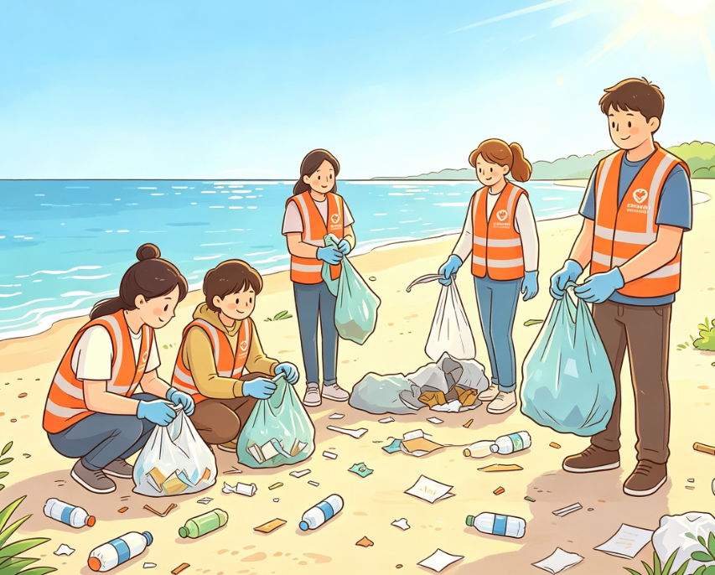
Now picture this: You are spending two weeks in a foreign country helping local kids with Chinese in the morning and sunbathing on a beach in the afternoon. That’s exactly what voluntourism is all about. “Voluntourism” is a blend (混合) of “volunteering” and “tourism”. It means doing volunteer work in the place where one is vacationing.
Voluntourism has many advantages. For local communities, volunteers bring them energy, skills and kindness. They build houses, clean the environment, provide medical care, and so on. For voluntourists, they get free meals and housing when volunteering. Also, it’s a great way to learn about other cultures while making a positive (积极的) change.
But there are problems too. First, some people say short-term voluntourism does not create lasting change. Building a house in one week might not be as helpful as training local workers. Another problem is that sometimes volunteers take away jobs and income (收入) from the locals. Also, some projects are not well planned. As a result, they may fail to meet expectations, and even do harm to both voluntourists and local communities.
So, what should you do if you want to be a good voluntourist? First, research carefully. Choose a responsible organization (负责任的机构) that listens to local people. Then, think about what skills you have to help those in need. Besides, consider the value of what you do: Does it meet the community’s needs? Is it sustainable (可持续的)? When asking yourself these questions, always remember: Helping isn’t just about you feeling good — it’s about doing real good.
Voluntourism could be a wonderful experience if done right. However, if it is done wrong, things will be different. The key is to make informed decisions that will leave the world better than it was when you started.
7．Which of the following best describes “voluntourism”?
A．Travelers study in another place.
B．Tourists volunteer while on a trip.
C．Visitors work part-time for money.
8．What might be a problem of short-term voluntourism according to Paragraph 3?
A．A shortage of workers. B．A waste of money. C．No lasting change.
9．What should you do to be a good voluntourist?
①Do careful research. ②Think about your skills.
③Consider the value of your act. ④Jump at any volunteer chance.
A．①②③ B．①③④ C．②③④
10．What is the best title for the text?
A．Voluntourism: Helpful or Harmful?
B．Voluntourism: Low-cost but High-risk
C．Voluntourism: Enjoyable and Sustainable

