2026年重庆市中考英语试题

D篇
By 2030, the world’s data (数据) centers are expected to use more than double the electricity they use today. AI is the main driver. It forces countries to look for new ways to solve the big problem. China is leading the way by putting data centers under the sea as a greener solution.
In December 2022, Hainan became home to China’s first underwater data center. This was followed by a more advanced (先进的) project in Shanghai in 2025.
AI servers give off heat while working, making the temperature rise. If the heat isn’t taken away in time, the servers won’t run well or even break down. On-land data centers have to use up to 40% of their electricity just for cooling AI servers.
Underwater data centers, like the one in Shanghai, use pipes to pump (输送) seawater. Seawater goes through the radiators on the back of the servers. It takes in heat and carries it away. The sea temperature is about 15℃, perfect for natural cooling. In this way, the electricity is saved. An assessment (评估) from the China Academy of Information and Communications Technology shows the underwater data center uses at least 30% less electricity than on-land data centers thanks to natural cooling.
Underwater data centers can also reduce land usage by 80%. And the one in Shanghai offers another benefit: it will get more than 95% of its electricity from a kind of renewable energy—wind energy. And the use of tidal (潮汐) and wave energy is also taken into consideration.
China’s efforts in developing underwater data centers show its promise to create low-carbon digital infrastructure (低碳数字基础设施). The act not only helps reduce the environmental influence of AI, but also could set a new standard for sustainable computing (可持续算力) worldwide.
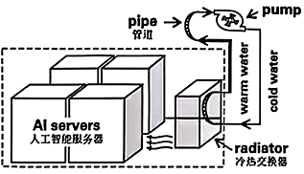
56．What is the main reason for China to develop underwater data centers?
A．To provide more electricity for AI servers directly.
B．To reduce the cost of building on-land data centers.
C．To solve the problem of high energy use caused by AI.
D．To increase the speed of internet connections worldwide.
57．How does an underwater data center cool AI servers?
A．It uses seawater to cool AI servers naturally.
B．It uses air conditioners for cooling AI servers.
C．It depends on wind energy to power its cooling.
D．It is connected with tidal and wave energy for cooling.
58．Which of the following is TRUE according to paragraph 4 and paragraph 5?
A．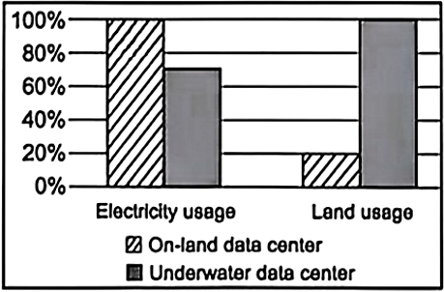 B．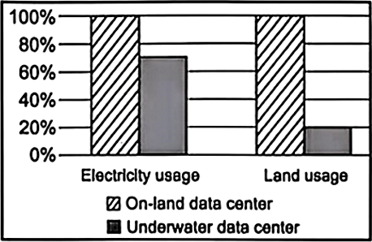
C．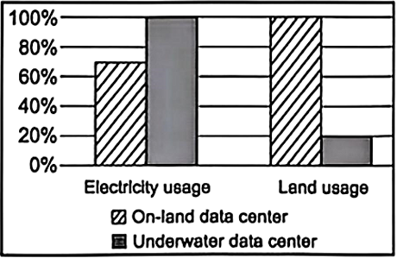 D．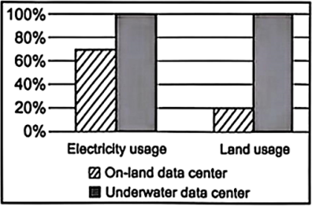
59．What would you do next if you were the developer of China’s underwater data centers according to the passage?
A．Close all the on-land data centers to save electricity in the near future.
B．Focus on developing on-land data centers instead of underwater data centers.
C．Cut down the cost of research and development since the projects are successful.
D．Explore the use of tidal and wave energy to further improve sustainable computing.

