AI-Generated Code Security Analyzer:
Developers increasingly use AI-generated code, but insecure patterns often go unnoticed. Build a system that automatically detects vulnerabilities in AI-generated code and suggests secure alternatives

This is an excellent problem statement for a hackathon or research project. Here's a complete solution architecture.
AI-Generated Code Security Analyzer
Detecting Vulnerabilities in AI-Generated Code Using AI + Static Analysis

Problem Statement
Large Language Models (LLMs) such as ChatGPT, Claude, Gemini, and Copilot generate code rapidly. However, they may also produce insecure code containing vulnerabilities like:
- SQL Injection
- Cross-Site Scripting (XSS)
- Command Injection
- Path Traversal
- Hardcoded Secrets
- Weak Cryptography
- Unsafe Deserialization
- Buffer Overflow
- Insecure Authentication
- Missing Input Validation
Most developers trust AI-generated code without performing security reviews.
The objective is to build an AI-powered code security analyzer that automatically detects vulnerabilities, explains the risk, and suggests secure fixes before deployment.

Proposed Solution
Develop a web application that:
- Accepts AI-generated source code.
- Identifies programming language.
- Performs static code analysis.
- Detects vulnerabilities using:
  - Rule-based engine
  - AI model
  - Security scanners
- Calculates risk score.
- Suggests secure code.
- Explains OWASP vulnerability.
- Generates a downloadable security report.

System Architecture
User
│
▼

Upload / Paste Code

│

▼

Language Detection

│

┌─────────┴──────────┐

▼ ▼

Static Rule Engine AI Vulnerability Detector

│ │

└─────────┬──────────┘

▼

Vulnerability Aggregator

▼

Risk Score Calculation

▼

AI Secure Code Generator

▼

Security Report Generator

▼

Dashboard + PDF

Supported Languages
- Python
- Java
- C
- C++
- JavaScript
- TypeScript
- Java
- Go
- Rust
- PHP

Vulnerabilities to Detect
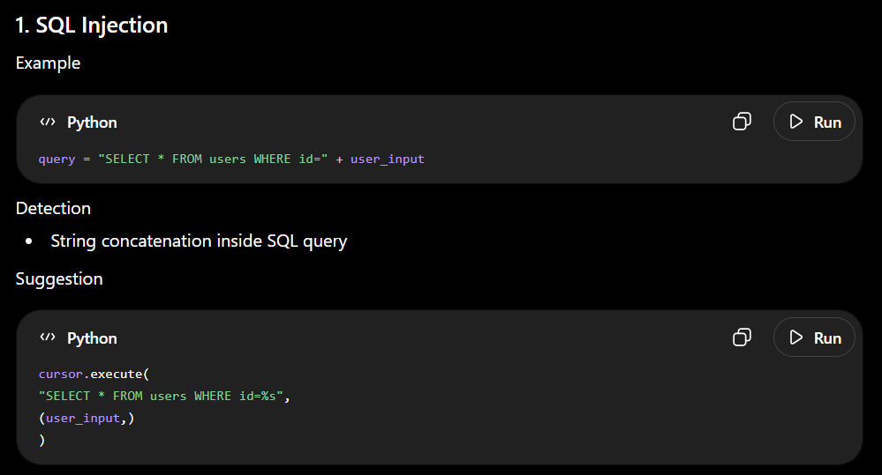
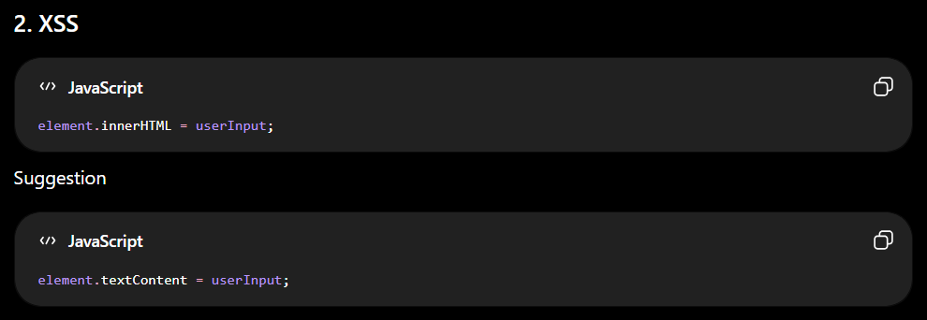
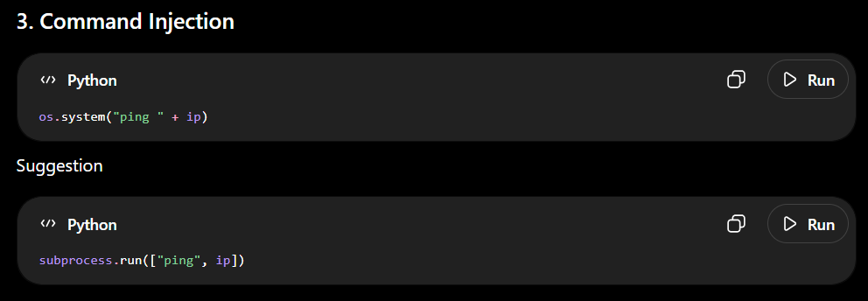
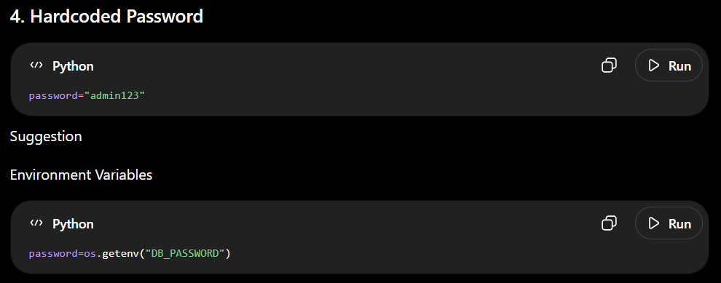

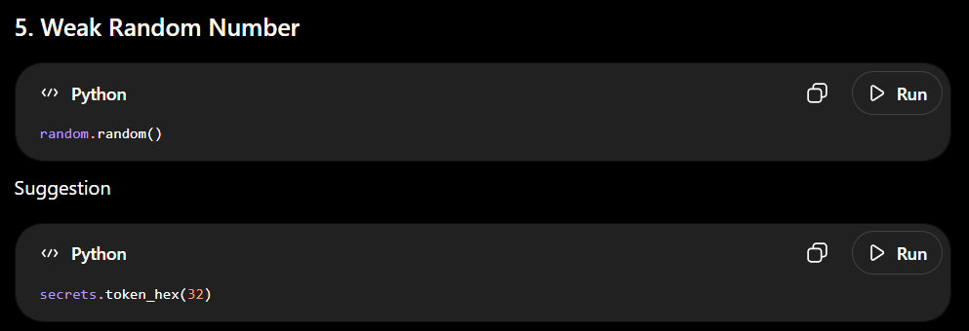
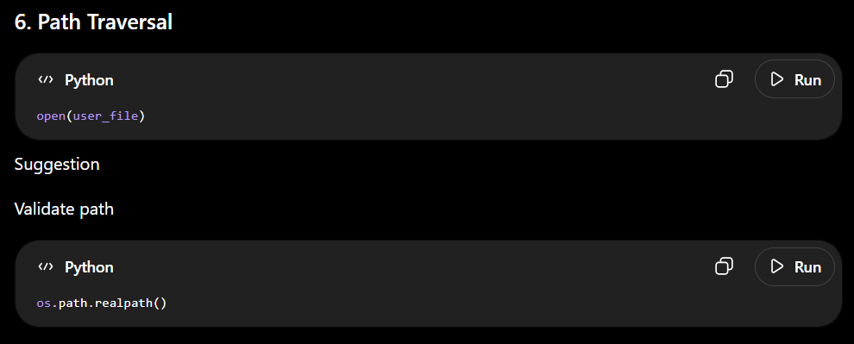
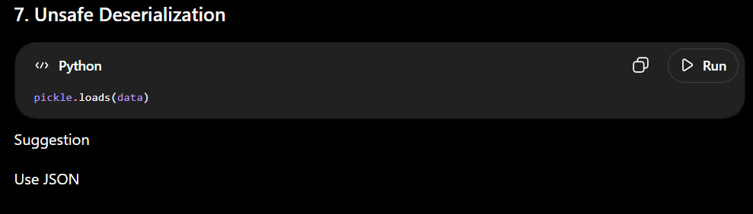
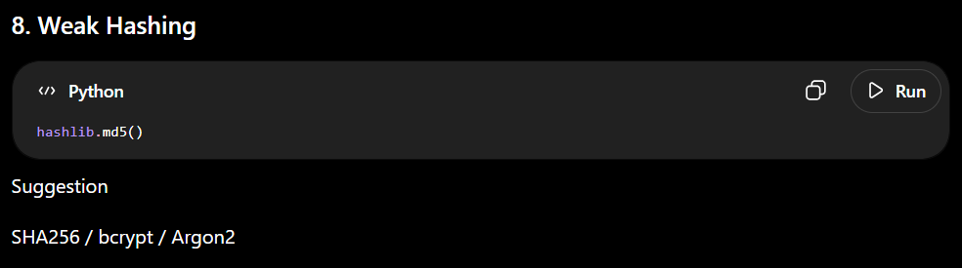
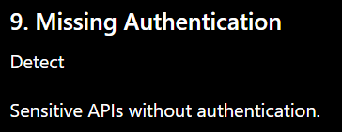
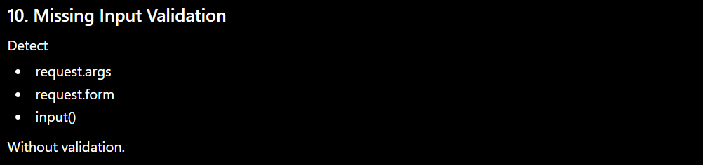

Technology Stack
Frontend
- React
- JavaScript Syntax Extension
- Monaco Editor
- Chart.js

Backend
- FastAPI
- Python

AI Models
Option 1
CodeBERT
Uses Transformer embeddings to understand code.

Option 2
GraphCodeBERT
Captures code semantics.

Option 3
StarCoder
Local inference.

Option 4
Llama 3
Fine-tuned for secure coding.

Static Analysis Tools
Python
- Bandit
JavaScript
- ESLint Security Plugin
Java
- SpotBugs
C/C++
- Flawfinder
- Cppcheck
Secrets
- TruffleHog
- Gitleaks
Dependencies
- Safety
- pip-audit
- npm audit

AI Detection Workflow
Input Code
↓
Tokenizer
↓
Embedding
↓
Transformer Model
↓
Classification
↓
Vulnerability Type
↓
Confidence Score
↓
Explanation
↓
Secure Code Recommendation

Risk Scoring
Each vulnerability gets:
Severity | Score
Critical | 10
High | 8
Medium | 5
Low | 2
Overall Score:
Security Score
100 - Risk

Example
92/100
Excellent

or
41/100
Critical

Dashboard
--------------------------------------

Security Score

87/100

--------------------------------------

Detected Vulnerabilities

✓ SQL Injection

✓ Hardcoded Password

✓ XSS

✓ Weak Hash

--------------------------------------

Secure Code Suggestions

View Diff

Replace

Download Report

--------------------------------------

AI Prompt Example
You are a cybersecurity expert.

Analyze the following code.

Detect:
- OWASP Top 10 vulnerabilities
- CWE IDs
- Severity
- Risk explanation

Rewrite the code securely.
Return JSON.

Database
MongoDB Collections
- Users
- Projects
- Analysis
- Reports
- Rules
- History

API Endpoints
POST /sca
POST /fix
POST /upload
GET /report
GET /history
GET /rules
POST /feedback

Machine Learning Pipeline
Dataset
↓
Cleaning
↓
Tokenization
↓
Code Embeddings
↓
Training
↓
Fine-tuning
↓
Evaluation
↓
Deployment

Dataset Sources
- GitHub Security Advisories
- OWASP Benchmark
- Juliet Test Suite (C/C++)
- SARD (Software Assurance Reference Dataset)
- Devign Dataset
- Big-Vul Dataset
- CVE Fix Commits
- CodeXGLUE

Additional Features
AI Chat Assistant
Ask
Why is this vulnerable?
AI explains.

VS Code Extension
Scan while coding.

GitHub Integration
Scan Pull Requests automatically.

CI/CD Integration
Fail builds if Critical vulnerabilities exist.

PDF Report
Include
- Vulnerability Summary
- Severity
- CWE
- OWASP Mapping
- Suggested Fixes
- Secure Code Snippets
- Risk Score

Explainability
For every finding
- Why detected
- Confidence %
- Line number
- Suggested fix
- References
- Secure alternative

Future Scope
- Fine-tune an LLM specifically on secure coding patterns.
- Support additional languages such as Kotlin, Swift, and Dart.
- Integrate dynamic analysis and sandbox execution alongside static analysis.
- Learn from developer feedback to reduce false positives over time.
- Detect AI-generated code fingerprints and prioritize review accordingly.
- Provide organization-wide security analytics and compliance dashboards.

Expected Outcomes
- Detect common vulnerabilities in AI-generated code before deployment.
- Improve developer awareness with contextual explanations and secure alternatives.
- Reduce manual security review effort through automated analysis.
- Integrate seamlessly into IDEs and CI/CD pipelines for continuous security checks.
- Promote secure-by-design software development aligned with OWASP and CWE standards.
This solution combines rule-based static analysis, AI-powered semantic vulnerability detection, and automated secure code generation, making it suitable as a modern DevSecOps tool for developers increasingly relying on AI-generated code.

